Master DOcumentation

Sprint Two

Team F

Table of Contents

Source Control 2

Software Review Plan 3

Performance Report 4

Project Management Plan 5

Software Testing Plan 6

# Source Control

For our second sprint we created an additional branch in our Github Project, we named this branch ‘version_two’.

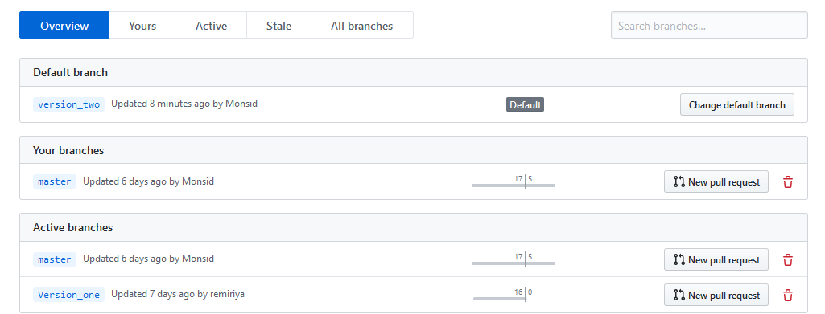

Within version two, the team has uploaded the project, with the database details for SQL and a two executable .bat files in the private folder for Admins of Acme Entertainment to use for emailing purposes. The readme has been updated with instruction for setting up Windows Task Scheduler task for monthly newsletters.

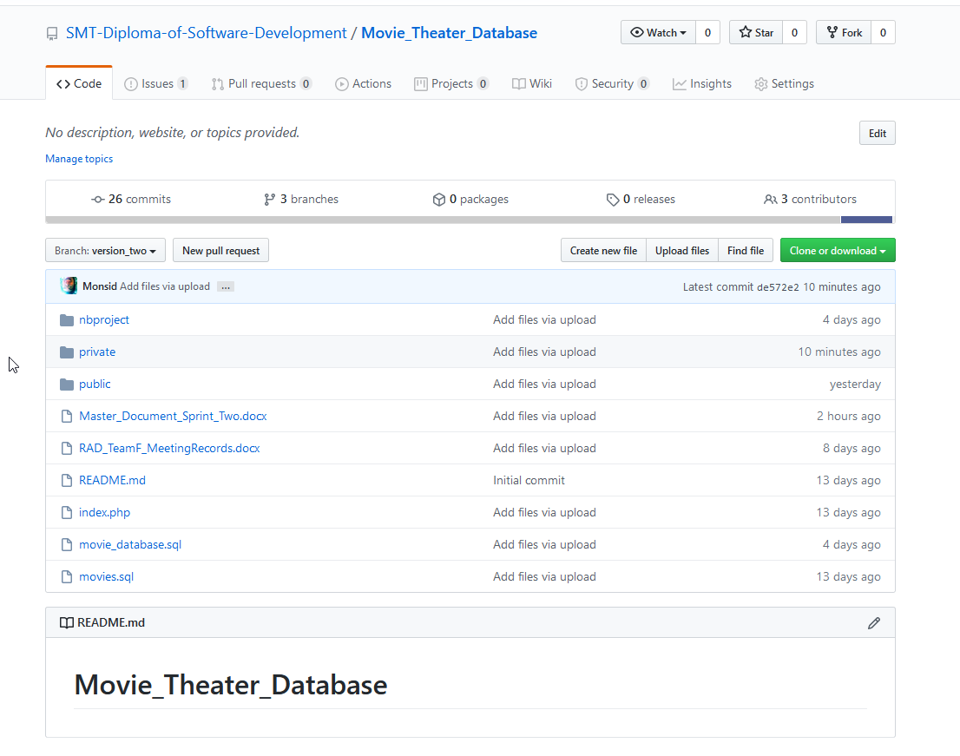

# Software Review Plan

## Feedback from Client

As the succession of Sprint One, the development is continued to next sprint. The Acme Entertainment Pty Ltd requested a free communication service for the customer who is signed up with their email address.

## Specification

They chose a monthly newsletter as their free communication service. This newsletter will be emailed during the last week of each month and a breaking newsflash notification will be sent as they occur. The members, who is signing up for this newsletter, will be able to select one or both communication options during the sign-up process. The signup will not require a password but there must be an option to remove their subscription. The removal process should send an email to the administrator requesting the removal of a member’s details from the database.

## Requirements

Our team is required to create a membership page to add new records to a membership database. In order to meet this requirement, the sing-up form of newsletter must be implemented. This form should include the text fields to obtain member’s full name and email address which should be validated to avoid incorrect or erroneous information. It is also required to implement an unsubscribe button other than subscribe button.

### Implementation of emailing system

In order to send an email to subscribers, PHP mailer which is A full-featured email creation and transfer class for PHP will be implemented. As it is not possible for any person to send email via any mail server they choose; mail servers will only allow the sending of email by legitimate users, users should be authenticated by SMTP Authentication. For SMTP Authentication, SendGrid will be used. SendGrid is a cloud-based email service that provides reliable transactional email delivery, scalability, and real-time analytics along with flexible APIs that make custom integration easy.

### Implementation of Automation for sending email

In order to set a timing to send an email, Windows Task Scheduler will be used as it can automatically send email at a specific time or in response to a specific event.

# Performance Report

Introduction/Purpose

This report provides a performance-based perspective into the development process for Sprint Two by identifying appropriate code optimizers and performance tools that could benefit this project such as IDEs for development and libraries for code implementation. A recommendation is also provided based on the teams review of the options included in this report, this recommendation is in the form of a table, the summary concludes by outlining the tools chosen by the programmer for implementing this sprint’s requirements.

Candidate Tools and Software

### IDEs/Editors

1. **Atom**

A free and open source text editor for Linux, Mac or Windows it supports plugins that runtime via JavaScript Node.js, a runtime environment that allows command line tools and server-side scripting. Atom feature auto completing and suggestions while writing any language which it supports (list of languages supported [here](https://en.wikipedia.org/wiki/Atom_(text_editor)#Programming_language_support)) these include HTML, PHP, JavaScript and even SQL.

1. **NetBeans**

A full IDE (Integrated Development Environment) which means that it has extensive and intelligent development features, such as seamless software modularization, language extensions and easier ways to integrate libraries into a project. NetBeans offers IDE Bundles for 3 development pathways these are:

* NetBeans IDE Bundle for Web and Java EE

Complete tools for all latest Java EE 6 standards.

* NetBeans IDE Bundle for PHP

Supports PHP 6.5+, includes code completion, highlighting and php code debugging.

* NetBeans IDE Complete Bundle

Includes both the bundles defined above in one complete package, includes other packages like JavaFX.

NetBeans also has a wide array of generic debugging features such as the profiler and debugger which can keep track of parameter values while stepping through debugging lines of code.

1. **Bootstrap Studio**

A very popular and powerful but proprietary development application with many components for building responsive paged including headers, footers, galleries, slideshows etc.

Intelligently component driven, this development application allows for a ‘workshop-type’ solution where the developer can build on an interactive prototype with an immense amount of modularized working components available in the ‘studio’. Example image provided below from <https://bootstrapstudio.io/>.

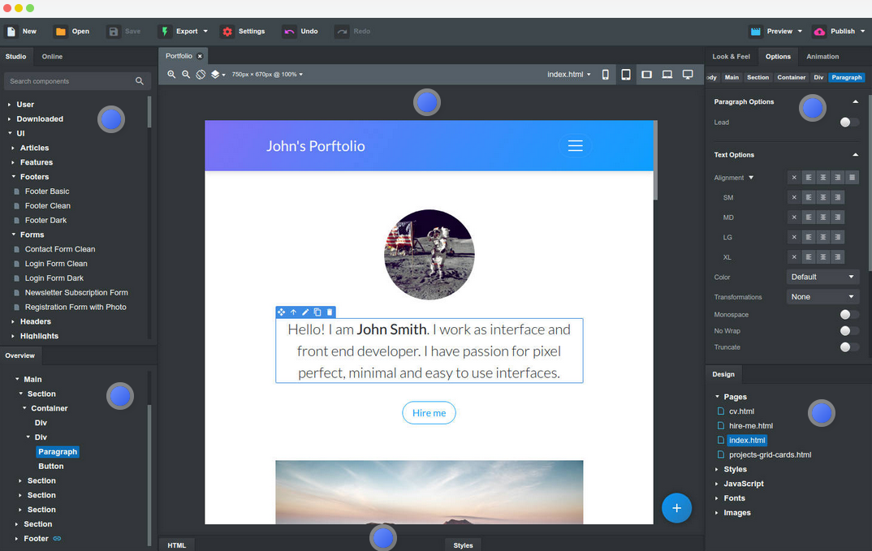

Scheduled Script Execution

1. **Cron-Job.org**

Call scripts attached to a link from a browser-based free service.  
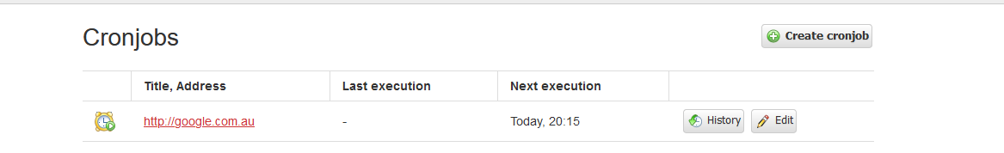

1. **PHP Cron Scheduler**

A php library which allows developers to instantiate a scheduler interface that is run every minute by a local systems crontab (task scheduler for Windows). The developer can then go to said php script and set scheduled time by using set methods of the library, e.g. $scheduler->php('script.php')->december(31);

<https://github.com/peppeocchi/php-cron-scheduler>

1. **Windows scheduler**UI by windows for scheduling scripts  
   Provided by default with every windows operating system, this application allows setting ‘triggers’ to executable files as dates and times. Using this application one can attach scripts to a bash file and set them to execute at any time throughout the year.
2. **Mail Chimp**  
   Create forms which you can link on your website or embed in your html files. Let Mail Chimp do the service of the newsletter by designing the emails and appointing them to which subscriber forms they will belong to. Very user friendly to do, simple to start by creating a campaign with an automated email service. A quality option however with a free account limit of 2000 subscribers, unless the client is willing to pay for subscription this is not a viable option.

<https://mailchimp.com/>

Emailing

1. **PHP Mail ()**

This is built-in to php, it’s a very simple method for sending emails, no use of email template or SMTP setup, start using it by applying the strings you wish to set as the email text like this example taken from <https://www.tutorialrepublic.com/php-tutorial/php-send-email.php>. Does not provide advanced emailing features such as adding attachments.

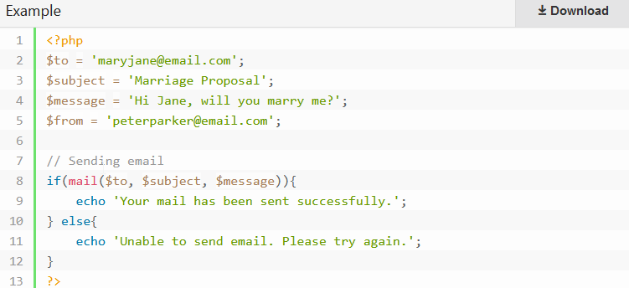

1. **PHP Mailer ()**

An external library for advanced email options in PHP requires using composer or similar installer to configure the library with a project. This library allows for sending advanced email e.g. emails with attachments and html elements with alternative plain text versions attached, more importantly allowing to set up a SMTP server for mailing uses, SMTP servers are useful to us because they allow emails to by-pass default spam filters; this is because if the server is sending an email from a remote SMTP server the other server to which it sends the emails will recognize the email came from the sender rather than including an intermediary party, if we just used mail() and set an email in from parameter that email will vary from our server’s host name thus defaulting that email to spam in most email services.

How to setup (with composer) and send emails with PHP Mailer - <https://www.youtube.com/watch?v=YtNraQxUTM0&t=44s>

Recommended Tools and Software

|  |  |  |  |
| --- | --- | --- | --- |
| **Tool/Software type** | **IDE** | **Emailing Library** | **Script Scheduling Solution** |
| **Name** | NetBeans | PHP Mailer () | Windows Scheduler |
| **Description** | Open-source IDE | An external library for simplifying advanced email options such as SMTP. | Included with every windows installation, very user friendly and intuitive to use. |
| **Download** | [NetBeans Download](https://netbeans.org/downloads/6.1/index.html) | [Instruction and Download](https://github.com/PHPMailer/PHPMailer) | Available with windows install |
| **Reason for recommendation** | Code suggestions, ide features, used to develop original prototype. | Can create an SMTP server to avoid default spam filter being applied by receiving email services. | I have had much experience in task scheduler with windows it is very easy to use, there is a lot of information online for setting up schedules via PowerShell, command prompt and through the admin UI. |

### Usage examples

* **NetBeans** (extract from <https://netbeans.org/kb/docs/php/quickstart.html>)

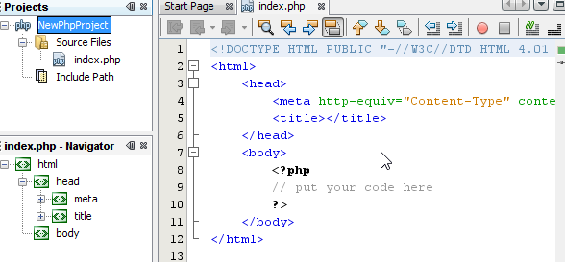

* **PHP Mailer** () (extract from <https://github.com/PHPMailer/PHPMailer/blob/master/examples/smtp.phps>)

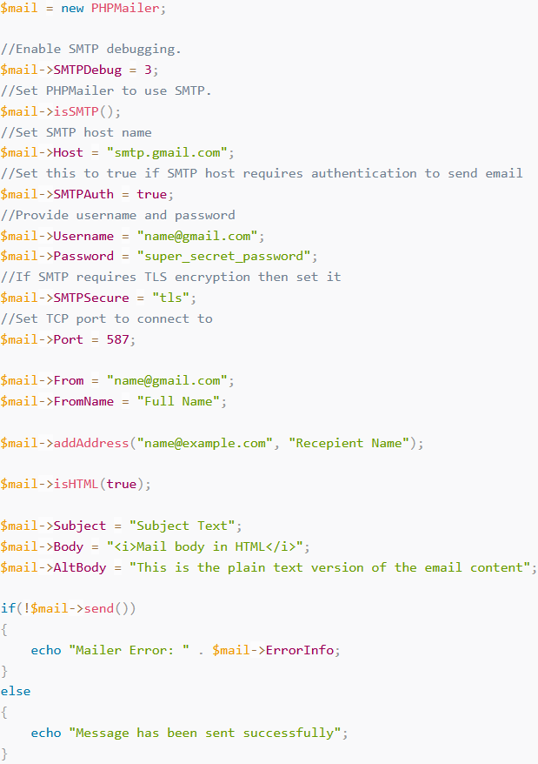

* **Windows Task Scheduler** (extract from writer’s Windows PC)

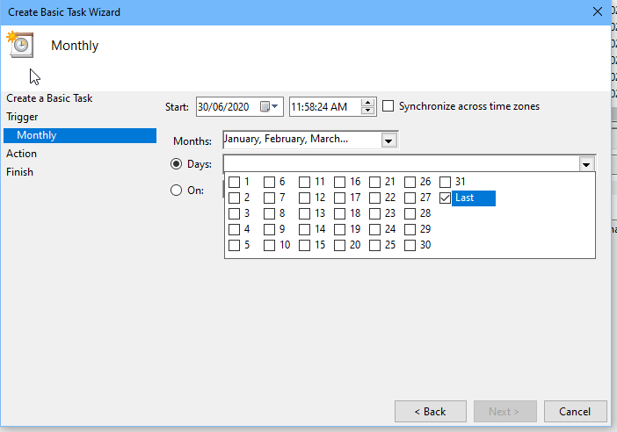

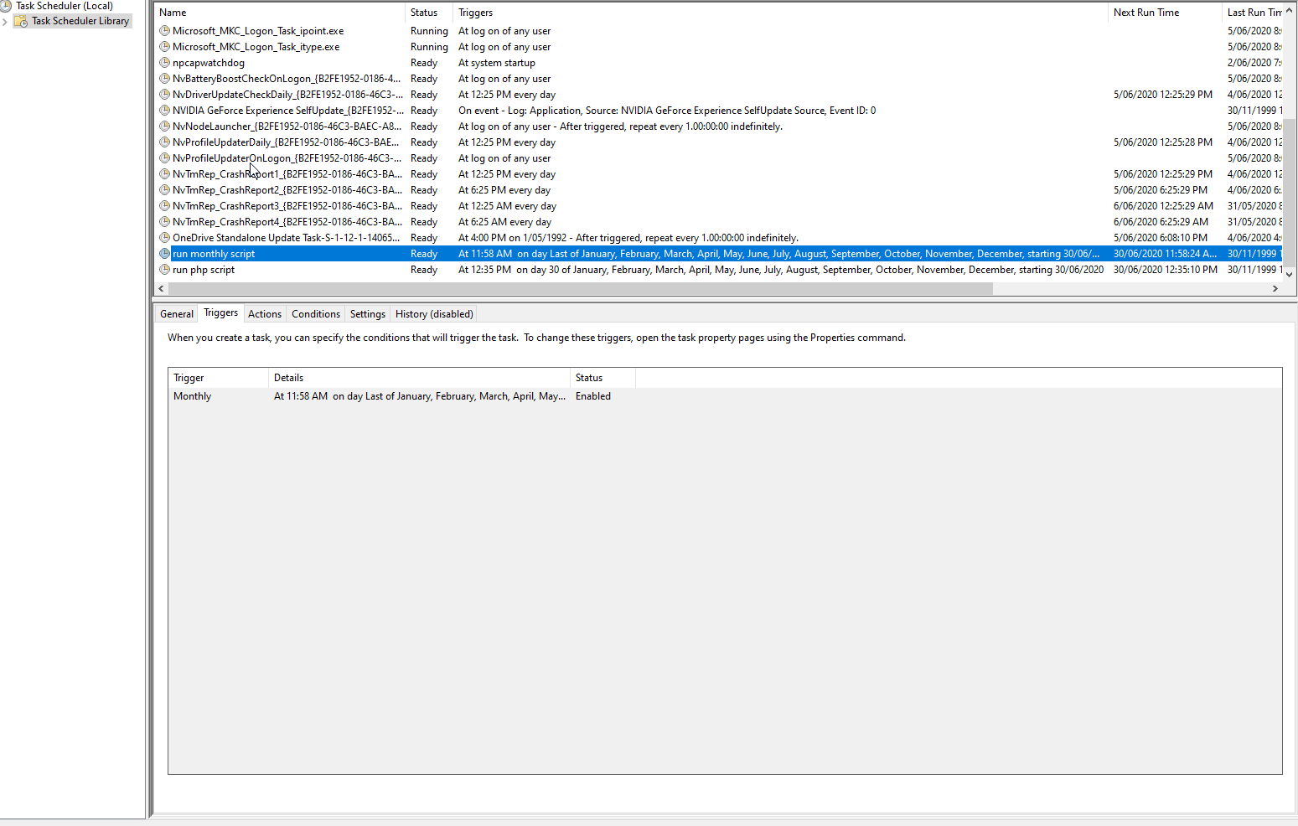

Summary/Decision

The appointed programmer has decided to follow recommendations using NetBeans, PHPMailer and Windows Scheduler, additionally implemented is an alternative SMTP host to SendGrid services, this is because Google Gmail has a limitation to free accounts of up to 500 emails per day, whereas SendGrid’s trial account will allow for 40, 000 emails for a duration of 30 days, It is in the interest of the Acme Corporation (the client) to either set up a local mailing server SMTP or pay for SendGrid or Google Services; which type of service subscription will depend on the future expansions the client is seeking to pursue, if SMTP is not implemented in newsletters it is highly likely that outgoing emails will be defaulted to the recipient’s spam folders.

End of Performance Report

# Project Management Plan

Monday.org screenshot of Team project timeline.

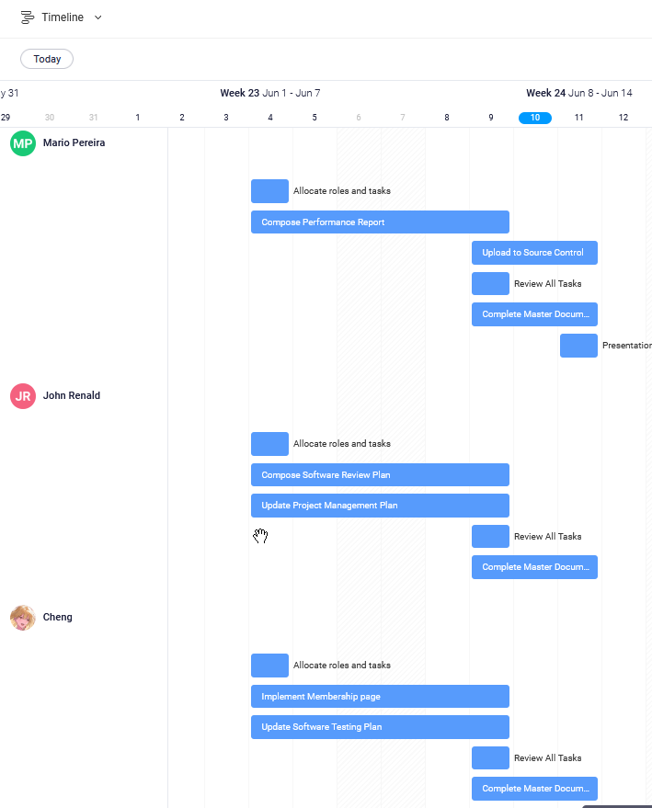

# Software Testing Plan

## Scope

### In Scope

Defines the features, functional or non-functional requirements of the software that **will be** tested

Functional(foundamental):

* Sign up with client’s email
* Monthly newsletter will be sent in correct time
* Newsflash notification will be sent as they occur
* Clients are able to choose suscribe monthly newsletter or newsflash
* Clients are able to unsuscirbe(send email to adminstrator)

Non-functional:

* Appropriate GUI
* Able to be used in Multi-Platform

### Quality Objective

* Ensure the Application Under Test conforms to functional and non-functional requirements
* Product quality verification and validation to ensure that it complies with clients’ business needs and expectations
* Bugs/issues are identified and fixed before release
* GUI provide user a good experience

### Roles and Responsibilities

* CITE Managed Services QA department: QA testing, configuration manage, risk manage
* Test Manager
* Developers and tester

## methodology

This project will adopt Agile model and RAD model, testing phase will be in the end of each iteration.

### Agile model and RAD model

Agile model is a combination of iterative and incremental process models with focus on process adaptability and customer satisfaction by rapid delivery of working software product. Agile Methods break the product into small incremental builds. These builds are provided in iterations. Each iteration (Requirement->Design->Development->**Testing**->Evaluation) typically lasts from about one to three weeks. **At the end of the iteration, a working product is displayed to the customer and important stakeholders**. (tutorialspoint, 2019)

Hence testing phase will execute in each interation, it ensure bug can be found early.

Rapid Application Development (formerly known as Rapid Application Development, abbreviated as RAD) is a methodology for software development. RAD methodology is quite different with traditional SDLC, traditional SDLC emphasize requirement analysis before code start. Changing requirement may not so feasible. However**, RAD emphasize the iterative and incremental delivery of working models to the customer rapidly and allow customer give feedback**.

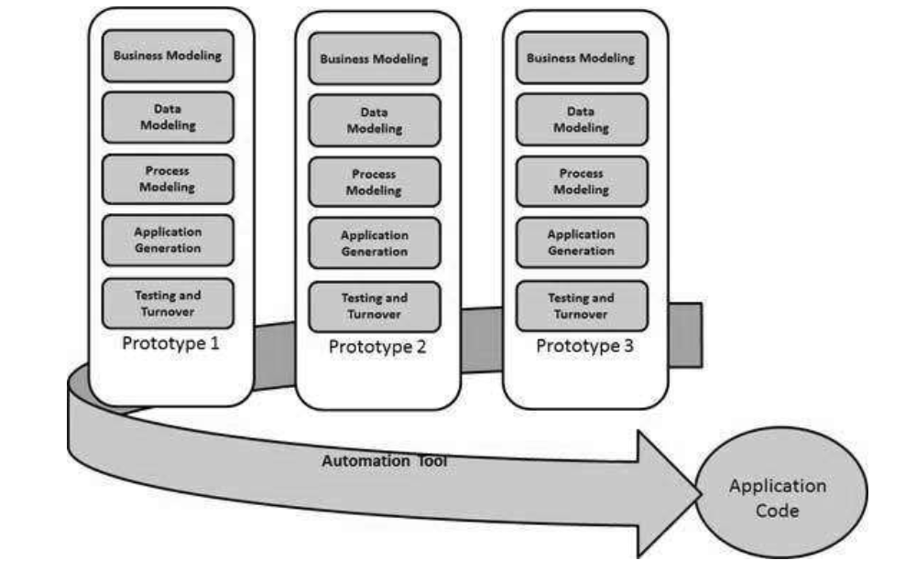

### Test method

White box testing:

White box testing or structural testing is tested by who understand the structural or implementation of application. Tester understand how the application works. Usually, white box testing tests application’s internal structure or working. Testers will choose inputs to exercise path through the code and determine the expected outputs.

### Test Completeness

Criterias that deem testing complete.

* 100% test coverage (all functionalities)
* All Test cases executed manually
* Software are tested under a various of platform.
* All testing result will be documented.

## Resource & Environment Needs

### Testing Tools

* XAMPP or server environment
* Multiplatform simulation environment (Google Developer tools)
* sendGrid <https://sendgrid.com/>
* Windows task scheduler
* Testing document
* Computer

### Test Environment

* OS: Windows 10 64bit
* Processor: Intel Core i7
* Memory: 16 GB RAM
* Graphics: NVIDIA GeForce GTX 1650
* Storage: 100 GB available space

## Test Deliverables

Here mentions all the Test Artifacts that will be delivered during different phases of the testing lifecycle.

### Test case

Testing video <https://www.youtube.com/watch?v=8Xohc7NlIGc>

Functional test

|  |  |  |  |
| --- | --- | --- | --- |
| Test case (In laptop 1440 X 900) | Data inputted | Expect Result | Result |
| Subscribe (Name input are not beginning with letter) | --fff | Warning message | Correct result show in testing video |
| Subscribe (Name begin with letter) | fff | Build data in database | Correct result show in testing video |
| Subscribe (Email string don’t have @) | Testgmail.com | Warning message | Correct result show in testing video |
| Subscribe (Email do not end with .com) | test@gamil | Warning message | Correct result show in testing video |
| Subscribe (Email end with .com but no character between @ and .com) | test@.com | Warning message | Correct result show in testing video |
| Subscribe (Email include hyphen) | Test-@gmail.com | Warning message | Correct result show in testing video |
| Subscribe (Email include space) | Test @gmail.com | Warning message | Correct result show in testing video |
| Subscribe (Correct format) | test@gmail.com | Build data in database | Correct result show in testing video |
| Subscribe (Correct format but didn’t choose subscribe plan) | test@gmail.com | Warning message | Correct result show in testing video |
| Unsubscribe | Correct mail which database have | Send email | Correct result show in testing video |
| Unsubscribe | Wrong mail which database don’t have | Guide to home page | Correct result show in testing video |
| Send monthly and newsflash mail | When event trigger | Send email | Correct result show in testing video |

|  |  |  |  |
| --- | --- | --- | --- |
| Test case (In mobile 360X640) | Data inputted | Expect Result | Result |
| Name input are not beginning with letter | --fff | Warning message | Correct result show in testing video |
| Name begin with letter | fff | Build data in database | Correct result show in testing video |
| Email string don’t have @ | Testgmail.com | Warning message | Correct result show in testing video |
| Email do not end with .com | test@gamil | Warning message | Correct result show in testing video |
| Email end with .com but no character between @ and .com | test@.com | Warning message | Correct result show in testing video |
| Email include hyphen | Test-@gmail.com | Warning message | Correct result show in testing video |
| Email include space | Test @gmail.com | Warning message | Correct result show in testing video |
| Correct format | test@gmail.com | Build data in database | Correct result show in testing video |
| Unsubscribe | Correct mail which database have | Send email | Correct result show in testing video |
| Unsubscribe | Wrong mail which database don’t have | Guide to home page | Correct result show in testing video |

|  |  |  |  |
| --- | --- | --- | --- |
| Test case (In ipad 1024 X 768) | Data inputted | Expect Result | Result |
| Name input are not beginning with letter | --fff | Warning message | Correct result show in testing video |
| Name begin with letter | fff | Build data in database | Correct result show in testing video |
| Email string don’t have @ | Testgmail.com | Warning message | Correct result show in testing video |
| Email do not end with .com | test@gamil | Warning message | Correct result show in testing video |
| Email end with .com but no character between @ and .com | test@.com | Warning message | Correct result show in testing video |
| Email include hyphen | Test-@gmail.com | Warning message | Correct result show in testing video |
| Email include space | Test @gmail.com | Warning message | Correct result show in testing video |
| Correct format | test@gmail.com | Build data in database | Correct result show in testing video |
| Unsubscribe | Correct mail which database have | Send email | Correct result show in testing video |
| Unsubscribe | Wrong mail which database don’t have | Guide to home page | Correct result show in testing video |

|  |  |  |  |
| --- | --- | --- | --- |
| Send monthly and newsflash mail | When event trigger | Send email | Correct result show in testing video |

### Report

The test met these requirements:

* Every logic path are tested, all output are as expected.
* In the applictaoin, there are no significant bug.
* Every path had noticed users when the operating of users is wrong.
* The layout is responsive