**From:** Kane Williams [mailto:williams.k@statewidebearings.com.au]   
**Sent:** 07 March 2018 8:28  
**To:** 'Bryce Richards'  
**Cc:** 'Statewide Bearings Linear'  
**Subject:** RE: Screw Jack EMT0025-U002100-0100-TB00-CB00

Hi Bryce,

4   x    E-Series S-Jack                                       $1457.21each +gst

1   x   Air                                                                $501.78+gst

Delivery approx 4-5 weeks A.R.O

**EMT0025-U002100-0100-TB00-CB00**

JACK SERIES: E-SERIES

SCREW TYPE: MACHINE SCREW

SCREW CONFIG: TRANSLATING SCREW

LIFT CAPACITY: 25KN

GEARBOX STYLE: UPRIGHT VERSION

GEARBOX FEATURE: NONE

GEARBOX FEATURE: NONE

GEAR RATIO: 24:1 (OPT RATIO)

LIFTING SCREW: RH 30x6mm

WORM SHAFT TYPE: STANDARD

WORM SHAFT ENDS: BOTH ENDS

RAISE: 100mm

END TYPE: TOP PLATE

GEARBOX MOUNT: BASE MOUNT

SCREW MATERIAL: STANDARD

SCREW COVER: COVER PIPE + NO BELLOWS

ACCESSORIES: MOTOR ADAPTOR + COUPLING LHS

MOTOR FRAME: 71 FRAME SIZE

LIMIT SWITCH: NONE

PAINT: STD PAINT + GREASE

Thank you

Kind Regards,

Kane Williams

Linear Department  
**Statewide Bearings**

5-7 Hargreaves St

Belmont WA 6104

P: 08 9475 5000

F: 08 9475 5050

[www.statewidebearings.com.au](http://www.statewidebearings.com.au/)

The contents of this message may contain information that is confidential and/or subject of legal privilege intended only

for use by the intended recipient. If you have received this in error, please notify the sender immediately and delete the

message.  Thank you.

Hi Kane,

Thanks for the update.  Appreciate the help.

Regards,

Bryce Richards.

Sent from my Samsung Galaxy smartphone.

-------- Original message --------

From: Kane Williams <williams.k@statewidebearings.com.au>

Date: 2/3/18 3:03 pm (GMT+08:00)

To: 'Bryce Richards' <bryce.richards@live.co.uk>

Cc: 'Statewide Bearings Linear' <linear@statewidebearings.com.au>

Subject: RE: Screw Jack

Hi Bryce,

I haven’t forgotten about this enquiry.

Due to bad weather in the UK. There is limited staff at the moment.

Soon as I hear anything I will let you know.

Thanks

Kind Regards,

Kane Williams

Linear Department  
**Statewide Bearings**

5-7 Hargreaves St

Belmont WA 6104

P: 08 9475 5000

F: 08 9475 5050

[www.statewidebearings.com.au](http://www.statewidebearings.com.au/)

The contents of this message may contain information that is confidential and/or subject of legal privilege intended only

for use by the intended recipient. If you have received this in error, please notify the sender immediately and delete the

message.  Thank you.

**From:** Bryce Richards [mailto:bryce.richards@live.co.uk]   
**Sent:** 27 February 2018 12:49  
**To:** Kane Williams  
**Subject:** Re: Screw Jack

Hi Kane,

The project we're running at South Metropolitan TAFE Munster is to design and construct an automatically guided vehicle for use in a workshop environment.  The vehicle will drive under a load then lift 80-100mm, drive to a new location, lower back to the full down position, then the vehicle returns to the home position.

We have a rectangular frame designed, and a rectangular lifting platform to sit on top.  The idea would be for 4 screw jacks to work together (one on each corner) to lift a 500-1000kg load.  We already have a microcontroller on board for the purpose of the 4 wheel motors, so running each screwjack via a single stepper-motor is probably easiest.  Due to the vehicle having to be able to drive under these loads we're pretty constrained on the fully-collapsed height (hence the 160mm maximum).

Have included a screenshot from the 2d image.  We'll just fabricate some kind of mounting platform for them to go in those corners.  Just need to find a screwjack that's small enough.  The lead nut would just sit flush with the top of that frame and lift another frame upward.

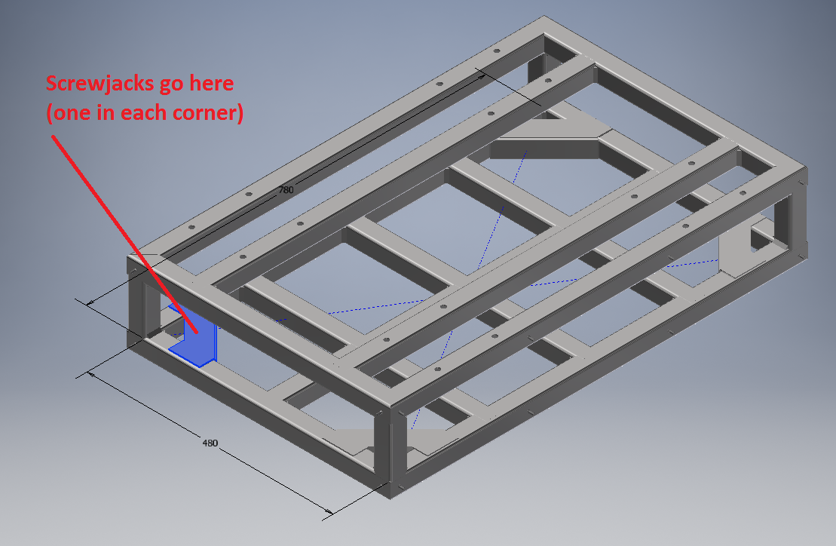

Regards,

Bryce Richards.

**From:** Kane Williams <[williams.k@statewidebearings.com.au](mailto:williams.k@statewidebearings.com.au)>  
**Sent:** Tuesday, 27 February 2018 12:12 PM  
**To:** 'Bryce Richards'  
**Cc:** 'Statewide Bearings Linear'  
**Subject:** RE: Screw Jack

Hi Bryce,

Are you able to give us a bit more information.

Are you looking to run these together or individually?

Kind Regards,

Kane Williams

Linear Department  
**Statewide Bearings**

5-7 Hargreaves St

Belmont WA 6104

P: 08 9475 5000

F: 08 9475 5050

[www.statewidebearings.com.au](http://www.statewidebearings.com.au/)

The contents of this message may contain information that is confidential and/or subject of legal privilege intended only

for use by the intended recipient. If you have received this in error, please notify the sender immediately and delete the

message.  Thank you.

**From:** Bryce Richards [<mailto:bryce.richards@live.co.uk>]   
**Sent:** 27 February 2018 11:50  
**To:** Kane Williams  
**Subject:** Re: Screw Jack

Hi Kane,

Please see attached.  Let me know if you need any more information.  Have essentially just filled this out on behalf of the institution.

Regards,

Bryce Richards.

**From:** Kane Williams <[williams.k@statewidebearings.com.au](mailto:williams.k@statewidebearings.com.au)>  
**Sent:** Tuesday, 27 February 2018 11:18 AM  
**To:** [bryce.richards@live.co.uk](mailto:bryce.richards@live.co.uk)  
**Cc:** 'Statewide Bearings Linear'  
**Subject:** Screw Jack

Hi Bryce,

As per phone call.

Could you please fill out the attached data form below.

<https://www.linearbearings.com.au/wp-content/uploads/Screw-Jack-application-data-form1.pdf>

|  |
| --- |
| [CUSTOMER DETAILS - Statewide Linear Bearings](https://www.linearbearings.com.au/wp-content/uploads/Screw-Jack-application-data-form1.pdf)  [www.linearbearings.com.au](http://www.linearbearings.com.au/)  SCREW JACK APPLICATION DATA FORM CUSTOMER DETAILS. Application requirements Screw Jack type. Screw Jack Features. Mounting options . Screw end: Clevis Thread Top plate |

Thank you

Kind Regards,

Kane Williams

Linear Department  
**Statewide Bearings**

5-7 Hargreaves St

Belmont WA 6104

P: 08 9475 5000

F: 08 9475 5050

[www.statewidebearings.com.au](http://www.statewidebearings.com.au/)

The contents of this message may contain information that is confidential and/or subject of legal privilege intended only

for use by the intended recipient. If you have received this in error, please notify the sender immediately and delete the

message.  Thank you.