Presented by: bryce richards

STUDENT

SOUTH METROPOLITAN TAFE – MUNSTER CAMPUS



Mecanum AGV Project

Workshop Tasks

Version 1.0

June 5, 2018

# Mecanum AGV Project

Table of Contents

Mecanum AGV Project 1

Cut SHS To Required Length / Angle 2

Participated In Grinding / Welding Exercises 3

### Cut SHS To Required Length / Angle

Now that we have both 3D Inventor files and 2D fabrication drawings for the chassis is was time to start cutting the members. Adam ordered 12m of 35x35x3mm SHS (as specified in the drawing), and two of us (small group due to PPE restrictions) headed to the Henderson campus to cut the material for later welding. This involved using a cold saw and horizontal band-saw to first make the straight cuts, then a second pass through the cold saw at a 45° angle on the external components. This task was completed in full in ~3hrs to a +/-1mm tolerance.

Relevant Files:

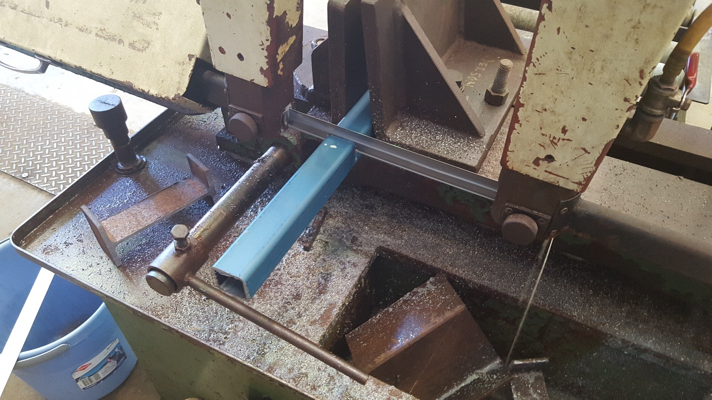

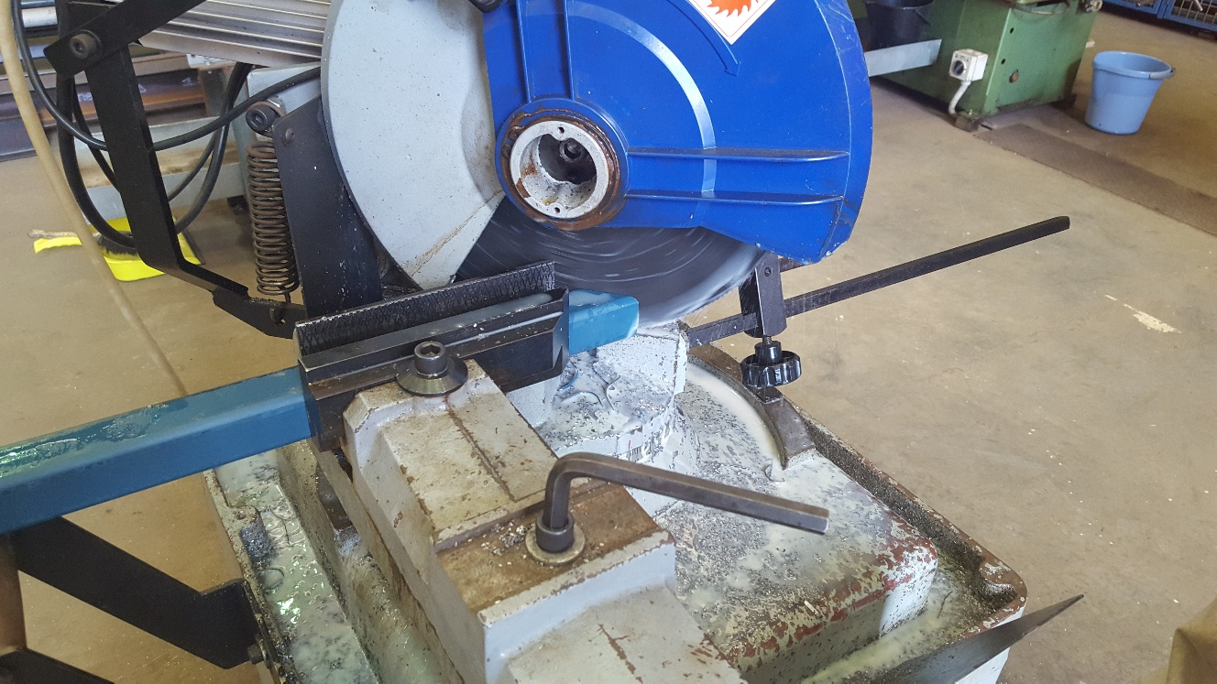

### Participated In Grinding / Welding Exercises

I have participated with two welding exercises and one grinding exercise as well as the above cutting of SHS. The Welding involved a tutorial in how to set up a GMAW device, use of appropriate PPE, voltage and wire selection and hands-on welding. The grinding exercise involved similar setup and selection protocols – but also a more in-depth inspection of the electrical componentry for defects. It should be noted that all inspected electrical equipment at the Henderson campus is overdue for test & tag.

Relevant Files:

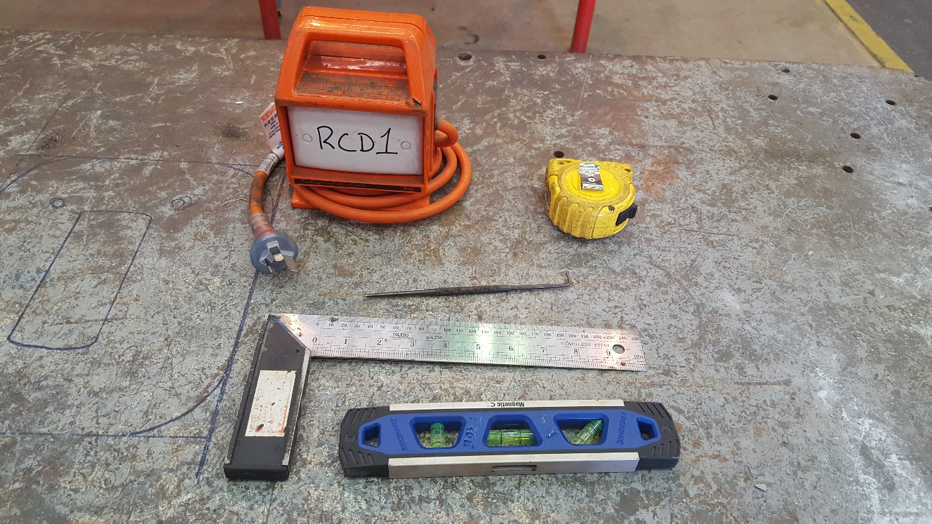

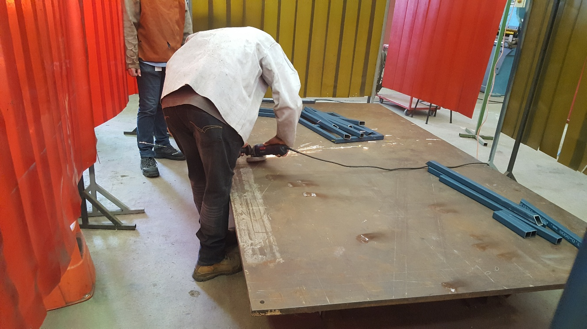

### Lathe Work

22/05/2018 we spent the day at the Henderson campus workshop. A variety of tasks were performed by the students. I was primarily involved with using the lathe to fabricate axles. These were of varying lengths with a 15mm thread cut on each end.

The process was essentially:

1. Extrude length of brass through chuck
2. Fasten chuck
3. Set lathe up for threading
4. Cut thread to ~15mm length
5. Set lathe up for cutting
6. Cut at desired length (determined by drawing provided by Ross)
7. Loosen chuck
8. Repeat from step 1

