CS 2341 – Fall 2020

**Homework Assignment 4**

Due: Nov 11, 2020 @ 11pm

Uploaded to Canvas

Submission Directions:

* Put your name inside the document in the header of the Word doc (or some equally

conspicuous place)

* Complete the questions below. Point values are indicated in square brackets.
* For questions that require diagrams, create the diagrams on your computer (no hand-

drawn/scanned diagrams). You can do this with PowerPoint, Google Draw, LibreOffice Draw, etc. Then copy-and-paste the diagrams into the correct place in the document you submit.

* For any code or pseudocode, please use a fixed-point mono font (courier for example) and consider appropriate spacing and indentation.
* Please **submit a PDF** file of your solutions.

1. For the tree that follows, provide a:

a) preorder traversal.

b) inorder traversal.

c) postorder traversal.

(5 points each)

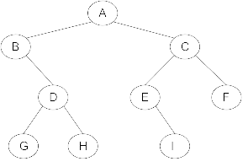

2. Use the characters from the string **SMUMUSTANGCODERS** to construct a binary search tree. Insert each letter from the string into a binary search tree starting with the first S and proceeding character-by-character from left to right. You only need to show the final tree. (10 points)

3. Assume a Binary Search Tree Class has the following structure:

class BSTree {

private:

struct BSTreeNode {

int x;

BSTreeNode* left, * right;

}

BSTreeNode* root;

//.. The rest of the class here…

};

Add a recursive countNodes member function and its public counterpart that will return an integer representing the total number of nodes in the Binary Search Tree. (10 points)

4. For a binary tree with *x* levels (empty tree has 0 levels; tree with 1 node has 1 level), what is the maximal number of nodes that can be stored in that tree? (5 points)

5. Use the characters from the string **SMUMUSTANGCODERS** to construct an AVL Tree. Insert each letter from the string into an AVL tree starting with the first S and proceeding character-by-character from left to right. Redraw the tree after each case of imbalance is corrected by a single or double rotation. (20 points)