Writing Documents 103
Tables, Lists, Pictures, Shapes

Quick table
Something | Something else  a new line

Fruit | Vegetables | Grains
Apples | Carrot | Wheat
Banana | Potato | Rice
Orange | Onion | Quinoa | Delete this

Inserting a picture:
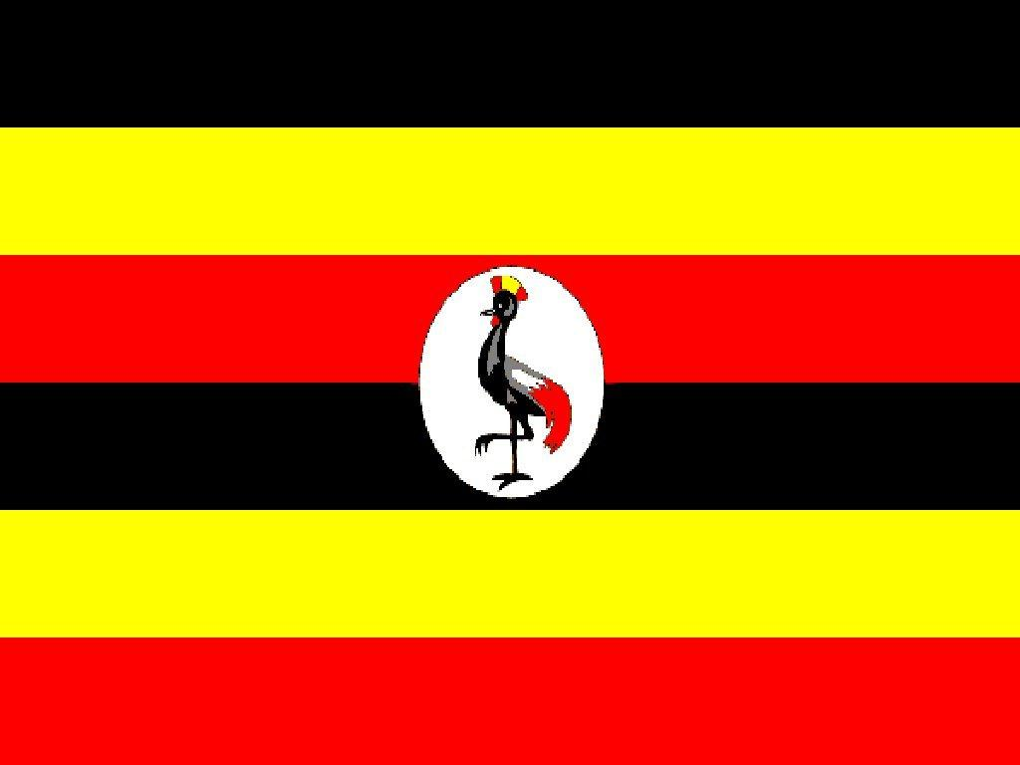

Text

Drawing a picture with shapes:

