Bedroom:

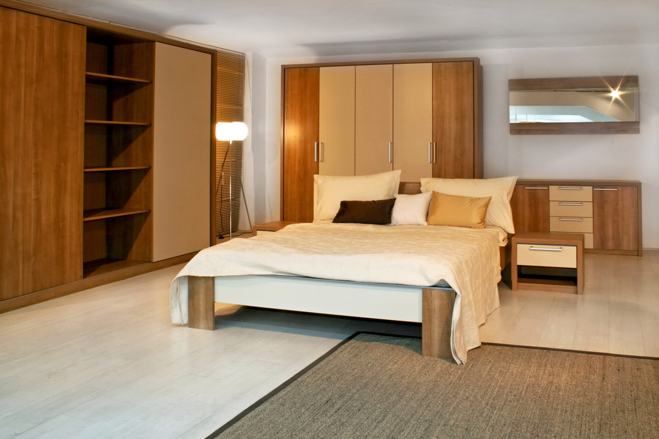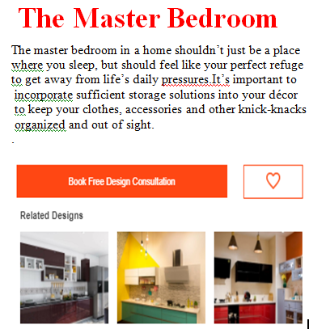

**The Master Bedroom**

The master bedroom in a home shouldn’t just be a place where you sleep, but should feel like your perfect refuge to get away from life’s daily pressures. It’s important to incorporate sufficient storage solutions into your décor to keep your clothes, accessories and other knick-knacks organized and out of sight

**Kids & Teens Room**

The biggest challenge in decorating a kid’s bedroom is the fact that the room will need to accommodate the changes needed as the child grows and matures. When choosing furniture for your kid’s room, keep things simple. You can add colourful accents with accessories that can be changed easily as the child grows

**The Guest Bedroom**

The best way to go about decorating a guest bedroom is to go by what feels comfortable and welcoming to you. If there is space available, you can add a comfortable chair and a table to your guest bedroom, for times when your guests might just want to sit and relax and may not use the bed for it.