Kitchens:

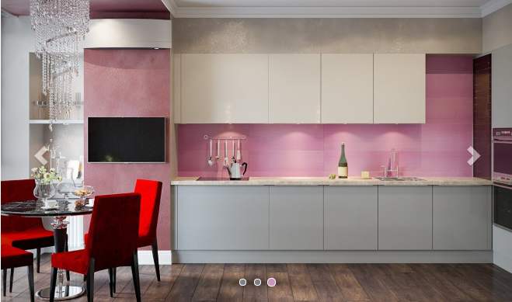 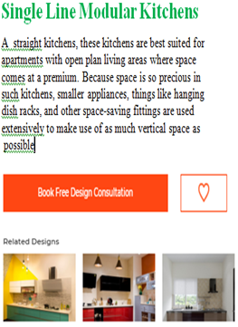

#### 1) Single Line Kitchens Best Suited For?

Also known as straight kitchens, these kitchens are best suited for apartments with open plan living areas where space comes at a premium. Because space is so precious in such kitchens, smaller appliances, things like hanging dish racks, and other space-saving fittings are used extensively to make use of as much vertical space as possible.

#### 2) L-shaped Kitchens Best Suited For?

L shaped kitchens, designed on two walls meeting at a corner of a room, are best suited for open plan kitchens and make the best use of the space available. Having a versatile and space-saving layout, they are commonly seen in medium to small kitchens.

#### 3) Parallel Kitchens Best Suited For?

Parallel kitchens happen to be one of the most efficient of kitchen layouts and are best suited for medium to large kitchens. They have two long working areas parallel to each other with one of them used for washing and cooking while the other one serves as an additional working area.

#### 4) U-Shaped Kitchens Best Suited For?

A U-shaped kitchen with its additional run of space, is more practical when compared with a single line kitchen or a parallel one. A U-shaped kitchen is best suited for large spaces but also works well in smaller kitchens, as it makes the most use of the available space.

#### 5) Kitchen Islands Best Suited For?

A kitchen island is a standalone piece of cabinetry, usually placed in the middle of a kitchen space, which provides an additional countertop to work with. Kitchen islands, of late have made themselves quite indispensable in modern kitchens, and apart from just providing an extended countertop and adding to the aesthetics of the kitchen, also perform many critical functions.

#### 4) acrylic kitchens?

Acrylic is the name given to a finish of kitchen cabinets, that gives them a glossy appearance. Acrylic kitchens have cabinets done with acrylic doors or acrylic-faced doors. Acrylic kitchens offer you durable and long-lasting kitchen cabinets that are moisture and scratch resistant, easy to maintain and come with a wide scope for customization and a wide variety of colors.