Wardrobes:

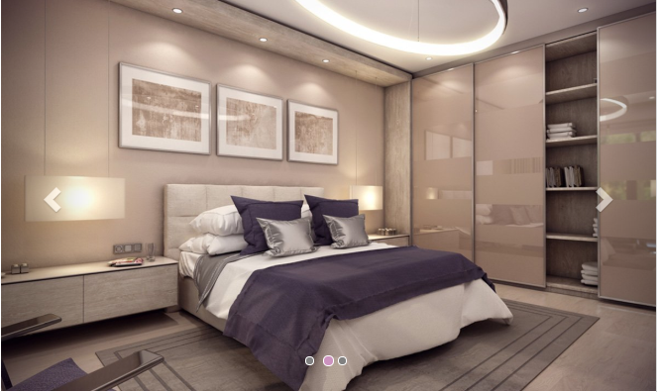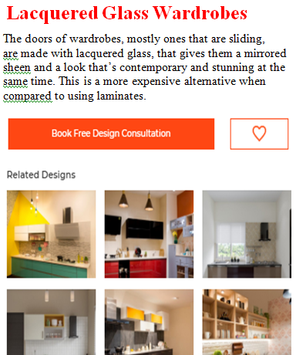

#### 1)Full Wall Wardrobes

A full wall wardrobe covers the entire wall and has many shelves, drawers and other storage space to keep your clothes, accessories and luggage pieces organized.

#### 3)Wardrobes With Sliding doors

. One of the most obvious and practical advantage is that sliding doors slide to open and don’t stick out, saving precious floor space in the room they are built in. This also makes them great additions to not just bedrooms, but also walk in closets or even the hall.

#### 4) ****Lacquered Glass Wardrobes****

#### The doors of wardrobes, mostly ones that are sliding, are made with lacquered glass, that gives them a mirrored sheen and a look that’s contemporary and stunning at the same time. This is a more expensive alternative when compared to using laminates.