第一单元
第8题、len(set(text4))
set(text4)获取文本text4中的词汇条目，指的是text4中有多少个不同的字符。
len()获取文本的长度。
len(set(text4))指的是文本text4中不同字符的个数

第19题、sorted ( set ( [ w.lower() for w in text1] ) ) //先将text1中的字符进行小写之后在进行筛选不一样的。不会存在相同的。
sorted ( [ w.lower() for w in set(text1) ] ) //先将text1中的文本中筛选出不一样的字符集，再进行小写。可能存在相同的。
如果其他文本中不会出现类似：“APPLE”、“apple”此类的词，两个文本输出的大小一样。

第二单元
- 在名字语料库中定义一个条件概率分布，看看哪个首字母在男性名字中比在女性名字中更常用。
import nltk
from nltk.corpus import names
cfd = nltk.ConditionalFreqDist(
(fileid, name[0])
for fileid in names.fileids()
for name in names.words(fileid)
)
cfd.plot()

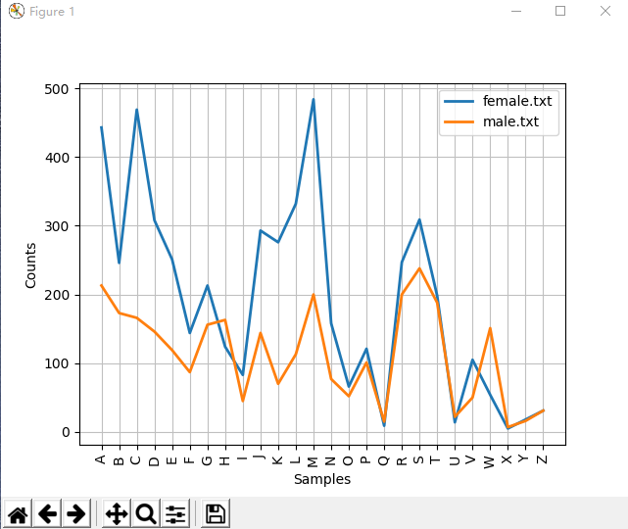
结果显示：H、W都比女性名字要常用。
- 编写一段程序，按文体创建词频表，选择自己的词汇，并尝试找出那些在文体中很突出或很缺乏的词汇。
import nltk
from nltk.corpus import brown
cfd=nltk.ConditionalFreqDist(
(genre,word)
for genre in brown.categories()
for word in brown.words(categories=genre))
genres=['news','religion','hobbies','science_fiction','romance','humor']
modals=['can','could','may','should','will','would']
cfd.tabulate(conditions=genres,samples=modals)
运行结果如图所示：
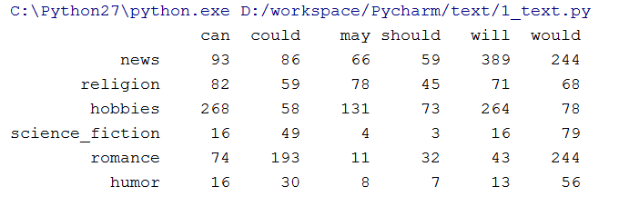
结果显示：would在news和romance中出现的次数最多，而should在science_fiction中出现次数最少。

第三单元
第8题：编写一个工具函数以（URL）为参数，返回删除所有的HTML标记的URL得内容。
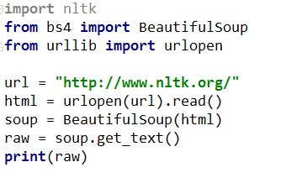
第19题：
创建一个文件，包含词汇和（任意指定）频率，其中每行包含一个词、一个空格和一个正整数。

#coding:utf-8
import io
file = open('file.txt',encoding='utf8').readlines()
for line in file:
line.strip('\n')
str = line.split()
m=float(str[1])
n=int(100*m)
print(str[0],n)

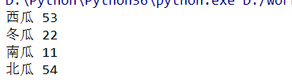

第30题、使用Porter词干提取器规范化一些已标注的文本叫做为每个词提取词干。用Lancaster词干提取器做同样的事情，看看你是否能观察到一些差别。
raw="""DENNIS:Listen,strange women lying in ponds distributing swords is... is no basis for a system of goverment. Supreme executive power derives from... a mandate from the masses, not from some farcical aquatic ceremony."""
import nltk
tokens = nltk.word_tokenize(raw)
porter = nltk.PorterStemmer()
lancaster = nltk.LancasterStemmer()
snowball_stemmer = nltk.SnowballStemmer("english")
print([porter.stem (t) for t in tokens])
print([lancaster.stem(t) for t in tokens])
print([snowball_stemmer.stem(t) for t in tokens])

['denni', ':', 'listen', ',', 'strang', 'women', 'lie', 'in', 'pond', 'distribut', 'sword', 'is', '...', 'is', 'no', 'basi', 'for', 'a', 'system', 'of', 'gover', '.', 'suprem', 'execut', 'power', 'deriv', 'from', '...', 'a', 'mandat', 'from', 'the', 'mass', ',', 'not', 'from', 'some', 'farcic', 'aquat', 'ceremoni', '.']
['den', ':', 'list', ',', 'strange', 'wom', 'lying', 'in', 'pond', 'distribut', 'sword', 'is', '...', 'is', 'no', 'bas', 'for', 'a', 'system', 'of', 'gov', '.', 'suprem', 'execut', 'pow', 'der', 'from', '...', 'a', 'mand', 'from', 'the', 'mass', ',', 'not', 'from', 'som', 'farc', 'aqu', 'ceremony', '.']
['denni', ':', 'listen', ',', 'strang', 'women', 'lie', 'in', 'pond', 'distribut', 'sword', 'is', '...', 'is', 'no', 'basi', 'for', 'a', 'system', 'of', 'gover', '.', 'suprem', 'execut', 'power', 'deriv', 'from', '...', 'a', 'mandat', 'from', 'the', 'mass', ',', 'not', 'from', 'some', 'farcic', 'aquat', 'ceremoni', '.']

41、

第四单元
8、
a = 'Monty'< 'Python'
b = 'Z'<'a'
c = 'Monty' <'Montague'
d = ('Monty',1) < ('Monty',2)
print(a,b,c,d)
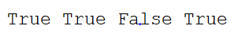
19、
import nltk
from nltk.corpus import wordnet as wn
a = []
b = ['minke_whale.n.01','orca.n.01','novel.n.01','tortoise.n.01']
rwhale = wn.synset ('right_whale.n.01')
path = []
for k in b:
a.append (wn.synset(k))
for n in a:
path.append(rwhale.path_similarity(n))
print(sorted(path))

30、

第五单元
8、
pos = {}
pos['headword'] = 'dog'
pos['part-of-speech'] = 'N'
pos['sense'] = 'may'
pos['example'] = 'lalalala'
print(pos)

19、
a 、执行标注前先将句子进行切分
b 、sum(x == y for x, y in zip(reference, test)) / len(test) 用程序的输出去和标准的输出去进行匹配，去求将匹配的数目和占句子长度的百分比。

30、
41、

第六章
8、
import nltk
import random
from nltk.corpus import movie_reviews
from nltk.probability import FreqDist
from nltk.corpus import wordnet
documents = [ (list(movie_reviews.words(fileid)),category)
for category in movie_reviews.categories()
for fileid in movie_reviews.fileids(category)]
random.shuffle(documents)
all_words = nltk.FreqDist(w.lower for w in movie_reviews.words())
word_features = wordnet.synsets(all_words).key()[:2000]
def document_features(document):
document_words = set(document)#集合
features = {}
for word in word_features:
features['contains(%s)' % word] = (word in document_words)
return features
#print(document_features(movie_reviews.words('pos/cv957_8737.txt')))
featuresets = [(document_features(d),c) for (d,c) in documents]
train_set,test_set = featuresets[100:],featuresets[:100]
classifier = nltk.NaiveBayesClassifier.train(train_set)
print(nltk.Classify.accuracy(classifier,test_set))

第七章
8、
from nltk.classify import megam
from nltk.corpus import conll2000
import nltk
class ConsecutiveNPChunkTagger(nltk.TaggerI):
def __init__(self, train_sents):
train_set = []
for tagged_sent in train_sents:
untagged_sent = nltk.tag.untag(tagged_sent)
history = []
for i, (word, tag) in enumerate(tagged_sent):
featureset = npchunk_features(untagged_sent, i, history)
train_set.append( (featureset, tag) )
history.append(tag)
self.classifier = nltk.NaiveBayesClassifier.train(train_set)
def tag(self, sentence):
history = []
for i, word in enumerate(sentence):
featureset = npchunk_features(sentence, i, history)
tag = self.classifier.classify(featureset)
history.append(tag)
return zip(sentence, history)
class ConsecutiveNPChunker(nltk.ChunkParserI):
def __init__(self, train_sents):
tagged_sents = [[((w,t),c) for (w,t,c) in
nltk.chunk.tree2conlltags(sent)]
for sent in train_sents]
self.tagger = ConsecutiveNPChunkTagger(tagged_sents)
def parse(self, sentence):
tagged_sents = self.tagger.tag(sentence)
conlltags = [(w,t,c) for ((w,t),c) in tagged_sents]
return nltk.chunk.conlltags2tree(conlltags)
def npchunk_features(sentence, i, history):
word, pos = sentence[i]
if i == 0:
prevword, prevpos = "<START>", "<START>"
else:
prevword, prevpos = sentence[i - 1]
if i == len(sentence) - 1:
nextword, nextpos = "<END>", "<END>"
else:
nextword, nextpos = sentence[i + 1]
return {"pos": pos,
"word": word,
"prevpos": prevpos,
"nextpos": nextpos,
"prevpos+pos": "%s+%s" % (prevpos, pos),
"pos+nextpos": "%s+%s" % (pos, nextpos),
"tags-since-dt": tags_since_dt(sentence, i)}
def tags_since_dt(sentence, i):
tags = set()
for word, pos in sentence[:i]:
if pos == 'DT':
tags = set()
else:
tags.add(pos)
return '+'.join(sorted(tags))
train_sents = conll2000.chunked_sents('train.txt',chunk_types=['NP'])
test_sents = conll2000.chunked_sents('test.txt',chunk_types=['NP'])
chunker = ConsecutiveNPChunker(train_sents)
print(chunker.evaluate(test_sents))

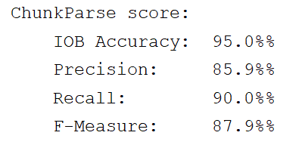

第八章
8、
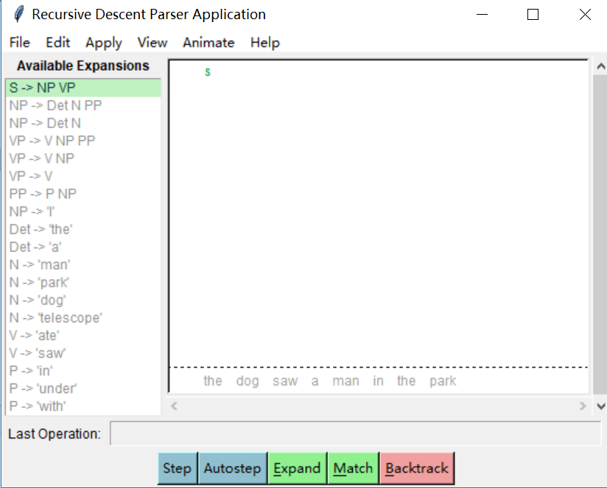
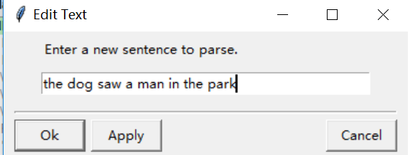
19、
https://en.wikipedia.org/wiki/Garden_path_sentence
30、
第九章
8、
import nltk
fs1 = nltk.FeatStruct("[A= ?x,B= [C = ?x]]")
fs2 = nltk.FeatStruct("[B = [D = d]]")
fs3 = nltk.FeatStruct("[B= [C = d]]")
fs4 = nltk.FeatStruct("[A= (1)[B =b ],C -> (1)]")
fs5 = nltk.FeatStruct("[A= (1)[D=?x],C = [E -> (1),F = ?x]]")
fs6 = nltk.FeatStruct("[A = [D = d]]")
fs7 = nltk.FeatStruct("[A = [D = d],C= [F = [D =d]]]")
fs8 = nltk.FeatStruct("[A= (1)[D = ?x,G = ?x],C = [B = ?x,E -> (1)]]")
fs9 = nltk.FeatStruct("[A= [B = b],C = [E = [G = e]]]")
fs10 = nltk.FeatStruct("[A = (1)[B=b],C ->(1)]")
print(fs1 and fs2)
print(fs1 and fs3)
print(fs4 and fs5)
print(fs5 and fs6)
print(fs5 and fs7)
print(fs8 and fs9)
print(fs8 and fs10)
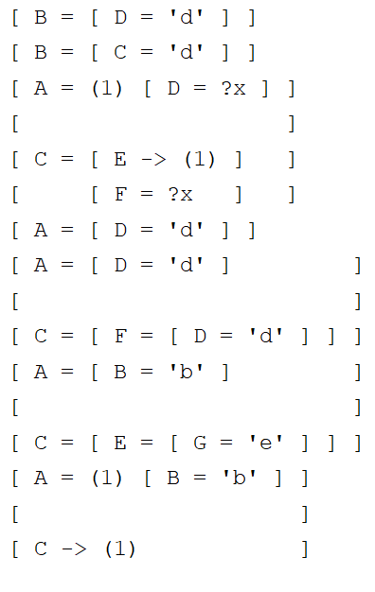
第十章
8、
from nltk import load_parser
parser = load_parser('grammars/book_grammars/simple-sem.fcfg',trace=0)
sentence = 'Angus gives a bone to every dog'
tokens = sentence.split()
trees = parser.parse(tokens)
for tree in trees:
print(tree)

第十一章
8、

