Ansibel

Linux Examples
https://github.com/lework/Ansible-roles

Create Roles
https://www.youtube.com/watch?v=BkFGmYyIRis

Vorbereitungen

Windows Client

Konfiguriere Ansible Listener am Client via PS

[Net.ServicePointManager]::SecurityProtocol = [Net.SecurityProtocolType]::Tls12
$url = "https://raw.githubusercontent.com/ansible/ansible/devel/examples/scripts/ConfigureRemotingForAnsible.ps1"
$file = "$env:temp\ConfigureRemotingForAnsible.ps1"

(New-Object -TypeName System.Net.WebClient).DownloadFile($url, $file)

powershell.exe -ExecutionPolicy ByPass -File $file -EnableCredSSP -Verbose
initAnsibleClient.ps1

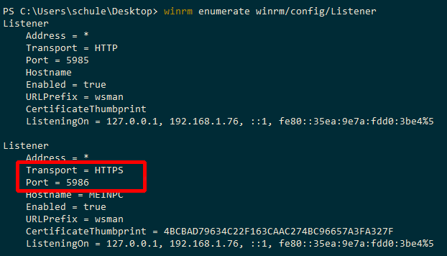
Achte auf die Port Nummer, die benötigst du später für dein Inventory.

User anlegen
User anlegen über Computer Verwaltung → Benutzer, und user zu Admingruppe geben
Username: ansible
Password: <password>

Verstecken am Login
HKEY_LOCAL_MACHINE\SOFTWARE\Microsoft\Windows NT\CurrentVersion\Winlogon
Neuer Key: SpecialAccounts
Neuer Key: UserList
DWORD (32-bit): ansible wert: 0

Authentication CredSSP einstellen
https://docs.ansible.com/ansible/latest/user_guide/windows_winrm.html#authentication-options

Art einstellen
Set-Item -Path WSMan:\localhost\Service\Auth\credSSP -Value $true

# enables CredSSP authentication on the client
Enable-WSManCredSSP -Role "Server"

Die Ausgabe sieht so aus

cfg : http://schemas.microsoft.com/wbem/wsman/1/config/service/auth
lang : de-DE
Basic : true
Kerberos : true
Negotiate : true
Certificate : false
CredSSP : true
CbtHardeningLevel : Relaxed

Linux Server

apt install python3 python3-pip
pip3 install ansible pywinrm requests-credssp jmespath

Einige Tests
ansible --version
ansible localhost -m ping

Inventory anlegen
#/etc/ansible/hosts
# see https://docs.ansible.com/ansible/latest/user_guide/intro_inventory.html
windows:
hosts:
# hostname allowed?
192.168.1.101:

#/etc/ansible/hosts/group_vars/windows.yaml
# file has name of group
ansible_user: ansible
ansible_password: schule
ansible_connection: winrm
ansible_winrm_transport: credssp
ansible_winrm_server_cert_validation: ignore
ansible_port: 5986

Usfull cmds
WinRM Beispiele
alle auf PS ausführen
- winrm get winrm/config
- winrm e winrm/config/Listener

cd wsman:
dir
cd localhost
dir

Ansible

Konfiguration
Am besten in /etc/ansible/ansible.cfg und dort die Pfade setzen

[defaults]
#inventory = /etc/ansible/hosts

# Paths to search for collections, colon separated
# collections_paths = ~/.ansible/collections:/usr/share/ansible/collections

# Paths to search for roles, colon separated
roles_path = ~/.ansible/roles::/home/schule/Schreibtisch/IT-School-Admin/Ansible/roles

ansible windows [-i inventory] -m win_ping -vvv
ansible-playbook --inventory= *script.sh *.yml –vault-password-file=<path>
ansible windows -m win_ping -vvv

Creating Roles

ansible-galaxy init <Pfad>
ansible-galaxy init /etc/ansible/roles/hostname

System Infos ansible_facts …

Module entwickeln
sudo apt install build-essential libssl-dev libffi-dev python-dev python3-venv

- Clone the Ansible repository:
git clone https://github.com/ansible/ansible.git
cd ansible

- Create a virtual environment:
pip2 install virtualenv
python3 -m venv venv
. venv/bin/activate

- Install development requirements:
pip3 install -r requirements.txt

- Run the environment setup script for each new dev shell process
. hacking/env-setup

Immer wenn man ein Module entwickeln möchte, kann man aus dem ansible Verzeichnis mit
. venv/bin/activate && . hacking/env-setup
starten

