**Week 8: Problem Understanding**

|  |  |  |  |  |  |
| --- | --- | --- | --- | --- | --- |
| **Team Name:** | | | | | |
| Name | Email | Country | College/Company | Specialization |  |
| Seyedeh Marzieh Hosseini | [shosseini@uni-potsdam.de](mailto:shosseini@uni-potsdam.de) | Germany | University of Potsdam | Data Science |  |
| Bao Khanh Nguyen | Nguyenkhanhbao8695@gmail.com | USA | American Energy Project | Data Science |  |
| Guillermo Leija | [leija.guillermo@gmail.com](mailto:leija.guillermo@gmail.com) |  |  | Data Science |  |
| Zain Ul Haq |  | Germany |  | Data Science |  |

**Project Life Cycle**

|  |  |  |  |  |  |
| --- | --- | --- | --- | --- | --- |
| **Tasks** | **08/11/2021**  **Week 0** | **15/11/2021**  **Week 1** | **22/11/2021**  **Week 2** | **29/11/2021**  **Week 3** | **6/12/2021**  **Week 4** |
| **Week 7** |  |  |  |  |  |
| **Week 8** |  |  |  |  |  |
| **Week 9** |  |  |  |  |
| **Week 10** |  |  |  |  |  |
| **Week 11** |  |  |  |  |  |
| **Week 12** |  |  |  |  |  |

**Problem Description**

ABC is a pharmaceutical business that wants to know the persistency of a drug after a physician has prescribed it for a patient. This company has approached an analytics firm to automate the identifying procedure. This analytics firm has entrusted our team with the task of developing a solution to automate the persistence of a medicine for the client ABC.

**Business Understanding**

One of the long-lasting business issues in the world of pharmaceutical companies is the persistency of drugs which can significantly affect the outcome of medical treatments. One of the important factors that is related to persistency is the adherence of the patient to the prescribed regimens, meaning if the patient is committed to the prescribed regimens or not. There is a lot of information about Non-Tuberculous Mycobacterial (NTM) infections. In fact, related studies show that around 50%-60% of the patients with different illnesses in US miss doses, take the wrong doses, or drop off treatment in the first year. Additionally, the illness, either chronic or acute can be related to the adherence and persistency of drugs.

ABC company also one of pharmaceutical companies, wants to know how long a medicine will last in a patient's system (persistency of a drug). Based on prescription data, the ABC corporation needs to determine whether a patient is persistent or not. ABC pharma would manufacture medicines in that number based on the persistency count so that they could operate their firm effectively and avoid the risks of NTM infections.

**Data Intake Report**

Name: Health care- Data Science Specialization

Report date: 5 November 2021

Internship Batch: LISUM04

Version:1.0

Data intake by: Seyedeh Marzieh Hosseini

Data intake reviewer: Bao Khanh Nguyen

Data storage location:

**Tabular data details:** [**https://github.com/Khanhbao8695/HealthCar_DS2021**](https://github.com/Khanhbao8695/HealthCar_DS2021)

|  |  |
| --- | --- |
| **Total number of observations** | 3424 |
| **Total number of files** | 1 |
| **Total number of features** | 69 |
| **Base format of the file** | xlsx |
| **Size of the data** | 898KB |

**GitHub Repository:**

**Project Link:** [**https://github.com/Khanhbao8695/HealthCar_DS2021**](https://github.com/Khanhbao8695/HealthCar_DS2021)

**Data Types**

There are 69 features in this dataset from more than 3424 inputs. The majority of the data types in this dataset are "object" types with more than 67 features and only 2 features are “inte64” data type.

**Data Problems**

There are 69 features in this dataset and about 3424 rows. The majority of the data types in this dataset are "object" types with about 69 features and only 2 features are “inte64” data type. The first problem with the dataset is the high number of categorical columns. Therefore it is important to drop few columns that does not seem to impact the persistency factor to high extent. One example would be the NTM_Speciality features which are three similar columns, Ntm_Speciality, Ntm_Specialist_Flag and Ntm_Speciality_Bucket. These columns are about the speciality of the person who prescribes the drug. Further investigation of feature Ntm_speciality shows the number of general practitioner is very high compared to other specialists and other specialits does not play that much of role.

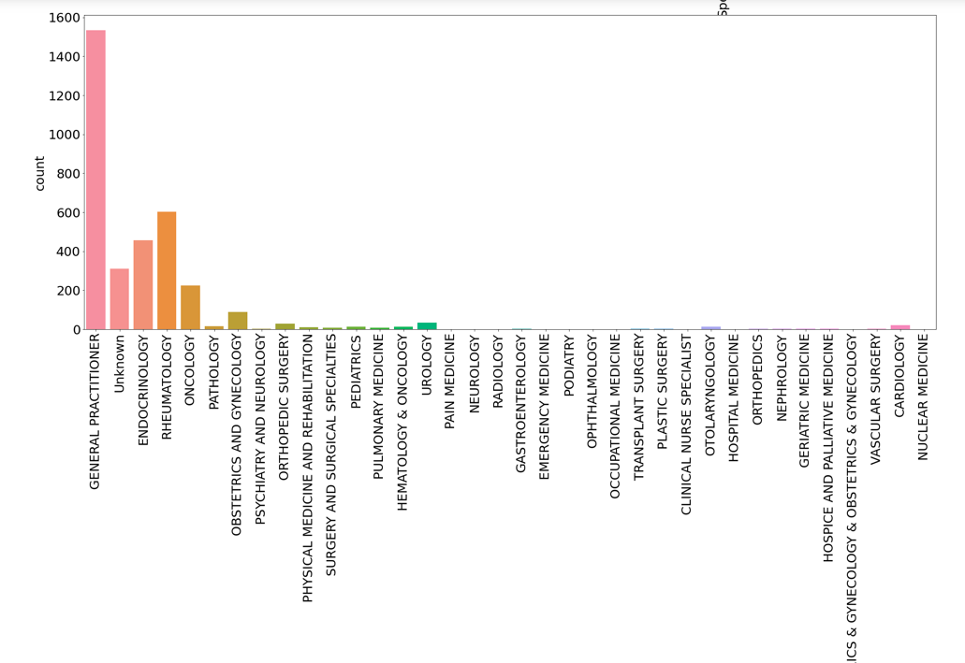

However, since there are three columns with similar information, its better to keep one. Additionally, its not clear if the speciality of the person who prescribed the medicine, is related to the persistency of drug. To investigate this, we plot the persistency and non_persistency of NTM_speciality flag. As can be seen in the second plot, the persistency is the same for the others and specialist flags. However, non-persistency is higher for other practioners than specialist. So to not lose additional information, we keep the NTM_speciality_flag .

