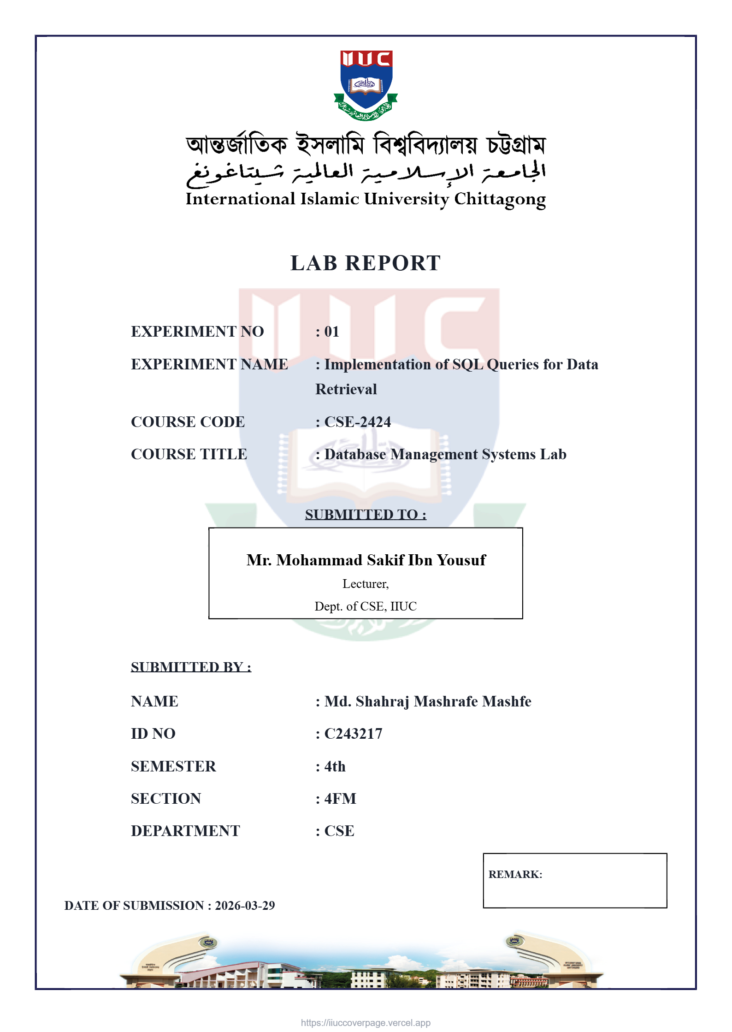
Database Initialization and Data Entry :
- First, I initialized the table using CREATE TABLE, where I defined all columns like id, name, dept, email, salary, and joining date with appropriate data types.
- I set the ID as the primary key to identify each employee uniquely.
- Then, I inserted data into the table using INSERT INTO statements.
- Each row was added with proper values matching the column order and correct formats (especially dates in YYYY-MM-DD).
- This setup ensured the table was structured correctly and ready for running different SQL queries.

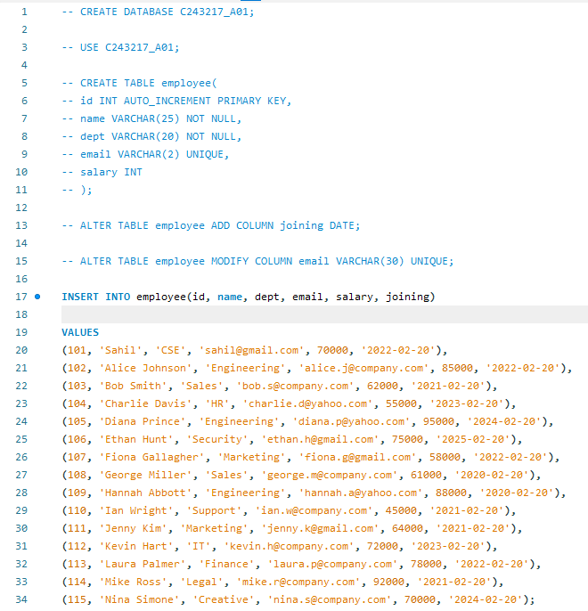
Q1: Display all records from the Employee table
I selected all columns using SELECT *.
No conditions were applied since I needed the full table.
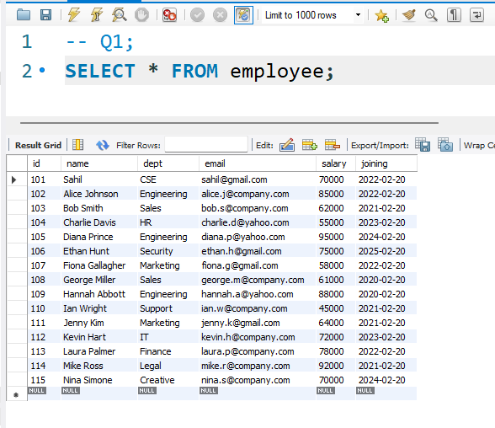

Q2: Display only employee names and salaries
I specified only the name and salary in the SELECT clause.
This limits the output to just those two fields.
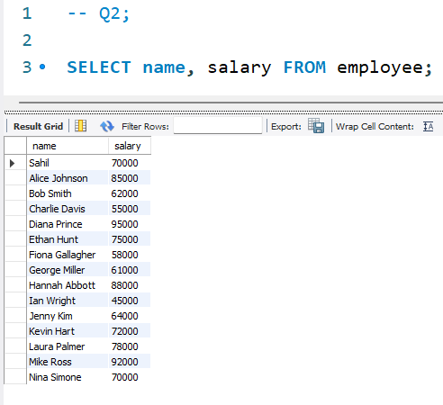
Q3: Display employee name and joining date with a custom column name
I selected the name and the joining date.
Then I used AS to rename the joining date to a custom heading.
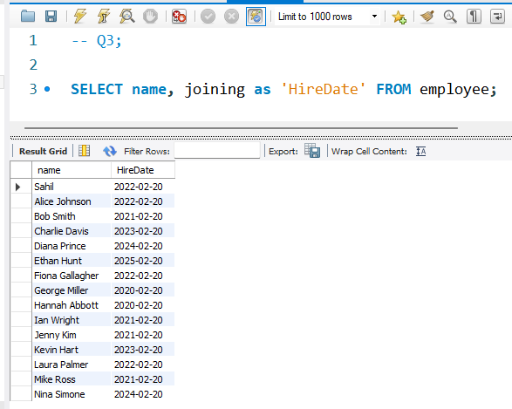

Q4: Display unique department names
I used SELECT DISTINCT dept to remove duplicates.
This ensures each department appears only once.
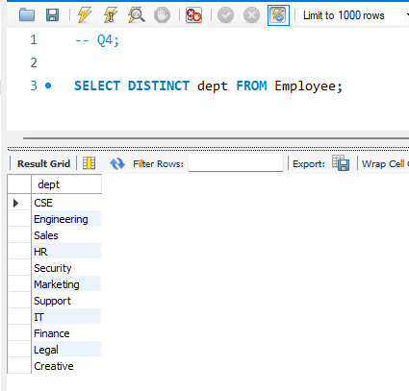
Q5: Display employees from the IT department
I filtered rows using WHERE dept = 'IT'.
This returns only employees from the IT department.
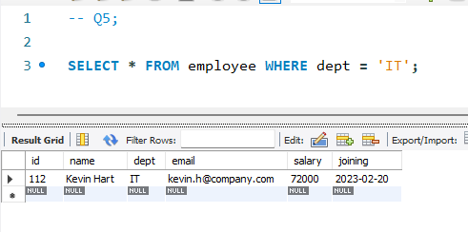
Q6: Display employees with salary greater than 75000
I applied a condition salary > 75000.
This shows employees earning more than the given amount.
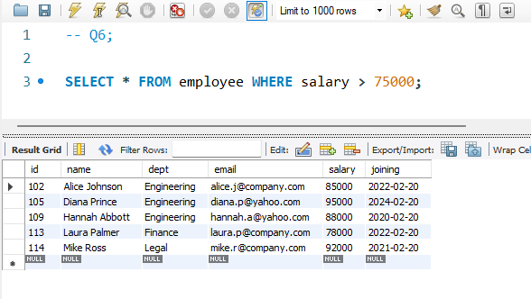

Q7: Display employees from Sales and HR departments
I used WHERE dept IN ('Sales', 'HR').
This filters employees working in either of the two departments.

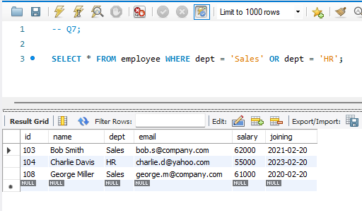
Q8: Display employees hired between 2022 and 2023
I used BETWEEN '2022-01-01' AND '2023-12-31'.
This selects employees hired within that date range.
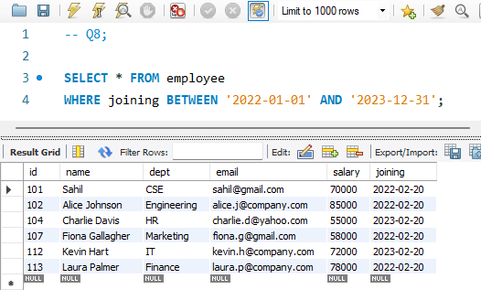
Q9: Display employees whose names start with 'M'
I used LIKE 'M%' to match names starting with M.
The % acts as a wildcard for remaining characters.
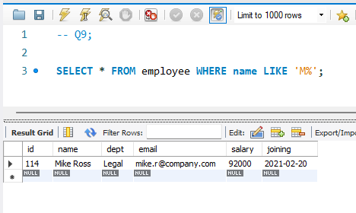
Q10: Display employees sorted by salary (highest first)
I sorted results using ORDER BY salary DESC.
This arranges employees from highest to lowest salary.
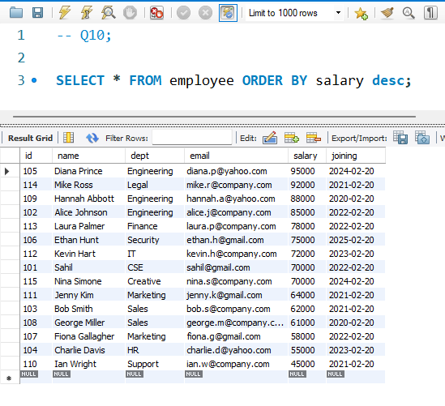
Q11: Display Finance department employees sorted by name
I filtered with dept = 'Finance'.
Then I used ORDER BY name ASC to sort alphabetically.
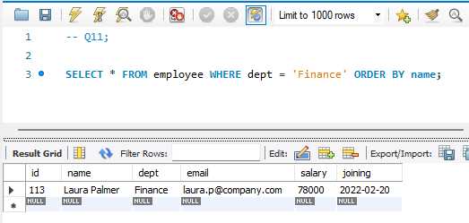

Q12: Display the top 3 highest-paid employees
I used ORDER BY salary DESC LIMIT 3.
This gives the top 3 highest-paid employees.
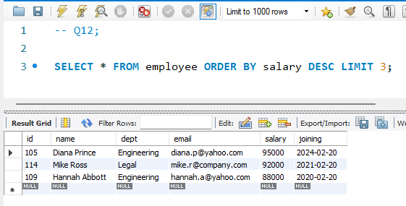

Q13: Display IT employees hired after 2021 sorted by salary
I filtered IT employees hired after 2021 using WHERE.
Then sorted by salary in descending order for ranking.
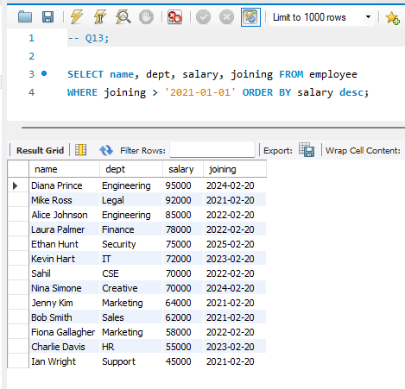
Q14: Display employees with Gmail or Yahoo email
I used LIKE '%gmail%' OR LIKE '%yahoo%'.
This finds employees with either Gmail or Yahoo emails.