|  |  |
| --- | --- |
| Prepared By | Sonam Matani |
| Project Tiltle | FoodMania |

**Description**: Foodmania is a nodejs application that allows users to add, delete, update the food items.

**Functional Details**:

1. The homepage of the application is the Menu with the available food items:

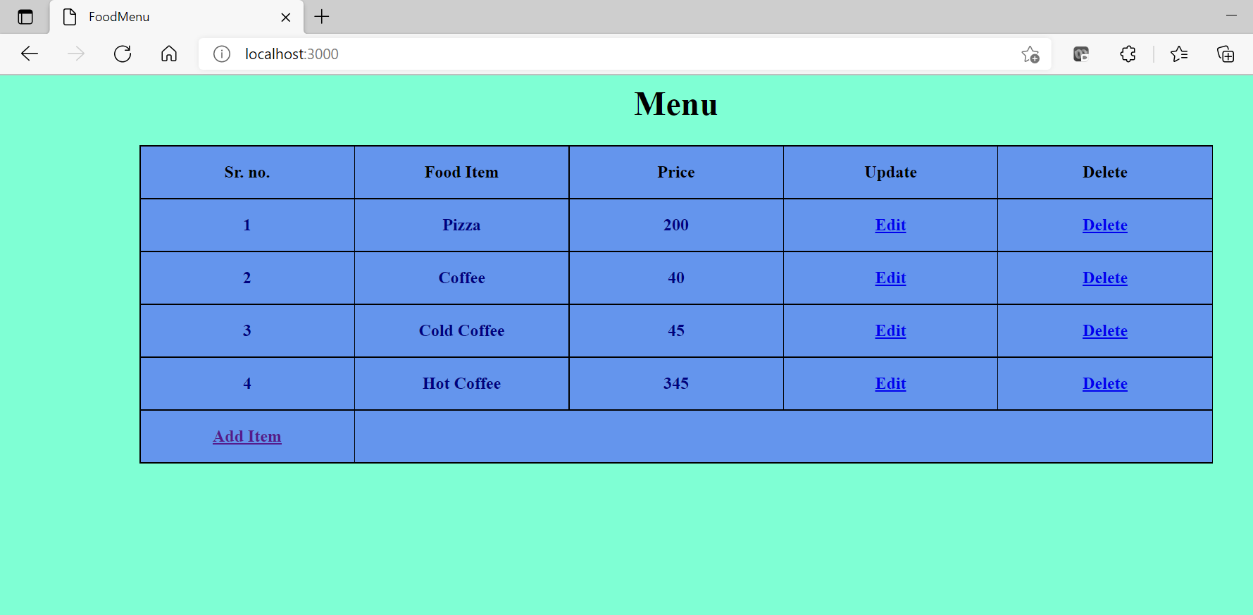

1. Click on Add Item to add a new item to the menu. Enter the food name and price and click on save.

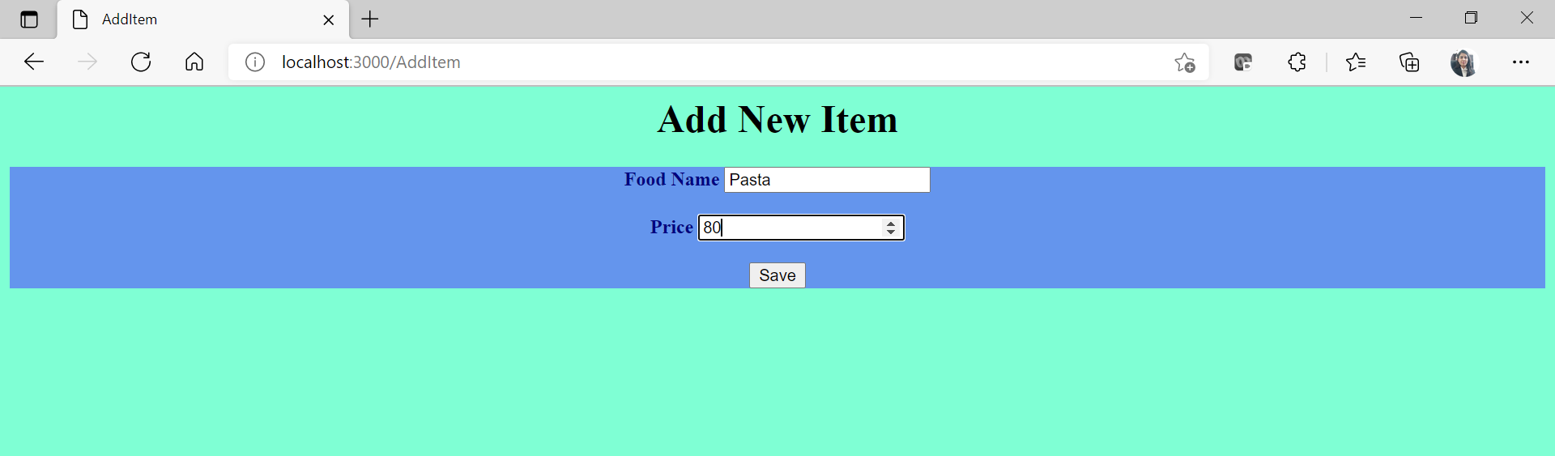

1. New item is added:

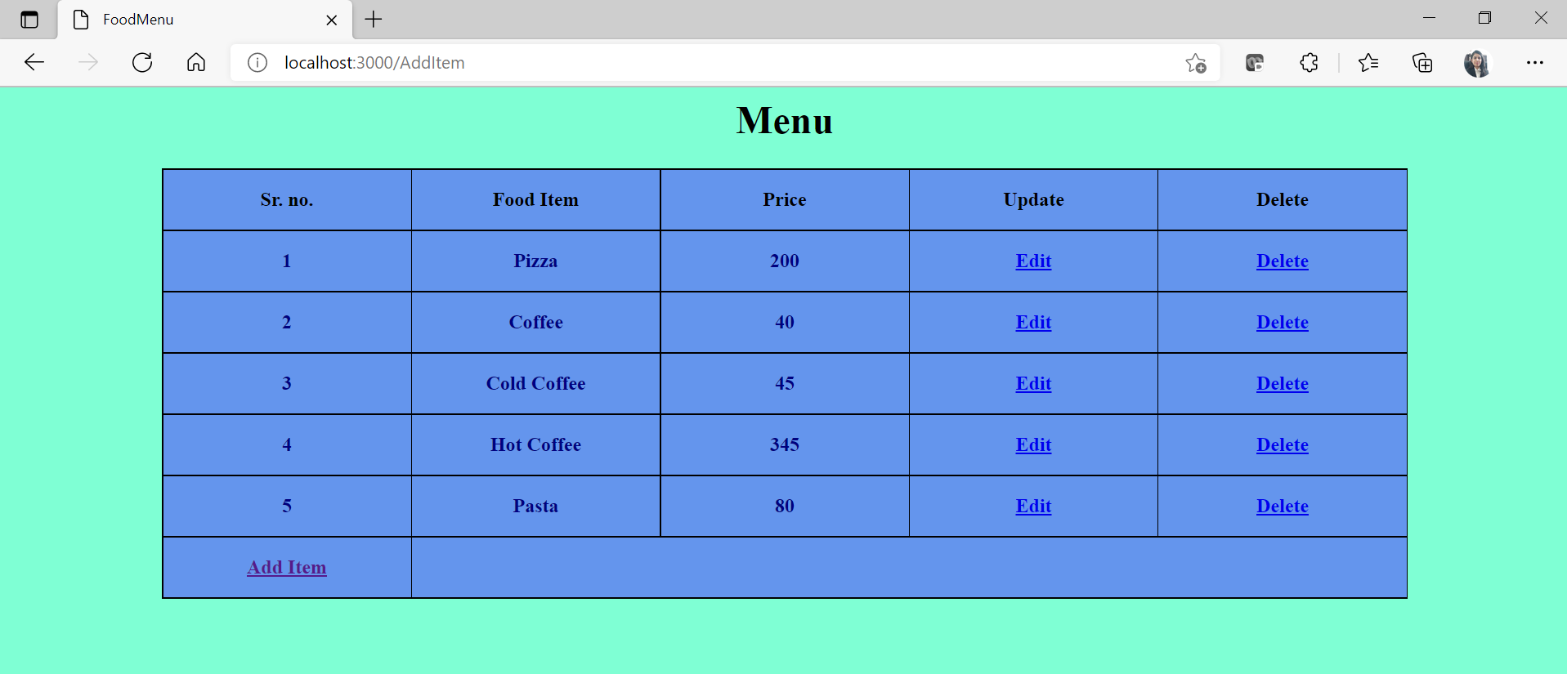

1. Click on edit to update a particular item.

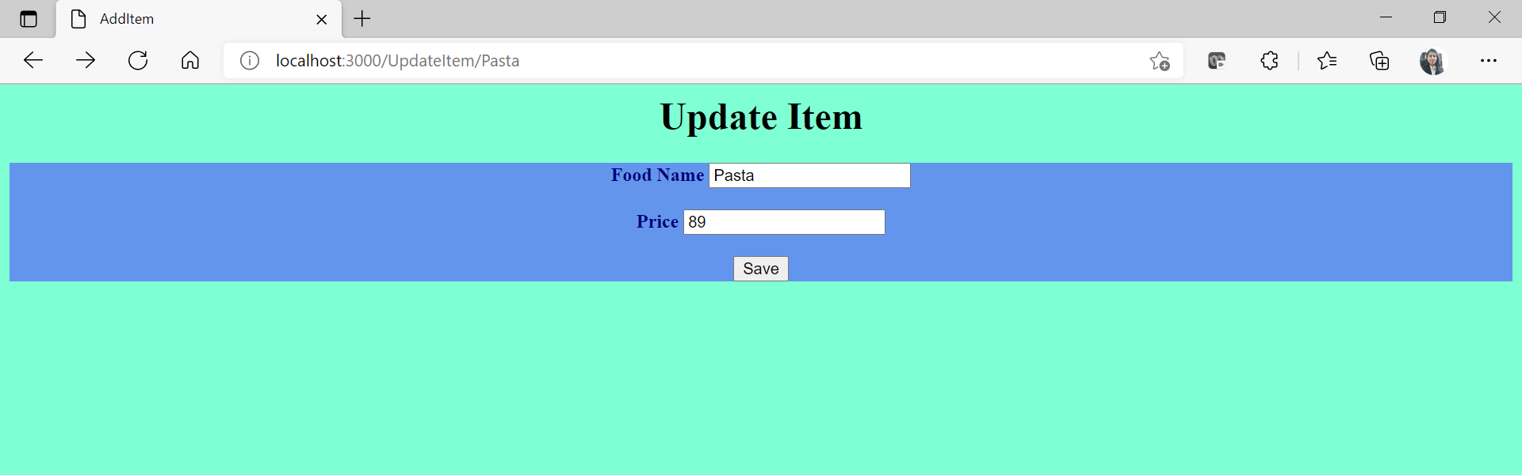

Price for Pasta is updated to 89:

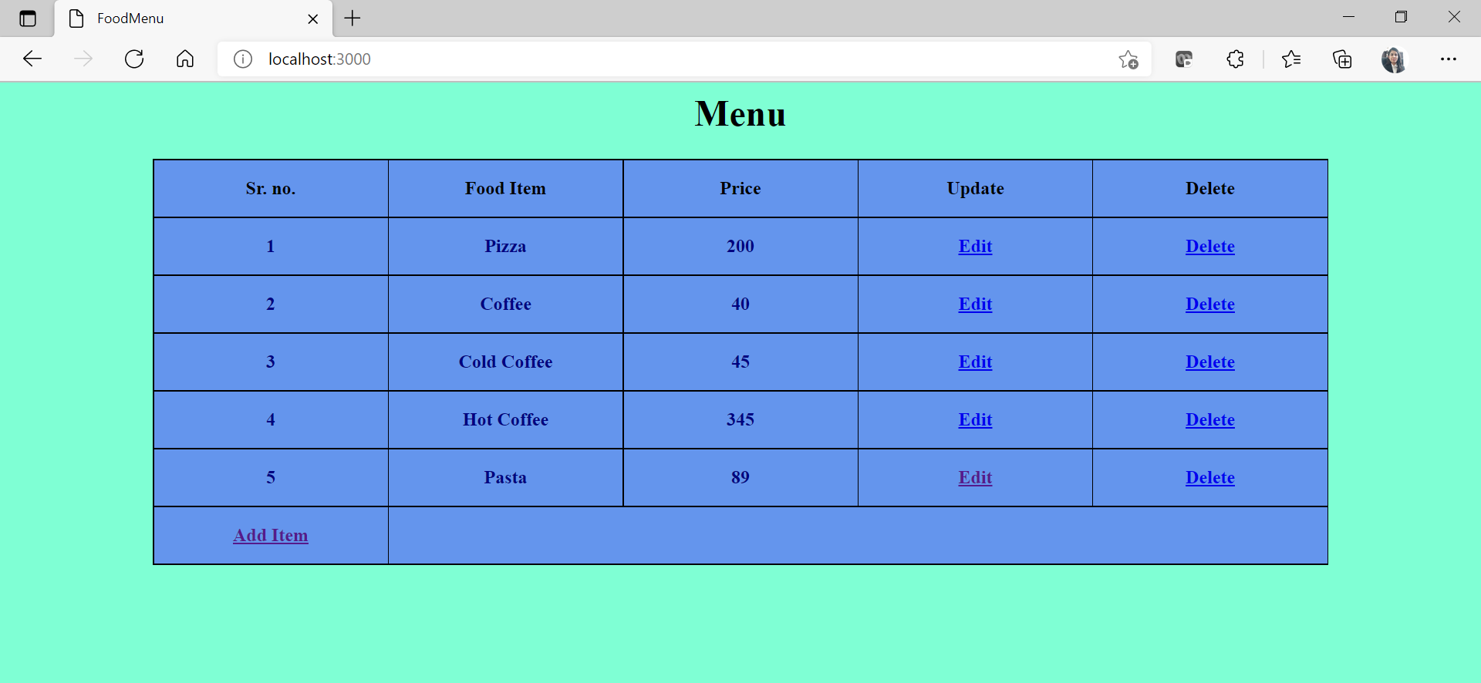

1. Click on delete to delete a particular item.

Item - Pizza is deleted from the menu:

