|  |  |
| --- | --- |
| Project Title | Online Evaluation Portal |
| Prepared By | Sonam Matani |

**Description:** Online Evaluation Portal is a php web application designed for managing the quiz examination and for availing the automatic evaluation of the tests performed.

**Functional Description:**

1. After the setup , browse- <http://localhost/OnlineEvaluationWebApp/INFO.php>

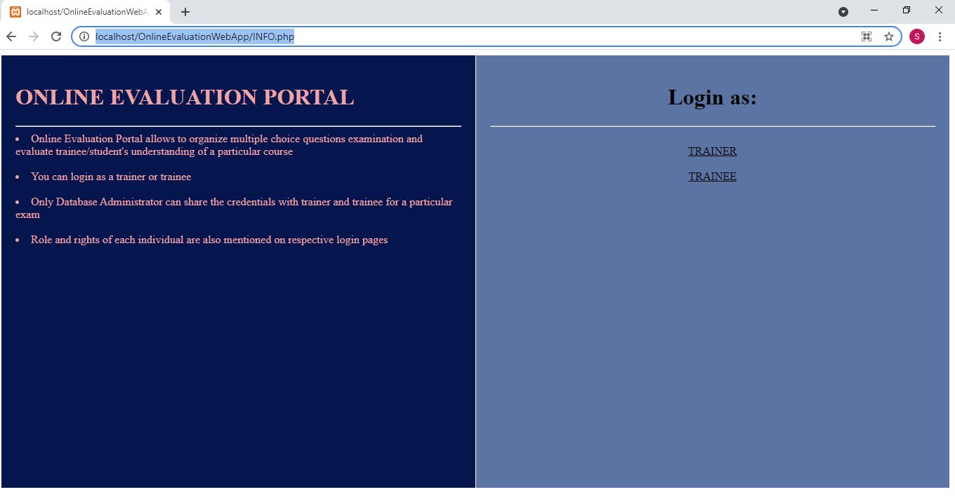

LHS gives the introduction about the application

RHS allows users to login with the authorization granted

1. Click on **Trainer** on the RHS
2. LHS describes the rights of a trainer

RHS is a login form for a trainer

Enter the credentials and Click on **login**:

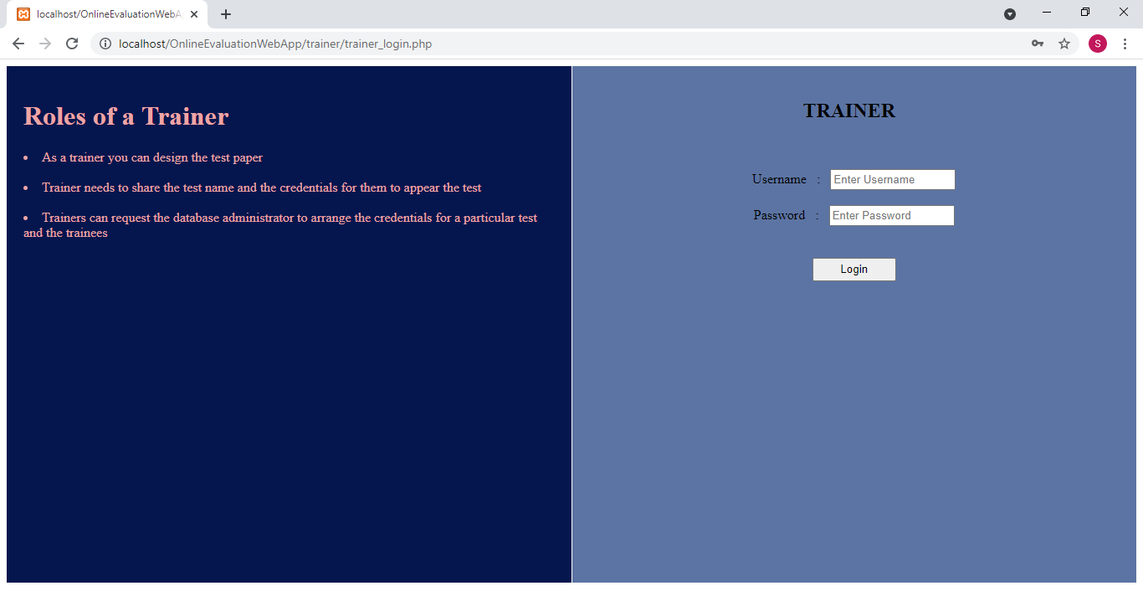

1. LHS explains the action to be performed on the RHS form

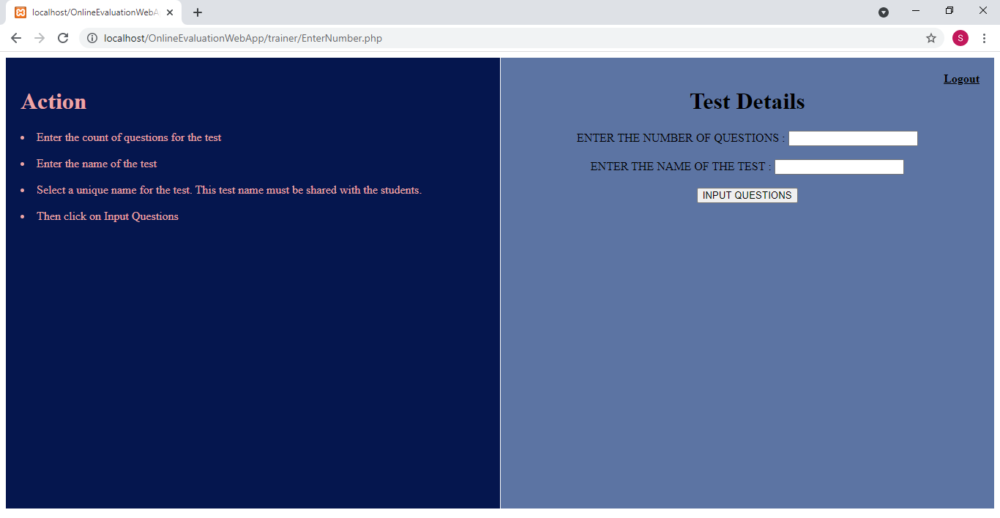

1. Enter the count and number of questions for the quiz and click on **Input Questions**:

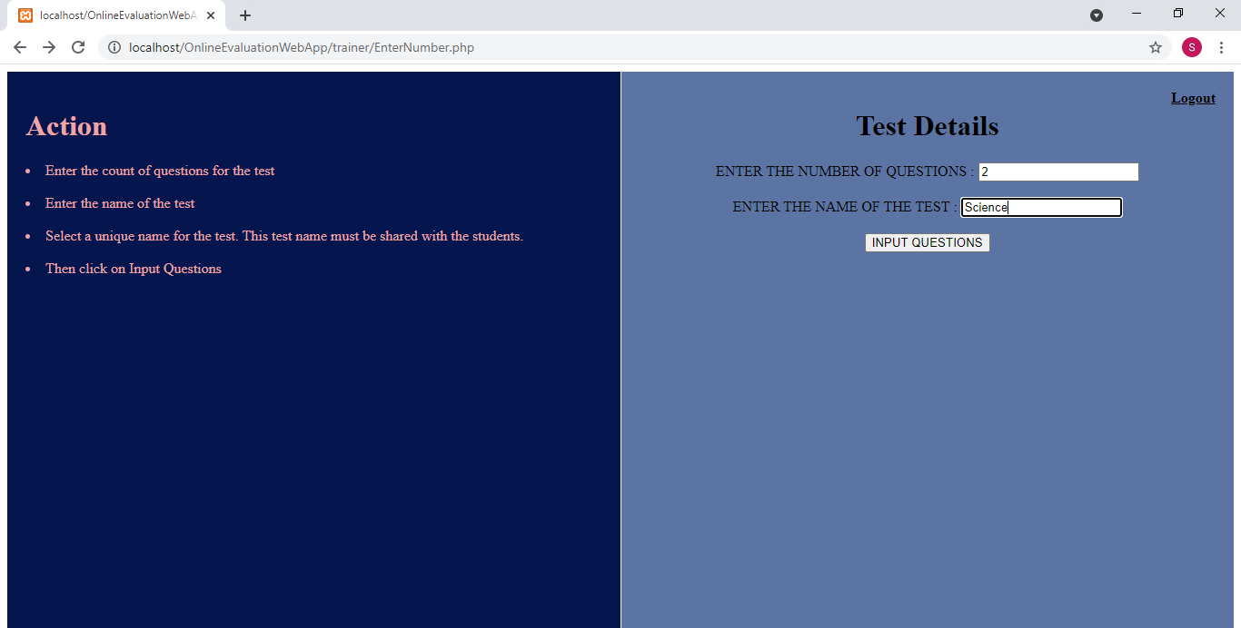

1. Enter the questions and options and the correct answer in the respective fields:

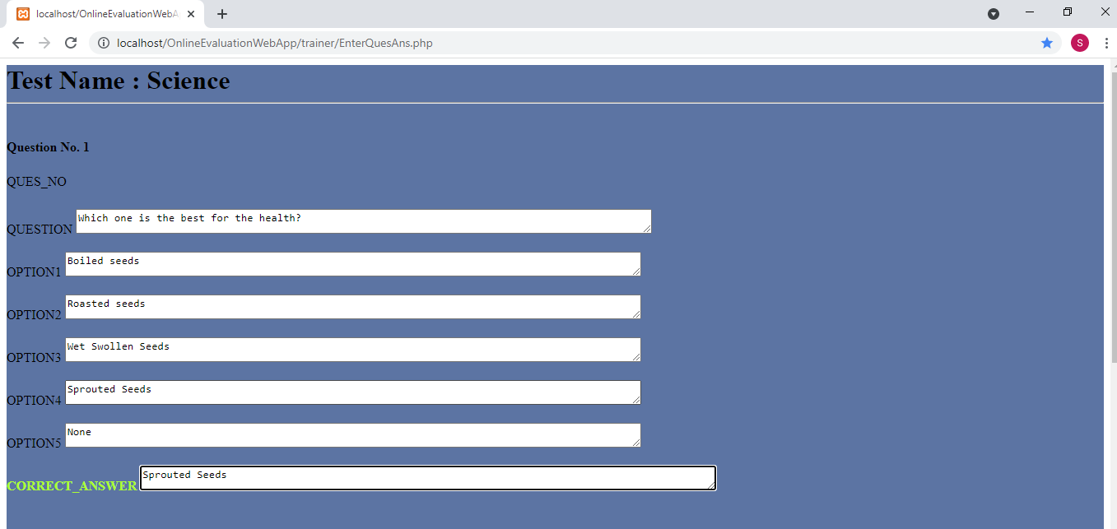

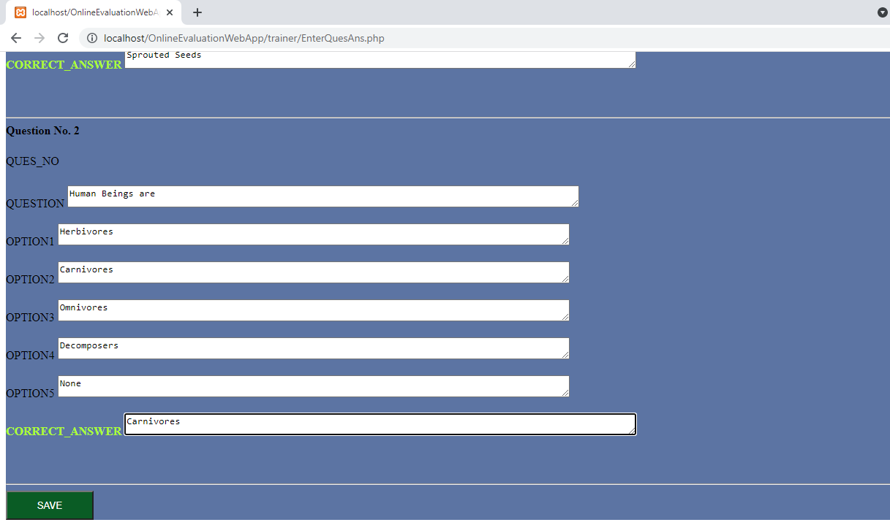

Click on **SAVE**.

1. Click on **PREVIEW** to check the test created 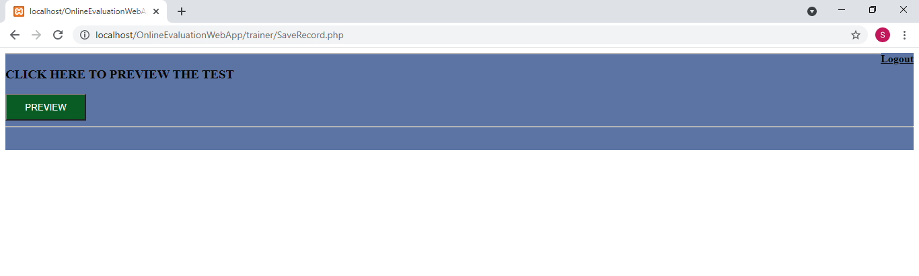
2. Click **DONE** once review is done

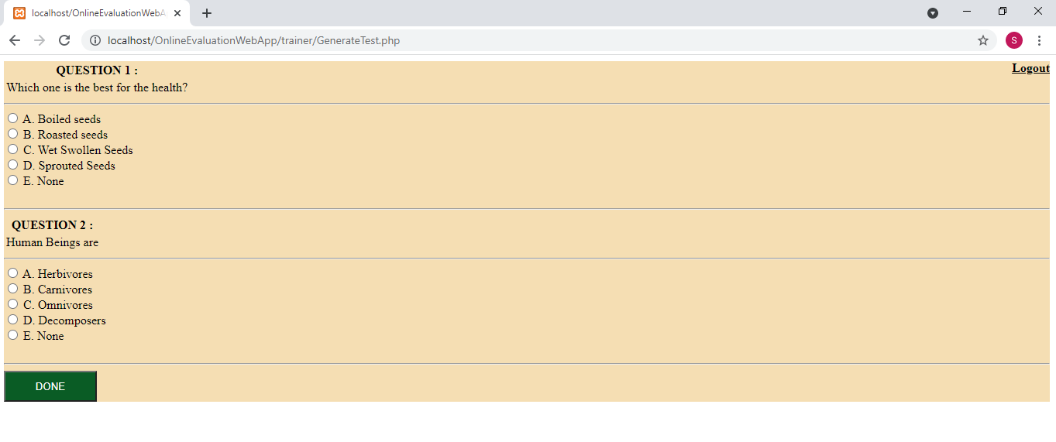

1. Do take the note of the test name in step 5.

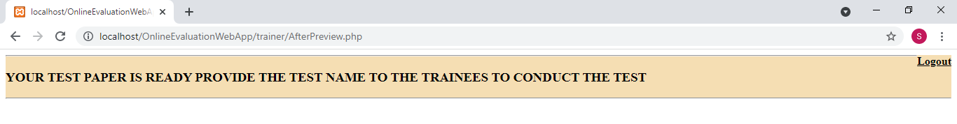You can now logout by clicking on Logout on the extreme right.

1. Click on **Trainee** to attempt the quiz

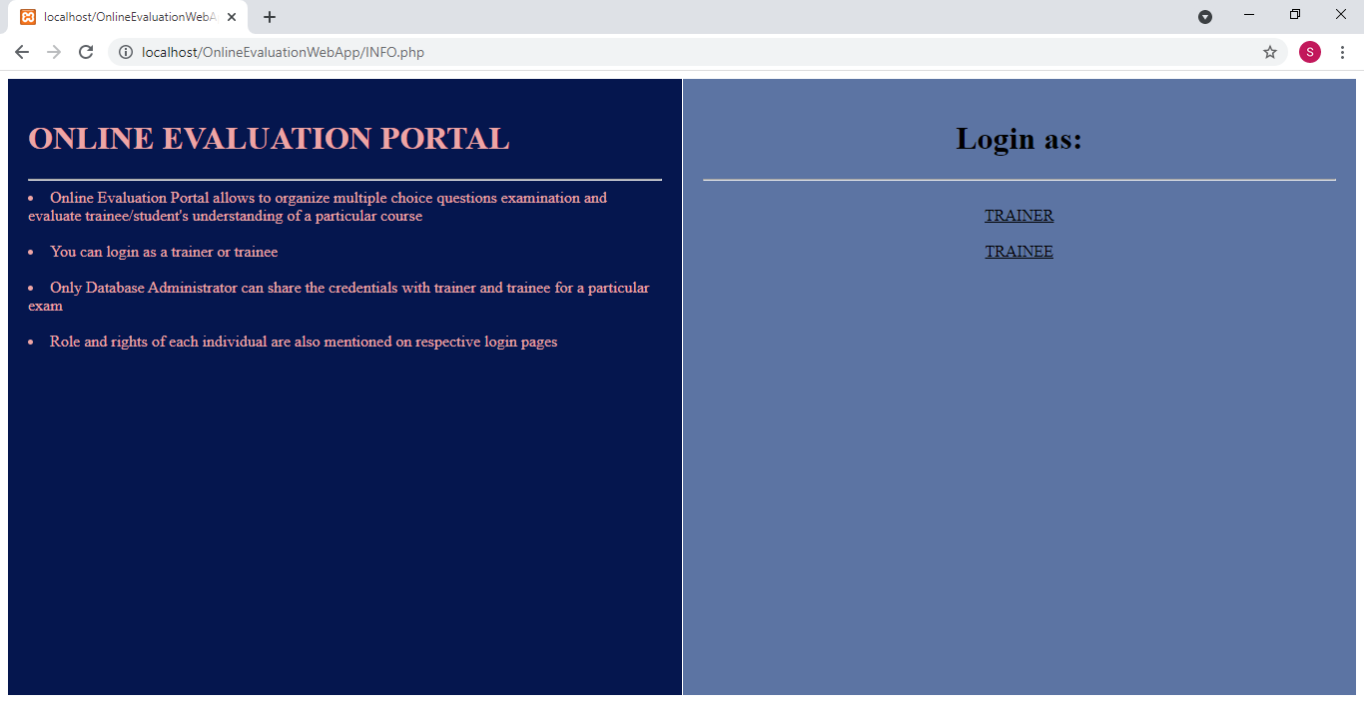

1. LHS describes the actions that trainee can perform

RHS has the login form for a particular test

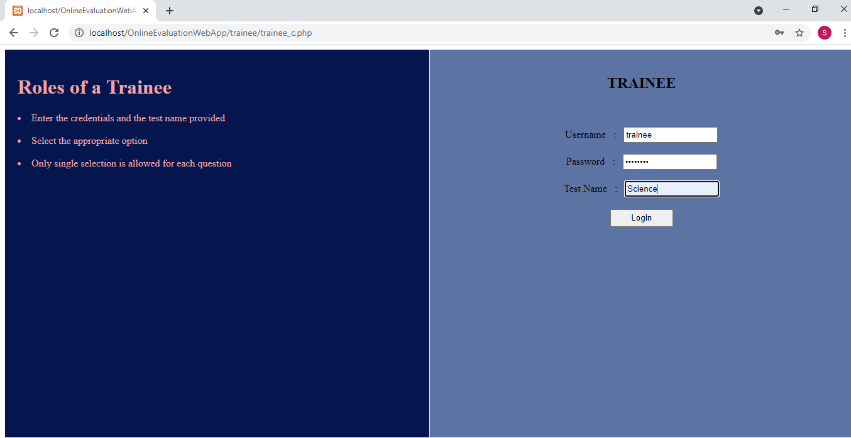

Enter the required details and click on **Login**.

1. Click on **START TEST**

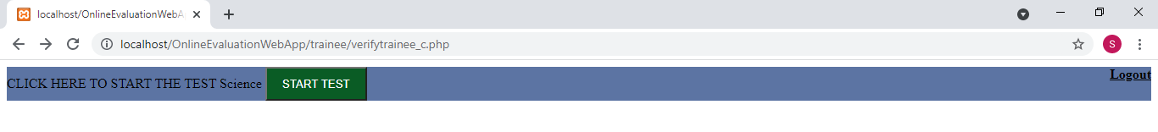

1. Attempt the quiz and click on **SUBMIT TEST**

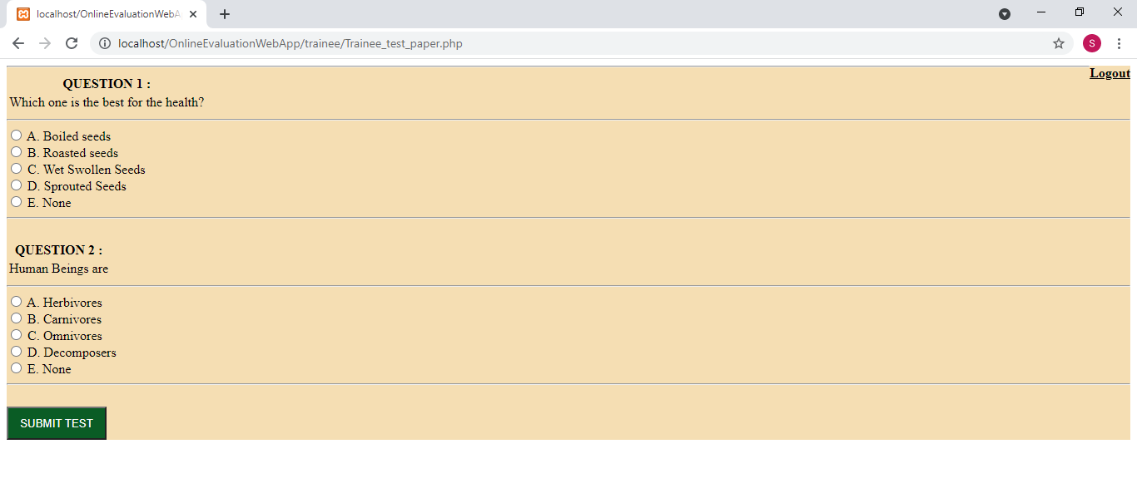

1. You’ll see the result with the selected and the correct response:

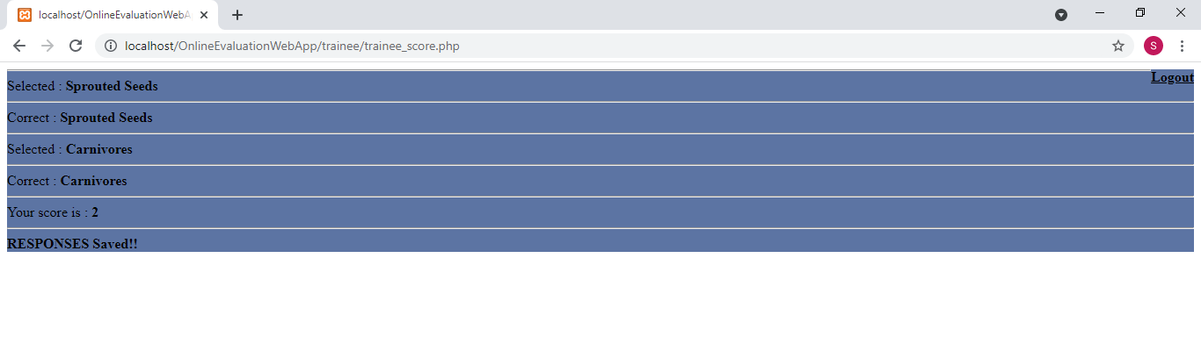

1. **Logout**