Upload of Atlassian Databases to Azure Managed Instance

1. Verify Specific Instance Collation:  SQL_Latin1_General_CP437_CI_AI
2. “Atlassian” Backup file(s) (.*bak*) obtained from SNC file share.
3. Backup restored to on-prem instance:  **PVWDB003\Azure**
4. Database exported from on-prem instance to “bacpac” file using Azure Data Studio Data-tier Application Wizard
   1. *Ensure that SQL Server Dacpac extension is installed*
   2. *bacpac is simply a file extension for an archive file containing metadata and data from a database.*
   3. *Todd K. explicitly mentioned the need to change the export file path to a shared location*

* *\*\*Log onto azure instances in Azure Data Studio using* ***engatladm*** *user. PW stored on PVWDB003 KeePass*

1. bacpac file imported to Azure Managed Instance using Azure Data Studio**: ent-app-atlassian-crowd-ssg-prod-sqlmi.b5e9ffa04b3a.database.usgovcloudapi.net** via Data-tier Application Wizard
   1. *Default database name appends datestamp to file.*
   2. *Remove datestamp, ensuring database name is retained without an extension.*
2. Verify successful completion message in Azure Data Studio status window

**SUPPORTING SCREENSHOTS FROM DEMO:**

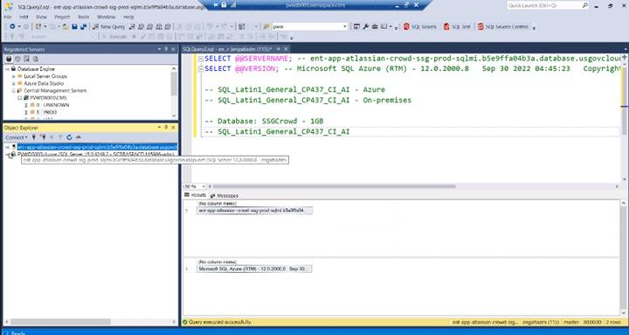



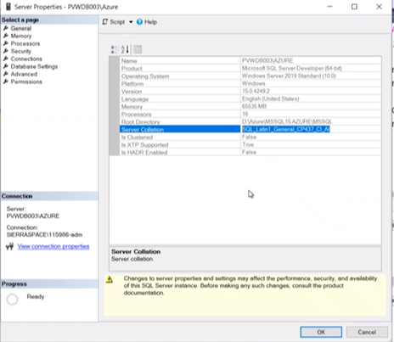

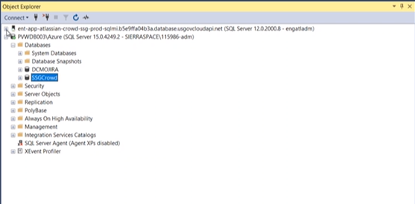

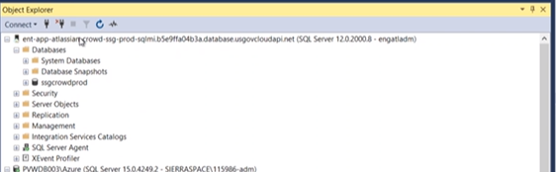

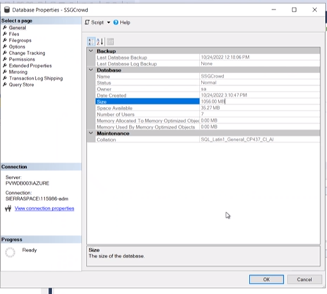

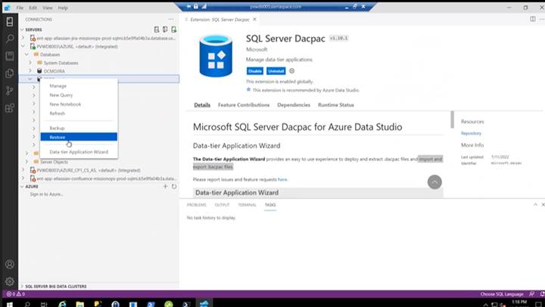

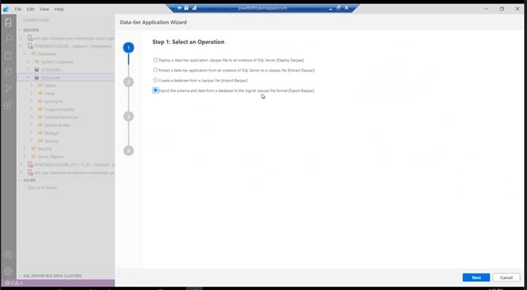

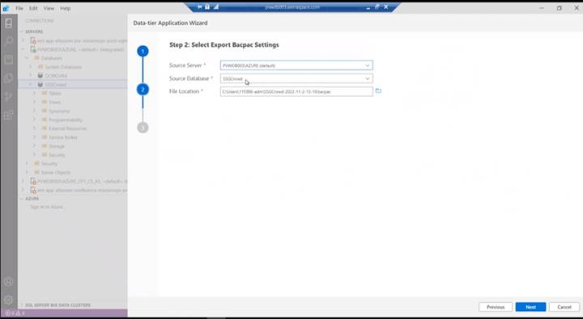

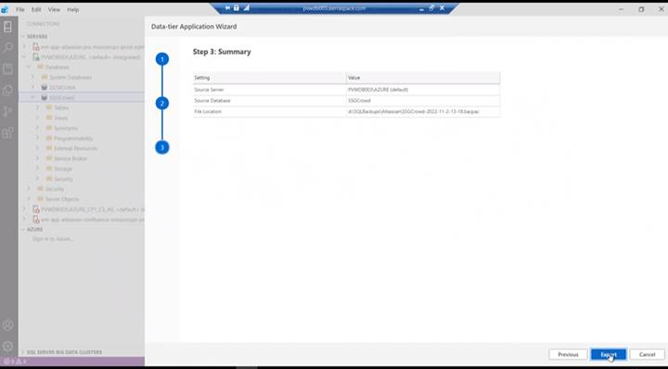

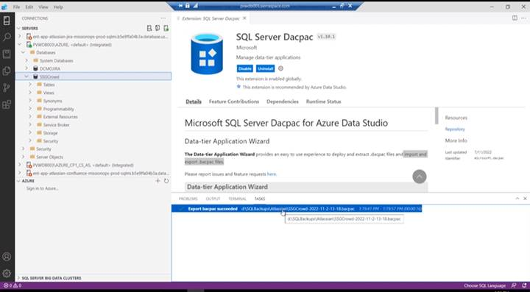

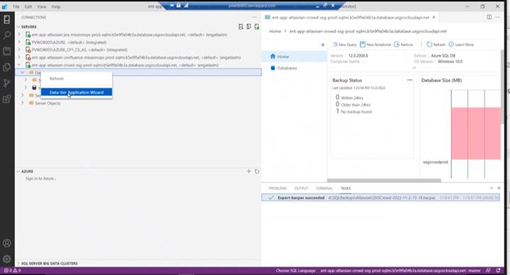

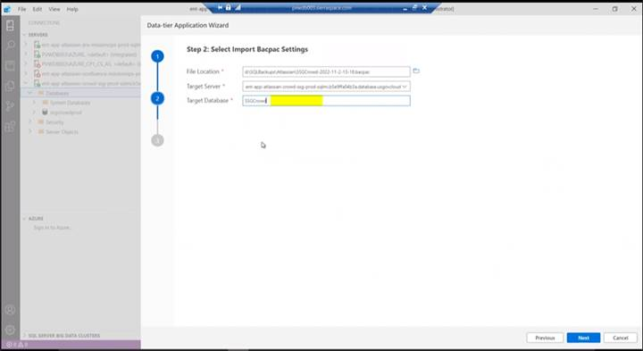

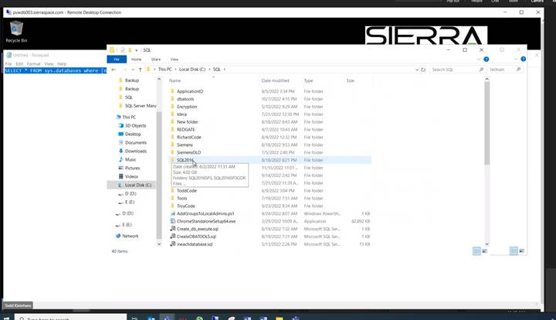

**Sierra Space Proprietary Information**