**Power BI Hands-on Assessment**

**Name – Meghna Sabharwal**

**Alias ID : 654791**

**Requirement 1: Data Loading**

All the four tables loaded in the file

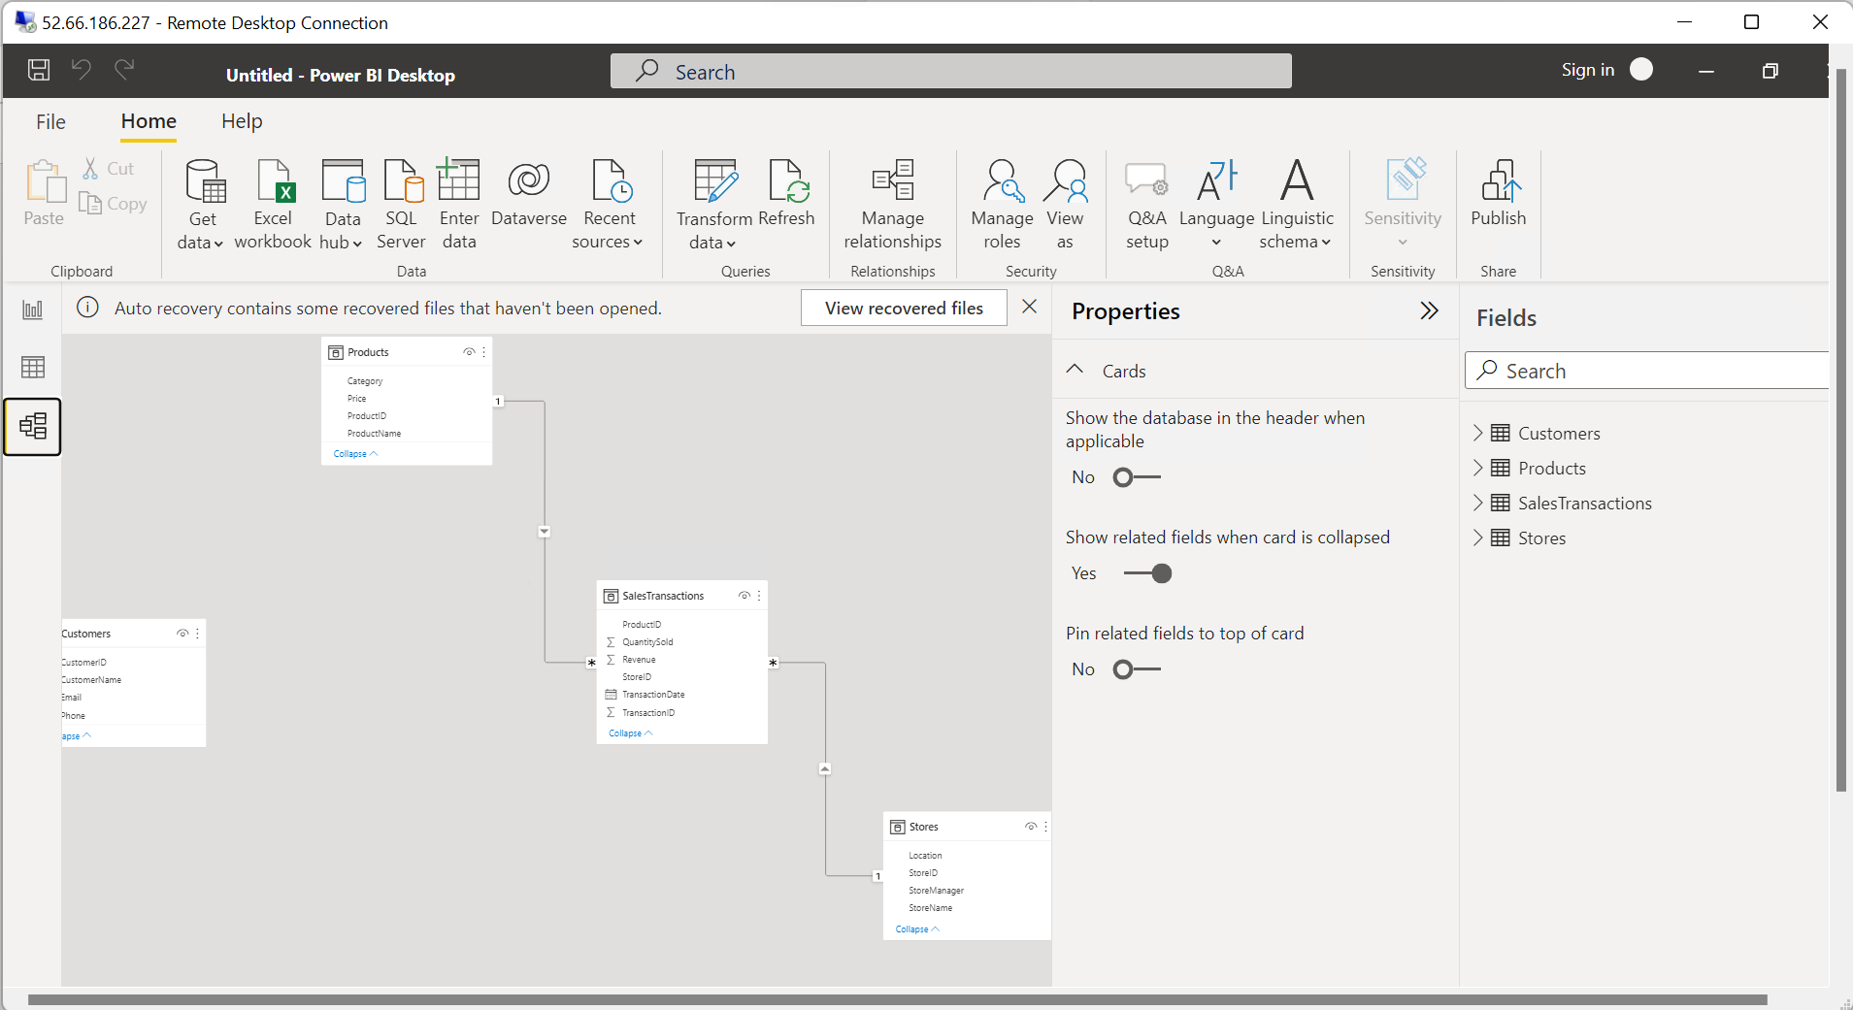

**Requirement 2: Data Transformation**

**Merge tables**

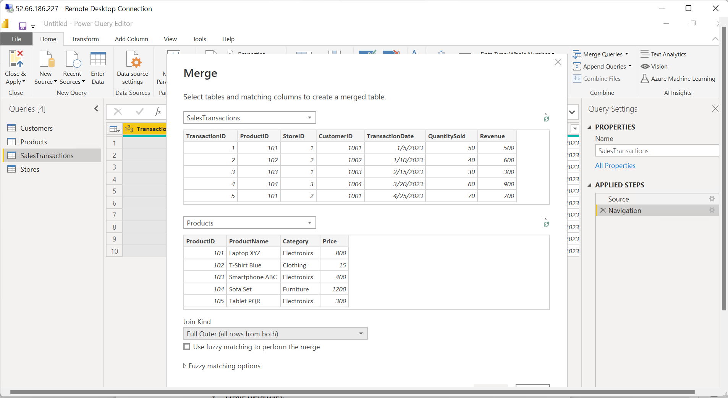

**Clean data**

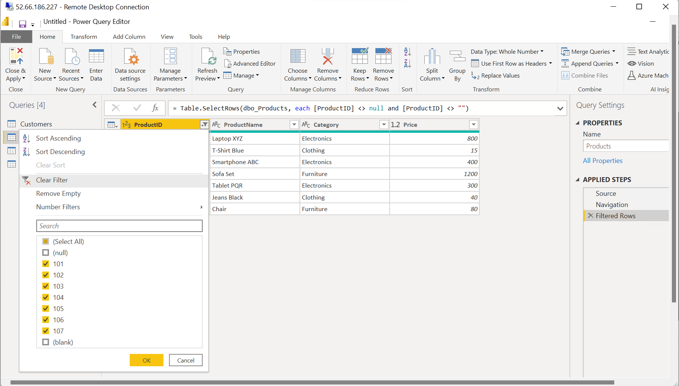

**Filter data**

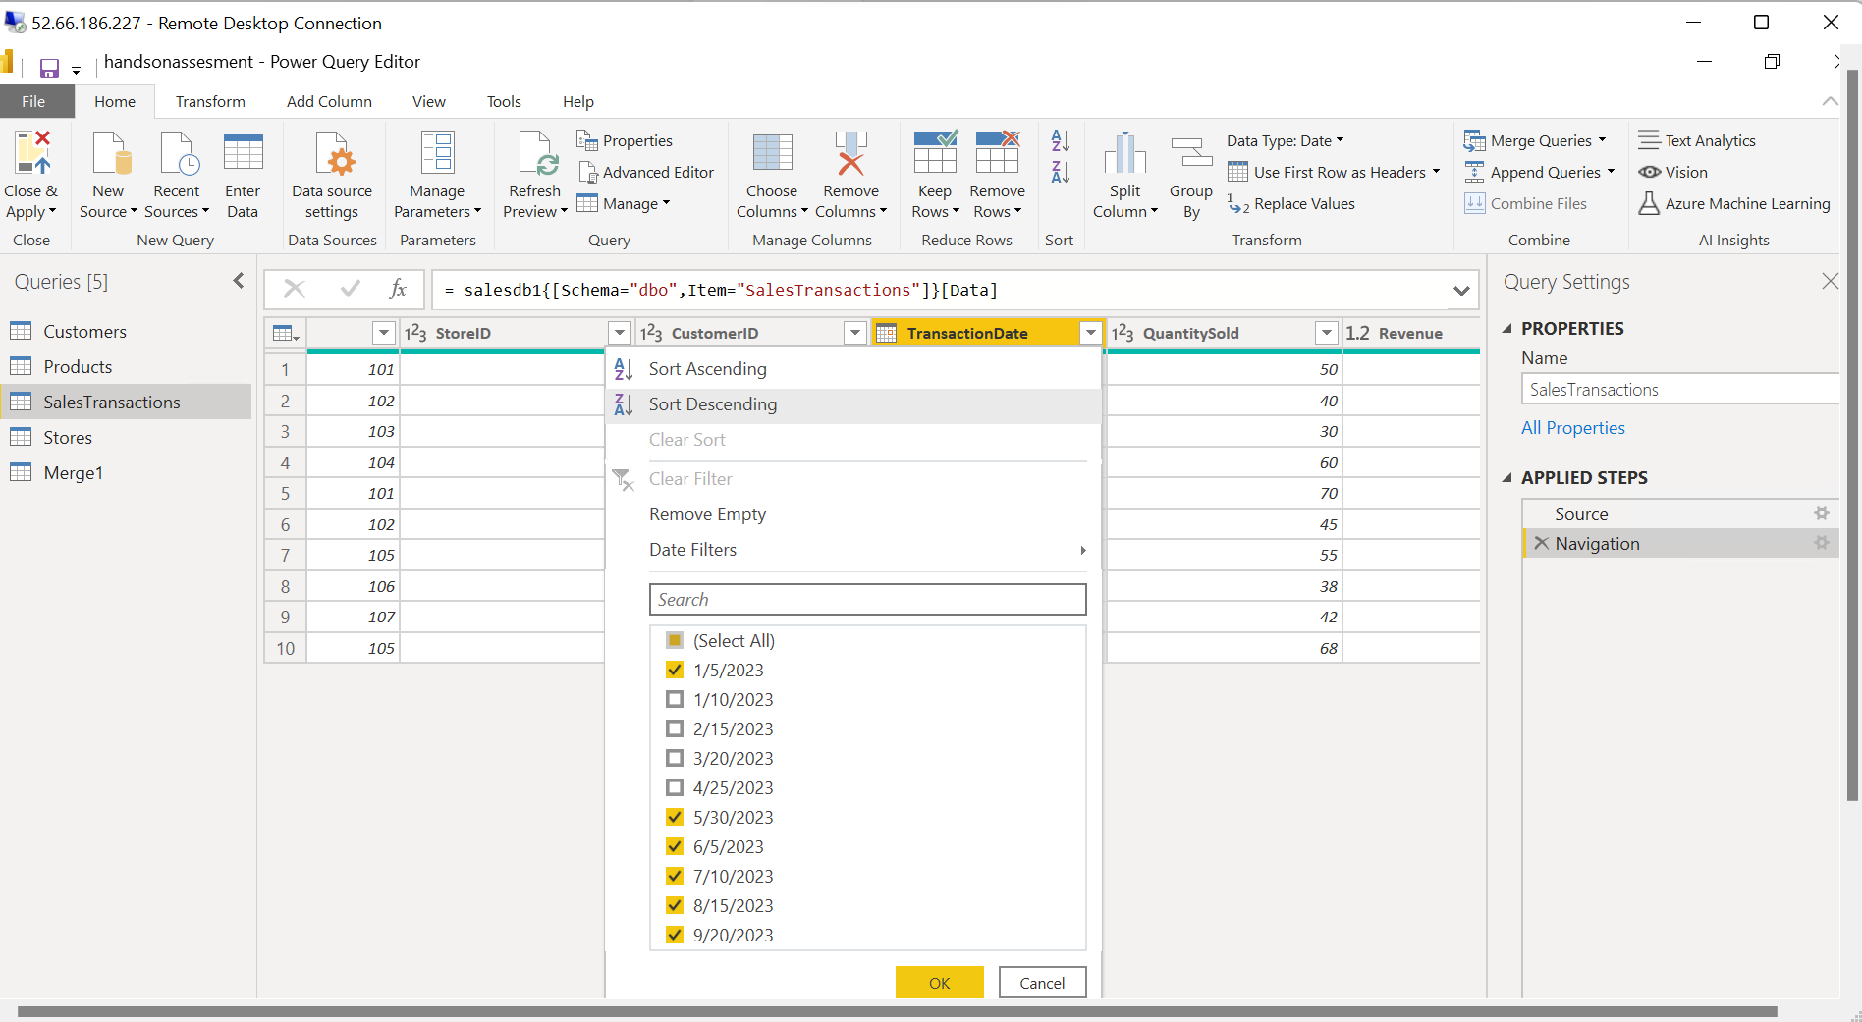

**Requirement 3: Data Modelling**

**Create relationships**

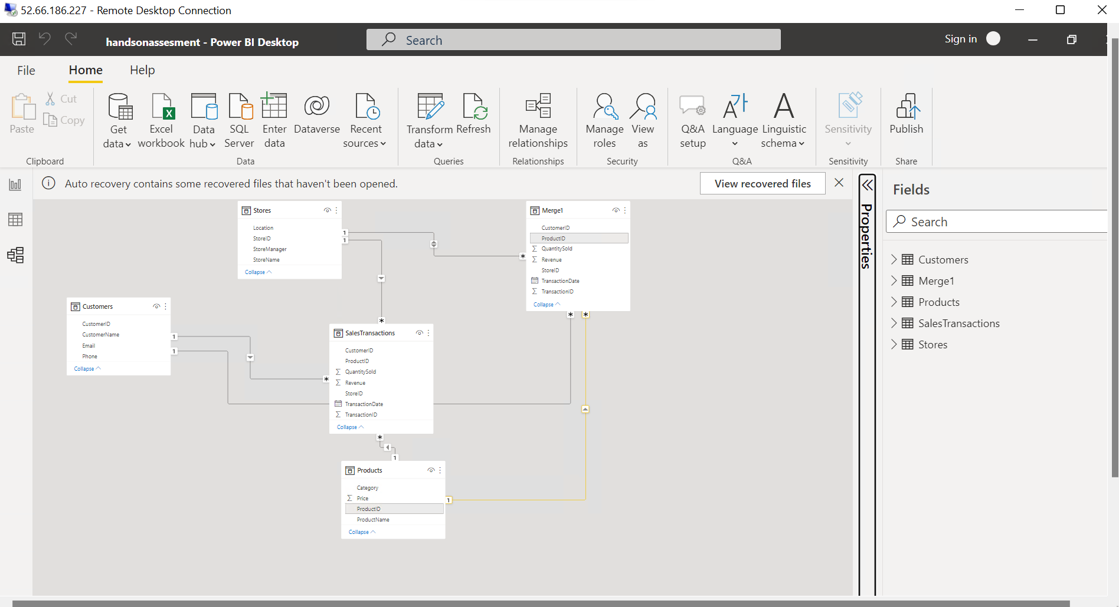

**Create hierarchy**

**Created hierarchy for the category column in the product table** 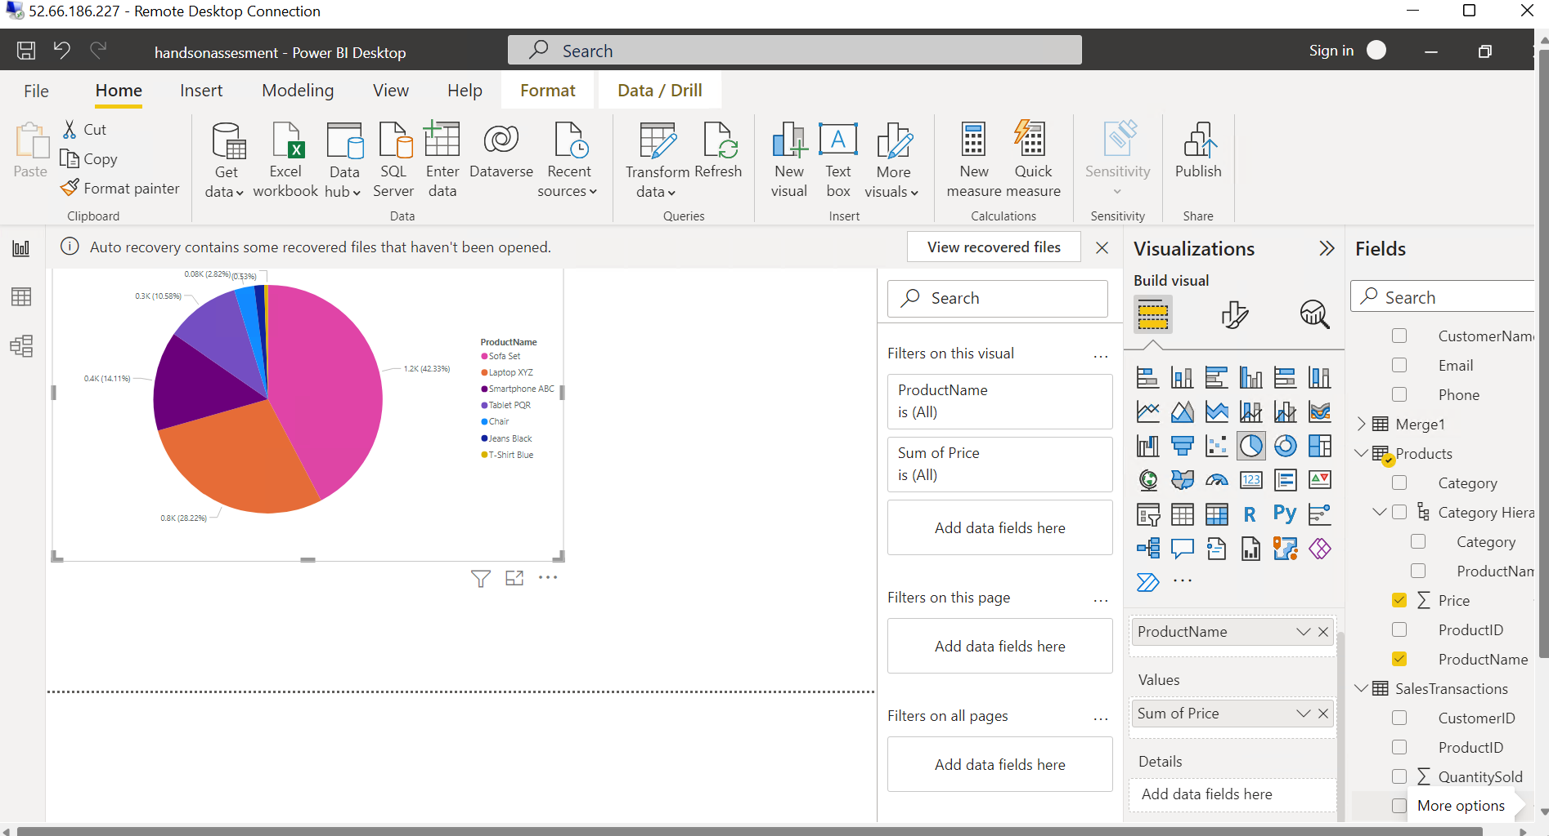

**Requirement 4: Business Queries and Analysis**

1. Who are the top-spending customers based on their total purchase amount?

Customer B and Customer E

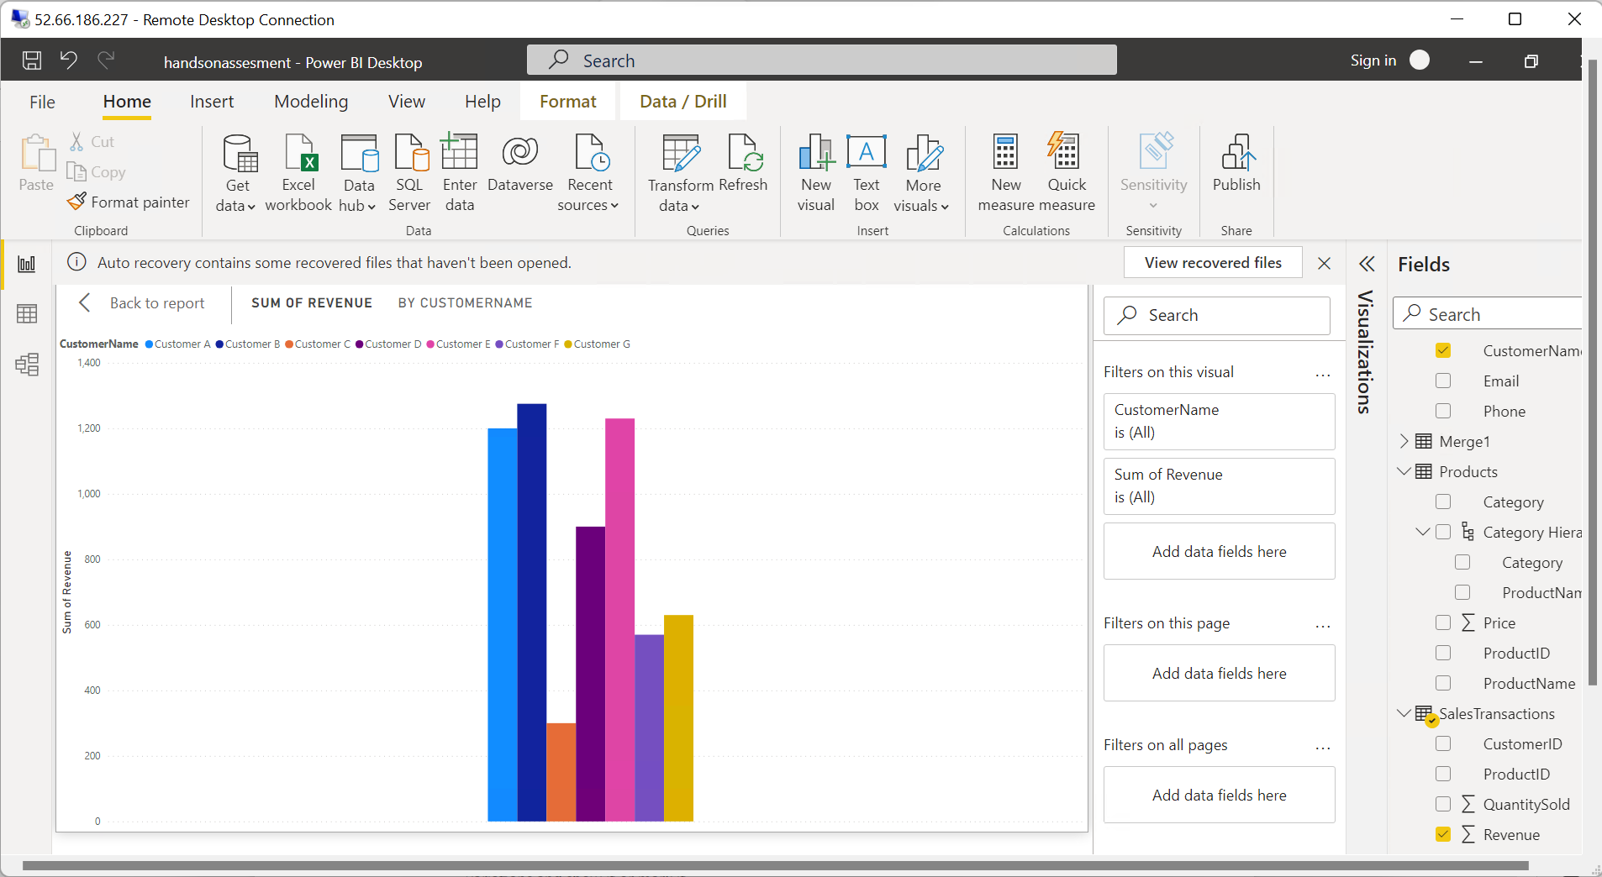

2. How is sales revenue distributed among different store managers?

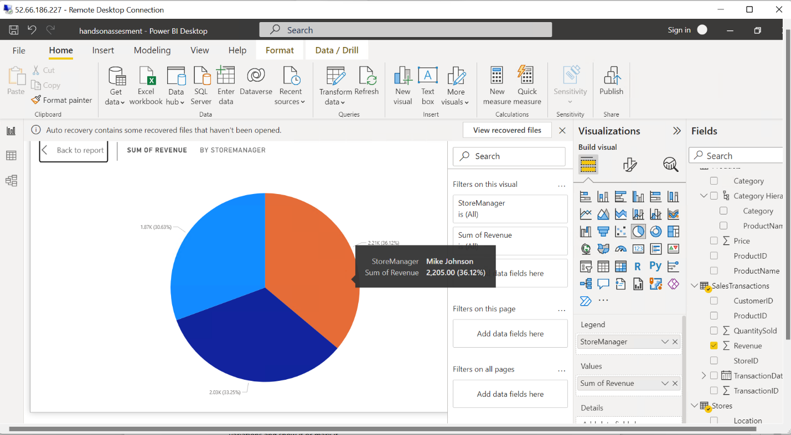

3. What is the average price of products in each category?

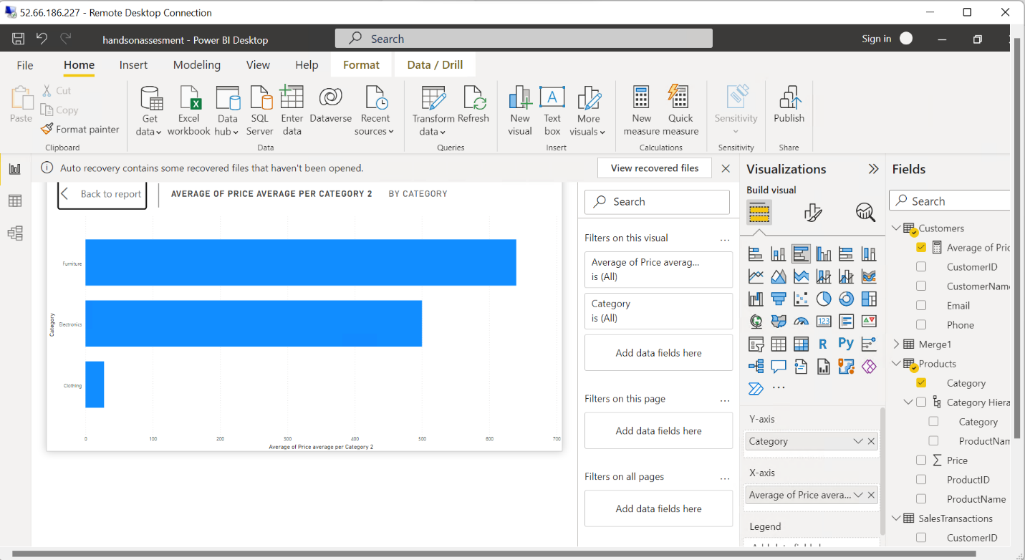

4. Are there specific days of the week when sales are higher?

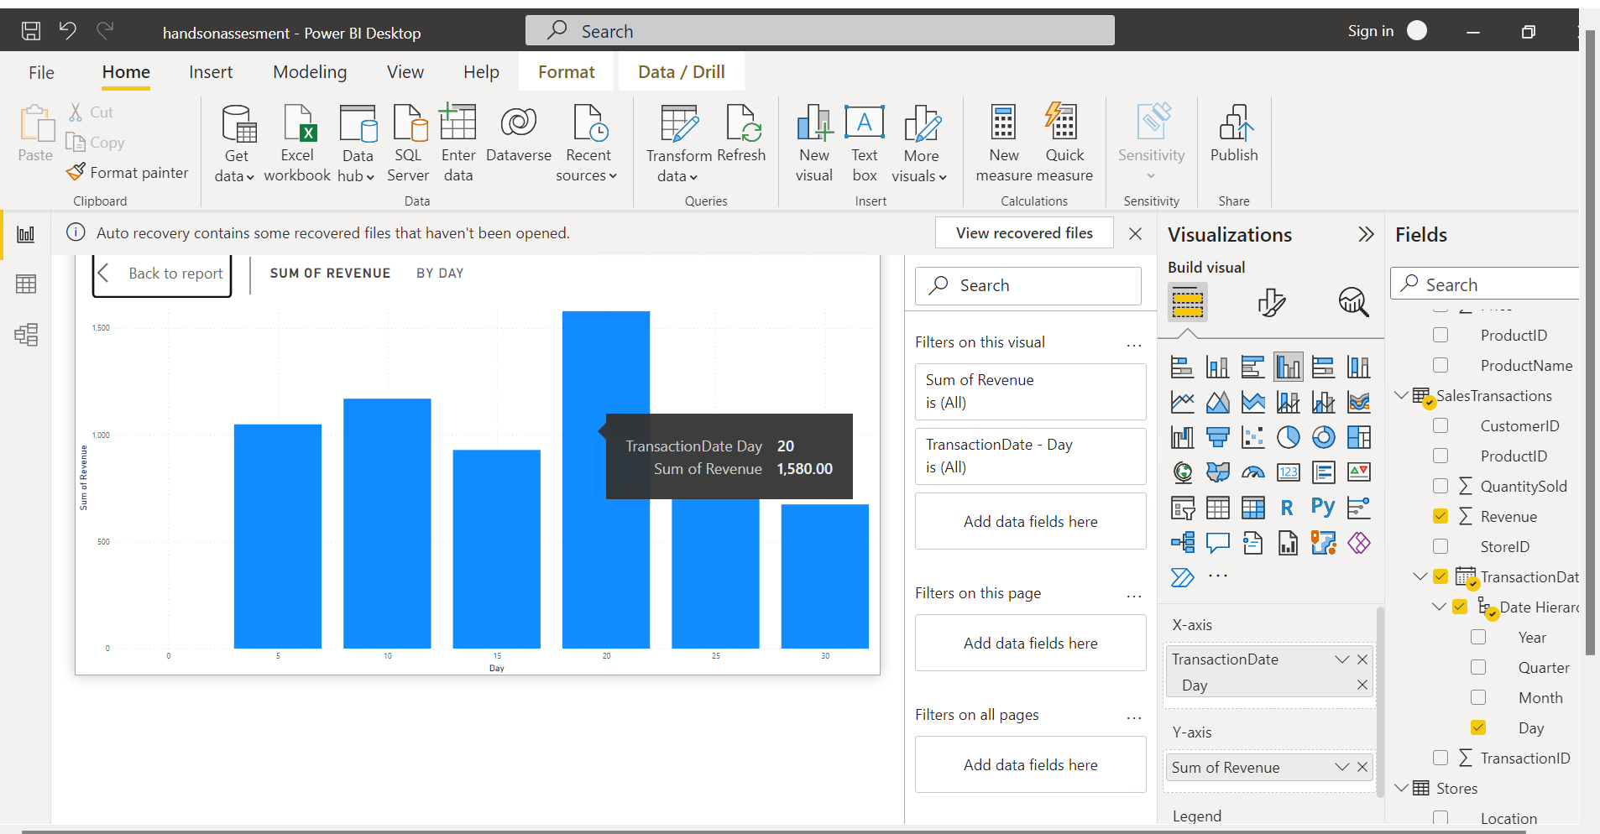

5. How do sales trends vary by product category on a monthly basis?

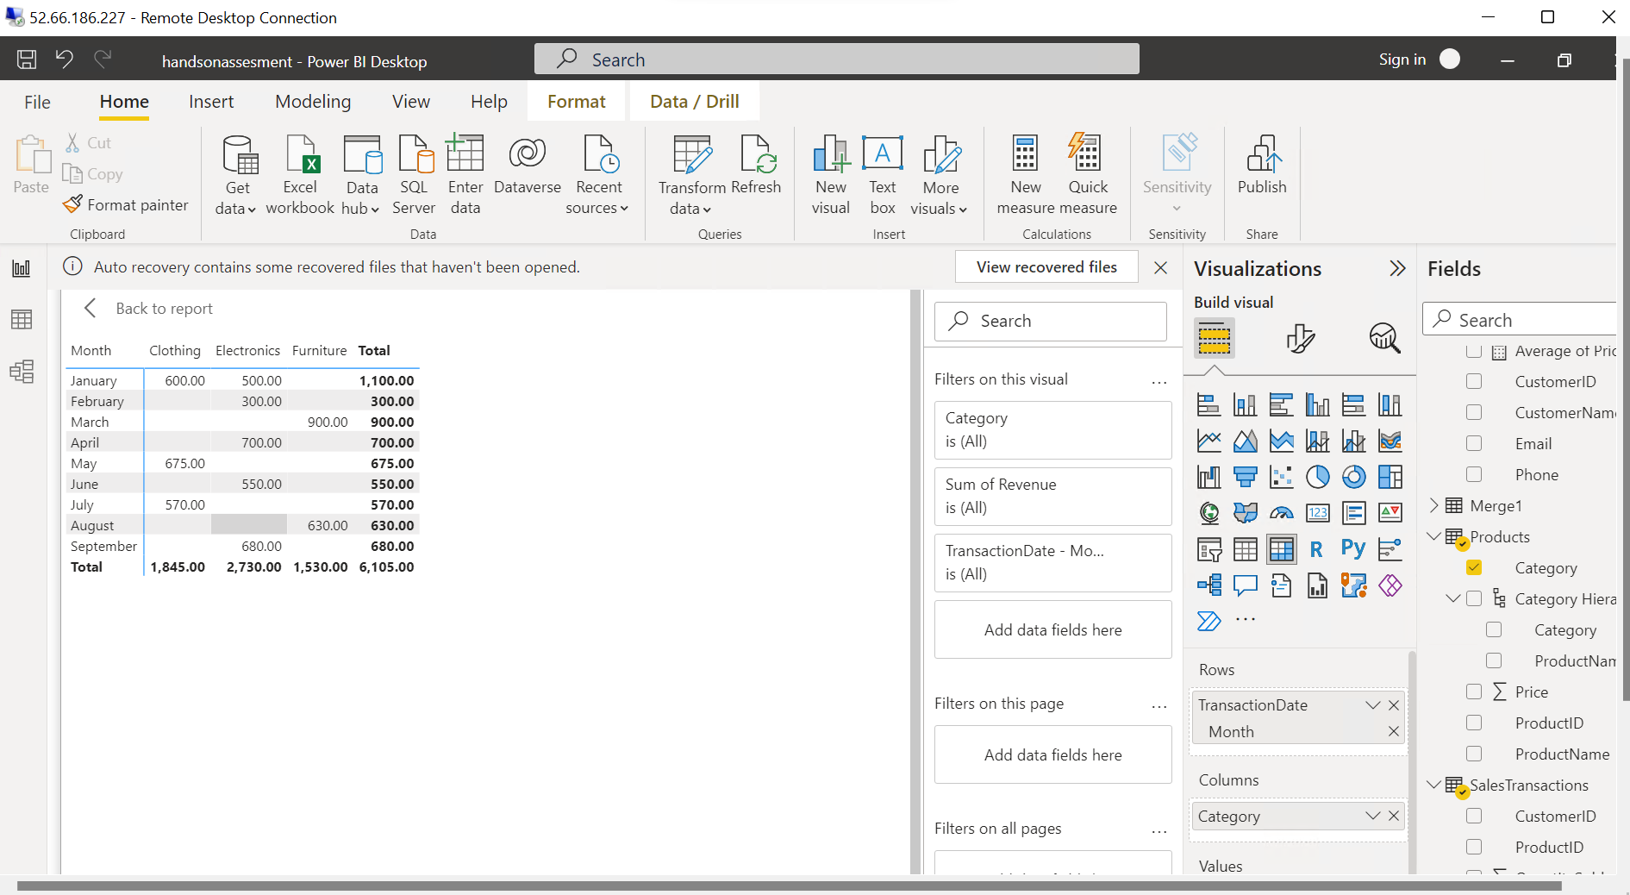

6. What percentage of products account for 80% of total sales revenue?

7. Are there any trends in repeat customer purchases?

Customer 1001, 1002, 1005 have purchased twice

8. Which product categories perform best at each store location?

Chicago : Furniture

Los Angeles : Clothing

New York : Electronics

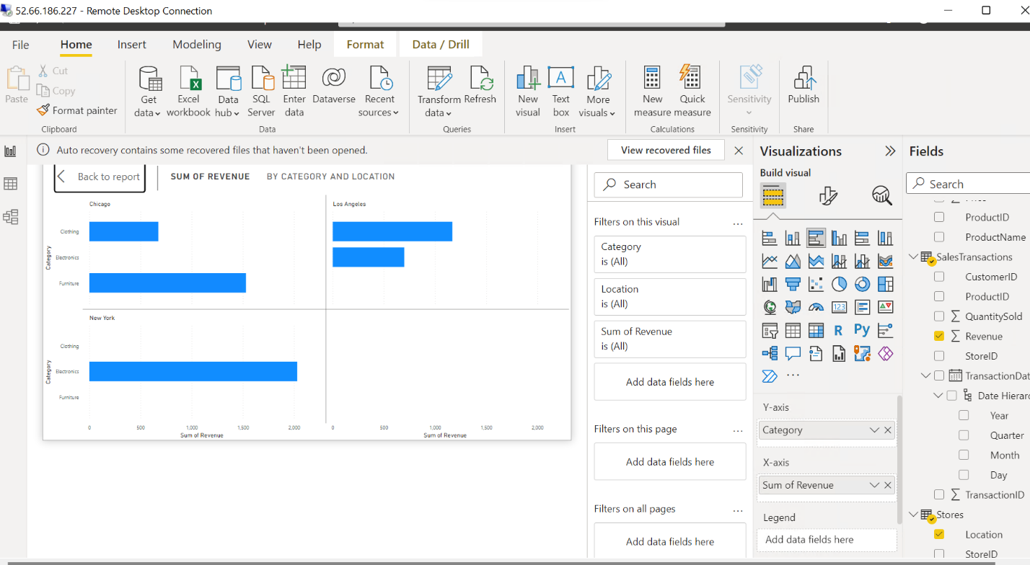

9. Are there any seasonal patterns or trends in sales for specific products or categories?

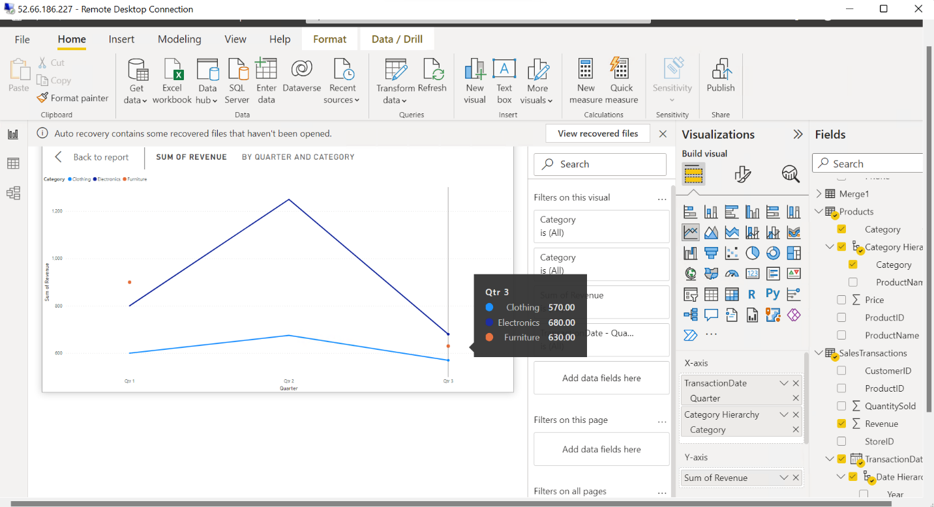

10. Can customers be segmented into high, medium, and low-value segments based on their purchase history.

1001, 1005, 1002 are high valued customers

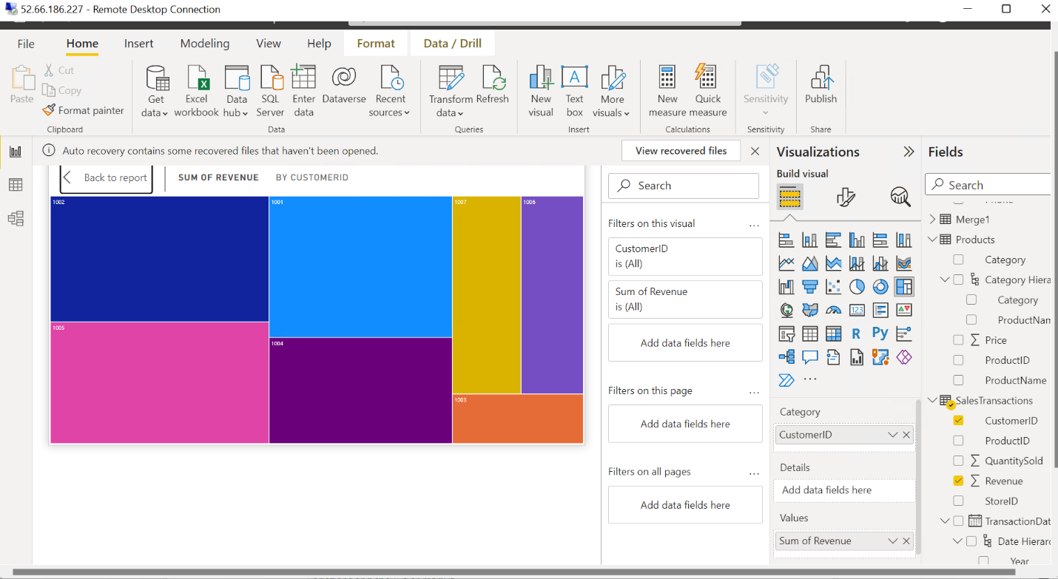

**Requirement 5: Data Insights and Recommendations**

Analyze Patterns: Identify patterns and trends in the data, such as seasonality or regional varia;ons and show it or mark it.

How different product sales vary over the different quarters, quarter 2 shows the maximum sales



Furniture provides the minimum revenue 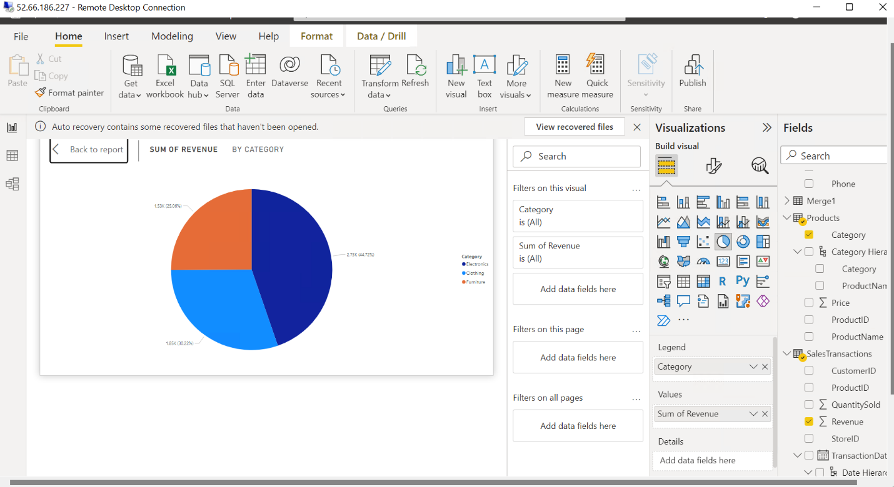

• Generate Insights: Provide actionable insights based on your analysis. For example, suggest increasing marketing efforts for the most profitable product category.

Strategies in the Los angeles must be revised to increase revenue

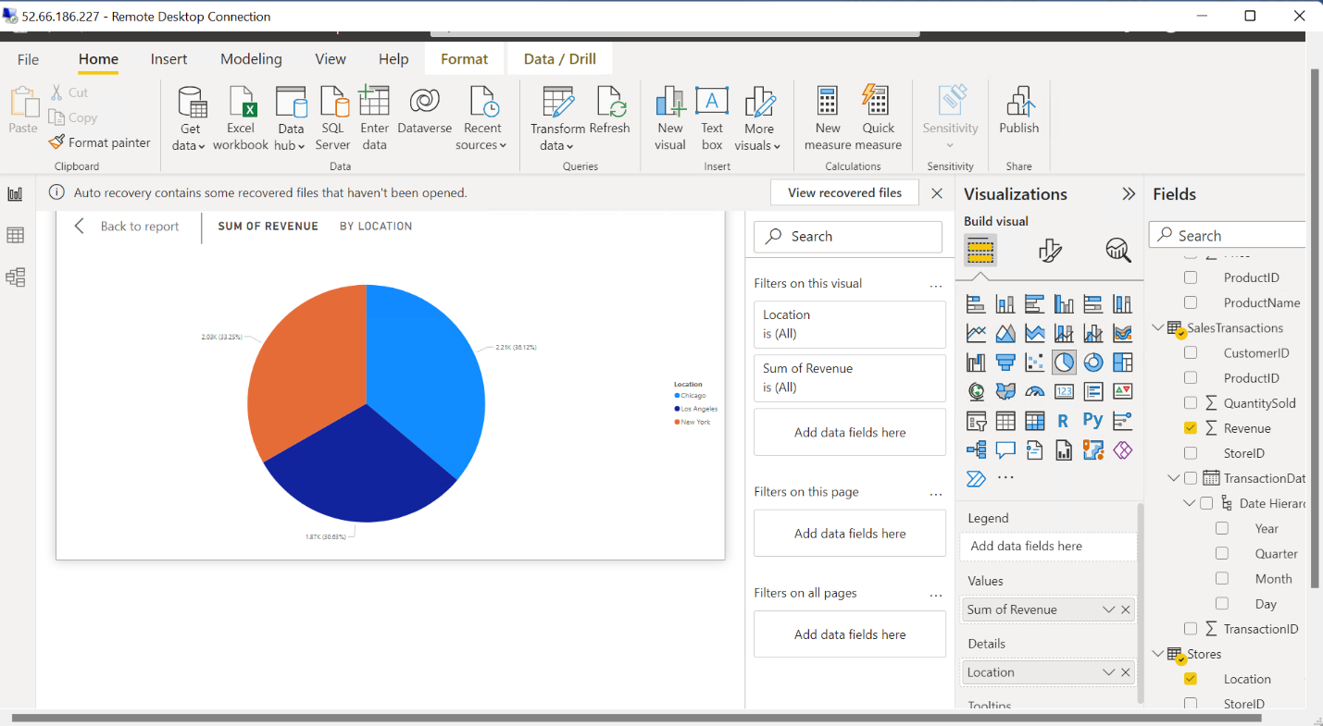

Tablet PQR is the highest selling product which is being sold in new york

