**UAFinance**

Application for Android to quick & easy search the nearest currency exchange with the best rate.

The application gets finance datas from Net and provides to the user, sorted by course or by distance.

Also, the application provides information about rate of National Bank Ukraine, the Inter bank and courses of precious metals.

Application is available on Yandex Store, and now is preparing for publication on Android PlayMarket.

In the application I used Google MAP API, LocationManager, Fragments, FragmentViewPager, AlarmManager, Services, BroadcastReciver (with start On Boot Device), AsyncTask, HttpURLConnection, NavigationView, Handlers, FloatingActionButton, DrawerLayout, Animation, WebView, GSON, JACKSON, XmlPullParser, PreferenceFragment, SQLiteOpenHelper, Parcelable, Intent.

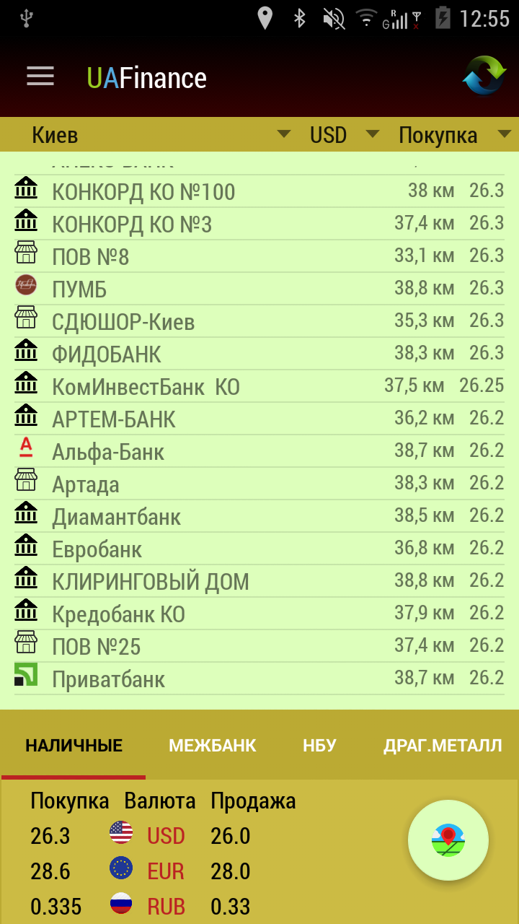

The application provides information about black market currency exchange

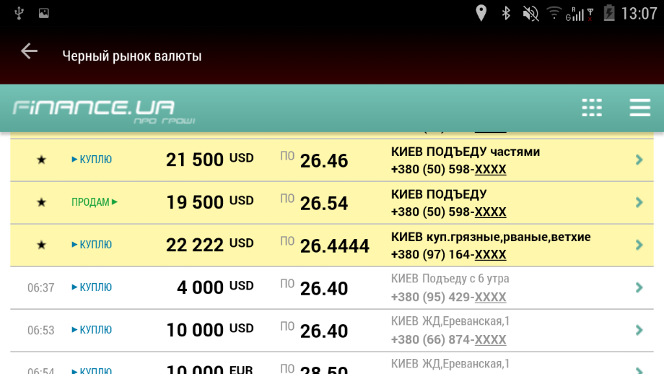

The application provides all the contact information of banks and their branches. The application also provides a currency calculator and map of nearby exchangers.

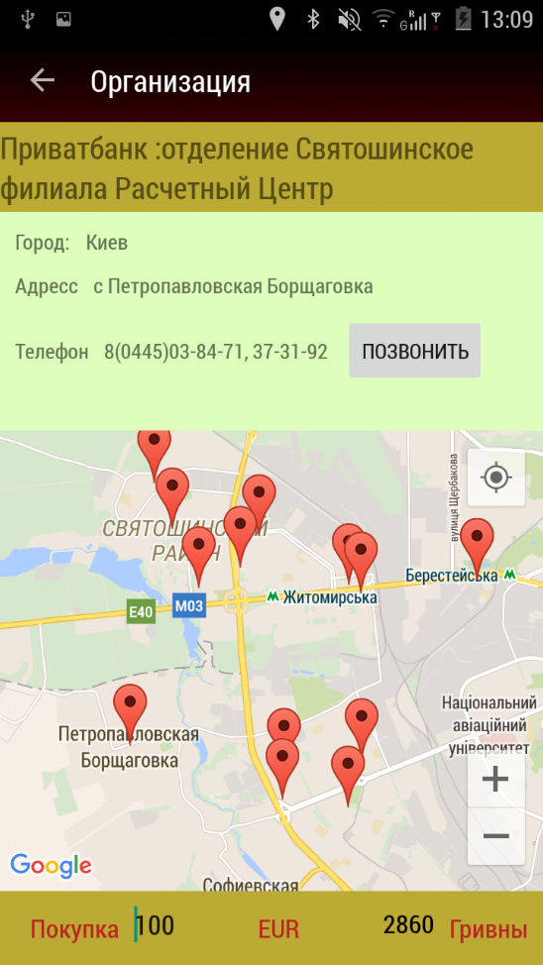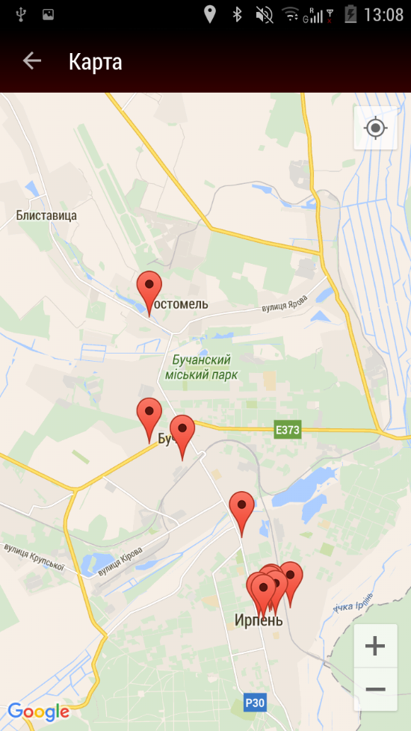

The application every day inform the user about the current courses and indicates if courses was jump using Notification.

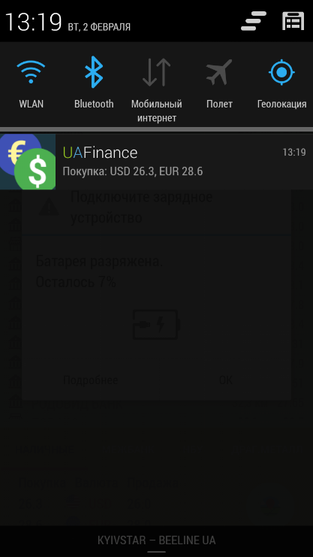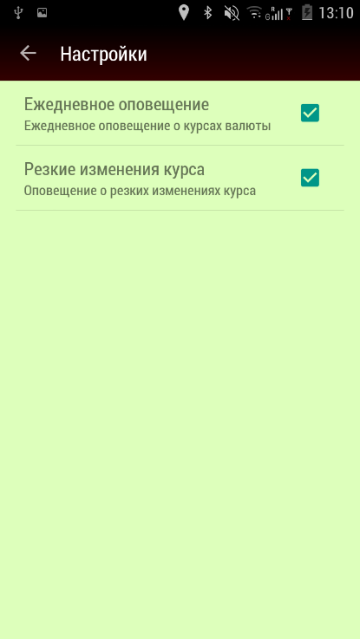

Application provides Widget for HomeScreen:

