# Git Task Steps

## Task Description:

Establish a new directory, populate it with script files, initiate an empty repository on GitHub, convert the local directory into a Git repository, and link it to GitHub for pushing the code into the repository. Perform merge, rebase, and stash commands in the GitHub repository.

### Step 1: Set Up a New Directory and Populate It with Script Files

- Open your terminal in Git Bash.

- Navigate to your preferred location: cd ~/Documents

- Create a new directory: `mkdir my-git-project && cd my-git-project`

- Create sample script files:  
  
echo '#!/bin/bash' > script1.sh  
echo 'echo "Hello, this is Script 1"' >> script1.sh  
chmod +x script1.sh  
  
### Step 2: Initialize a Git Repository Locally

- Inside the project folder, initialize Git: `git init`

- Verify Git is initialized: ls -a

- Configure your Git username and email:   
git config --global user. name "SMugilan"

git config --global user.email "smugil1911@gmail.com"

### 

### Step 3: Create a GitHub Repository

- Go to GitHub and log in.

- Click on New Repository and enter a name.

- Select Public, do not initialise with a README.

- Click Create Repository and copy the remote URL.

### Step 4: Link Local Repository to GitHub

- Add the remote repository: `git remote add origin <your-repo-url>`

- Verify the remote URL: `git remote -v`

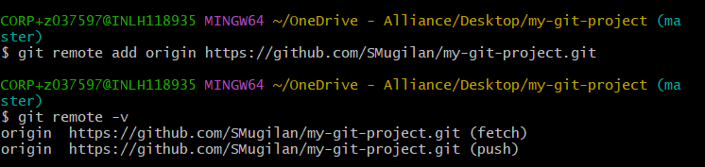

### Step 5: Commit and Push Initial Code

- Add files to staging: `git add .`

- Commit changes: `git commit -m "Initial commit"`

- Push code to GitHub: `git push -u origin main`

### Step 6: Perform Merge, Rebase, and Stash Operations

- Merge: Create a new branch, modify a file, commit, and merge.

- Rebase: Create another branch, modify a file, commit, and rebase.

- Stash: Modify a file, stash changes, apply back, and commit.

