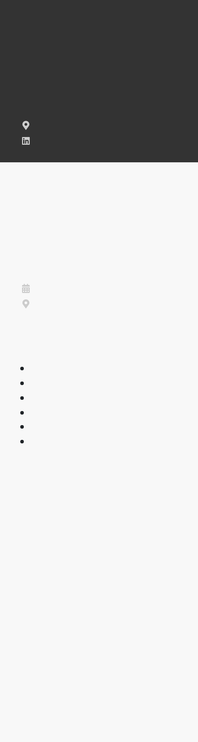**SUHEL MULLA**

*Sales Manager*

 **suhelmulla24@gmail.com**

 **8530031361**

**Karandwadi, Sangli**

[**LinkedIn**](https://www.linkedin.com/marvin-tello)

**EDUCATION**

Bachelor of Technology

Electronics Engineering

**Padmabhooshan Vasantraodada Patil Institute of Technology**

2018 - 2022

Budhgaon, Sangli

**SKILLS**

Negotiation

Problem-solving

Lead Generation (LinkedIn, email)

Reporting

Results-oriented

Microsoft Ofce (Word, Excel, PowerPoint)

**CAREER OBJECTIVE**

Energetic, enthusiastic, and ready to be part of a growing team of salespeople to lead your company into a bright and proftable future.



Success-driven team player who works well with marketing as well as research and development departments. Brings understanding of the sales funnel process and a willingness to work with everyone on the team to reach company goals.



**WORK EXPERIENCE**

sales executive

**Param E Motors**

October 2021 - May 2022  Sangli



Created and delivered presentations to decision makers, leading to a 27% improvement over expected lead conversion



Supported the evaluation of new products, and provided service feedback to marketing and sales



Sales Manager

**verginking e motors**

August 2022 - february 2023  sangli



Analyzed costs, competition, and trends, adjusting sales prices to maintain a 22% net proft margin



Minimized 26% of product order errors and delays by initiating the use of ActiveCampaign software

