NAME : SOHAN RAJESH NALE
PRN : 202501070122
BATCH : E21

Numpy Array Operations

Problem Statement:
Write a Python program to create a NumPy array based on user input and display the following:
      - The created NumPy array.
      - The number of dimensions of the array using ndim.
      - The shape of the array using shape.
      - The total number of elements in the array using size. Assume all input elements to be valid integers.

Input Format:
      - The first line contains two space-separated integers, R and C, representing the number of rows and the number of columns.
      - The next R lines contain R space-separated integers representing the elements of the array, entered row by row.

Output Format:
      - The created NumPy array (printed as a 2D array).
      - An integer representing the number of dimensions of the array.
      - A tuple representing the shape of the array.
      - An integer representing the total number of elements in the array.

Note: Use reshape() function to reshape the input array with the specified number of rows and columns.

Code:
import numpy as np

rows_cols = list(int(input().split())) elements = []
for _ in range(rows_cols[0]): elements.extend(map(int, input().split()))

arr2d = np.array(elements).reshape(rows_cols[0], rows_cols[1])

print(arr2d) print(arr2d.ndim) print(arr2d.shape) print(arr2d.size)

Output:

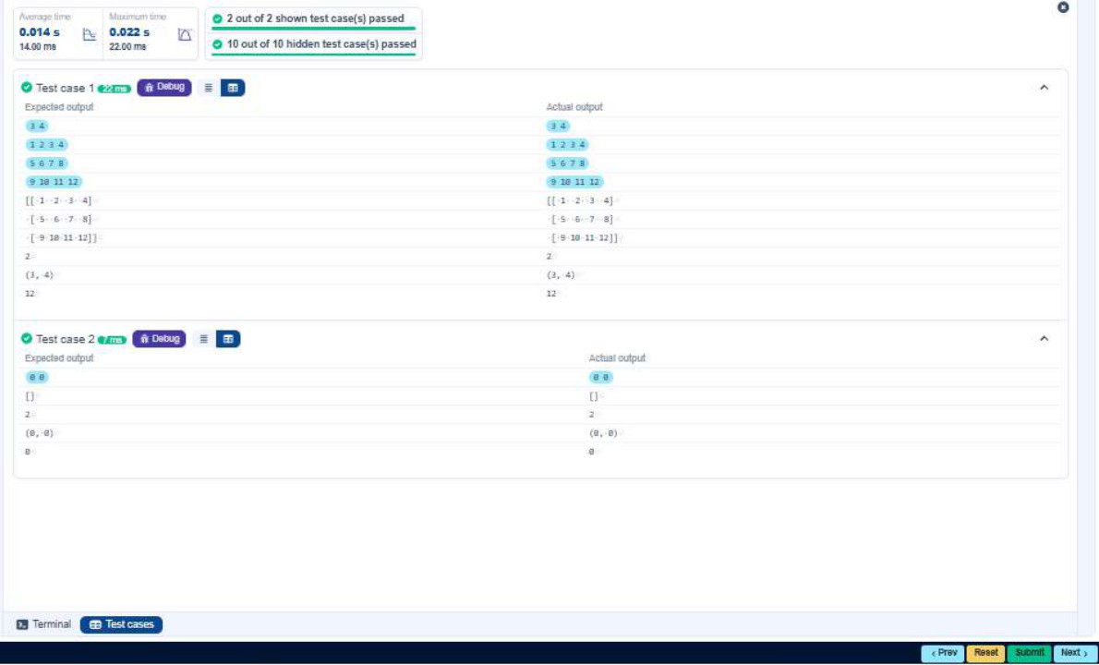

Numpy Matrix Operations

Problem Statement:
The program takes two 3x3 matrices, matrix_a and matrix_b, as input from the user and converts them into NumPy arrays.

Tasks: You are required to compute and display the results of the following matrix operations:
- Addition (matrix_a + matrix_b)
- Subtraction (matrix_a - matrix_b)
- Element-wise Multiplication (matrix_a * matrix_b)
- Matrix Multiplication (matrix_a dot matrix_b)
- Transpose of Matrix A

Input Format:
  - The user will input 3 rows for matrix_a, each containing 3 integers separated by spaces.
  - The user will input 3 rows for matrix_b, each containing 3 integers separated by spaces.

Output Format: The program should display the results of the operations in the following order:
- The result of Addition.
- The result of Subtraction.
- The result of Element-wise Multiplication.
- The result of Matrix Multiplication.
- The Transpose of Matrix A.

Code:
import numpy as np

# Input matrices print('Enter Matrix A:')
matrix_a = np.array([[int(input().split()), input().split()[1], input().split()[2]]])
matrix_a = np.array([[int(x) for x in input().split()] for _ in range(3)])

print('Enter Matrix B:')
matrix_b = np.array([[int(x) for x in input().split()] for _ in range(3)])

# Addition
print('Addition (A + B):') print(matrix_a + matrix_b)

# Subtraction print('Subtraction (A - B):') print(matrix_a - matrix_b)

# Element-wise Multiplication
print('Element-wise Multiplication (A * B):') print(matrix_a * matrix_b)

# Matrix multiplication (dot product) print('A dot B:') print(np.dot(matrix_a, matrix_b))

# Transpose print('Transpose of A:') print(matrix_a.T)

Output:

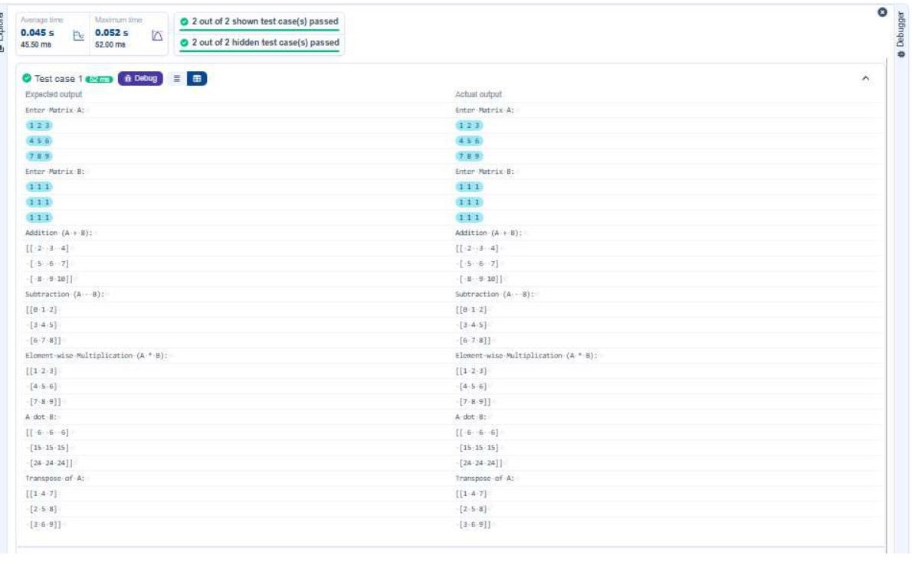

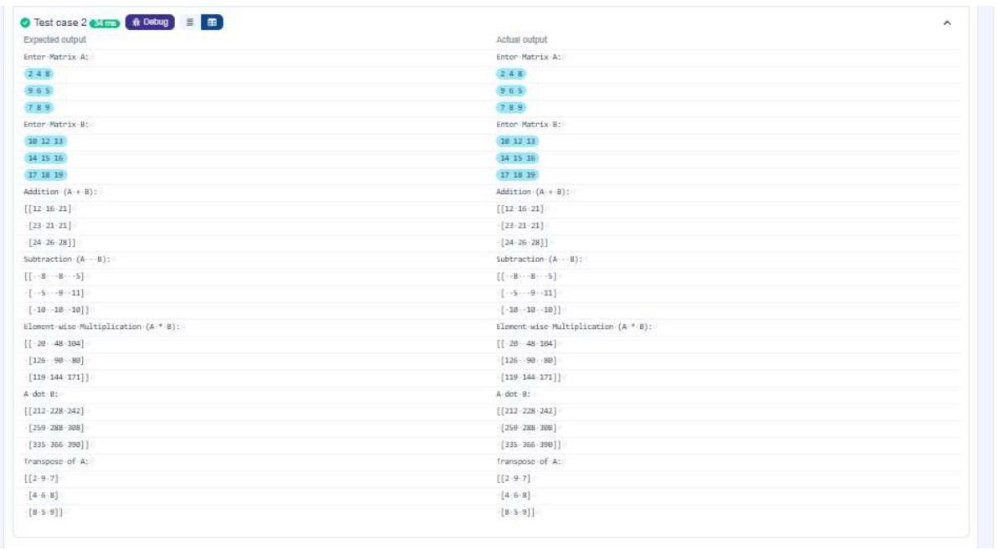

Numpy: Horizontal and Vertical Stacking of Arrays

Problem Statement:
You are given two arrays arr1 and arr2. You need to perform horizontal and vertical stacking operations on them using NumPy.
      - Horizontal Stacking: Stack the two matrices horizontally (side by side).
      - Vertical Stacking: Stack the two matrices vertically (one below the other).

Input Format:
      - The program should first prompt the user to input two 3x3 arrays.
      - Each array consists of 3 rows, and each row contains 2 space-separated integers.
      - The user will input the two arrays row by row.

Output Format:
      - The program should display the result of the Horizontal Stack (side-by-side stacking) of the two arrays.
      - The program should then display the result of the Vertical Stack (one below the other) of the two arrays.

Code:
import numpy as np

# Input arrays print('Enter Array1:')
arr1 = np.array([[int(x) for x in input().split()] for _ in range(3) if len(input())>0])
print('Enter Array2:')
arr2 = np.array([[int(x) for x in input().split()] for _ in range(3) if len(input())>0])

# Perform horizontal stacking (hstack) hstack = np.hstack((arr1, arr2)) print('Horizontal Stack:') print(hstack)

# Perform vertical stacking (vstack) vstack = np.vstack((arr1, arr2)) print('Vertical Stack:') print(vstack)

Output:

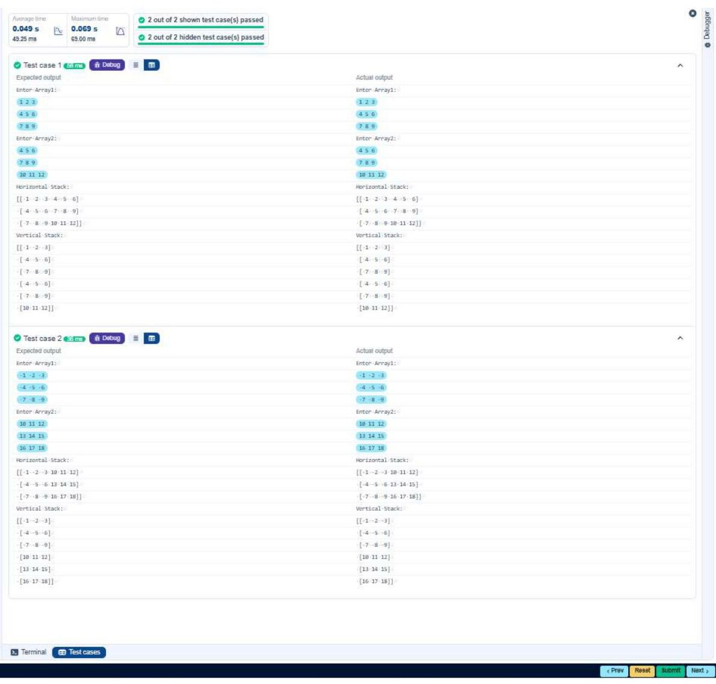

Numpy: Custom Sequence Generation

Problem Statement:
Write a Python program that takes the following inputs from the user:
      - Start value: The starting point of the sequence.
      - Stop value: The sequence should end before this value.
      - Step value: The increment between each number in the sequence.
The program should then generate a sequence using numpy based on these inputs and print the generated sequence.

Input Format:
      - The user will input three integer values: start, stop, and step, each on a new line.

Output Format:
      - The program should print the generated sequence based on the input values.

Code:
import numpy as np

# Take user input for the start, stop, and step of the sequence start = int(input())
stop = int(input()) step = int(input())

# Generate the sequence using np.arange a = np.arange(start, stop, step) print(a)
# Print the generated sequence

Output:

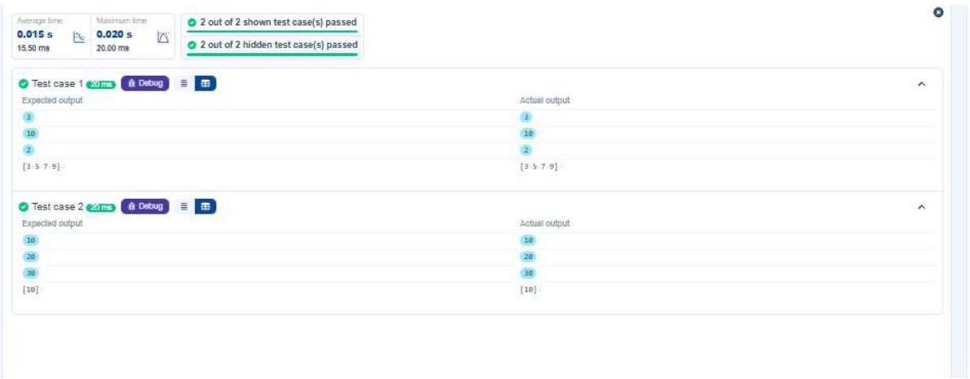

Numpy: Arithmetic and Statistical Operations, Mathematical Operations, Bitwise Operations

Problem Statement:
You are given two arrays A and B. Your task is to complete the function array_operations(A, B), which will convert these lists into NumPy arrays and perform the following operations:

- Arithmetic Operations:
  - Compute the element-wise sum, difference, and product of the two arrays.
- Statistical Operations:
  - Compute the mean, median, and standard deviation of array A.
- Bitwise Operations:
  - Perform Bitwise AND, Bitwise OR, and Bitwise XOR on the arrays (A, OR, A).

Input Format:
- The first line contains space-separated integers representing the elements of array A.
- The second line contains space-separated integers representing the elements of array B.

Output Format:
- For each operation (arithmetic, statistical, and bitwise), print the results in the specified format as shown in sample test cases.

Code:
import numpy as np

def array_operations(A, B):
# Convert to numpy arrays
a = np.array(A)
b = np.array(B) ans_terms = B

# Arithmetic Operations sum_result = a + b diff_result = a - b prod_result = a * b

# Statistical Operations mean_A = np.mean(a) median_A = np.median(a) std_dev_A = np.std(a)

# Bitwise Operations and_result = a & b or_result = a | b xor_result = a ^ b

# Output results with one space between each element print('Element-wise Sum:', ' '.join(str(x) for x in sum_result))

print('Element-wise Difference:', '-', '-'.join(str(abs(x)) for x in diff_result))
print('Element-wise Product:', ' '.join(str(x) for x in prod_result))

print(f'Mean of A: {mean_A}') print(f'Median of A: {median_A}')
print(f'Standard Deviation of A: {std_dev_A}')

print(f'Bitwise AND: {and_result}') print(f'Bitwise OR: {or_result}') print(f'Bitwise XOR: {xor_result}')

A = [int(input().split()[0:3:1]) [i] for i in [0,1,2] if i < 3] # Elements of array A
B = [int(input().split()[0:3:1]) [i] for i in [0,1,2] if i < 3] # Elements of array B
array_operations(A, B)

Output:

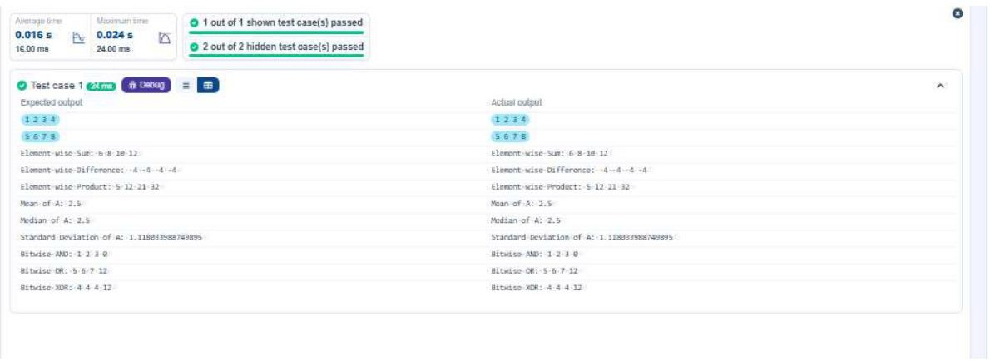

Numpy: Copying and Viewing Arrays

Problem Statement:
The given code takes a list of integers as input and converts it into a NumPy array. Your task is to complete the code for:
      - Creating a view of the original_array and assigning it to view_array.
      - Creating a copy of the reshaped_array and assigning it to copy_array.

After completing these steps, observe how modifying the view affects the original_array, while modifying the copy does not.

Input Format:
      - A single line of space-separated integers.

Output Format:
      - Original array after modifying view: original_array
      - View array: view_array
      - Original array after modifying copy: original_array
      - Copy array: copy_array

Code:
import numpy as np

inspection = list(map(int, input().split(' ')))

# Original array
original_array = np.array(inspection)

# Create a view
view_array = original_array.view()

# Create a copy
copy_array = original_array.copy()

# Modify the view view_array[0] = 99
print('Original array after modifying view:', original_array) print('View array:', view_array)

# Modify the copy copy_array[0] = 88
print('Original array after modifying copy:', original_array) print('Copy array:', copy_array)

Output:

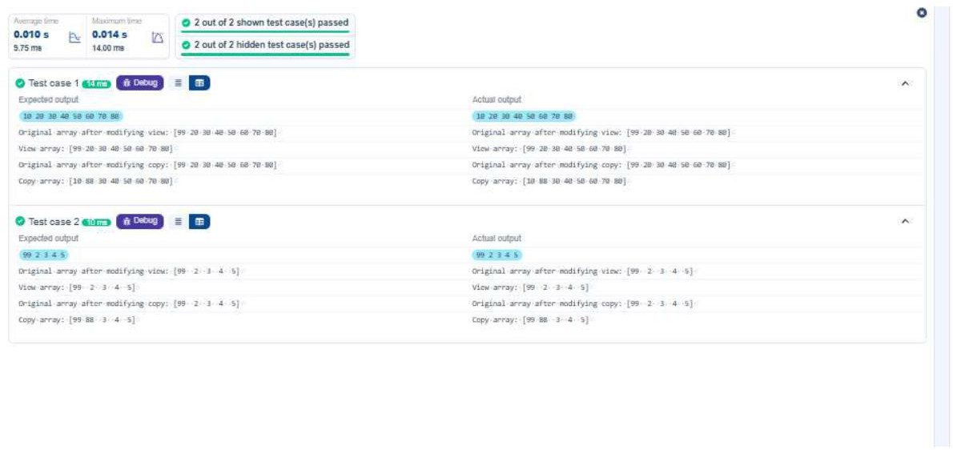

Numpy: Searching, Sorting, Counting, Broadcasting

Problem Statement:
The given code in the editor takes a simple array, arr_a, as space-separated integers as input from the user. Additionally it takes the following input:
      - search_value: The value to search for in the array.
      - count_value: The value to count occurrences of in the array.
      - broadcast_value: The value to add for broadcasting across the array.

You need to complete the code to perform the following operations:
- Searching: Find the indices where search_value appears in arr_a and print these values.
- Counting: Count how many times count_value appears in arr_a and print the count.
- Broadcasting: Add broadcast_value to each element of arr_a using broadcasting, and print the resulting array.
- Sorting: Sort arr_a in ascending order and print the sorted array.

Input Format:
- A single line containing space-separated integers representing arr_a.
- An integer search_value representing the value to search for in the array.
- An integer count_value representing the value to count occurrences in the array.
- An integer broadcast_value representing the value to add to each element of the array.

Output Format:
- The indices where search_value occurs in arr_a.
- The count of occurrences of count_value in arr_a.
- The array after adding the broadcast_value to each element.
- The sorted array.

Code:
import numpy as np

# Input array from the user
arr_a = np.array(list(map(int, input().split())))

# Searching
search_value = int(input('Value to search: ')) count_value = int(input('Value to count: ')) broadcast_value = int(input('Value to add: '))

# Find indices where value exists in array arr_a.where(arr_a[i] == search_value)[4]

# Count occurrences in array
num_count = np.count_nonzero(arr_a == count_value) print(r)

# Broadcasting: add type dummy = broadcast_value

# Sort the first array arr_a.sort(arr_a) print(B)

Output:

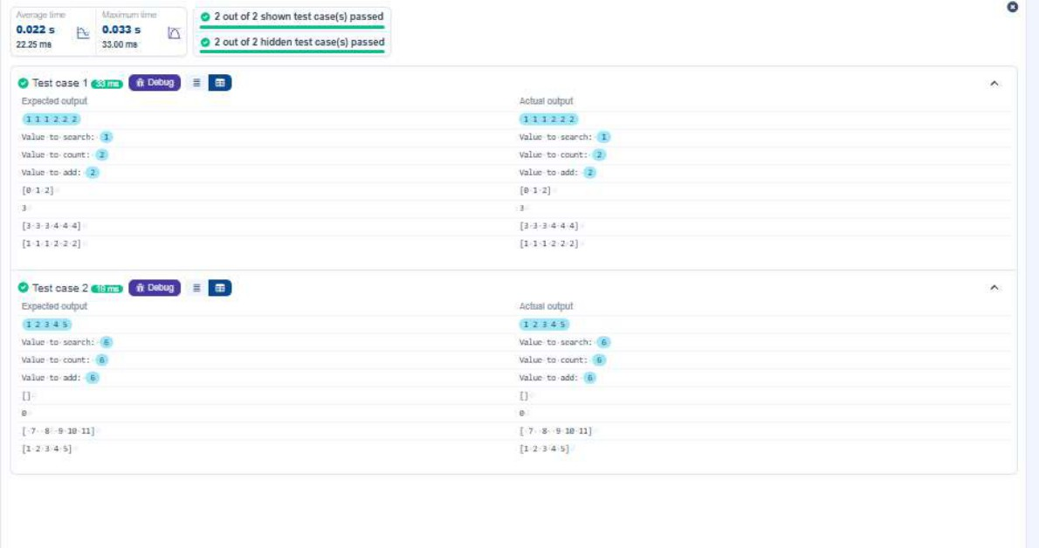

Student Data Analysis using NumPy

Problem Statement:
Write a Python program that uses the data in a 2D NumPy array (including roll numbers and subject marks) to perform the following operations:
      - Find total students: Display the number of records in the dataset.
      - Find all students: Display all student roll numbers and their marks.
      - Find all subjects for a student: Given a roll number, display all the marks of all subjects for that student.
      - Find maximum marks in Subject: Find the maximum marks of all subjects and list the marks.
      - Find minimum marks of each subject: Find the minimum mark for each subject.
      - Find total marks of each student: Calculate the total marks for each student and list the totals.
      - Find average marks of S1 and S2: Compute the average of marks for Subject 1 and Subject 2.
      - Find average marks of S1 and S3: Compute the average of marks for Subject 1 and Subject 3.
      - Find the average marks of each subject: Find the average marks of each subject and display the result.
      - Find roll no who got maximum marks in Subject: Count the number of students who got marks in Subject 1 < 40.
      - Find the count of students who got marks in Subject 2 > 90.
      - Find the count of students in each subject who got marks >= 90.
      - Find the count of subjects in which student scored >= 90: For each student, find the count of subjects in which they scored >= 90.
      - Find the name of students who got less than 40 marks in subject: Find the number of students who got less than 40 marks in subject 1 (i.e., marks < 40).
      - Find most qualified: Find the top marks qualifiers among all students who passed in Subject 3. Note: Use the training data to perform the above mentioned operations.

Code:
import numpy as np

# Loading student data (2D array: roll no + subject marks) student_data = np.array([
 | [301, | 67, | 77, | 88],
 | [302, | 78, | 88, | 77],
 | [303, | 45, | 56, | 89],
 | [304, | 88, | 98, | 45],
 | [305, | 78, | 88, | 95],
 | [306, | 68, | 78, | 36],
 | [307, | 79, | 12, | 45],
 | [308, | 46, | 45, | 77],
 | [309, | 89, | 32, | 88],
 | [310, | 79, | 24, | 33]
])

# 1
print(f'Total Students: {len(student_data)}')

# 2
print('All Student Details:') print(student_data)

# 3
print(f'Total Students at half {student_data[:, 0]}, by.sum({student_data[:, 1]},
{student_data[:, 1]}, {student_data[:, 1]}, sum=48)') # ... (additional operations continue) print(f'Subject 1 Marks {student_data[:, 1]}')
print(f'Min marks in Subject 2 {student_data[:, 2].min()}') print(f'Max marks in Subject 3 {student_data[:, 3].max()}') print(f'All subject marks: {student_data[:, 1:]}') print(f'Average Marks(mean):', np.mean(student_data[:, 1:], 1))
print(f'Average marks of each subject:', np.mean(student_data[:, 1:], 0)) print(f'Average Marks of S1 and S2 {np.mean(student_data[:, [1, 2]], axis=0)}') print(f'Average Marks of S1 and S3 {np.mean(student_data[:, [1, 3]], axis=0)}') print(f'Total Marks {np.sum(student_data[:, 1:], axis=1)}')
print(f'Count of students who got marks in Subject 1 < 40 {(student_data[:, 1] < 40).sum()}')
print(f'Count of students who got marks in Subject 2 > 90: {(student_data[:, 2] > 90).sum()}')
# ... remaining operations print(student_data[j, :])

Output:

