User Experience Report on SNAP: DRGN Project Search Page

The SNAP: DRGN project has merged several core datasets and some other contributing datasets, and has reidentified nearly seven hundred thousand person records with SNAP ID. However, currently, there is no a user-friendly way to search and find the person records on the SNAP: DRGN website. This report focuses on the user experience aspects of the search function, gives wireframe mock-ups of search and index pages, and suggests further improvements.

1 Wireframe Mock-ups
1.1 Search Page
At present, the search pages includes name search, place search, ID search (SNAP ID and original ID search). Disambiguator and occupation search is also under consideration.
1.1.1 Name Search
The wireframe below (See Figure1) shows the name search page. It allows a free text search for names, with a warning that names may be encoded in Unicode, transliteration, or Beta code. Beside the search box, there is also a keyboard option to enable Greek letters input.
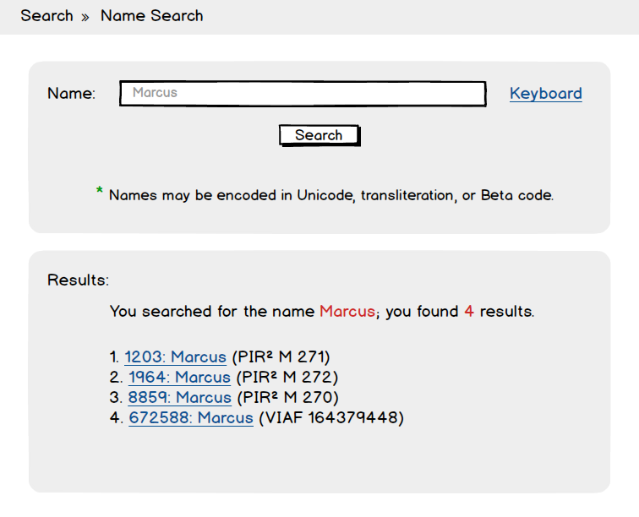
Figure 1
Ideally, while users are inputting the letters, a few names with the same initial letters will start appearing in the search box, and users can simply click on the name they are searching for directly from this list. In this way, the situation of no results found due to a user typo can be avoided.

The example of result page is also shown in Figure 1, which writing out the search term (you searched for the name ‘X’), displaying the number of matching results (you found ‘X’ results), and leaving the search term in the search box. For each of the result, there is a link to the actual person page and information of its original ID.

1.1.2 Place Search
Place search page provides place URI search and place name search (See Figure 2), which allows users to search for an associated place in person records. The result page is similar to the result page of name search, with a link to person page, original ID and the name associated.
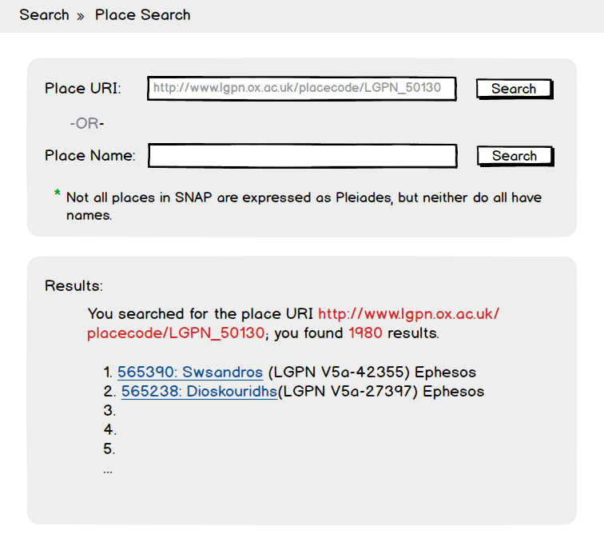
Figure 2
1.1.3 ID Search
Users are also able to search person record by ID, either by SNAP ID or original ID. In terms of search by original ID, there is a dropdown list of project names for users to choose and a text box for ID input, which is convenient for users to input and reduce input error (See Figure 3).
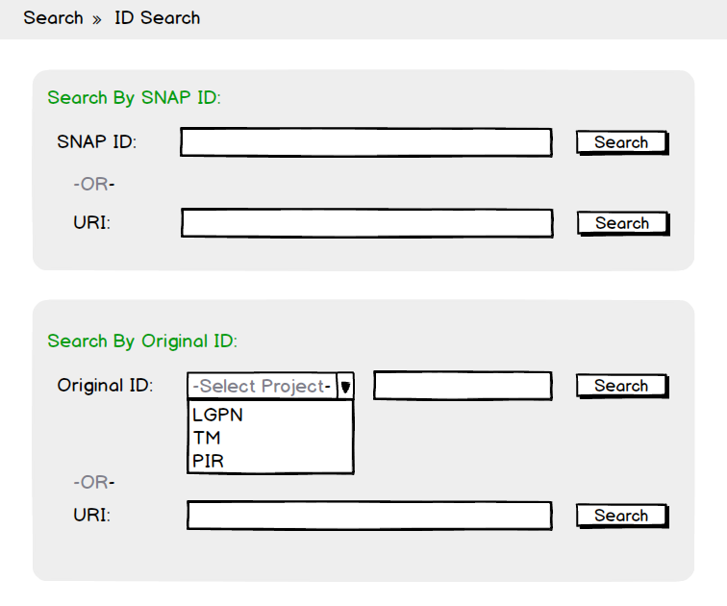
Figure 3
1.2 Index page
Figure 4 shows the wireframe of name index page. This index page has listed all names in the record alphabetically so that users can browse for names rather than having to know who they're looking for, which facilitates quick and accurate retrieval of search results. In addition, the page also enables other alphabets (Greek in this case, for example). Similarly, each name in the list links to the SNAP person page.
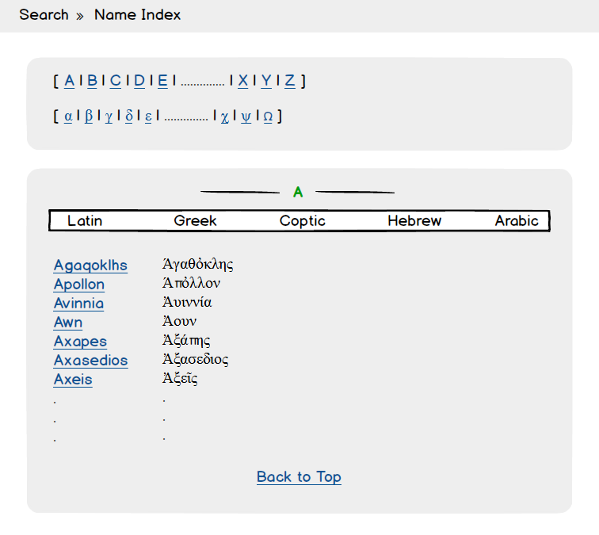
Figure 4
2 Further Improvements
2.1 Search Page
At present, there are three separate search pages. It would be better if combines them by tab bars (Figure 5).
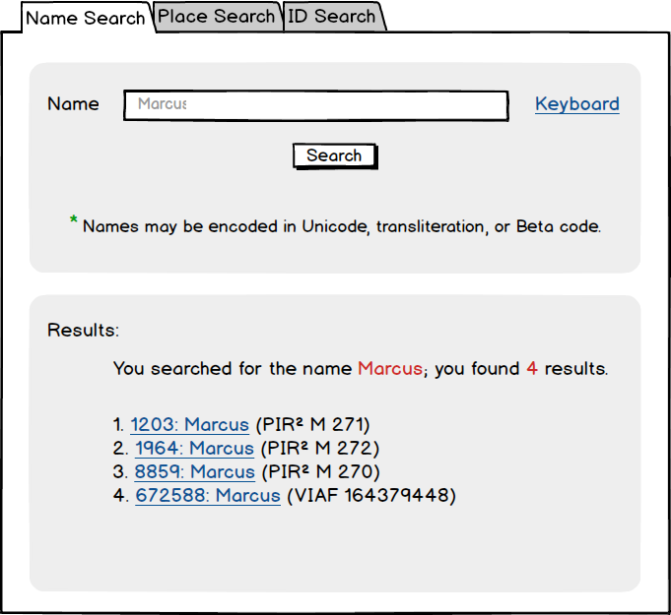
Figure 5

It would also be better to provide further filtering options on the result pages, if feasible. For example, for the name search, allow users to filter the results by person’s occupation, sex, date and etc (See Figure 6).
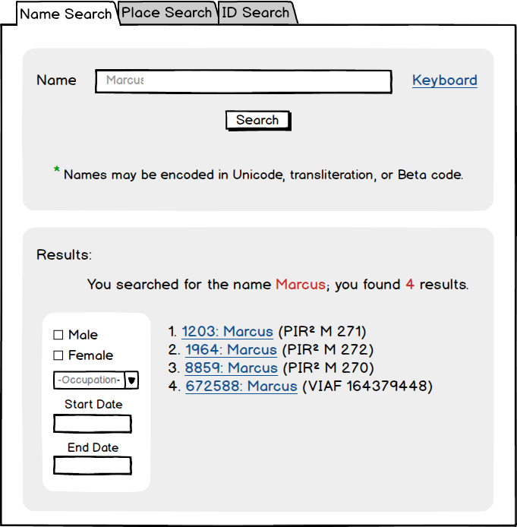
Figure 6

If necessary, provide options for advanced search and help.

2.2 Search Results
Categorising the results will make it easier for users to find what they are looking for. For instance, categorise the results of names according to the date. Or alternatively, provide some basic information of the person right behind the name on the result page (See Figure 7), so that users can indentify which person is the one they are looking for instead of opening the links one by one to find the right one.
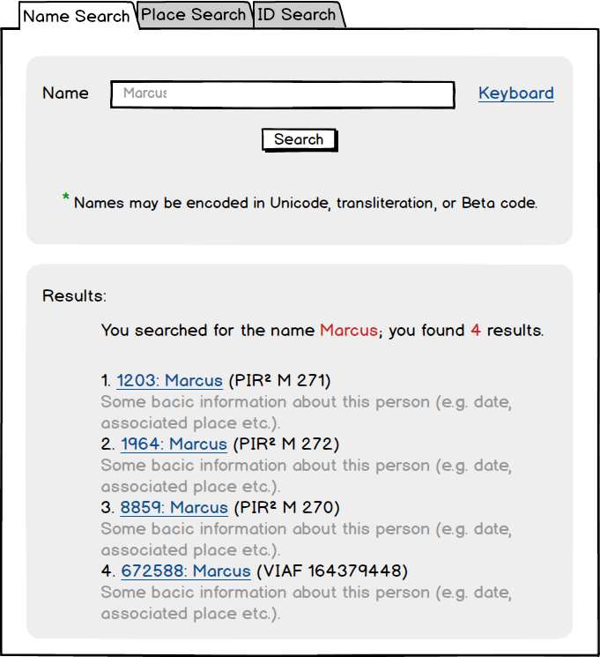
Figure 7

As for optimising the search results, it has something to do with the backend. There is an article that may be useful for giving the most related results.
http://labs.cooperhewitt.org/2014/rethinking-search-on-the-collections-site/#f1

