Computer Vision and Machine Learning for Viticulture Technology

In this paper author is divided the paper into two parts and in first part he gave brief literature on technologies which can be used to improve vineyard growth and in second part he describe ‘GrapeCS-ML Database’ which can be used to train various machine learning algorithms such as SVM, KNN, Logistic Regression and many more. Once we trained model on ML algorithms then that trained model can be used to predict grape growth, harvest time and phenology (development cycle) type on new test images.

In given database author has given five different types of dataset which describe below

1. Dataset 1: This dataset can be used to train ML algorithms and this trained model can be used to predict harvest time
2. Dataset 2: This dataset cab used to train ML algorithms which can be used to predict growth
3. Dataset 3: This can be used to predict phenology stage.
4. Dataset 4 and 5 can be used to predict maturity.

Note: In dataset there is no images for disease prediction so we cannot implement that module

Here in this project we are using first 3 dataset to predict harvest time, growth rate and phenology type and dataset 4 and 5 we are skipping as it’s taking too much long time for execution due to huge images and for same reason we have implemented only SVM algorithm.

You can see all images inside ‘GrapeDatabase’ folder and this folder contains 3 different datasets for harvesting images, growth rate and phenology type. Below screen shots showing dataset images

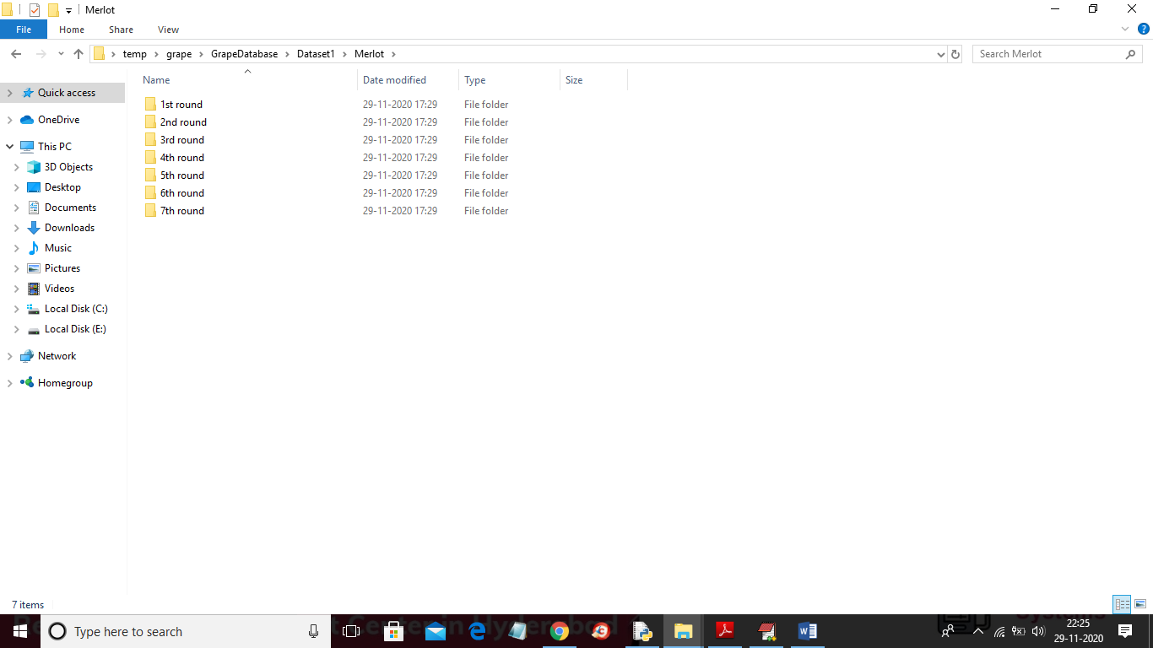

In above screen in Dataset1 Merlot type we have 7 rounds for harvesting time and each round contains different images based on its growth and development and in below screen showing first round images where you can see images of grapes in dry stage

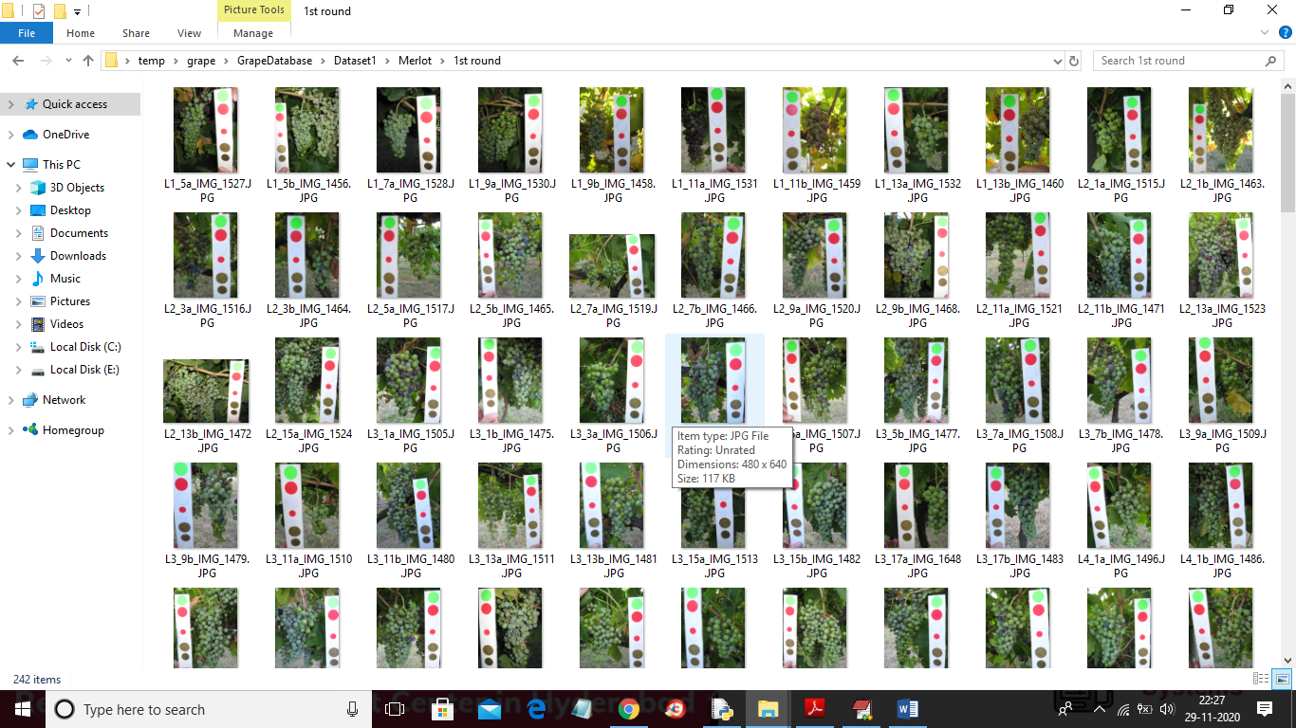

After building trained model when we apply test image then ML algorithm will predict the round of test images from 1 to 7. Based on predicted round farmers will understand then fruit growth.

In this project as propose word I added SVM, KNN and Logistic Regression Algorithms and as extension I added Extension algorithm as Extreme Learning Machine (ELM) and this algorithm is a special type of algorithms which filter dataset 500 times to obtained optimal features and then trained the model and the model obtained from this algorithm can get accuracy more than 90% which is more than any other propose algorithm given in paper

To run project double click on ‘run.bat’ file to get below screen

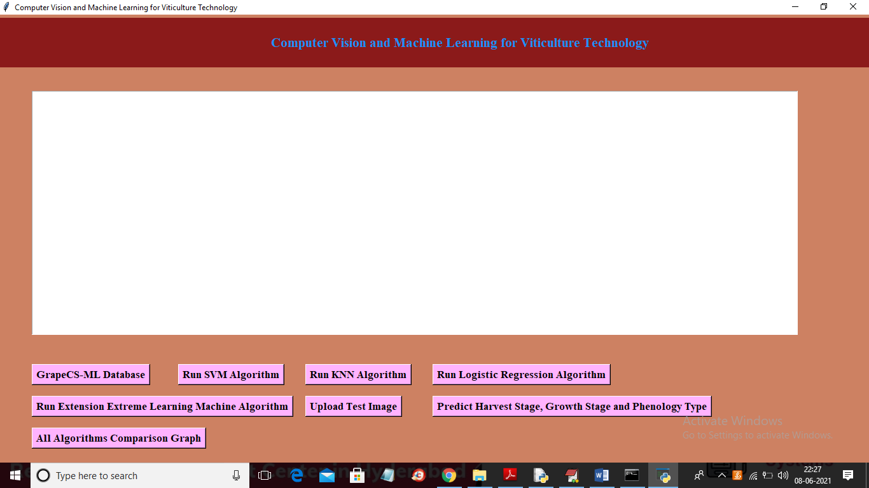

In above screen click on ‘GrapeCS-ML Database’ button and then upload database folder to get below screen

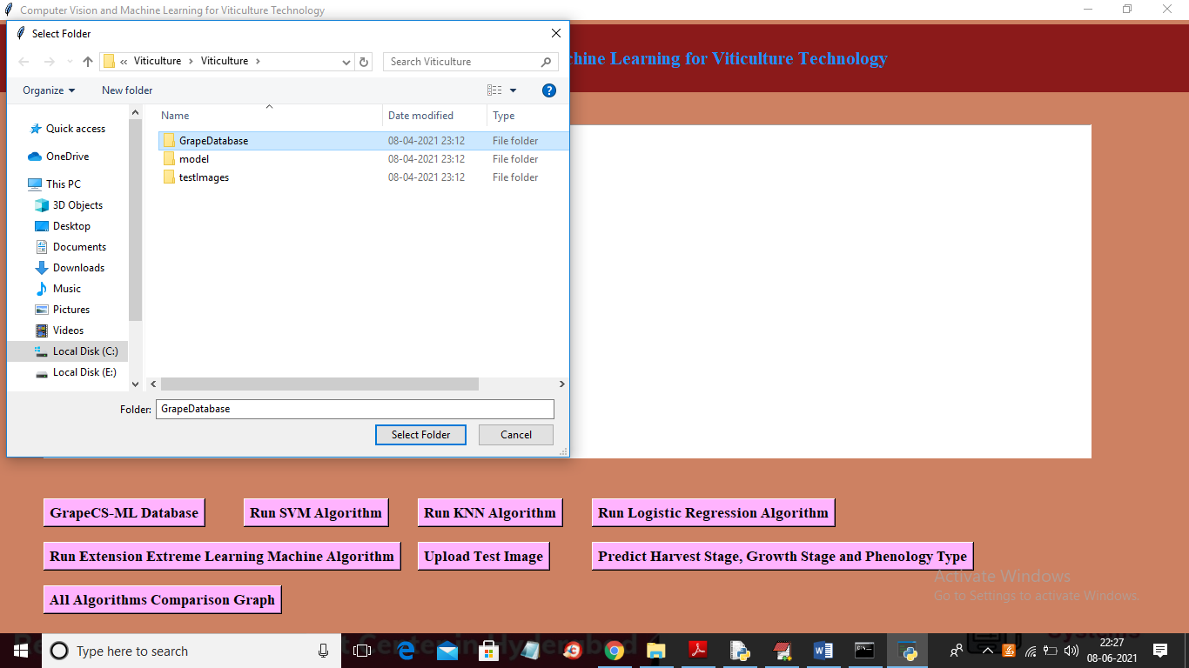

In above screen selecting and uploading ‘GrapeDatabase’ folder and after upload it will take nearly 3 to 5 minutes to load all images and to extract features from image and after successful processing will get below image

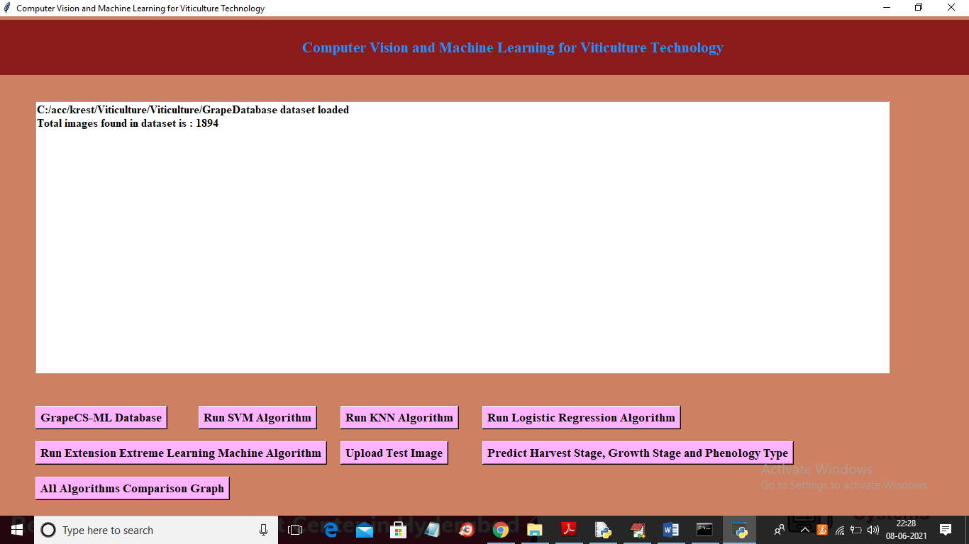

In above screen we can see in entire dataset we found 1894 images and then click on ‘Run SVM Algorithm’ button to train SVM on all images and to get below classification rate

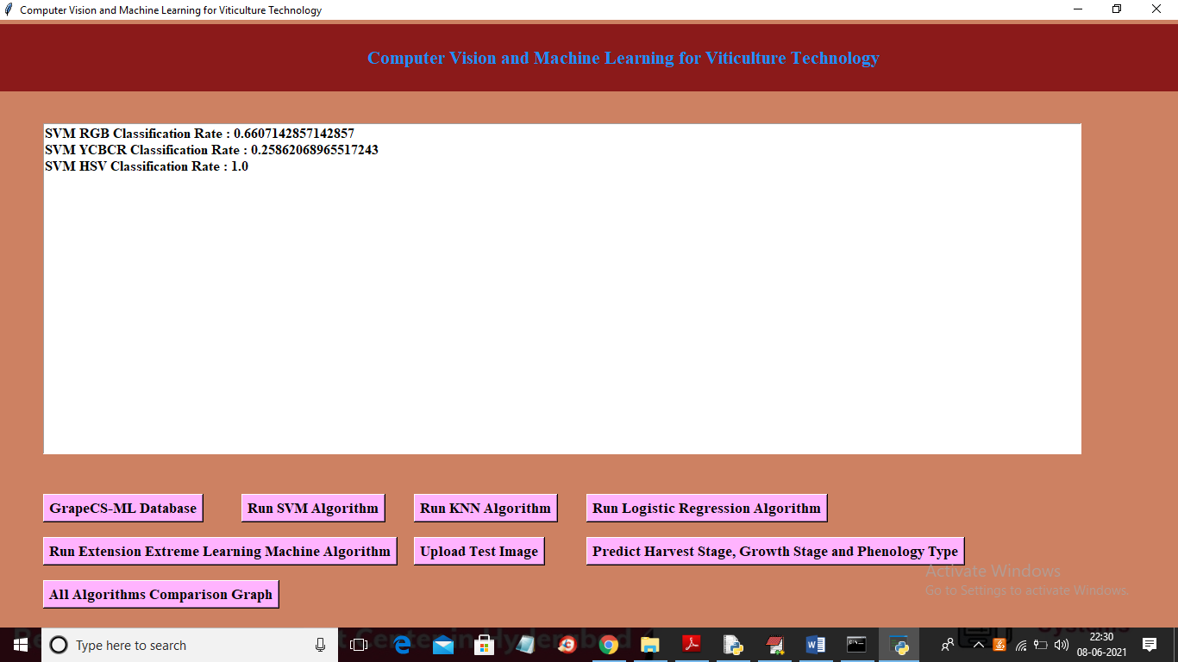

In above screen for each colour space we got classification rate of SVM algorithm and this rate may vary for each run as ML algorithms takes train and test randomly so always test will be different so classification rate may vary. Now run KNN Algorithm button

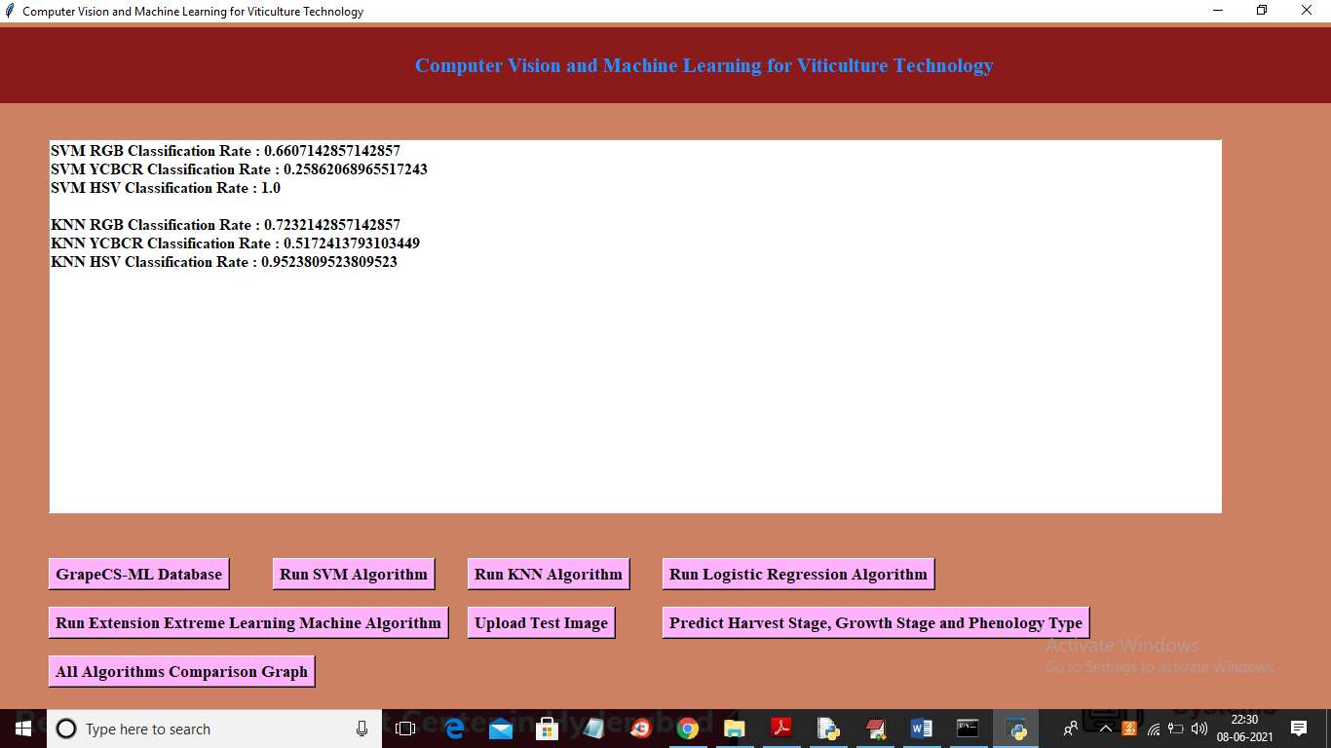

In above screen we got KNN rate for each colour space and now click on ‘Run Logistic Regression Algorithm’ button to train dataset images with logistic regression

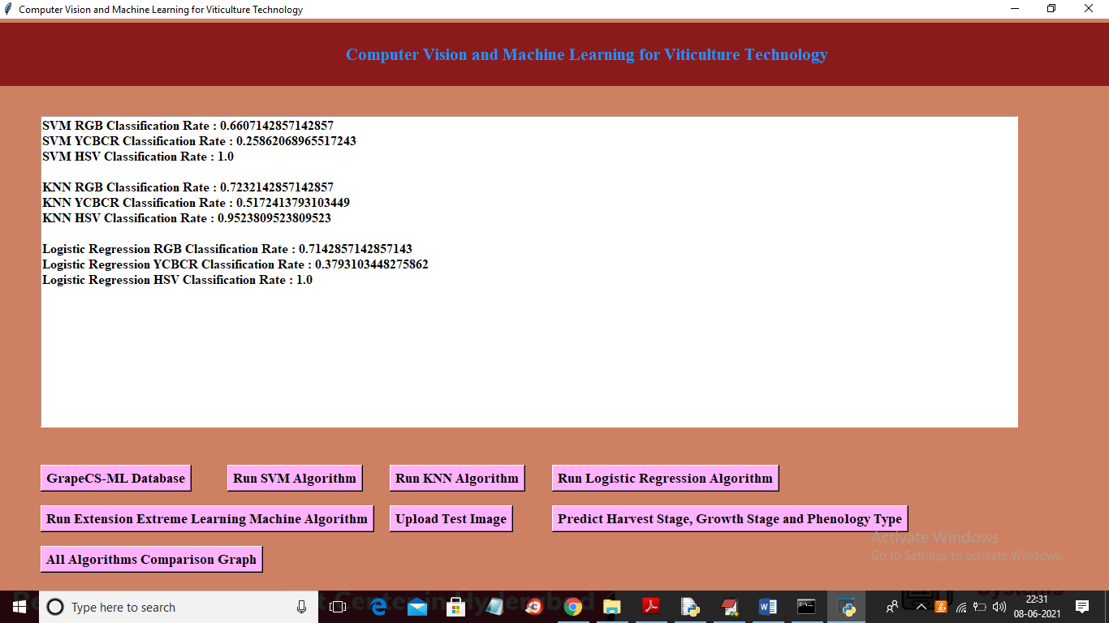

In above screen we got classification rate for each colour space using logistic regression and now click on ‘Run Extension Extreme Learning Machine Algorithm’ button to train extension algorithm on above dataset

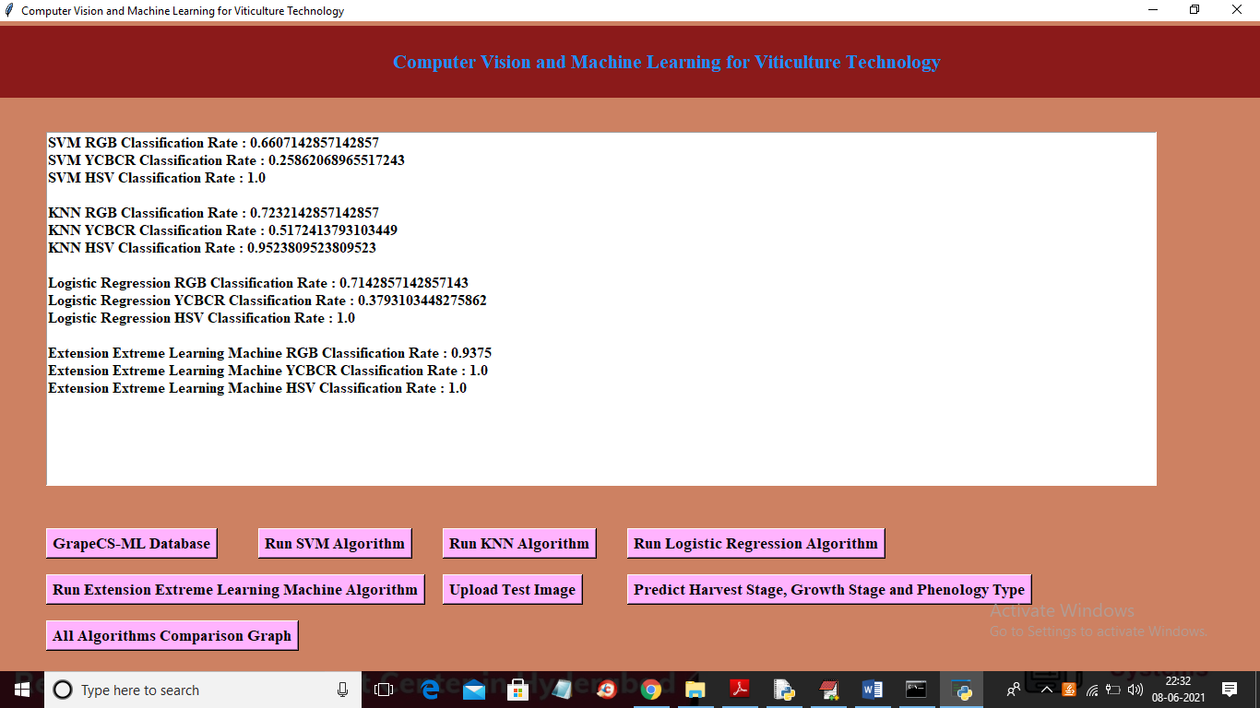

In above screen we can see with extension Extreme Learning Machine we got 0.93% classification rate and its more than any propose algorithms and now click on ‘Upload Test Image’ button to upload grape images and then application will identify HARVEST TIME, Growth rate and Phenology type.

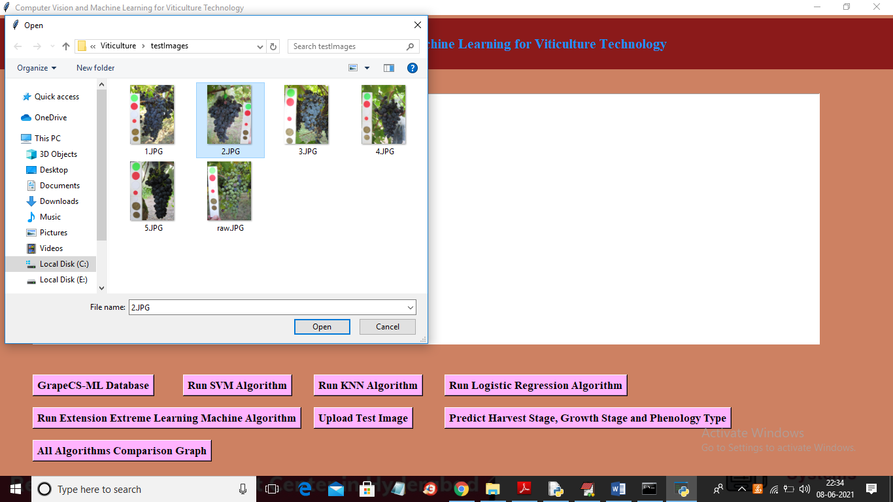

In above screen selecting and uploading ‘2.JPG’ file and then click on ‘Open’ button and then click on ‘Predict Harvest Stage, Growth Stage and Phenology Type’ button to get below result

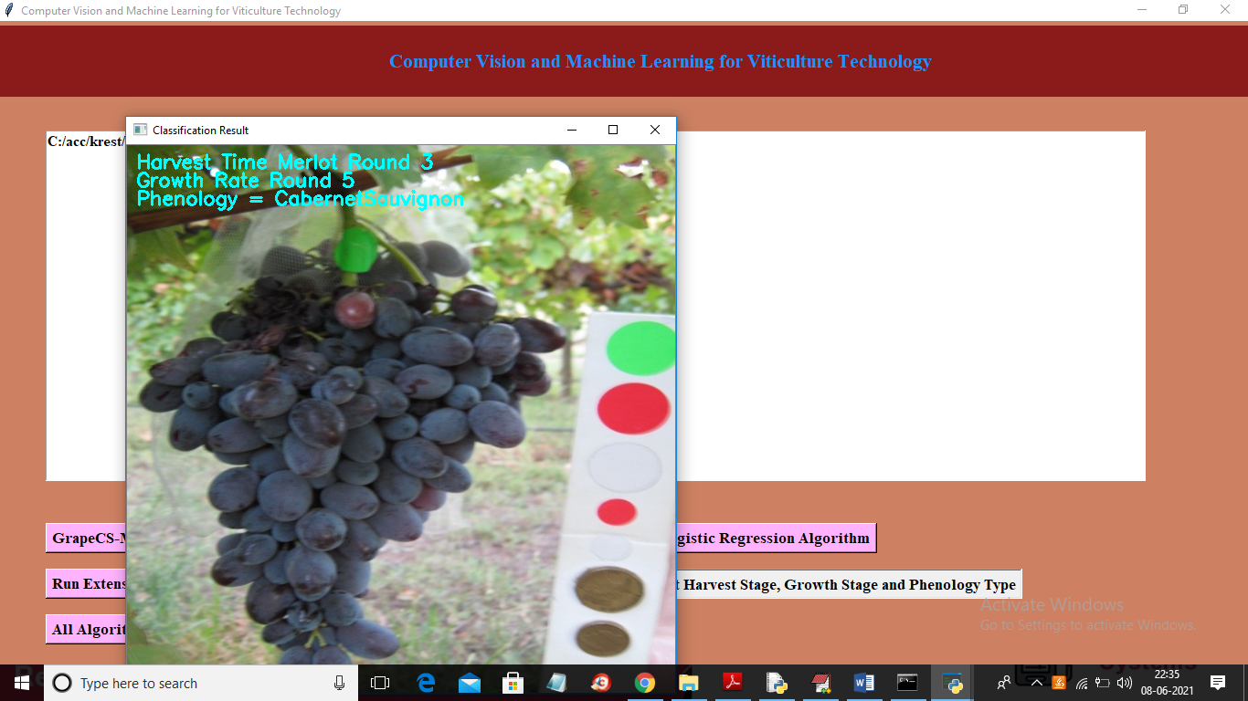

In above screen on image we wrote predicted harvest time, growth rate and phenology type and similarly you can upload other images and predict harvest time, growth rate and phenology type and now click on ‘All Algorithms Comparison Graph’ button to get below comparison graph

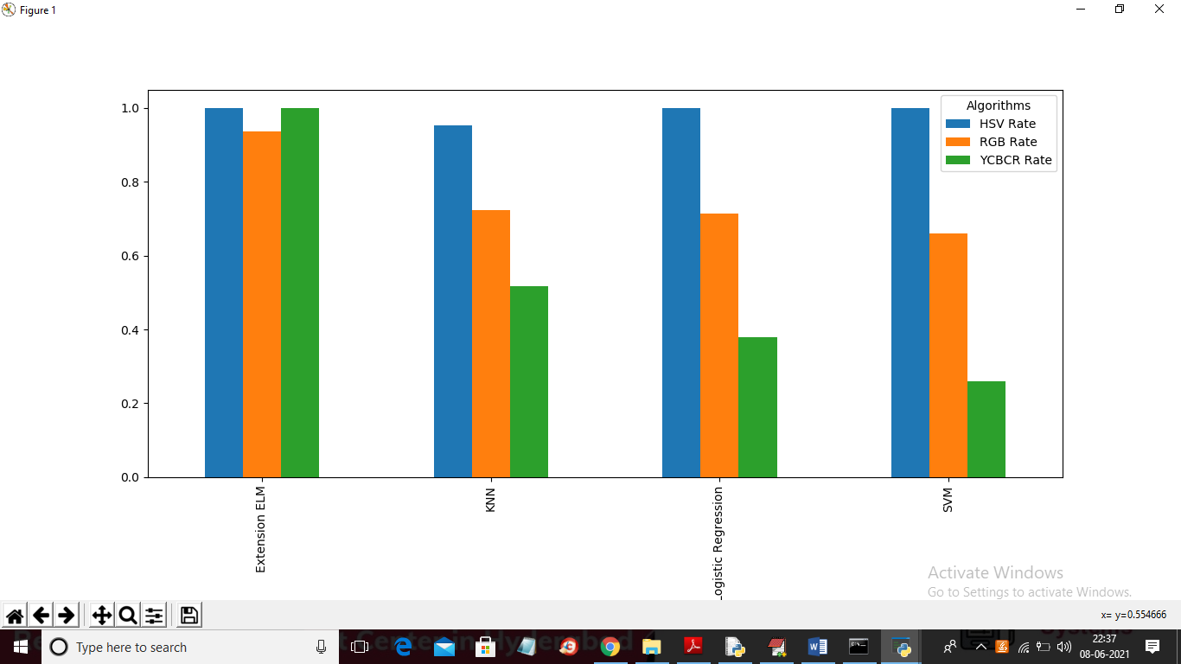

In above graph x-axis represents algorithm names and y-axis represents HSV, RGB and YCBCR classification rate and each colour graph represents classification rate for each colour space like RGB, HSV and YCBCR. In above graph we can see Extension EML got high classification rate