ABSTRACT

The main objective of the proposed solution is to be automated the various functions and activities of the bank through Internet. The solution will facilitate to the bank employees and the account holders with the different modules. This solution is very much necessary for the private sector banks and the corporate sector. The banking industry will take a new shape and explore like never before. Using the solution the bankers and account holders can generate various kinds of reports.
To develop net banking project we used the software html, java script, are used to develop front page .jsp and servlets are used to develop front end. Oracle is used to store the details of customer in database. Jdbc drivers is used to connect the java with oracle.

TABLE OF CONTENTS

1.Introduction 03
  - Introduction and objective 04
  - About organization 06
2.Current system 08
3.Purpose of the system 09
3.1 Modular description 10
4.Feasibility study 18
5.documentation 19
5.1 Java and Internet 19
5.2 Oracle 22
6.Software & Hardware specification 24
7.UML Diagrams
7.1 Use case diagram 25
7.2 Sequence diagram 26
8.Data flow diagram 27
9.Data dictionary 30
10.Sample code 37
11.System testing & Implementation 49
12.Scerens 51
12.1 reports 79
13.Conclusion 90
14.Bibliography 91

introduction

INTRODUTION & OBJECTIVE

The main objective of the proposed solution is to be automated the various functions and activities of the bank through Internet. The solution will facilitate to the bank employees and the account holders with the different modules. This solution is very much necessary for the private sector banks and the corporate sector. The banking industry will take a new shape and explore like never before. Using the solution the bankers and account holders can generate various kinds of reports.

BUSINESS REQUIREMENTS:
Searching Capabilities:
For the account holder’s convenience and on hand information, this solution provides certain searching and checking features for his account. The account holder can any time and any number of time can log on and search for various details as the account’s balance, details of transactions, interest amounts, debits / credits, etc. The account holder will have his unique id and password for logging on to the account’s information.
User friendly:
The solution provides very simple and modified features, which are very easy to view and operate various features. The said project is designed and organized in very simplified manner to suit the current requirements of the account holders of various models such as Saving Bank Account, Current Account and Recurring Deposit Account.

Transaction Management:
The transaction made through either net or manually in bank need to have a
consistency with respect to the account details and other related information like transaction details across various databases.

Value Added Service
The solution provides good number of value added services in comparison to the normal banking services. Account holder can view his accounts and give the instructions of making payment to various government organizations for various services. An account holder can issue the instructions to transfer certain amount to any particular account number of the same / different bank. Individual can log on to the site and open new bank account in his name online by following the simplified registration form instructions

Security
The Net Banking system deals with a lot of proprietary information for its users, which are confidential. It is therefore imperative to provide a means though which information can be kept confidential. This is also ensures that the data that is put into the system maintains its integrity because malicious or unauthorized individual will not have access to alter them. The security is at two different levels, one at account holder and other at administrative level at the bank’s office.

ABOUT ORGANISATION
Annex Solutions has emerged to be a world-class solutions and products organization with clientele spread across geographies. It has time-and-again taken up challenges for accomplishing the mission of customer satisfaction armored with a focused vision and technical expertise.
Our growth and success has evolved from our ability to foresee customer challenges and address them with apt solutions. Our teams, comprising of research innovators, architects and developers have constantly worked on developing products, solutions and mission-critical applications
Annex Solutions Technologies is a global software development firm specializing in software testing and product development services catering to technology companies across diverse industry segments
Our world-class practices and methodologies make us the preferred technology partner for many technology companies. Our growth comes from the unique business model and integration of people, processes and technology. We have continually demonstrated our commitment to develop cost-effective, quality products and custom-applications built on strict time-lines by adopting industry standard processes.

NET BANKING

CURRENT SYSTEM

In current banking system if we want perform any operation in bank we must go to bank. For example we want clear a cheque, going to a bank and waiting for some time and clearing the cheque.
It is possible only we are in the same city. If we are out of station it is not possible due to this the customer wasting the money and time. If u want to perform any operation we must go to bank.
In the bank side increasing the customer numbers they become busy. They are not satisfying the customers to reduce the burden banks are decided to online the bank operations.
If we want to pay the bills like current bill, phone bill, or any other bills we have to by our own hands. there is no third party to pay.
These are the problems in current banking system

PURPOSE OF THE SYSTEM

The Net Banking is a web-based application some of its features are pointed out here:
The proposed system can be accessed from any part of the world, as opposed to stand alone or manual system, and provides information at any time, anywhere round the clock to the customers.
Even though it is a web-based application it will keep the details of its clients private and no body is allowed to tinker with the details.
The customer needs to register, by which he is given user name and password through which he can login and do the transactions whatever he wants to do. It provides easy to use and user friendly interface for the user.
The system provides freedom to the user to move freely around various screens and status of the system returned, as it was when he left the screen.
by expert personalities maintaining the web site.
The user can access the system at any time, because it’s 24-hour online from any where in the world.
The customer can do all the work online without persisting him to go to the bank like he can deposit the money, transfer amount from account to another account, can get this available balance, able to see the transaction reports that has done etc to mention a few.
The customer can save his money and time that is a valuable one in today’s day- to – day life.

MODULE DESCRIPTION
The system can be differentiated into the following modules which are closely integrated together.

New Account

Teller Services

Transaction Details

Interest Statement

Un Cleared Cheque

Transaction Services

Bill Payment Services

Other Payments

Requests

Maintenance Services

User Alerts

Out of these the modules I have done are

New Account

Teller Services

Bill Payment Services

Other Payments

New Account
Opening an account is possible through Internet. Account can be opened in the following methods explained below.

Savings Account

Input
Customer Details.

Output
Alert message.

Current Account

Input
Customer Details.

Output
Alert message.

Credit Card
Customer needs to open a savings/current account bank account before opening the credit card account. Credit card account will be linked with their savings/current account. Customer needs to give their account detail when applying for the credit card.

Input
Customer account details

Output
Alert message

Term Deposit
Term Deposit can be of two types: Flexible deposit and Cumulative deposit.

Flexible Deposit
Flexible deposit has links with the savings bank account.
  - Input
- Customer details
- Amount
- Period
  - Years
  - Months
  - Days
- Renewal Option
  - Repay the deposit
  - Auto Renewal
    - Principal only
    - Principal along with interest
  - Output
Alert message.

Cumulative Deposit
  - Input
- Customer details
- Amount
- Period
  - Years
  - Months
  - Days
  - Output
Alert message

Recurring Deposit
  - Input
- Customer details
- Period
- Installment amount
  - Output
  - Alert message

Teller Services
Customer can use the facility of Teller to receive the details of their account. Teller services component provides the following services:

Account Summary

Transaction Details

Card Transaction

Interest Statement

Un Cleared Cheque

Account Summary
Customer can go to the Teller option and select the Account Summary. It provides account summary of the customer. Account summary will be grouped as:

Regular Accounts

Investment Accounts

Loan Accounts

Credit card Account

On selecting the account summary field, the type of accounts field will be displayed. Here the customer selects their account type and the account number will be entered further. On entering these, the account summary is displayed. Further, customer can enter from and to dates to see the opening balance and the closing balance.
  - Input
- Account Type
- Account Number
- Statement Duration
  - Output
- Date
- Description
- Credit/Debit
- Amount
- Balance

Transaction Details
User can use the transaction details option to obtain the details of their particular transactions.
  - Input
- Account type
- Account number
- Period of transaction
  - Output
Transaction history for the specified period

Card Transaction
The card transaction option will be provided for displaying the card transaction details.
  - Input
- Card Type
- Card Number
- Period of transaction
  - Output
- Card Number
- Account Number
- Expiry Date
- Date of transaction
- Pay To
- Amount

Interest Statement
In this option, a customer receives statement on interest earned/debited in their account for a particular period
  - Input
- Account Type
- Account Number
- Interest type (accrued/credited/debited)
- From and to dates
  - Output
- Date
- Description (loan no. or flexi deposit no etc)
- Interest Accrued/Credited/Debited
- Interest credited during last year
- Interest credited during the current year

Un Cleared Cheque
Here, a customer gets report about the Un Cleared Cheque. A separate table is being maintained for tracking cheque clearance.
  - Input
- Account type
- Account number
  - Output
Details of Un-Cleared Cheque:
- Date
- Drawn on
- Cheque number
- Amount

Bill Payment Services
Bill Payment Service components facilitate customers to instruct the banks to issue payment to their bills regularly against utilities such as electricity, gas, water etc. Customer nominates the service provider to the bank, provided the bank has a tie up with the provider. Service providers publish the bills to the bank and the customers will be alerted subsequently. Bank will make payment to these service providers as they get on line instructions from the customer. Bank debits service charge from customer’s account for providing the service.
Following details will be displayed and the customer has multiple options to choose:
- Bill No.
- Bill date
- Bill period
- Payee
- Amount
- Description
- Select for payment (check box)
Customer has to select bills to be paid from the check box option. The customer also gives the account number in which the amount has to be debited.
  - Output
Alert message will be displayed to the user showing the service charge amount that will be debited from his account.

Other Payments
Other Payments component incorporates the following services:
- Recurring Payments
- Remittances
- Recurring Payments
A customer can move the regular payment facility from one account to another. Bank determines the service charge for providing the service to the user. It will be displayed to the user for information to decide for utilizing the services provided by the bank.
Here, the Customer instructs the bank to remit their recurring payment.
  - Input
User has to enter the following fields:
- Payee Name
- Payment frequency
- Start date
- End date
- Payment Amount
- Account Type
- Account No.
- Branch
  - Output
Alert message showing the service charge for providing the service.

Remittances
Following services are provided to the customer:
  - Transferring funds from one account to another within the bank.
  - Making remittances.
Service charges will be displayed for the customer to avail the facility and will be determined by the bank.
  - Input
The customer provides following details:
- Payee name
- Payee bank name and branch
- Payee account number
- Amount
- Account type
- Account No.
- Branch
  - Output
Alert message showing the service charge to be debited from the customer’s account.
- Account Type
- Account No.
  - Output
Alert message showing the service charge to be debited from the customer’s account.

.FEASIBILITY STUDY

Feasibility and risk analysis are related in many ways. If project risk is great the feasibility of producing quality software is reduced. During product engineering, however, we concentrate our attention on two primary areas of interest:

Technical Feasibility
This application in going to be used in an Internet environment called www (World wide web). So, it is necessary to use a technology that is capable of providing the networking facility to the application. This application as also able to work on distributed environment. Application on developed with java Technology. One major advantage in application is platform independent.. We can deploy and used it in any operating system.
GUI is developed using HTML.to capture the information from the customer. HTML is used to display the content on the browser. It uses TCP/IP protocol. It is an interpreted language. It is very easy to develop a page/document using HTML some RAD (Rapid Application Development) tools are provided to quickly design/develop our application. So many objects such as button, text fields, and text area etc are providing to capture the information from the customer.
We can use this application in any operating system. They can have their own security and transactional advantages. But are the responsible for selecting suitable and secured operating system, which is suitable to our application.
The back-end Oracle 9i and front-end application are platform independent. So we can port this enterprise application in any environment. Both are having their individual configuration to get better performance and backup issues.

Operational Feasibility:
In our application front end is developed using GUI. So it is very easy to the customer to enter the necessary information. But customer has some knowledge on using web applications before going to use our application. If customer make any mistake then an alert message will be displayed .

DOCUMENTATION
Java and Internet:
The Internet helped catapult Java to the forefront of programming and Java in turn has had a profound effect on the Internet. The reason is simple: Java expands the universe of objects that can move about freely in cyberspace. In a network, there are two broad categories of objects transmitted between the Server and your Personal Computer: passive information and dynamic, active programs like an object that can be transmitted to your computer, which is a dynamic, self-executing program. Such a program would be an active agent ton the client computer, yet the server would initiate it. As desirable as dynamic, networked programs are, they also present serious problems in the areas of security and portability. Prior to Java cyberspace was effectively closed to half the entities that now live there. Java addresses these concerns and doing so, has opened the door to an exiting a new form of program.
The rise of server-side Java applications is one of the latest and most exciting trends in Java programming. It was first hyped as a language for developing elaborate client-side web content in the form of applets. Now, Java is coming into its own as a language ideally suited for server-side development. Businesses in particular have been quick to recognize Java’s potential on the server-Java is inherently suited for large client/server applications. The cross platform nature of Java is extremely useful for organizations that have a heterogeneous collection of servers running various flavors of the Unix of Windows operating systems. Java’s modern, object-oriented, memory-protected design allows developers to cut development cycles and increase reliability. In addition, Java’s built-in support for networking and enterprise API provides access to legacy data, easing the transition from older client/server systems.
Java Servlets are a key component of server-side java development. A Servlets is a small, plug gable extension to a server that enhances the server’s functionality. Servlets allow developers to extend and customize and Java enabled server a web server, a mail server, an application server, or any custom server with a hitherto unknown degree of portability, flexibility and ease.
JAVA SERVER PAGE (JSP)
Java Server Pages is a simple, yet powerful technology for creating and maintaining dynamic-content web pages. Based on the Java programming language, Java Server Pages offers proven portability, open standards, and a mature re-usable component model.
PORTABILITY
Java Server Pages files can be run on any web server or web-enabled application server that provides support for them. Dubbed the JSP engine, this support involves recognition, translation and management of the Java Server Pages lifecycle and its interaction with associated components.
The JSP engine for a particular server might be built-in or might be provided through a 3rd –party add-on. As long as the server on which you plan to execute the Java Server Pages supports the same specification level as that to which the file was written, no change should be necessary as you move your files from server to server. Note, however, that instructions for the setup and configuration of the files may differ between files.

ORACLE 9i
Introduction to Oracle:
Any programming environment used to create containers, to manage human data, in the conceptualization as a Data Management System. Traditionally, the block of human data being managed is called a Database. Hence, in very simple terms, these programming environments can the conceptualized as Database Management Systems, in short DBM systems.
All Databases Management Systems (that is, Oracle is DBMS) allow users to create containers for data stories and management. These containers are called ‘cells’. The minimum information that has to be given to Oracle for a suitable container to be constructed, which can hold free from human data, is
The cell name
The cell length
Another name that programming environments use for a ‘Cell’ is ‘Field’. These can the conceptualized as follows.
Basic Database Concepts:
A database is a corporate collection of data with some inherent meaning, designed, built and populated with data for a specific purpose. A database stores data that is useful to us. This data is only a part of the entire data available in the world around us.
To be able to successfully design and maintain databases we have to do the following:
Identify which part of the world’s data is of interest to us.
Identify what specific objects in that part of the world’s data are of interest to us.
Identify a relationship between the objects.
Hence the objects, their attributes and the relationship between them that are of interest to us are still owed in the database that is designed, built and populated with data for a specific purpose.
Characteristics of a Database Management System:
It represents a complex relationship between data.
Keeps a tight control of debtor redundancy.
Enforces user-defined rules to ensure integrity of table data.
Has a centralized data dictionary for the storage of information pertaining to data and its manipulation.
Ensures that data can be shared across applications.
Enforces data access authorization has automatic, intelligent backup and recovery procedures for data.
Have different interfaces via which users can manipulate data.
Relational Database Management:
A relational database management system uses only its relational capabilities to manage the information stored in its databases.
Information Representation:
All information stored in a relational database is represented only by data item values, which are stored in the tables that make up the database. Associations between data items are not logically represented in any other way, such as the use of pointers from one table to the other.

. SOFTWARE AND HARDWARE SPECIFICATIONS
Net Banking System is a network-based application. When we talk about hardware and software, we have to mention requirements on both the Client and Server part.
  - Internet connection with 33.6 KBPS Modem.
  - Pentium 2.77 GHz. 40 GB HDD, 512 MB RAM (Server).
  - Any P.C with Windows compatibility, 64 MB RAM (Client).
  - JDK 1.4 Enterprise Edition (J2EE)
  - Tomcat
  - Enterprise Java Beans
  - JDBC/ODBC drivers installed.
  - Functional Java enabled browser.
  - Data Base (Oracle 9i).
  - Operating System (Windows).

UML DIAGRAMS

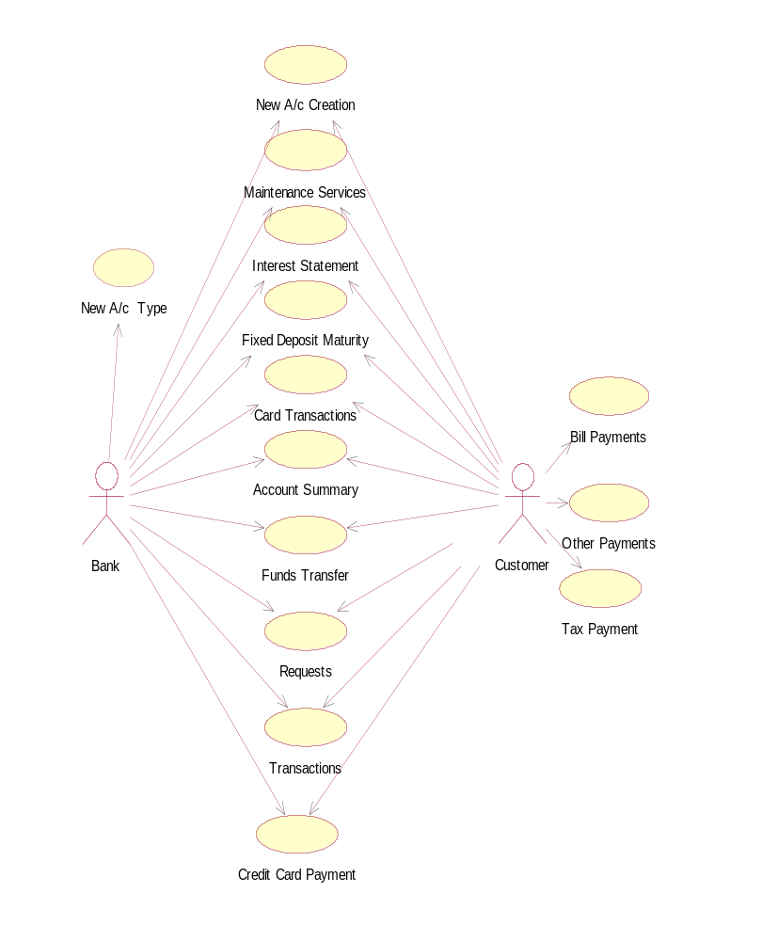
USE CASE DIAGRAME
: Customer
: Authenticator
: Options
: Menu
: InputScreen
: PersonalInfo
Validator
: ChangePwd
: PersoalInfo
press change password
new Customer
existing customer
register
sign up
id, password
authenticate()
personal details
validate()
id,oldpwd
validate pwd
store
forward id
forward id
get pwd
get pwd
new pwd
SEQUENCE DIAGRAM

DATA FLOW DIAGRAMS

CONTEXT -LEVEL
Net
Banking System
Account Transaction & Services

Reports

NEW_ACCOUNT

New A/C
New Account Details
New Account Report Details
Account-Types
States
Get
Store
Accounts
Nominee
Require-Deposits
Term-Deposits
Credit-Cards
Customers

ANOTHER ACCOUNT

Open Another
Account

New Account Details
New Account
Created
Accounts
Customers
Nominee
Accounts
Customers
Nominee
Get
Store

CLOSE ACCOUNT
Close
Account

Account Details
Account
Closed
Accounts
Accounts
Get
Customers
Nominee
Transaction
Store

BILL PAYMENT
Bill
Payment
Bill
Details
Bill
Paid
Accounts
Get
Store
Bill- Payments

DATA DICTORANY

1) ACCOUNT_TYPES Table contains details of different types of Accounts.

Field Name | Data Type/Size | Description
ACC_TYPE_CD | Char(2) | Account Type Code (Primary Key)*
ACC_TYPE_DESC | Varchar(20) | Account Type Description
MIN_AMT | Number(5) | Minimum Amount to Deposit
INTEREST_RATE | Number(4,2) | Rate of Interest
MIN_PERIOD | Number(2) | Minimum Period in Months

*Possible values are:
SB – Saving Banks Account CA – Current Account
CC – Credit Card Account TD – Term Deposit
RD – Recurring Deposit

2) STATES Table contains details of the Indian States.

Field Name | Data Type/Size | Description
STATE_CD | Char(2) | State Code (Primary Key)
STATE_NAME | Varchar(30) | State Name

3) ACCOUNTS Table contains details of each Account.

Field Name | Data Type/Size | Description
ACCOUNT_NO | Char(8) | Account Number (Primary Key)
ACC_CAT | Char(1) | Account Category*
OPERATION_MODE | Char(1) | Operation Mode#
OPEN_DATE | Date | Opening Date
BALANCE_AMT | Number(10,2) | Balance Amount
INT_NAME | Varchar(25) | Introducer’s Name
INT_ACC_NO | Char(8) | Introducer’s Account Number
BRANCH | Varchar(20) | Introducer’s Branch
KNOW_APPLICANTS | Number(2)) | Introducer knows applicants since number of months

* Possible values include:
S – Single J – Joint C – Custodial

# Possible values include:
S – Self F – Former/Survivor E – Either/Survivor C –
4) CUSTOMERS Table contains details of each Customer.

Field Name | Data Type/Size | Description
Cust_code | Char(7) | Customer Code (Primary Key)
APPLICANT_NO | Number(1) | Applicant Number (1 or 2 or 3)
ACCOUNT_NO | Char(8) | Account Number
ACCOUNT_NO2 | Char(8) | Second Account Number (Optional)
CUST_FNAME | Varchar(25) | Customer’s First Name
CUST_MNAME | Varchar(25) | Customer’s Middle Name
CUST_LNAME | Varchar(25) | Customer’s Last Name
HOUSE_NO | Varchar(10) | House Number
STREET1 | Varchar(20) | Street Name
STREET2 | Varchar(20) | Street Name
AREA | Varchar(20) | Area Name
CITY | Varchar(20) | City Name
PIN | Char(6) | PIN Code
STATE_CD | Char(2) | State Code
RES_PHONE | Char(13) | Residence Phone
CELL_PHONE | Char(10) | Cell Phone
EMAIL | Varchar(30) | E-Mail Address
NO_YEARS_ADDRESS | Number(2) | Number of years residing in the address
PROFESSION | Varchar(20) | Profession Name
ORGANIZATION | Varchar(20) | Organization Name
WORKING_SINCE | Date | Date since working
DESIGNATION | Varchar(20) | Designation Name
OFF_DOOR_NO | Varchar(10) | Office Door Number
OFF_STREET | Varchar(20) | Office Street Name
OFF_AREA | Varchar(20) | Office Area Name
OFF_CITY | Varchar(20) | Office City Name
OFF_PIN | Char(6) | Office PIN Code
OFF_STATE_CD | Char(2) | Office State Code
OFF_PHONE | Char(13) | Office Phone Number
PAN_GIRN | Char(10) | PAN/GIRN Number
GENDER | Char(1) | Gender (Male/Female)
BIRTH_DATE | Date | Date of Birth
MAR_STATUS | Char(1) | Marital Status
REL_FIRST_APP | Varchar(10) | Relationship with the First Application
EDUCATION | Varchar(20) | Educational Qualification
MONTHLY_INCOME | Number(6) | Monthly Income
GUARDIAN_NAME | Varchar(25) | Guardian Name

5) TERM_DEPOSITS Table contains details of Term Deposit Accounts

Field Name | Data Type/Size | Description
ACCOUNT_NO | Char(8) | Account Number
DEPOSIT_AMT | Number(10,2) | Deposit Amount
TENURE_YEARS | Number(2) | Tenure Years
TENURE_MONTHS | Number(2) | Tenure Months
TENURE_DAYS | Number(2) | Tenure Days
PAYMENT_PERIOD | Char(1) | Payment Period*
RENEWAL_OPTION | Char(1) | Renewal Option#
ACCOUNT_NO | Char(8) | Account Number

* Possible values include:
M – Monthly Q – Quarterly O – On Maturity

# Possible values include:
P – Principal only D – Repay Deposit B – Principal + Interest

6) TERM_DEPOSIT_ALERTS Table contains details of Alerts for Term Deposits.

Field Name | Data Type/Size | Description
ACCOUNT_NO | Char(8) | Account Number
ALERT_OPTION | Char(1) | Alert Option*

* Possible values include:
T – Two days O – One week (before the date of maturity)

7) TRANSACTIONS Table contains details of Credit and Debit Transactions.

Field Name | Data Type/Size | Description
ACCOUNT_NO | Char(8) | Account Number
TRANS_TYPE | Char(1) | Transaction Type*
TRANS_DESC | Varchar2(30) | Transaction Description
AMOUNT | Number(10,2) | Transaction Amount
TRANS_DATE | Date | Transaction Date
TRANS_MODE | Char(1) | Transaction Mode#

* Possible values include:
C – Credit D – Debit
# Possible values include:
C – Cash Q – Cheque D – Demand Draft I – Internet S – Service Charge

8) NOMINEE Table contains details of Nominees.

Field Name | Data Type/Size | Description
ACCOUNT_NO | Char(8) | Account Number
NOM_NAME | Varchar(25) | Nominee Name
NOM_ADDR | Varchar(40) | Nominee Address
NOM_AGE | Number(3) | Nominee Age
RELATIONSHIP | Varchar(10)) | Relationship with Account Holder

9) CREDIT_CARDS Table contains details of Credit Card Accounts.

Field Name | Data Type/Size | Description
CREDIT_CARD_NO | Char(10) | Credit Card Number (Primary Key)
ACCOUNT_NO | Char(8) | Account Number
ISSUE_DATE | Date | Date of Issue
EXPIRY_DATE | Date | Date of Expiry
MAX_AMT | Number(6) | Maximum Credit Amount
STATUS | Char(1) | Status*

* Possible values include:
V – Valid L – Lost

10) CARD_TRANSACTIONS Table contains details of Card Transaction.

Field Name | Data Type/Size | Description
CREDIT_CARD_NO | Char(10)
DESCRIPTION | Varchar(50)
CREDIT_AMT | Number(10,2)
CREDIT_DATE | Date
PAYTO | Varchar(30)

11) CREDIT_CARD_ALERTS Table contains details of Alerts for Credit Cards.

Field Name | Data Type/Size | Description
CREDIT_CARD_NO | Char(10) | Credit Card Number
ALERT_OPTION | Char(1) | Alert Option*

* Possible values include:
T – Two days O – One week (before the date of maturity)

12) RECURRING_DEPOSITS Table contains details of Recurring Deposit Accounts.

Field Name | Data Type/Size | Description
ACCOUNT_NO | Char(8) | Account Number
INSTAL_AMT | Number(10,2) | Installment Amount
TENURE_YEARS | Number(2) | Tenure Years
TENURE_MONTHS | Number(2) | Tenure Months
TENURE_DAYS | Number(2) | Tenure Days

13) LOAN_TYPES Table contains details of different Types of Loans.

Field Name | Data Type/Size | Description
LOAN_TYPE | Char(3) | Loan Type Code (Primary Key)
LOAN_DESC | Varchar(20) | Loan Type Description
INTEREST_RATE | Number(4,2) | Rate of Interest

14) LOANS Table contains details of Loans availed by different Account Holders.

Field Name | Data Type/Size | Description
LOAN_CODE | Char(9) | Loan Code (Primary Key)
LOAN_TYPE | Char(3) | Loan Type Code
ACCOUNT_NO | Char(8) | Account Number
APPLIED_DATE | Date | Date of applying for Loan
LOAN_PERIOD | Number(3) | Loan Period in Months
LOAN_AMT | Number(6) | Loan Amount
EMI | Number(6) | Equal Monthly Installments
DOC_DETAILS | Long | Document Details
STATUS | Char(1) | Status
NO_OF_INSTAL | Number(3) | Total Number of Installments
LAST_PAID | Date | Date of Last Payment

15) CHEQUES Table contains details of Cheques submitted by the Account Holders.

Field Name | Data Type/Size | Description
CHEQUE_NO | Varchar(10) | Cheque Number
PAYER_ACC_NO | Char(8) | Account Number of Payer
PAYER_BANK | Varchar(20) | Bank of Payer
PAYER_BRANCH | Varchar(15) | Branch of Payer Bank
PAYEE_ACC_NO | Char(8) | Account Number
CHEQUE_DATE | Date | Cheque Date
SUBMITTED_DATE | Date | Submitted Date
CHEQUE_AMT | Number(10,2) | Cheque Amount
STATUS | Char(2) | Status of Cheque
16) FUNDS_TRANSFERS Table contains details of Funds Transfers.

Field Name | Data Type/Size | Description
FUNDS_TRANS_CODE | Char(10) | Funds Transfer Code
ORIGIN_ACC_NO | Char(8) | Origin Account Number
TRANS_AMT | Number(10,2) | Transfer Amount
TRANS_DATE | Date | Transfer Date
DEST_ACC_NO | Char(8) | Destination Account Number
DEST_BANK | Varchar2(20) | Destination Bank Name
DEST_BRANCH | Varchar2(20) | Destination Bank Branch
FREQUENCY | Char(1) | Frequency of Transfer
INSTALMENTS | Number(2) | Number of Installments

17) TAX_PAYMENTS Table contains the details of Tax Payments.

Field Name | Data Type/Size | Description
TAX_PAY_CODE | Char(10) | Tax Payment Code
ORIGIN_ACC_NO | Char(8) | Origin Account Number
TAX_PAYER_ID | Char(10) | Tax Payer ID
TAX_PAY_DATE | Date | Tax Payment Date
TAX_FROM | Date | Tax From Date
TAX_TO | Date | Tax To Date
INCOME | Number(10,2) | Income during above period
TAX_AMOUNT | Number(8,2) | Tax Amount
TAX_AUTHORITY | Varchar(30) | Tax Authority

18) BILL_PAYMENTS Table contains the details of Bill Payments.

Field Name | Data Type/Size | Description
BILL_PAY_CODE | Char(10) | Bill Payment Code
ACCOUNT_NO | Char(8) | Account Number
BILL_NO | Char(10) | Bill Number
BILL_DATE | Date | Bill Date
BILL_FROM | Date | Bill From Date
BILL_TO | Date | Bill To Date
PAYEE | Varchar(30) | Payee Name
BILL_AMOUNT | Number(10,2) | Bill Amount
BILL_DESC | Varchar(30) | Bill Description

19) CHEQUE_REORDER Table contains the details of the Cheque Reorders.

Field Name | Data Type/Size | Description
CHEQ_RO_CODE | Char(9) | Cheque Reorder Code
ACCOUNT_NO | Char(8) | Account Number
REQUEST_DATE | Date | Request Date

20) DRAFT_CHEQUE Table contains the details of Drafts and Cheques Issued.

Field Name | Data Type/Size | Description
ACCOUNT_NO | Char(8) | Account Number
DD_OR_CHEQ | Char(1) | DD or Cheque
PAYEE | Varchar(30) | Payee Name
DRAWN_ON | Date | Drawn On Date
DD_CHEQ_NO | Varchar(10) | DD or Cheque Number
AMOUNT | Number(10,2) | Amount
DELIVERY | Char(1) | Delivery Option*
PAYEE_DOOR_NO | Varchar(10) | Payee Door Number
PAYEE_STREET | Varchar(20) | Payee Street
PAYEE_AREA | Varchar(20) | Payee Area
PAYEE_CITY | Varchar(20) | Payee City
PAYEE_PIN | Char(6) | Payee PIN Code
STATUS | Char(1) | Status

* Possible values include:
C – Customer’s doorstep P – Payee’s doorstep

SAMPLE CODE

AccountDetails.jsp:

<%@ page import="java.sql.*,java.util.*" session="true"%>
<%
int accno=0;
String type=(String)session.getAttribute("acctype");
String top="";
try {
Class.forName("sun.jdbc.odbc.JdbcOdbcDriver");
Connection con = DriverManager.getConnection("jdbc:odbc:netbank" , "scott" , " “tiger");
Statement st=con.createStatement();
ResultSet rs=null;
PreparedStatement pst=null;
rs=st.executeQuery("select max(accno) from auto");
if(rs.next()) {
accno=rs.getInt(1);
accno+=1;
pst=con.prepareStatement("insert into auto(accno) values(?)");
pst.setInt(1,accno);
pst.execute();
} else accno=1000;
if(type.equals("SB")) top="SB"+accno;
else if(type.equals("CA")) top="CA"+accno;
else if(type.equals("CC")) top="CC"+accno;
else if(type.equals("TD")) top="TD"+accno;
else top="RD"+accno;
} catch(Exception e) {out.println("<h1>"+e+"</h1>");}
%>
<html>
<head>
<title>
Account Details
</title>
</head>
<body id=body>
<SCRIPT Language="JavaScript" Purpose="Dom" Runat="Browser" SRC="validate.js"></SCRIPT>
<SCRIPT Language="VBScript" Purpose="Dom" Runat="Browser" SRC="warn.vbs"></SCRIPT>
<SCRIPT Language="JavaScript">onload=function() {
elementEffect();
document.getElementById('grad').style.cssText="padding:10px;filter:alpha(style=1,startX=100,startY=0);background:green;color:aliceblue;font-family:tahoma;font-size:30px;height:120px";
document.getElementById('body').style.cssText="margin:0px;background:floralwhite";}
</script>
<Table width=100% cellspacing=0 cellpadding=0><TR><Td id=grad valign=top>Online Net Banking Solutions For Life Time</td></tr></table>
<h1 align="center">Account Details </h1>

<form action="Accounts.jsp">
<table align="center"> <tr><td>Account No</td><td> <input type="text" name="acctnum" value='<%=top%>' readonly/> </td></tr>
<tr><td>Account Category</td><td><select name="acctcategory" >
<option value="s">Single
<option value="j">Joint
<option value="c">Custodial
</select></td></tr>
<tr><td>Operation Mode</td><td><select name="opermode" >
<option value="s">Self
<option value="f">Former/Survivor
<option value="e">Either/Survivor
</select></td></tr>
<tr><td>Open Date </td><td> <input type="text" name="opendate" value="" />*dd-mmm-yy</td></tr>
<tr><td>Balance Amount</td><td> <input type="text" name="balanceamt" value="" /></td></tr>
<tr><td>Introducer Name</td><td> <input type="text" name="introdname" value="" /> </td></tr>
<tr><td>Introducer Account No</td><td> <input type="text" name="introacno" value="" /> </td></tr>
<tr><td>Branch</td><td> <input type="text" name="branch" value="" /> </td></tr>
<tr><td>Known Applicants</td><td> <input type="text" name="knownApplicants" value="" maxlength=2 onkeypress="return blockkey(this)" /> </td></tr>

</table><br><br>
<center>
<input type="submit" name="submit" value="SUBMIT"/>
<input type="reset" name="reset" value="Cancel"/>
</center
</form>
</body></html>
Accounts.jsp:
<%@ page import="java.sql.*"%>
<%@ page import="java.io.*"%>
<%@ page import="java.util.*" session="true"%>
<html>
<head><title>Account Information</title></head>
<body background="pink">
<hr color=#bb055E>
<%
String accno = request.getParameter("acctnum").trim();
String acccat = request.getParameter("acctcategory").trim();
String opermode = request.getParameter("opermode").trim();
String opendate=request.getParameter("opendate").trim();
float balamt=Float.parseFloat(request.getParameter("balanceamt"));
String introname=request.getParameter("introdname").trim();
String introacno=request.getParameter("introacno").trim();
String bran=request.getParameter("branch").trim();
int knowapp=Integer.parseInt(request.getParameter("knownApplicants"));

try {
try {
Class.forName("sun.jdbc.odbc.JdbcOdbcDriver");
} catch (Exception ex) {
System.out.println("Error while loading the Driver : " + ex);
}

Connection con = DriverManager.getConnection("jdbc:odbc:netbank" , "scott" , "tiger");
// int accno=-1;
PreparedStatement ps=con.prepareStatement("insert into accounts values(?,?,?,?,?,?,?,?,?,?)");
ps.setString(1,accno);
ps.setString(2,acccat);
ps.setString(3,opermode);
ps.setString(4,opendate);
ps.setFloat(5,balamt);
ps.setString(6,introname);
ps.setString(7,introacno);
ps.setString(8,bran);
ps.setInt(9,knowapp);
ps.setString(10,"SB");
int n=ps.executeUpdate();

if(n>0)
{
session.setAttribute("account",accno);
response.sendRedirect("customers_reg.jsp");
}else
out.println("<html><body bgcolor=pink><h2>Not Successful");

ps.close();
con.close();
} catch (Exception e) {
out.println("Error occured Due to the insertion os date"+e);
}
%>

AccoutsType.jsp:

<%@ page import="java.sql.*"%>
<%@ page import="java.io.*"%>
<%@ page import="java.util.*" %>
<html>
<head><title>Account Information</title></head>
<body background="pink">
<hr color=#bb055E>
<%
String acc = request.getParameter("acctcode").trim();
String acccat = request.getParameter("acctypedesc").trim();
int opermode =Integer.parseInt(request.getParameter("miniamtdep").trim());
float itrname=Float.parseFloat(request.getParameter("interestrate").trim());
int intronum=Integer.parseInt(request.getParameter("minpermonths").trim());

try {
Class.forName("sun.jdbc.odbc.JdbcOdbcDriver");
Connection con = DriverManager.getConnection("jdbc:odbc:netbank" , "scott" , "tiger");
PreparedStatement ps=con.prepareStatement("insert into account_types values(?,?,?,?,?)");
ps.setString(1,acc);
ps.setString(2,acccat);
ps.setInt(3,opermode);
ps.setFloat(4,itrname);
ps.setInt(5,intronum);
int n=ps.executeUpdate();
if(n>0) {
out.println(" <a href='javascript:self.close()'>Back to Home Page</a>");}
//response.sendRedirect("customers_reg.jsp"); }
else out.println("<h1>Invalid Transaction</h1><center><BR><a href=\"javascript:history.back()\">Back to Accounts </a></center>");
} catch(Exception e) { out.println("Error occured Due to the insertion date"+e);}
%>

customers.jsp:

<%@ page import="java.sql.*"%>
<%@ page import="java.io.*"%>
<%@ page import="java.util.*" %>
<%@ page session="true" %>
<html>
<head><title>Account Information</title></head>
<body background="pink">

<hr color=#bb055E>
<%
String cuscode = request.getParameter("customercode").trim();
int appnum =Integer.parseInt(request.getParameter("applnum").trim());
String accnum = request.getParameter("accnum").trim();
String secondappno=request.getParameter("secondappno").trim();
String ftname=request.getParameter("ftname").trim();
String midname=request.getParameter("midname").trim();
String lstname=request.getParameter("lstname").trim();
String houseno=request.getParameter("houseno").trim();
String street1=request.getParameter("street1").trim();
String street2=request.getParameter("street2").trim();
String area=request.getParameter("area").trim();
String city=request.getParameter("city").trim();
String pin=request.getParameter("pin").trim();
String statecd=request.getParameter("statecd").trim();
String resphn=request.getParameter("resphn").trim();
String cellphn=request.getParameter("cellphn").trim();
String email=request.getParameter("email").trim();
int noyersadds=Integer.parseInt(request.getParameter("noyersadds").trim());
String profession=request.getParameter("profession").trim();
String orgni=request.getParameter("orgni").trim();
String worksin=request.getParameter("worksin").trim();
String designation=request.getParameter("designation").trim();
String offdoorno=request.getParameter("offdoorno").trim();
String offstreet=request.getParameter("offstreet").trim();
String offarea=request.getParameter("offarea").trim();
String offcity=request.getParameter("offcity").trim();
String offpin=request.getParameter("offpin").trim();
String offstatecd=request.getParameter("offstatecd").trim();
String offphone=request.getParameter("offphone").trim();
String pangrin=request.getParameter("pangrin").trim();
String gender=request.getParameter("gender").trim();
String datebirth=request.getParameter("datebirth").trim();
String marstatus=request.getParameter("marstatus").trim();
String relshipapp=request.getParameter("relshipapp").trim();
String eduquali=request.getParameter("eduquali").trim();
float monthincome=Float.parseFloat(request.getParameter("monthincome").trim());
String garname=request.getParameter("garname").trim();
try {
try {
Class.forName("sun.jdbc.odbc.JdbcOdbcDriver");
} catch (Exception ex) {
System.out.println("Error while loading the Driver : " + ex);
}

Connection con = DriverManager.getConnection("jdbc:odbc:netbank" , "scott" , "tiger");
int accno=-1;
PreparedStatement ps=con.prepareStatement("insert into customers values(?,?,?,?,?,?,?,?,?,?,?,?,?,?,?,?,?,?,?,?,?,?,?,?,?,?,?,?,?,?,?,?,?,?,?,?,?)");
ps.setString(1,cuscode);
ps.setInt(2,appnum);
ps.setString(3,accnum);
ps.setString(4,secondappno);
ps.setString(5,ftname);
ps.setString(6,midname);
ps.setString(7,lstname);
ps.setString(8,houseno);
ps.setString(9,street1);
ps.setString(10,street2);

ps.setString(11,area);
ps.setString(12,city);
ps.setString(13,pin);
ps.setString(14,statecd);
ps.setString(15,resphn);
ps.setString(16,cellphn);
ps.setString(17,email);
ps.setInt(18,noyersadds);
ps.setString(19,profession);
ps.setString(20,orgni);
ps.setString(21,worksin);
ps.setString(22,designation);
ps.setString(23,offdoorno);
ps.setString(24,offstreet);
ps.setString(25,offarea);
ps.setString(26,offcity);
//ps.setString(25,offcity);
ps.setString(27,offpin);
ps.setString(28,offstatecd);
ps.setString(29,offphone);
ps.setString(30,pangrin);
ps.setString(31,gender);
ps.setString(32,datebirth);
ps.setString(33,marstatus);
ps.setString(34,relshipapp);
ps.setString(35,eduquali);
ps.setFloat(36,monthincome);
ps.setString(37,garname);
int n=ps.executeUpdate();
if(n>0){
out.println("You are successfully registered your ccount");
out.println("<h3><a href='home.htm'>Back to Home Page</a></h3>");
}else
out.println("<html><body bgcolor=pink><h2>Not successful");
ps.close();
con.close();
} catch (Exception e) {
out.println("Error occured Due to the insertion os date"+e);
//out.println("<a href='accountdetails.html'>Back to Account</a>");
}
%>

billpmt.jsp:

<%@ page import="java.util.*,java.sql.*,java.text.*"%>
<%
String bill_pay_code=request.getParameter("billpaycode").trim();
String account_no=request.getParameter("account_no").trim().toUpperCase();
String bill_no=request.getParameter("bill_no");
String bill_date=request.getParameter("bill_date");
String bill_from=request.getParameter("bill_from");
String bill_to=request.getParameter("bill_to");
// java.sql.Date bill_date=new java.sql.Date( new java.util.Date(request.getParameter("bill_date")).getTime());
// java.sql.Date bill_from= new java.sql.Date( new java.util.Date(request.getParameter("bill_from")).getTime());;
// java.sql.Date bill_to = new java.sql.Date( new java.util.Date(request.getParameter("bill_to")).getTime());;
String payee=request.getParameter("payee");
float bill_amount=Float.parseFloat(request.getParameter("bill_amount"));
String bill_desc=request.getParameter("bill_desc");
Connection con=null;
PreparedStatement pst=null;
Statement st=null;
ResultSet rs=null;
try{
Class.forName("sun.jdbc.odbc.JdbcOdbcDriver");
con=DriverManager.getConnection("jdbc:odbc:netbank","scott","tiger");
String cmd1="Select Balance_amt from Accounts where account_no='"+account_no+"'";
st=con.createStatement();
ResultSet rs1=st.executeQuery(cmd1);
long a=0,b=0;
if(rs1.next()){
a=rs1.getInt(1);
if(a-300>bill_amount){
a-=bill_amount;
String cmd2="UPDATE ACCOUNTS SET BALANCE_AMT='"+a+"' where account_no='"+account_no+"'";
PreparedStatement pstup=con.prepareStatement(cmd2);
pstup.executeUpdate();
String cmd="INSERT INTO BILL_PAYMENTS VALUES(?,?,?,?,?,?,?,?,?)";
pst=con.prepareStatement(cmd);
pst.setString(1,bill_pay_code);
pst.setString(2,account_no);
pst.setString(3,bill_no);
pst.setString(4,bill_date);
pst.setString(5,bill_from);
pst.setString(6,bill_to);
pst.setString(7,payee);
pst.setFloat(8,bill_amount);
pst.setString(9,bill_desc);
pst.execute();
out.println("<h1>Bill Payment Accepted</h1>");
out.println("<h4><a href='billpayment.jsp'>Want to pay Another Payment?</a></h4>");
out.println("<h4><a href=\"javascript:self.close()\">Back to Home Page</a></h4>");
}else{ out.println("Your Balance amount is less to pay your bill");
out.println("<h4><a href=\"javascript:self.close()\">Back to Home Page</a></h4>");}
}else{ out.println("Check your account no:");
out.println("<h4><a href=\"javascript:self.close()\">Back to Home Page</a></h4>"); }
//String comm="insert into bill_payments(bill_pay_code,account_no,bill_no,bill_date,bill_from,bill_to,payee,bill_amount,bill_desc) values(?,?,?,?,?,?,?,?,?)";
}catch(Exception e){ out.println(e);}
%>

newuser.jsp:

<%@ page import="java.sql.*"%>
<%@ page import="java.io.*"%>
<%@ page import="java.util.*" %>

<html>
<head><title> Login Authentication</title></head>
<body background="background.jpg">
<SCRIPT Language="JavaScript" Purpose="Dom" Runat="Browser" SRC="validate.js"></SCRIPT>
<SCRIPT Language="VBScript" Purpose="Dom" Runat="Browser" SRC="warn.vbs"></SCRIPT>
<SCRIPT Language="JavaScript">onload=function() {
elementEffect();
document.getElementById('grad').style.cssText="padding:10px;filter:alpha(style=1,startX=100,startY=0);background:green;color:aliceblue;font-family:tahoma;font-size:30px;height:120px";
document.getElementById('body').style.cssText="margin:0px;background:floralwhite";}
</script>
<Table width=100% cellspacing=0 cellpadding=0><TR><Td id=grad valign=top>Online Net Banking Solutions For Life Time</td></tr></table>
<hr color=#bb055E>

<%
String uname = request.getParameter("account").trim();
String pass = request.getParameter("upass").trim();
String repass = request.getParameter("repass").trim();
if(pass.equalsIgnoreCase(repass)) {

try {
try {
Class.forName("sun.jdbc.odbc.JdbcOdbcDriver");
} catch (Exception ex) {
System.out.println("Error while loading the Driver : " + ex);
}
Connection con = DriverManager.getConnection("jdbc:odbc:netbank" , "scott" , "tiger");
int accno=-1;
PreparedStatement ps=con.prepareStatement("INSERT INTO USERS VALUES(?,?)");
ps.setString(1,uname);
ps.setString(2,pass);
int n=ps.executeUpdate();
if(n>0){
out.println("User Successfully Registered");
out.println("<a href='login.html'>Back to Login</a>");}
ps.close();
con.close();
} catch (Exception e) {out.println("error"+e);}
}
%>

useracctype:
<%@ page import="java.sql.*"%>
<%@ page import="java.io.*"%>
<%@ page import="java.util.*" session="true" %>
<html>
<head><title>Account Information</title></head>
<body background="pink">
<hr color=#bb055E>
<%
String acc = request.getParameter("acctcode").trim();
String acccat = request.getParameter("acctypedesc").trim();
int opermode =Integer.parseInt(request.getParameter("miniamtdep").trim());
float itrname=Float.parseFloat(request.getParameter("interestrate").trim());
int intronum=Integer.parseInt(request.getParameter("minpermonths").trim());
out.println(acc+"<BR>"+acccat+"<BR>"+opermode+"<BR>"+itrname+"<BR>"+intronum);
try {
Class.forName("sun.jdbc.odbc.JdbcOdbcDriver");
Connection con = DriverManager.getConnection("jdbc:odbc:netbank" , "scott" , "tiger");
PreparedStatement ps=con.prepareStatement("insert into user_account_types values(?,?,?,?,?)");
ps.setString(1,acc);
ps.setString(2,acccat);
ps.setInt(3,opermode);
ps.setFloat(4,itrname);
ps.setInt(5,intronum);
int n=ps.executeUpdate();
if(n>0) {
session.setAttribute("acctype",acc);
response.sendRedirect("accountdetails.jsp"); }
else
out.println("<h1>Invalid Transaction</h1><center><BR><a href=\"javascript:history.back()\">Back to Accounts </a></center>");
} catch(Exception e) { out.println("Error occured Due to the insertion date"+e);}
%>

carddetails.jsp:
<%@ page import="java.sql.*,java.util.*"%>
<body id=body>
<SCRIPT Language="JavaScript" Purpose="Dom" Runat="Browser" SRC="validate.js"></SCRIPT>
<SCRIPT Language="VBScript" Purpose="Dom" Runat="Browser" SRC="warn.vbs"></SCRIPT>
<SCRIPT Language="JavaScript">onload=function() {
elementEffect();
document.getElementById('grad').style.cssText="padding:10px;filter:alpha(style=2,startX=100,startY=0);background:green;color:aliceblue;font-family:tahoma;font-size:30px;height:50px";
document.getElementById('body').style.cssText="margin:0px;background:floralwhite";}
</script>
<Table width=100% cellspacing=0 cellpadding=0><TR><Td id=grad valign=top align=center>Online Net Banking Solutions For Life Time</td></tr></table>
<fieldset>
<legend align=center><font face=tahoma>CardCard Issuing </legend><BR>
<%
int crcardno=0;
String top="a";
try {
Class.forName("sun.jdbc.odbc.JdbcOdbcDriver");
Connection con = DriverManager.getConnection("jdbc:odbc:netbank" , "scott" , "tiger");
Statement st=con.createStatement();
ResultSet rs=null;
PreparedStatement pst=null;
rs=st.executeQuery("select max(credit_cardno) from auto");
if(rs.next()) {
crcardno=rs.getInt(1);
crcardno+=1;
pst=con.prepareStatement("insert into auto(credit_cardno) values(?)");
pst.setInt(1,crcardno);
pst.execute();
} else
crcardno=100;
top= "cre"+crcardno;

} catch(Exception e) {out.println("<h1>"+e+"</h1>");}

%>
<table style="border:1px solid gray" align="center" id=register width=500 cellspacing=0 cellpadding=2><form action="CreditCardIssue.jsp" method="post" onsubmit="return validate(this)">
<tr><td align=right>CardNo</td><td><input type="text" name="cardnum" value="<%=top%>" maxlength=10 readonly /></td></tr>
<tr><td align=right>AccountNo</td><td><input type="text" name="accountno" value="" /></td></tr>
<tr><td align=right>IssueDate</td><td><input type="text" name="issuedate" value="" />*dd-mmm-yy</td></tr>
<tr><td align=right>ExpiryDate</td><td><input type="text" name="expirydate" value="" />*dd-mmm-yy</td></tr>
<tr><td align=right>MaximumAmount</td><td><input type="text" name="maxamt" value="" maxlength=6/></td></tr>
<tr><td align=right>Status</td><td><select name="status">
<option value="v">valid</option><option value="l">lost</option></td></tr>
<tr bgcolor=mistyrose><td colspan=2 align=center><button type="submit"><u>S</u>ubmit</button>&nbsp;&nbsp;<button type=reset><u>R</u>eset</button></td></tr>
</form></table><br></fieldset><script>setColor()</script>
</body>
</html>

SYSTEM TESTING & IMPLEMENTATION

SOFTWARE TESTING TECHNIQUES:
Software testing is a critical element of software quality assurance and represents the ultimate review of specification, designing and coding.
TESTING OBJECTIVES:
- Testing is process of executing a program with the intent of finding an error.
- A good test case design is one that has a probability of finding an as yet undiscovered error.
- A successful test is one that uncovers an as yet undiscovered error.
These above objectives imply a dramatic change in view port.
Testing cannot show the absence of defects, it can only show that software errors are present.
TEST CASE DESIGN:
Any engineering product can be tested in one of two ways:
White Box Testing: This testing is also called as glass box testing. In this testing, by knowing the specified function that a product has been designed to perform test can be conducted that demonstrates each function is fully operation at the same time searching for errors in each function. The NETBANKING has 11 modules by checking each module ,unit testing is applied. Unit Testing: Unit testing focuses verification efforts in smallest unit of software design (module). :
Black Box Testing: In this testing by knowing the internal operation of a product, tests can be conducted to ensure that “ all gears mesh”, that is the internal operation performs according to specification and all internal components have been adequately exercised. It fundamentally focuses on the functional requirements of the software.
In NETBANKING each operation in every module is tested by using black box testing
Integration Testing: Integration testing is a systematic technique for constructing the program structure while conducting tests to uncover errors associated with interfacing.
It is opposite to unit testing
There are two types of integration testing:
- Top-Down Integration: Top down integration is an incremental approach to construction of program structures. Modules are integrated by moving down wards throw the control hierarchy beginning with the main control module.
- Bottom-Up Integration: Bottom up integration as its name implies, begins construction and testing with automatic module .In NETBANKING Top-down Integration is used.

SCREENS

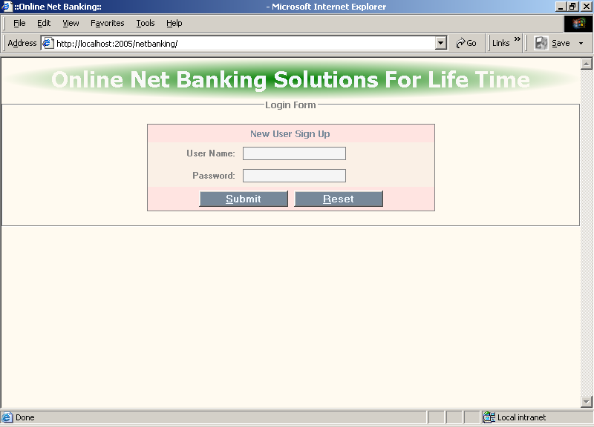

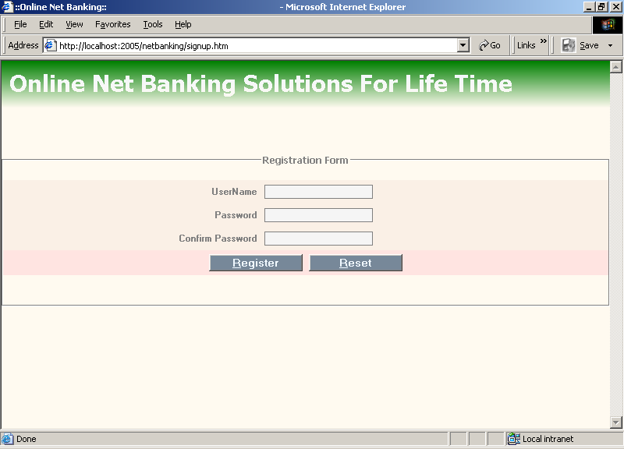

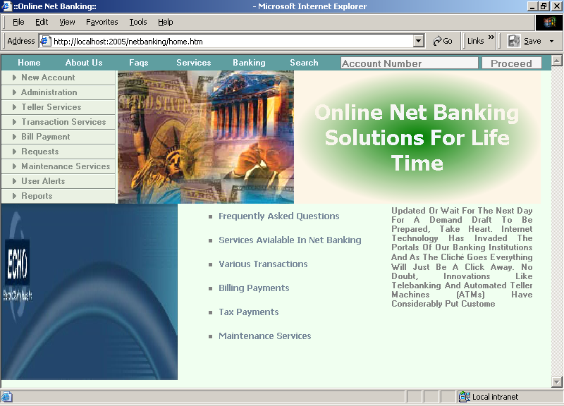

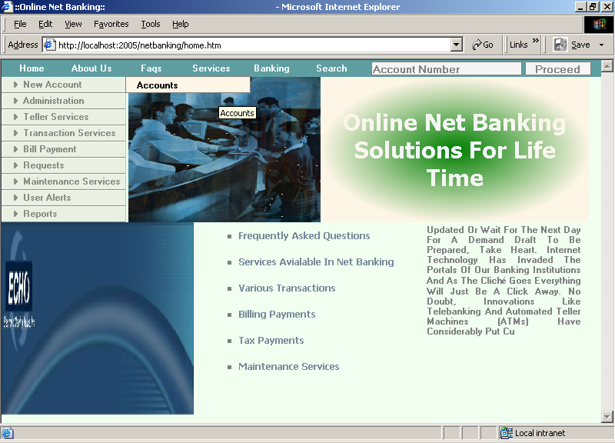

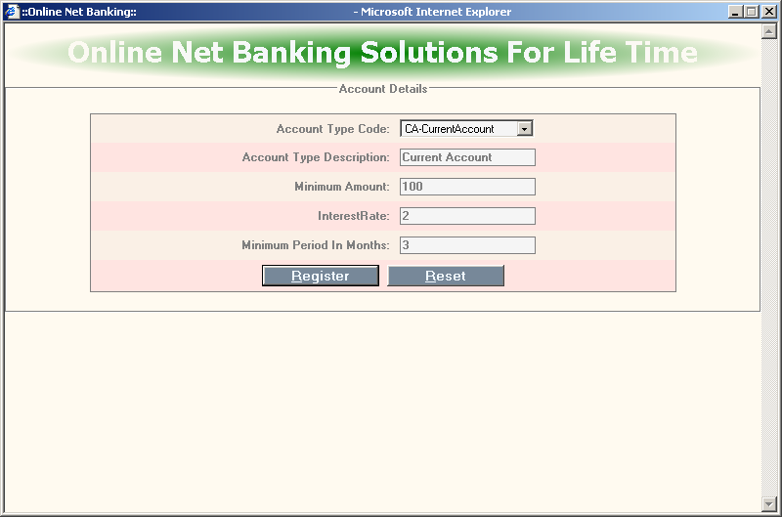

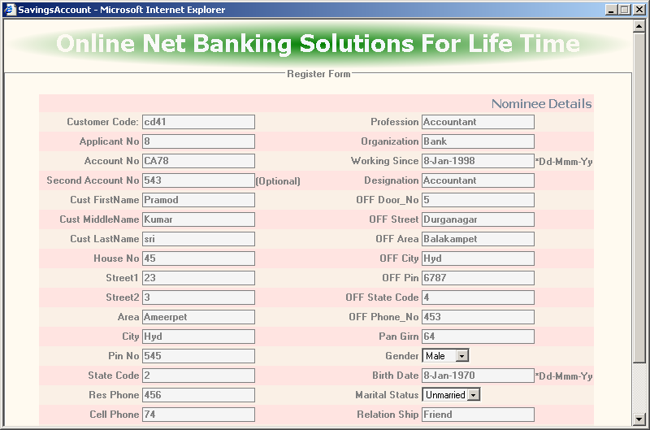

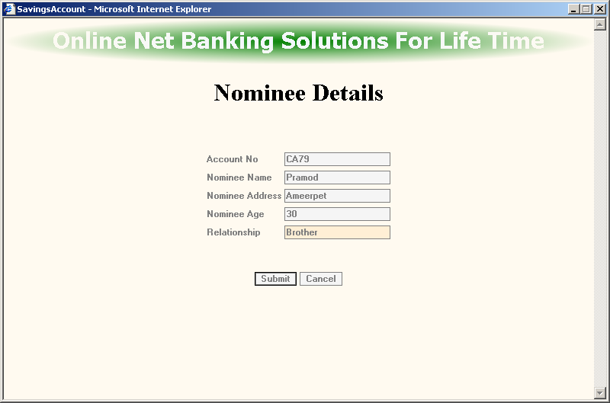

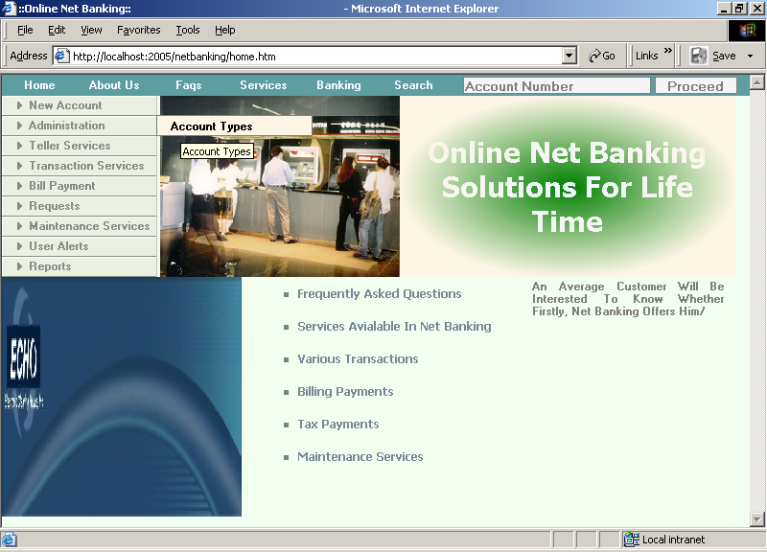

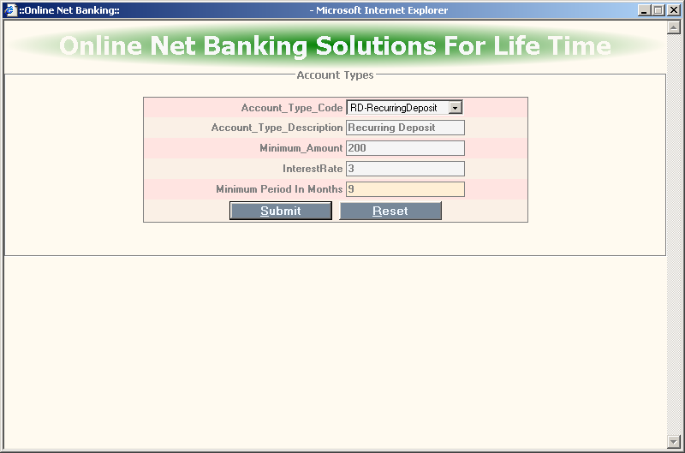

:

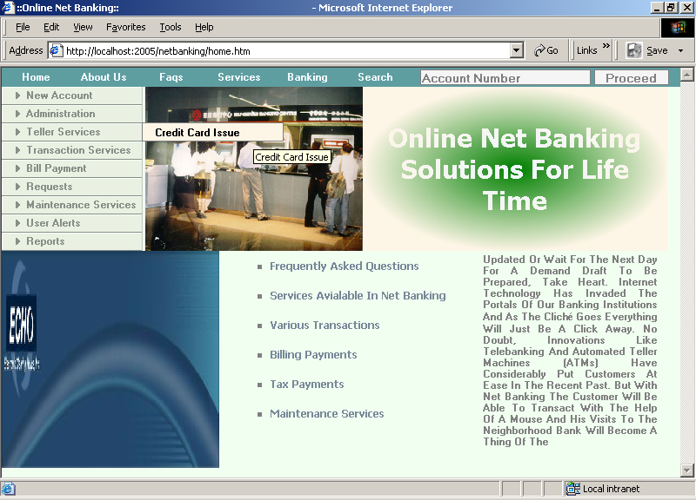

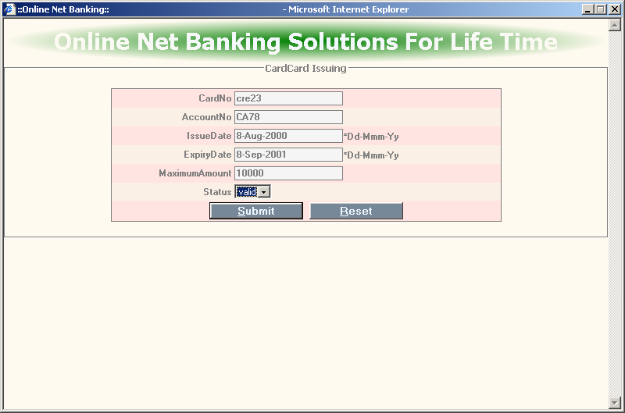

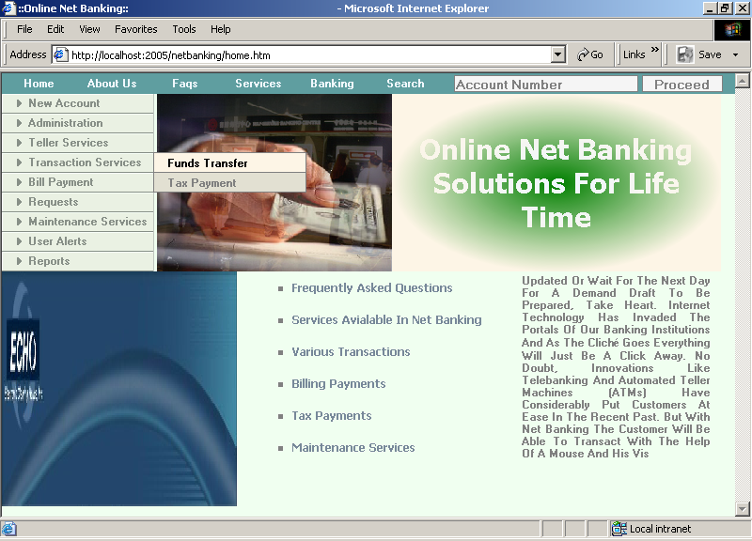

:

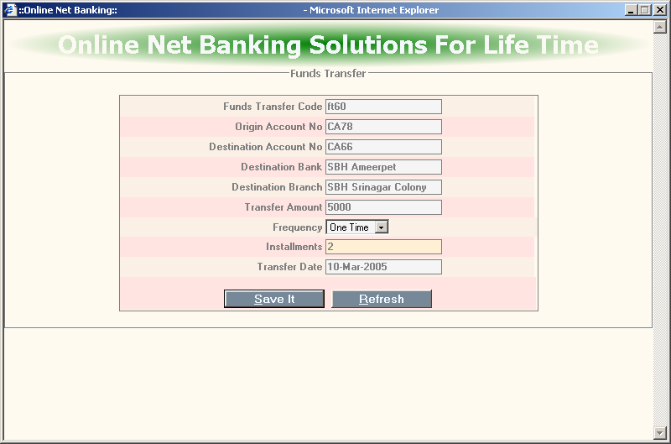

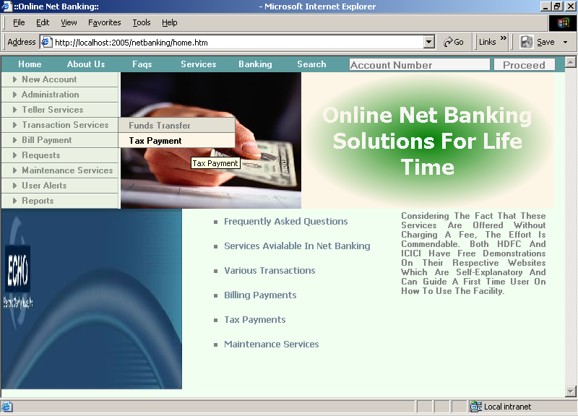

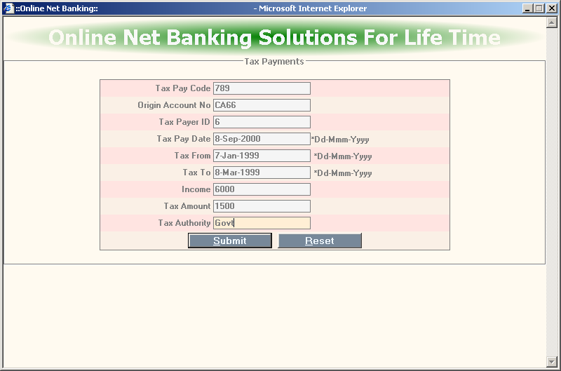

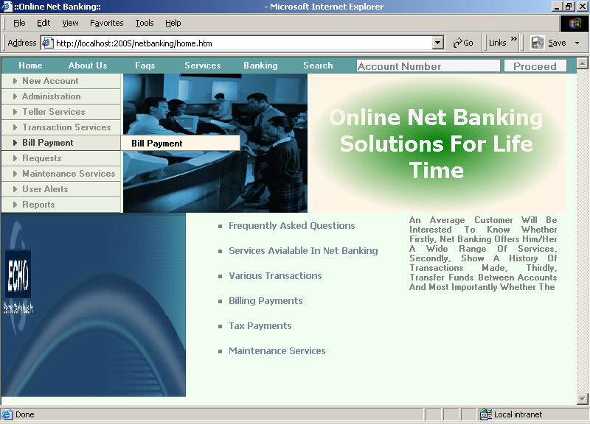

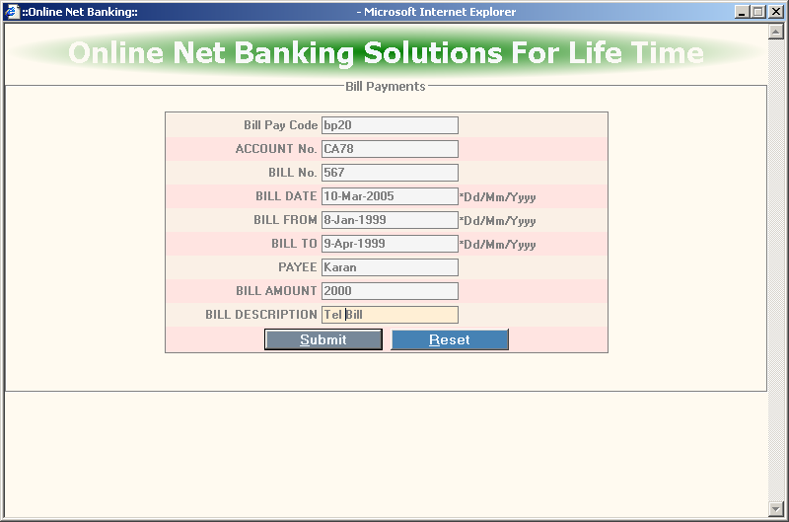

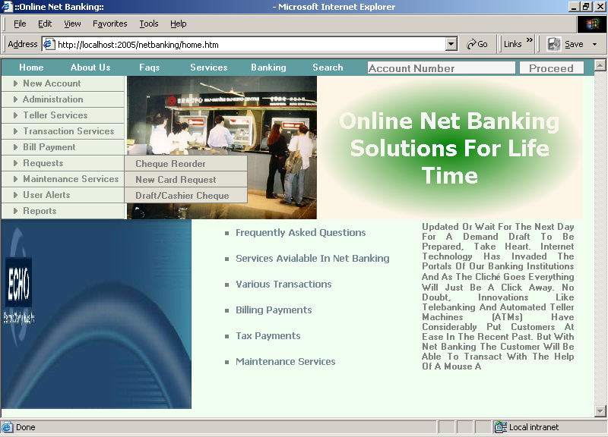

:

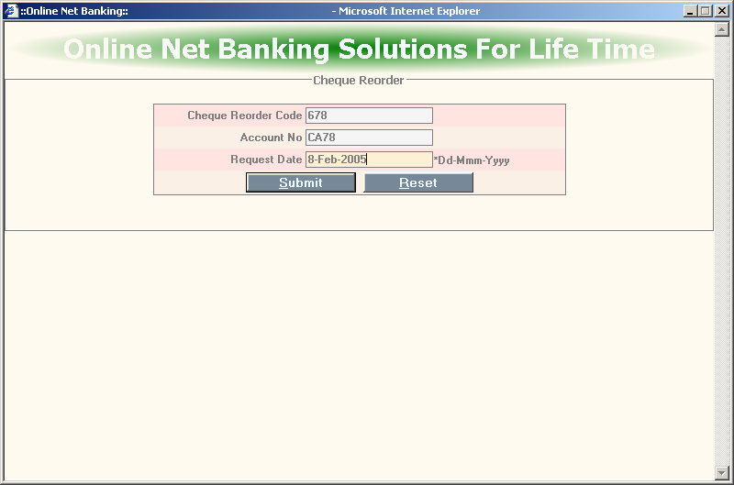

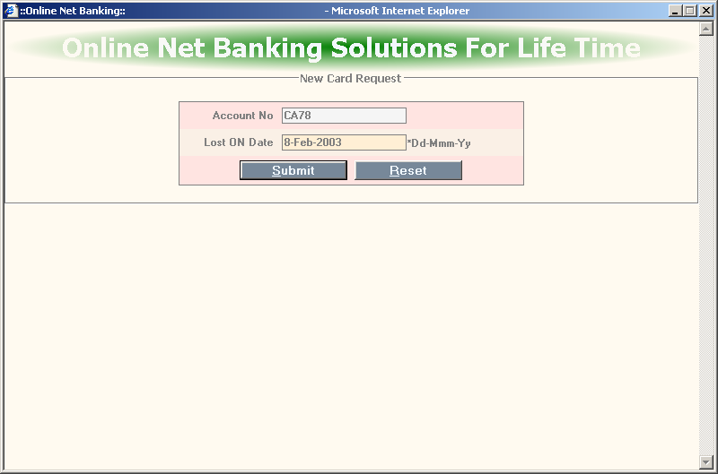

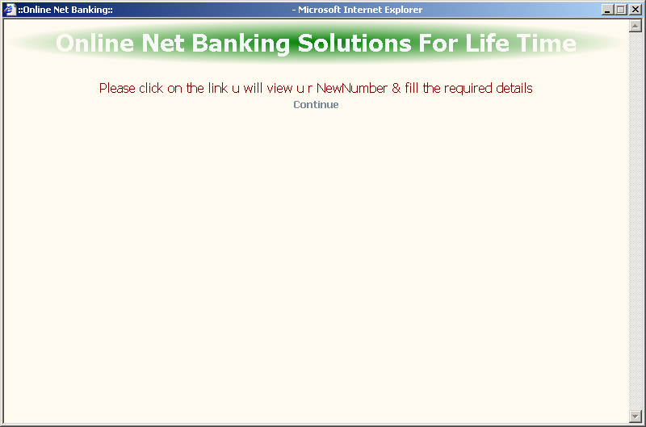

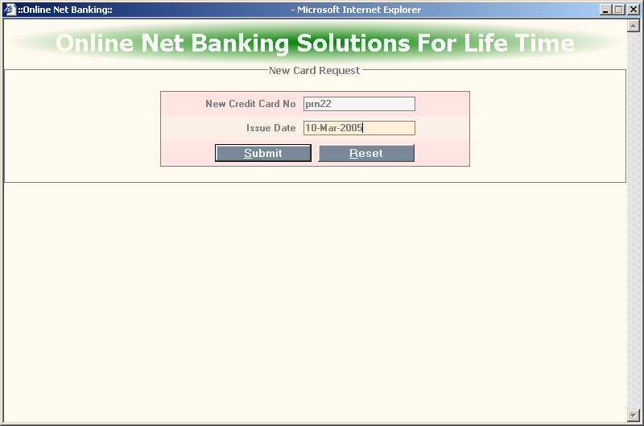

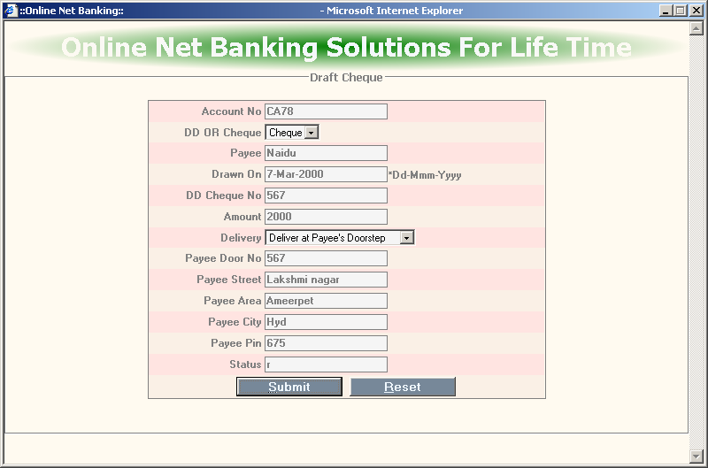

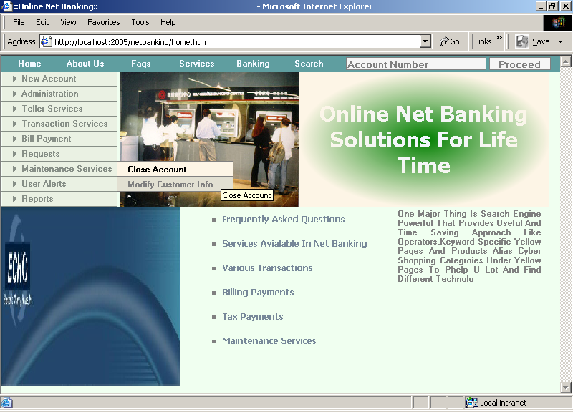

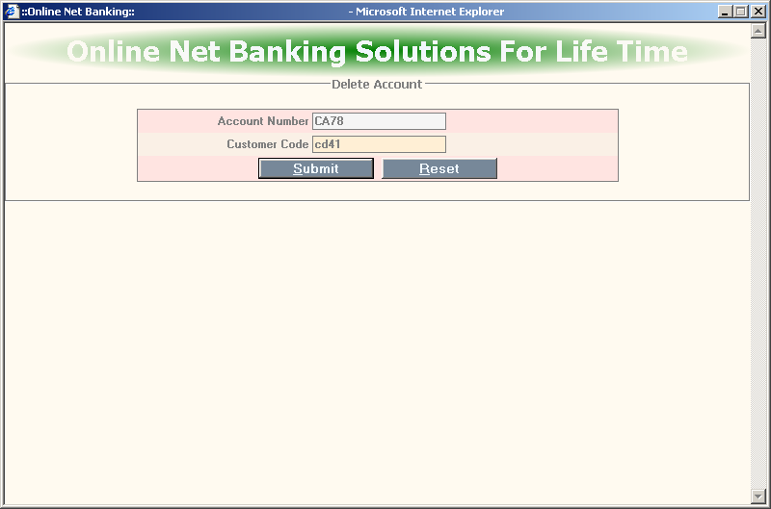

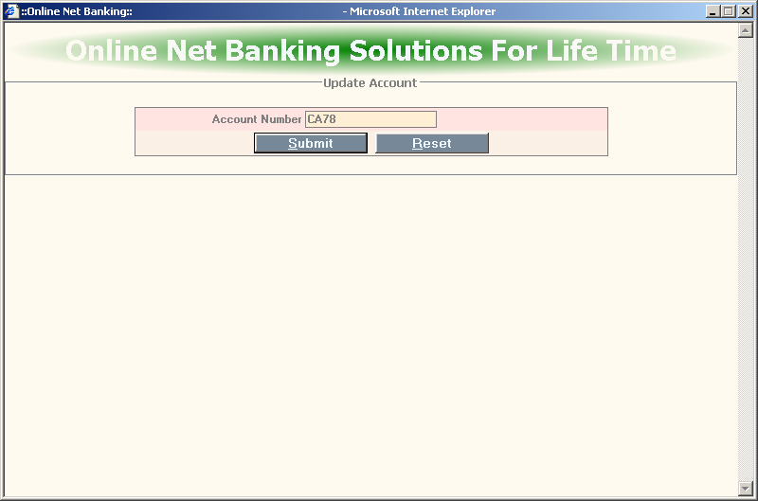

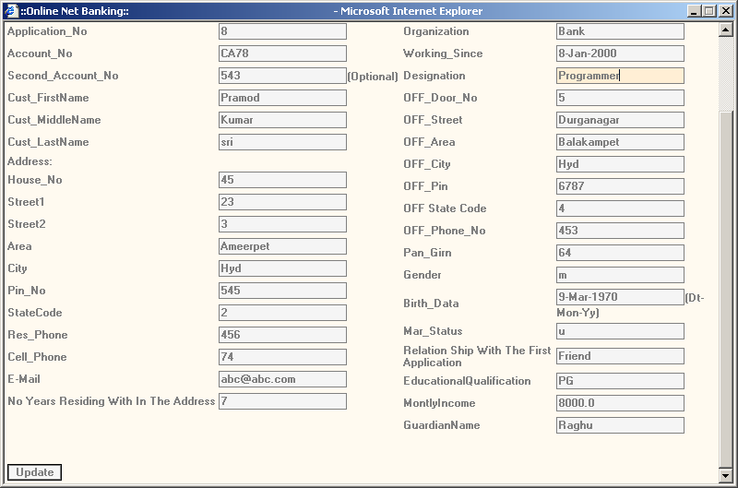

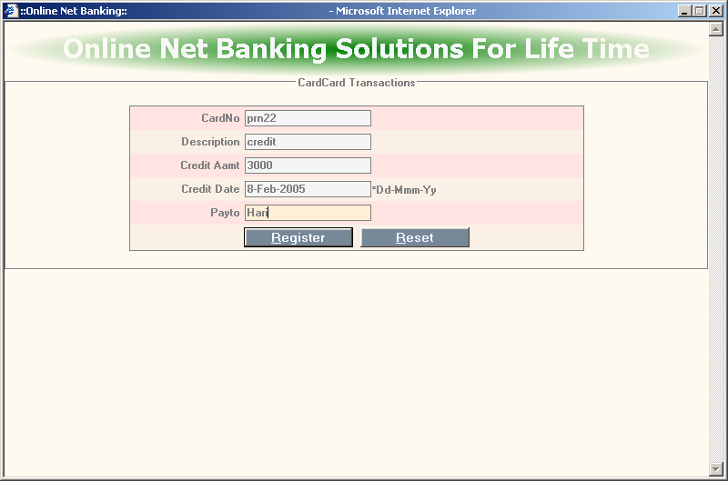

REPORTS

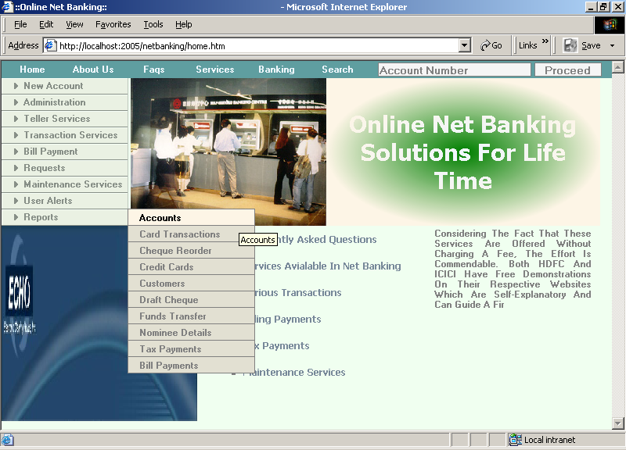

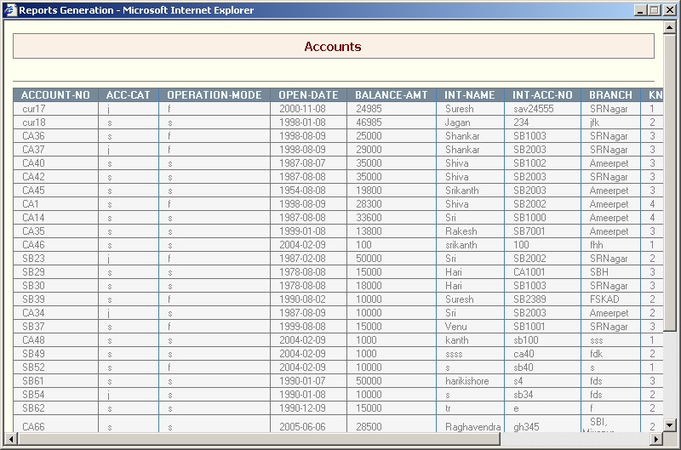

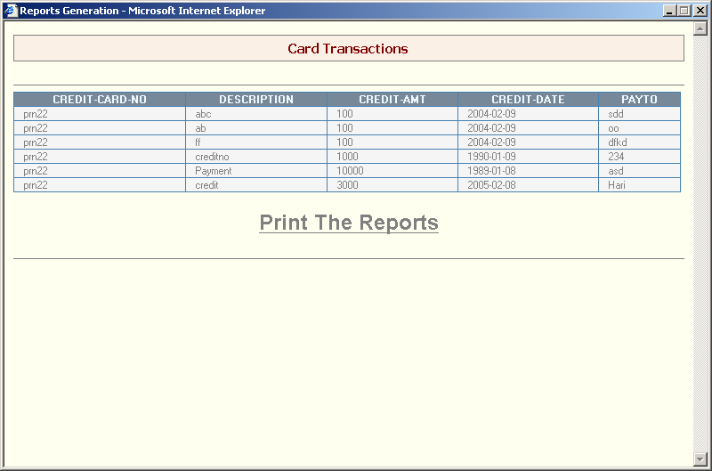

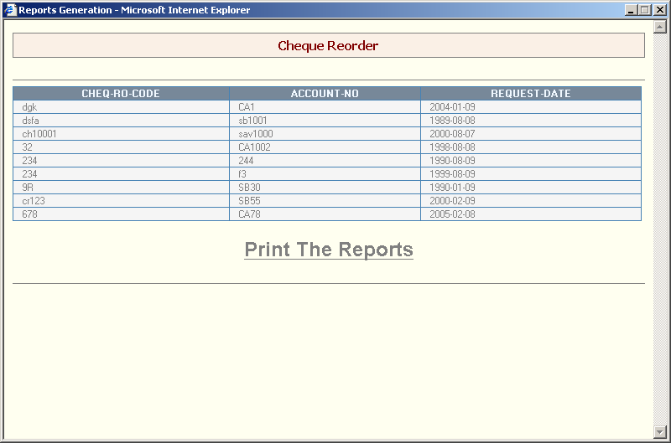

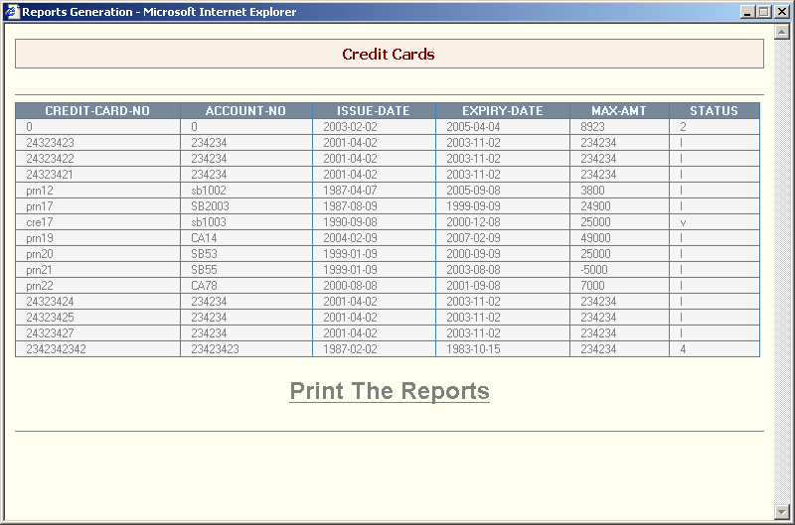

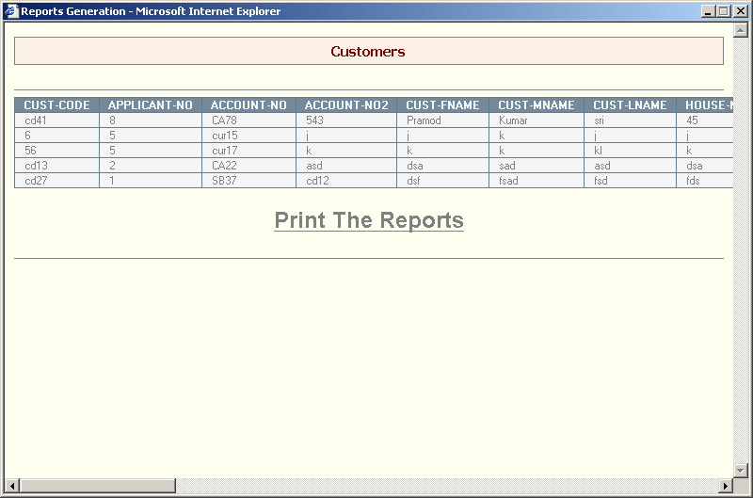

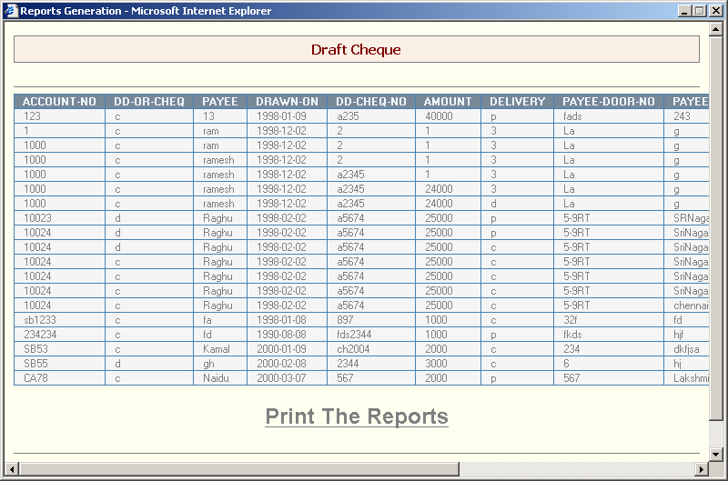

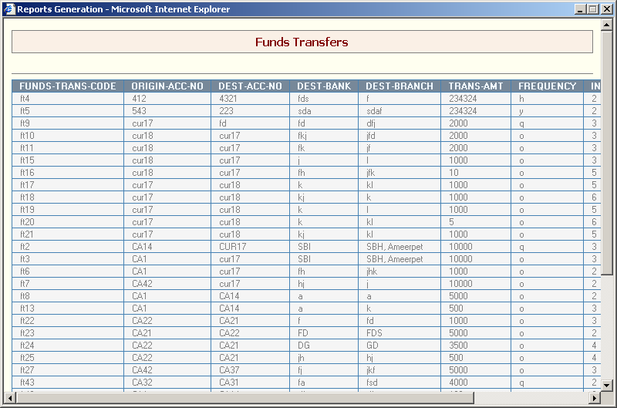

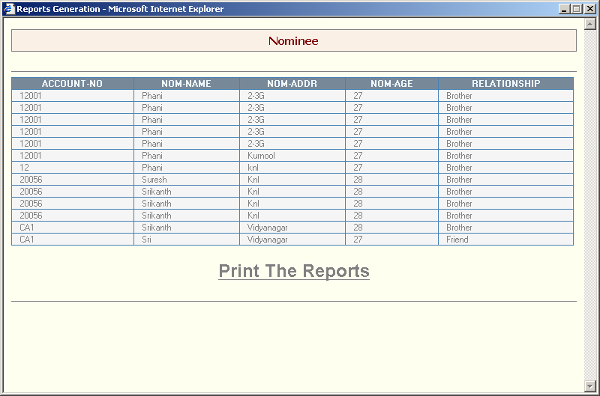

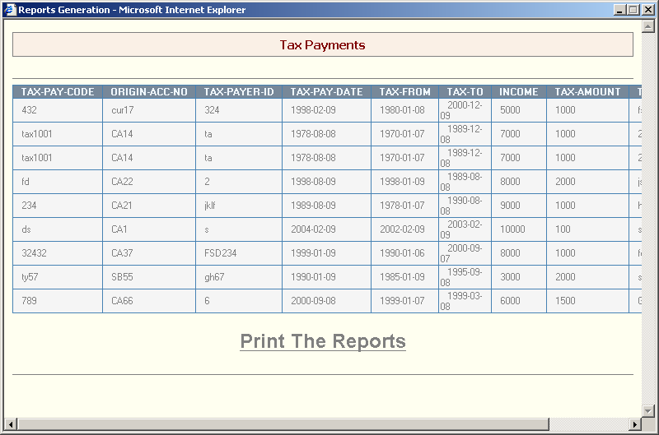

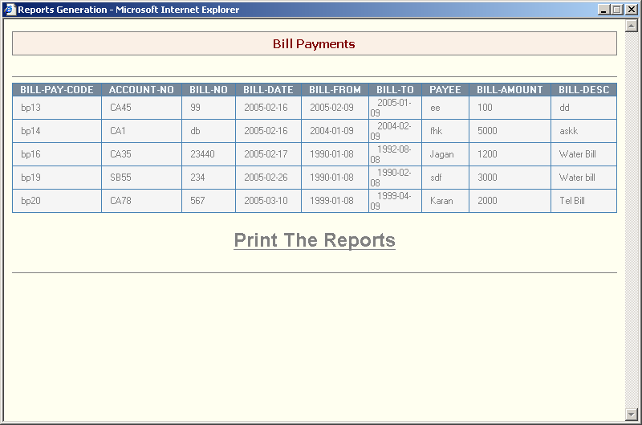

Conclusion

The project titled as Net Banking was deeply studied and analyzed to design the code and implement with various testing methods was done under the guidance of the experienced project guide. All the current requirements and possibilities have been taken care during the project time.
Net Banking is a useful project for all the local and corporate banks and the customers of the banks It saves the money and time. The costumer no need to go for bank to create account, for money transfer. Issuing of checks. It has a extra futures like bill payments (phone bill, current bill etc.) .Funds transfer from one accounts to another account is very easy.

BIBLIOGRAPHY

The following books and manuals provided a lot of help to us in making this project a reality.
JAVA COMPLETE REFERENCE
PATRICK NAUGHTON,
HERBERT SCHILDT
JAVA HOW TO PROGRAM
DEITERL & DEITEL
JAVA UNLEASHED
JDBC DATABASE ACCESS WITH JAVA
GRAHAM AMELTON,
RICK CATTEL,
MATDENE FISHER.
SERVLET PROGRAMMING
O’RELLY
OBJECT ORIENTED SOFTWARE ENGINEERING
BERND BTUEGGE & ALLEN H.DOTOIT
ORACLE COMPLETE REFARENCE
LONKY KOCH

