Books.XML
<?xml version="1.0" encoding="UTF-8"?>
<?xml-stylesheet type="text/css" href="Rule.css"?>
<books>
<heading>Welcome To GeeksforGeeks </heading>
<book>
<title>Title -: Web Programming</title>
<author>Author -: Chrisbates</author>
<publisher>Publisher -: Wiley</publisher>
<edition>Edition -: 3</edition>
<price> Price -: 300</price>
</book>
<book>
<title>Title -: Internet world-wide-web</title>
<author>Author -: Ditel</author>
<publisher>Publisher -: Pearson</publisher>
<edition>Edition -: 3</edition>
<price>Price -: 400</price>
</book>
<book>
<title>Title -: Computer Networks</title>
<author>Author -: Foruouzan</author>
<publisher>Publisher -: Mc Graw Hill</publisher>
<edition>Edition -: 5</edition>
<price>Price -: 700</price>
</book>
<book>
<title>Title -: DBMS Concepts</title>
<author>Author -: Navath</author>
<publisher>Publisher -: Oxford</publisher>
<edition>Edition -: 5</edition>
<price>Price -: 600</price>
</book>
<book>
<title>Title -: Linux Programming</title>
<author>Author -: Subhitab Das</author>
<publisher>Publisher -: Oxford</publisher>
<edition>Edition -: 8</edition>
<price>Price -: 300</price>
</book>
</books>

Rules.css
books {
color: white;
background-color : pink;
width: 100%;
}
heading {
color: green;
font-size : 40px;
background-color : powderblue;
}
heading, title, author, publisher, edition, price {
display : inline; (block, inline-block)
}
title {
font-size : 25px;
font-weight : bold;
}

Output1: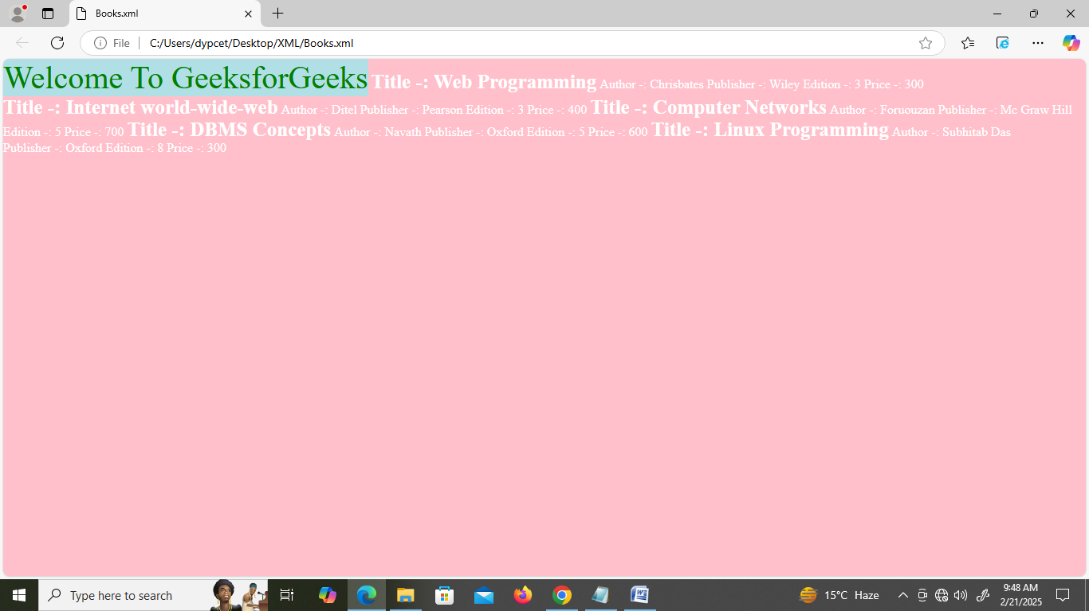

Output2:
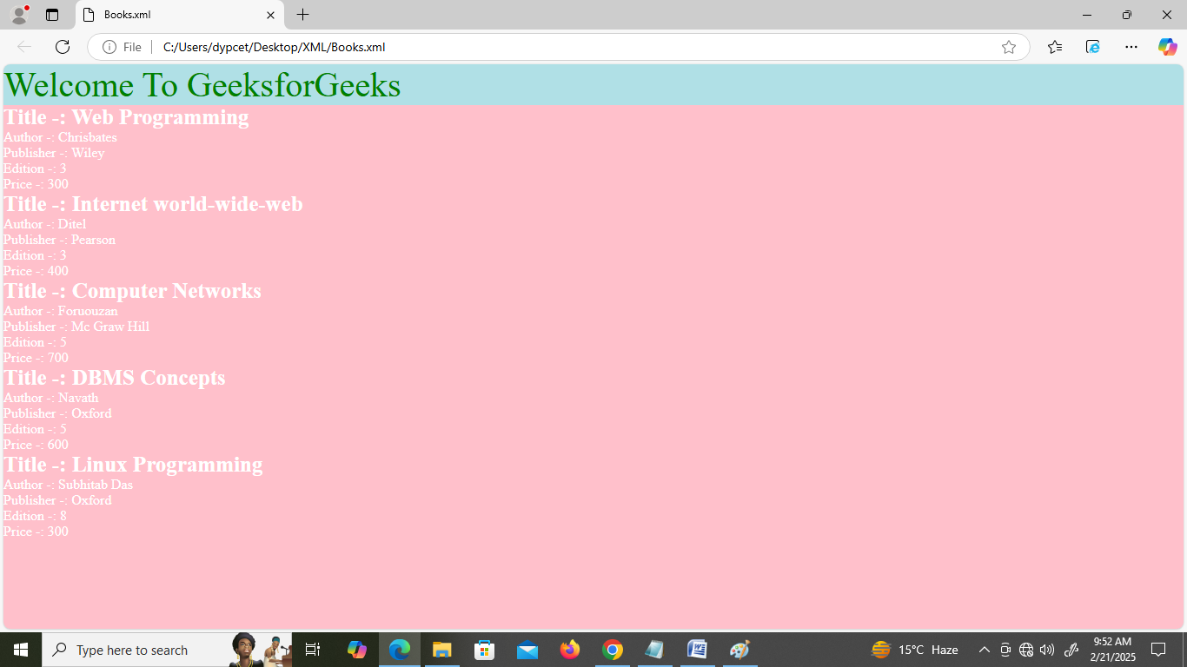

The display property specifies the display behavior (the type of rendering box) of an element.
Link:- https://www.w3schools.com/cssref/playdemo.php?filename=playcss_display

Value | Description
inline | Displays an element as an inline element (like <span>). Any height and width properties will have no effect. This is default.
block | Displays an element as a block element (like <p>). It starts on a new line, and takes up the whole width
contents | Makes the container disappear, making the child elements children of the element the next level up in the DOM
flex | Displays an element as a block-level flex container
grid | Displays an element as a block-level grid container
inline-block | Displays an element as an inline-level block container. The element itself is formatted as an inline element, but you can apply height and width values
inline-flex | Displays an element as an inline-level flex container
inline-grid | Displays an element as an inline-level grid container
inline-table | The element is displayed as an inline-level table
list-item | Let the element behave like a <li> element
run-in | Displays an element as either block or inline, depending on context
table | Let the element behave like a <table> element
table-caption | Let the element behave like a <caption> element
table-column-group | Let the element behave like a <colgroup> element
table-header-group | Let the element behave like a <thead> element
table-footer-group | Let the element behave like a <tfoot> element
table-row-group | Let the element behave like a <tbody> element
table-cell | Let the element behave like a <td> element
table-column | Let the element behave like a <col> element
table-row | Let the element behave like a <tr> element
none | The element is completely removed
initial | Sets this property to its default value. Read about initial
inherit | Inherits this property from its parent element. Read about inherit

