1. Create table Student (Rno, Name, DOB, Gender, Class, College, City, Marks)

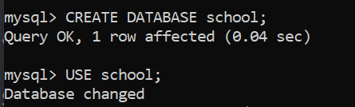

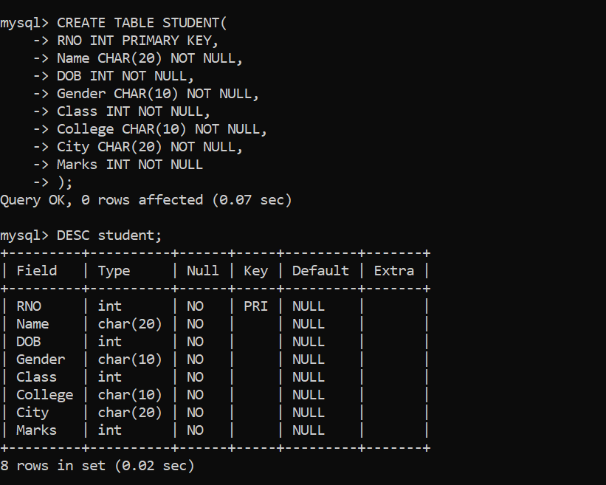

1. **Insert 5 records in student table**

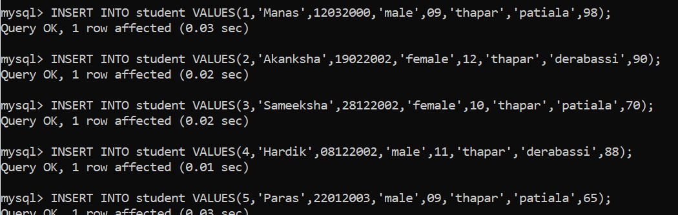

1. Display the information of all the students

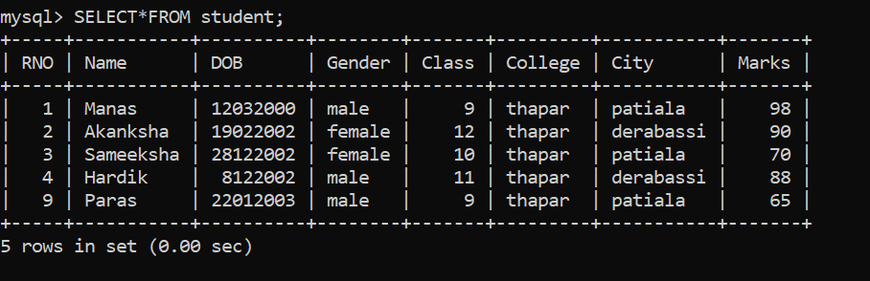

1. Display the detail structure of student table

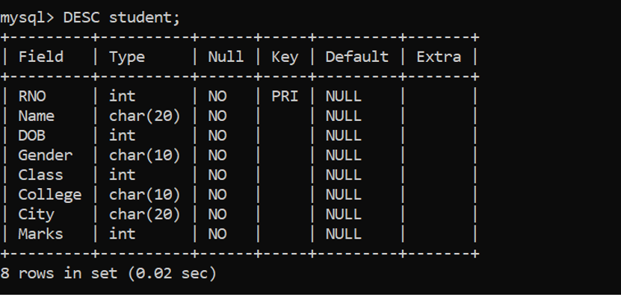

1. Display Rno, Name and Class information of ‘Patiala’ students.

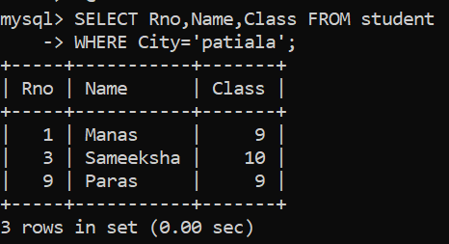

1. Display information on ascending order of marks

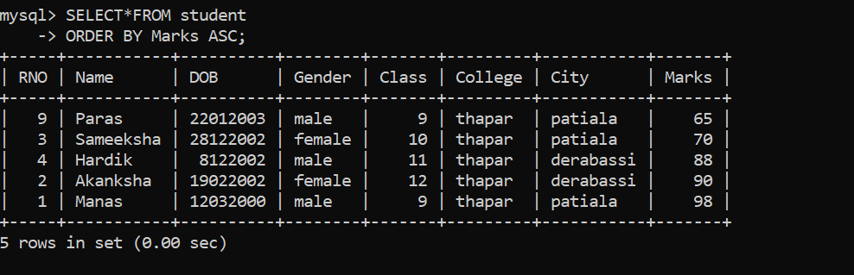

1. Change the marks of Rno 4 to 89.

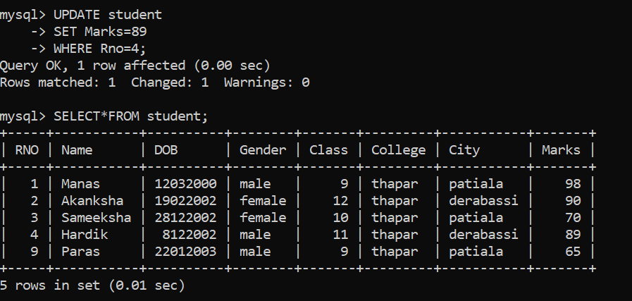

1. Change the name and city of Rno 9.

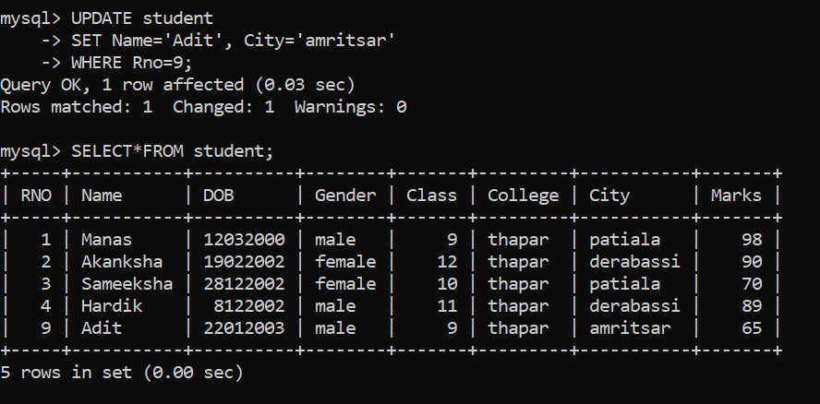

1. Delete the information of ‘Amritsar’ city records

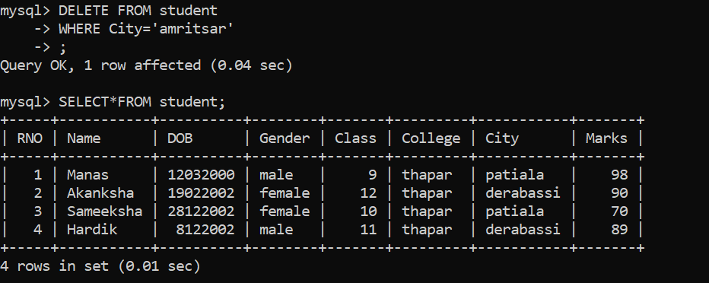

1. Delete the records of student where marks<30.

