**ASSIGNMENT-2**

**Name:Snehleen Cheema**

**Roll number: 102016037**

**Batch: 2CS9**

1. **Display the system date**

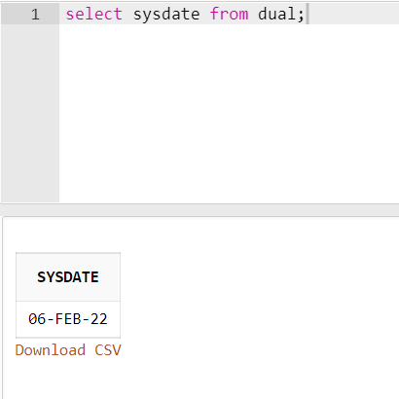

1. **Display current day**

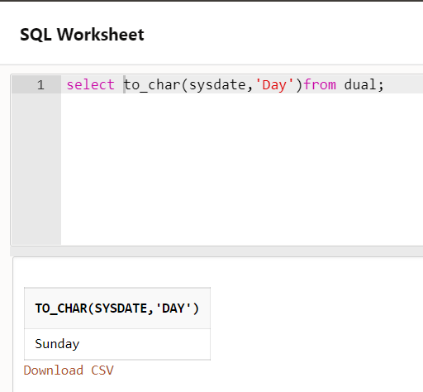

1. **Display current month and spell out year**

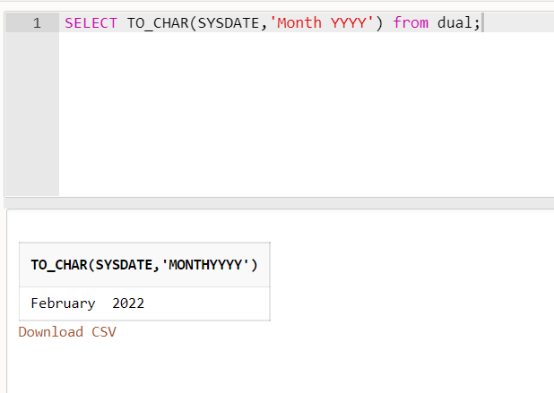

1. **Display spell out current date**

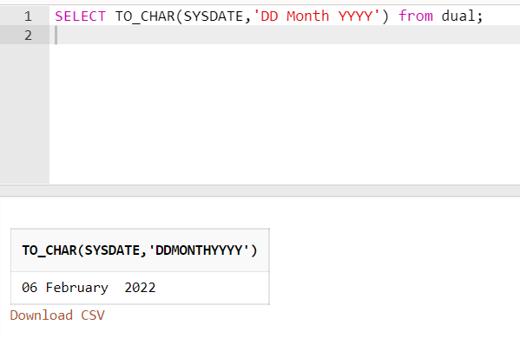

1. **Check whether it is AM or PM right now**

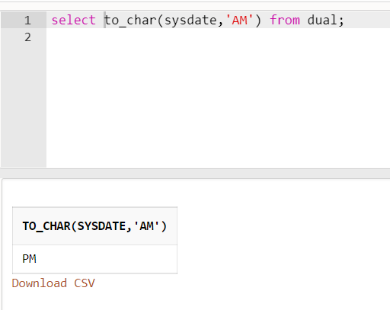

1. **Display the date of next Friday**

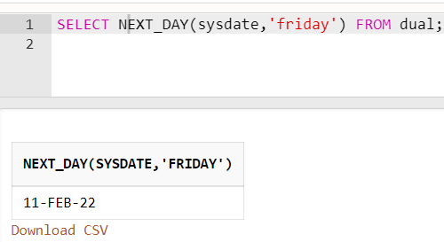

1. **Round the system date on month**

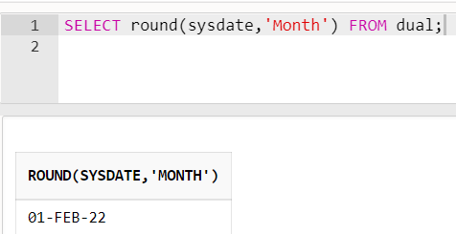

1. **Truncate the system date on month**

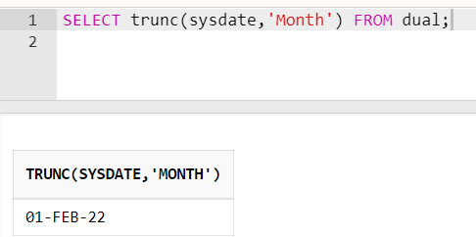

1. **Round the system date on year**

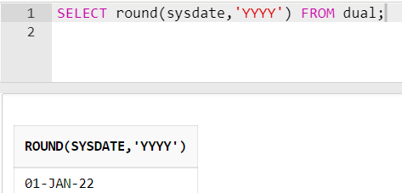

1. **Truncate the system date on year**

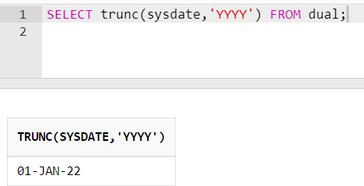

1. **Find the day after three days**

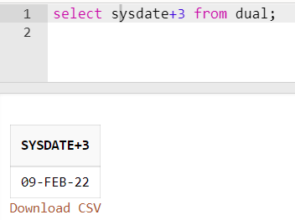

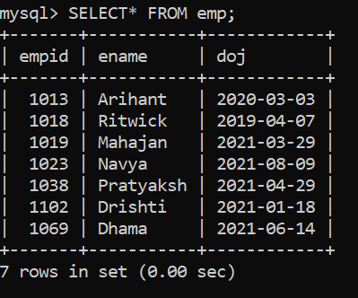

1. **Display day of date of joining column**

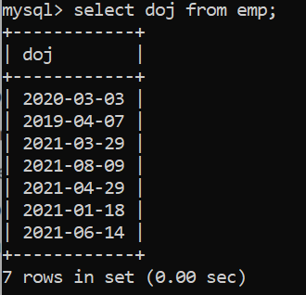

1. **Display those employees who join the company on Monday**

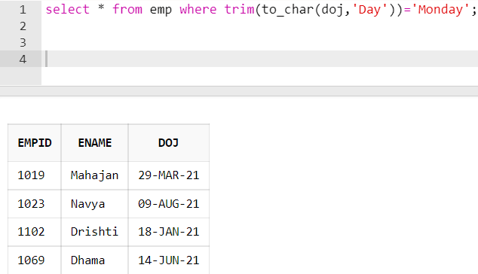

1. **Display those employees who join the company this month**

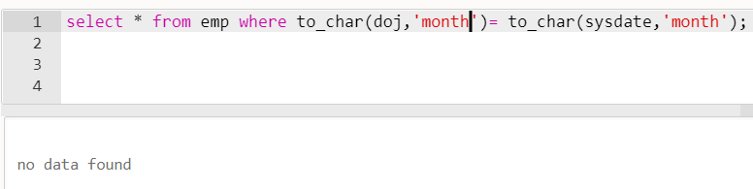

1. **Display those employees who join the company in last 30 days**

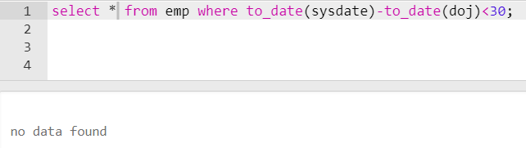

1. **Create a table train having three four columns: Train Number, date of Departure, time of departure, time of arrival**

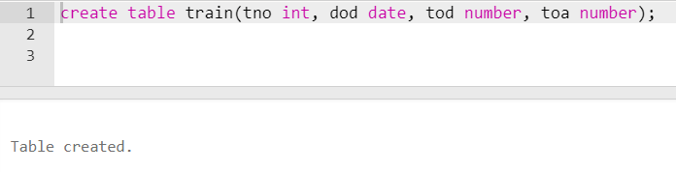

1. **Insert five columns in train table**

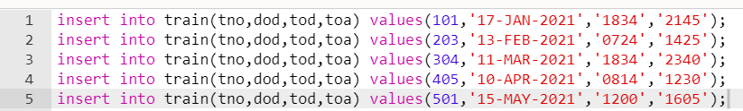

1. **Display all the records**

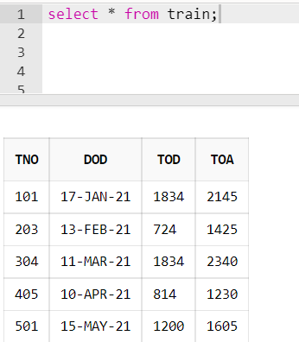

1. **Display the time values inserted in the columns**

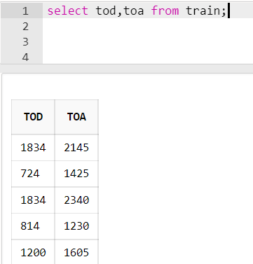

1. **Display those trains which arrived on PM**

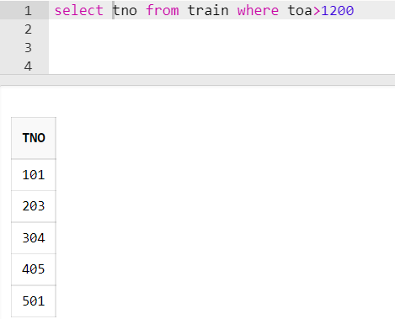

1. **Display train number who are going to depart in next on hour.**

