NAME: SNEHLEEN CHEEMA

ROLL NO.: 102016037

BATCH:2CS9

1. Create table emp which has the following attributes (employee table) (empno, ename, job, sal, deptno)

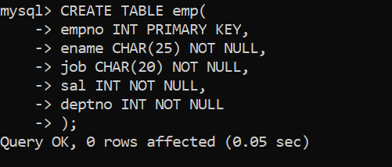

1. Insert appropriate records in above tables

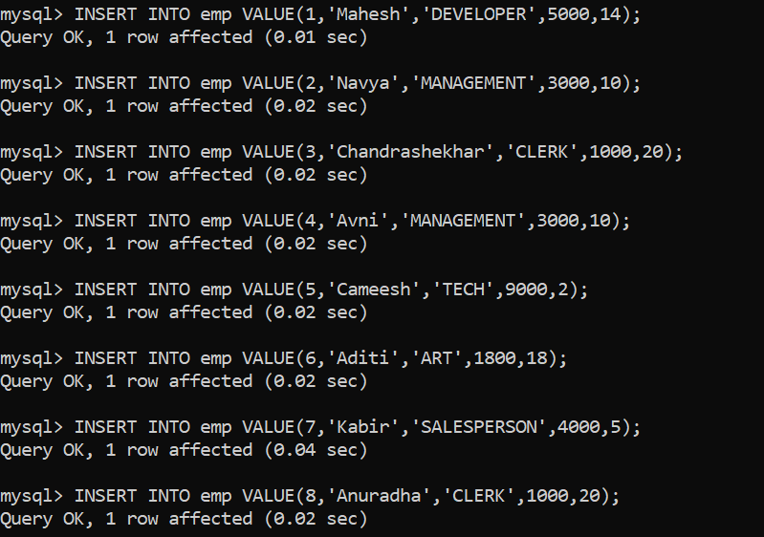

1. Get employee no and employee name who works in dept no 10

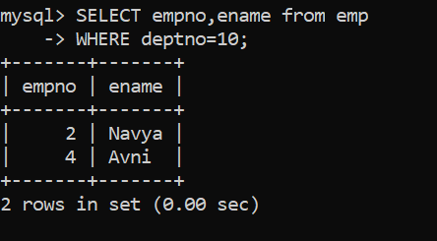

1. Display the employee names of those clerks whose salary > 2000

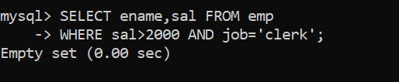

1. Display name and sal of Salesperson & Clerks

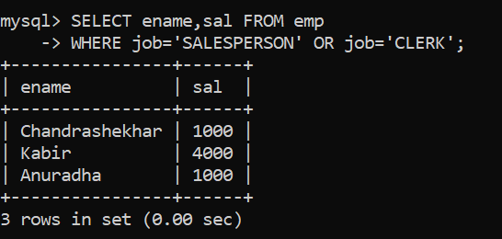

1. Display all details of employees whose salary between 2000 and 3000

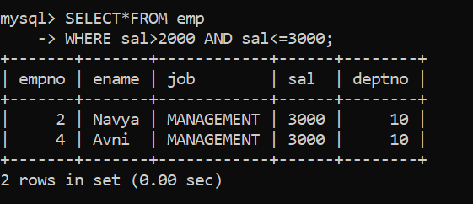

1. Display all details of employees whose dept no is 10, 20, or 30

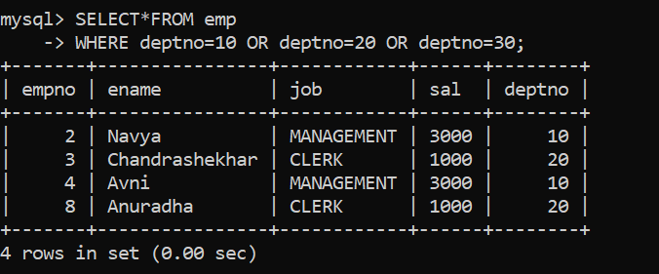

1. Display dept no & salary in ascending order of dept no and within each dept no salary should be in descending order

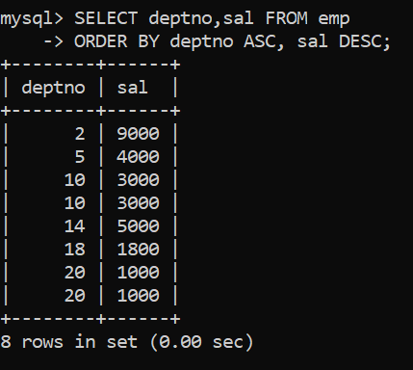

1. Display name of employees that starts with ‘C’

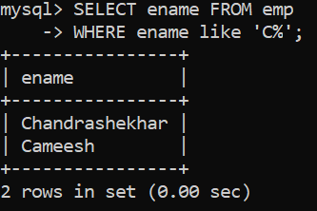

1. Display name of employees that ends with with ‘C’

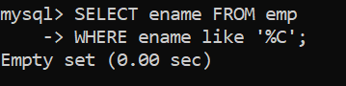

1. Display the name of the employees whose second char is ‘b’ or ‘B’

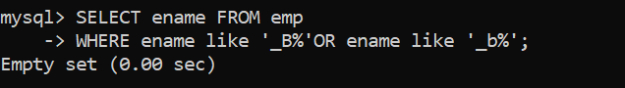

1. Display the name of the employees whose first or last char is ‘a’ or ‘A’

