TKG Test ROM
Last revised: 23 August 2026
Written by: SNESNESCUBE64

Table of Contents
Chapter 1: Overview 3
Compatible Hardware 3
Using the Test ROM 3
Expectations 3
Chapter 2: Startup Tests 3
RAM Tests 3
RAM Tests 3
RAM Bank Test 3
TRS2 and TKG2 RAM Locations 3
TKG3 RAM Locations 3
TKG4 RAM Locations 4
ROM Checksums 4
Test Overview 4
Test ROM Integrity Test 4
ROM Locations 4
ROM Checksum Table 5
DMA Test 6
NMI Test 6
Audio Tests 6
Sound Test 6
Music Test 6
Transition to Runtime 6
Chapter 3: Runtime Tests 6
Controls Test 6
DIP Switch Test 6
Palette Test 6
Screen Invert 6
Monitor Test 6
Sound Test 6
Music Test 6
Background Test 6
Sprite Test 6
Reset 6
Chapter 4: Test Architectures 6

Chapter 1: Overview

Compatible Hardware

Using the Test ROM

Assumptions

Chapter 2: Startup Tests

RAM Tests

RAM Tests

RAM Bank Test

TRS2 and TKG2 RAM Locations

Name | Designation | Type | Start Address | Size | High Bit Location | Low Bit Location
RAM0 | Work RAM | 2114 | 0x6000 | 1k x 4 | C-6L | C-6H
RAM1 | Work RAM | 2114 | 0x6400 | 1k x 4 | C-6M | C-6J
RAM2 | Work RAM | 2114 | 0x6800 | 1k x 4 | C-6N | C-6K
RAM3 | Sprite | 2148 | 0x7000 | 1k x 4 | V-5J | V-5K
RAM4 | Video/Background | 2114 | 0x7400 | 1k x 4 | V-3K | V-3J

TKG3 RAM Locations
Name | Designation | Type | Start Address | Size | High Bit Location | Low Bit Location
RAM0 | Work RAM | 2114 | 0x6000 | 1k x 4 | C-6L | C-6H
RAM1 | Work RAM | 2114 | 0x6400 | 1k x 4 | C-6M | C-6J
RAM2 | Work RAM | 2114 | 0x6800 | 1k x 4 | C-6N | C-6K
RAM3 | Sprite | 2148 | 0x7000 | 1k x 4 | V-2L | V-2M
RAM4 | Video/Background | 2114 | 0x7400 | 1k x 4 | V-5L | V-5M

TKG4 RAM Locations
Name | Designation | Type | Start Address | Size | High Bit Location | Low Bit Location
RAM0 | Work RAM | 2114 | 0x6000 | 1k x 4 | C-4C | C-3C
RAM1 | Work RAM | 2114 | 0x6400 | 1k x 4 | C-4B | C-3B
RAM2 | Work RAM | 2114 | 0x6800 | 1k x 4 | C-4A | C-3A
RAM3 | Sprite | 2148 | 0x7000 | 1k x 4 | V-6R | V-6P
RAM4 | Video/Background | 2114 | 0x7400 | 1k x 4 | V-2R | V-2P

ROM Checksums

Test Overview
The ROM test performs a 16-bit checksum on the contents of all ROMs. This test does not report the integrity of the ROMs nor does it validate that it is correct for a location. That is up to the user to determine. The exception to this is ROM 0, which is where the test ROM is located.

Test ROM Integrity Test
As part of the ROM test, ROM 0 will be validated. ROM 0 is the test ROM itself. Its own checksum is appended to the footer as part of a post-build script. It will compare the measured checksum with what is expected. If there is any corruption of the test ROM or if there is issues with accessing say the upper addresses, it will report a failure by printing “Integrity Fail”. In this case, the test ROM may not be trustworthy and could run into issues during execution.
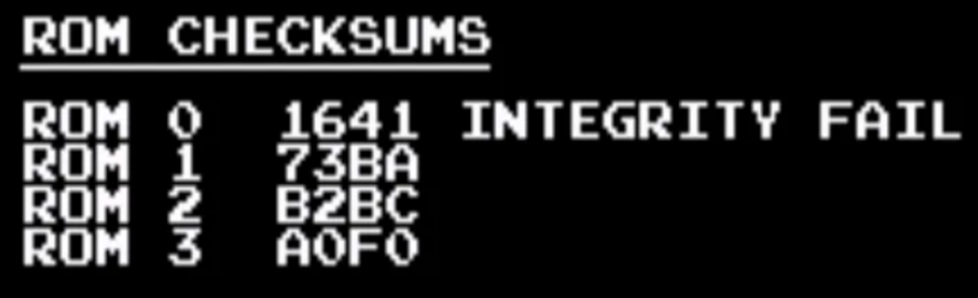
ROM Locations
ROM ID | ROM Type | ROM Size | Start Address | TKG2/TKG3 Location | TKG4 Location
ROM 0 | 2532 | 4k | 0x0000 | 5F | 5E
ROM 1 | 2532 | 4k | 0x1000 | 5G | 5C
ROM 2 | 2532 | 4k | 0x2000 | 5H | 5B
ROM 3 | 2532 | 4k | 0x3000 | 5K | 5A

ROM Checksum Table
ROM ID | US Set 1 | US Set 1 Hard | US Set 2 | Japan Set 1 | Japan Set 2 | Japan Set 3
ROM 0
ROM 1 | 73BA
ROM 2 | B2BC
ROM 3 | A0F0

DMA Test

NMI Test

Audio Tests

Sound Test

Music Test

Transition to Runtime

Chapter 3: Runtime Tests

Controls Test

DIP Switch Test

Palette Test

Screen Invert

Monitor Test

Sound Test

Music Test

Background Test

Sprite Test

Reset

Chapter 4: Test Architectures

