Request Title: Request to use color resist and adhesion promoter CT-3050L
Requestor: Tracy Lu Date: Nov. 4th , 2020
Non-SNF staff, please complete the following:
Badger ID: tracylu@royole.com
Company name/PI: Royole Corporation
Send completed form to: snf-promcommittee@lists.stanford.edu

- The chemical or material. Please provide all common names, trade names, and CAS numbers where appropriate. Include an MSDS, if available; or provide the reason, if not. Make sure to include information for any new secondary chemicals (such as a developer for a new resist). Read the MSDSs as well as the Stanford Chemical Storage Groups to determine the Storage Group Identifier and Main Hazard Class of your chemical/material.
CT-3050L is a color resist and adhesion promoter from Fujifilm. Below are the constituents of the chemical and their corresponding CAS numbers.
CT-3050L hazardous ingredients:
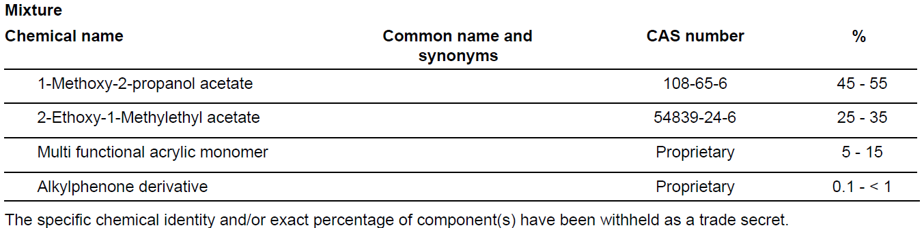
Please find attached the MSDS for the chemical in the same folder as this document.
- Vendor/manufacturer info: address and phone number, website URL.
FUJIFILM Electronic Materials U.S.A., Inc.
80 Circuit Road, North Kingstown, RI 02852.
Telephone: 1-800-553-6546.
https://www.fujifilm.com/us/en/business/semiconductor-materials/image-sensor-color-mosaic/transparent/applications
- Reason for request: Please give serious thought to this. If you have any process information (application notes from the vendor, protocol from another lab, experimental methods section of an article), please include it, preferably as attachments. Ask yourself these questions: Is this the latest procedure? Are there newer/safer alternatives that will also work for my project? Will any of the current SNF approved chemicals and materials work for me?
CT-3050L is a transparent material designed for surface adhesion promotion and planarization. Since we’re developing advanced display technology with QDPR and color filter, we encountered poor adhesion issue for yellow color resist CY-7000. This CT-3050L is recommended by Fujifilm vendor as a good partner of color resists for adhesion enhancement. And CT-3050L can be used as a planarization layer too.
- Process Flow: Please provide a detailed process flow description on how and where you proposed to use this chemical. This should include all Lab equipment to be used for processing your wafers once your new chemical or material has been used (even if your new material is a film that is removed, it may still pose potential contamination concerns.) Make sure to include wet benches. Please note that f the chemical/material is to be used in any the "clean" equipment, purity specifications will be needed. This is most important for chemicals/material that are not normally used for VLSI device fabrication. To be allowed into a "clean" tool, the material should MOS grade or better.
Below are the proposed processing steps:
- Spin coat the resist CT3050 on Headway.
- Using a resealable container, thansfer CT3050 coated wafer to the hotplate under the venting hood for soft bake
- Soft-bake using hotplate at 100C for 2mins.
- Spin coating SY-7000 on Headway.
- 2nd round of Soft-bake using hotplate at 100C for 2mins.
- Expose using Karlsuss Contact Aligner
- Develop using CD2060 and rinse with DI water on the wbmiscres/Headway2 bench. CD2060 is a diluted TMAH solution for the color resist, which has been applied by other lab users and approved PROM committee before
- Hard-bake using hotplate at 220C for 10mins.
All excess solvent and resist will be poured into the solvent waste carboys and wipes, foils, waste swabs etc. will be placed into zip-locks and disposed-off into the solvent trash can.
- Amount and form. How much will you bring in? Is it solid, powder or liquid? (Note: as a general rule, powders are not permitted in the cleanroom.) Do you need to mix it to use it?
We will store one bottle of 100mL of CT-3050L in the refrigerator at SNF, together with approved color resist SY-7000. One bottle of 4L CD2060 developer will be stored at room temperature in the metal flammables cabinet.
- Storage: Will you be storing your chemical/material at SNF? If so, please note any potential reactivity’s (this should be on the MSDS). Storage groups A, B, D and L are stored in the yellow solvent cabinet in the furnace support area, while storage groups C, E, F and G are stored on top of one of the Pass-through Carts. Ensure your chemical container or material is properly labeled. If there is no available room, it must be stored by in the bulk storage area. You will then need to obtain it from receiving area personnel each time you want to use it and return it to them when you are finished using it (or each time you leave the lab). Note that there is no storage of chemicals/materials in the processing lab or at any wet bench.
We propose to store the resist in the freezer inside the SNF cleanroom, where all the other resists, spin-on-glass, etc. are stored.
- Disposal: How will you dispose of any waste or excess chemical or material? In your discussions with experts and vendors, try to determine the best way to dispose of your spent chemicals and by-products. Please refer to the SNF Lab members Safety Manual for the different methods of waste disposal that are available in the lab.
We will dispose-off excess resist into the solvent waste carboys or seal in plastic zip lock bags and dispose-off in the solvent waste receptacles.

To be completed by the PROM COMMITTEE:
Special handling requirements:

On-going approval or staff interaction requirements:

Approved By/Date:

