Request Title: Request processing sealed silicon particles in SNF
Requestor: Yufei Yang Date: 11/22/2021
Non-SNF staff, please complete the following:
Badger ID: yuffie
Company name/PI: Yi Cui
Send completed form to: snf-promcommittee@lists.stanford.edu

- The chemical or material: silicon powder (sealed in a special sample holder), more specifically, micron-size porous silicon particle with diameter around 1-15 μm. CAS: 7440-21-3. Storage group: L. Main hazard: flammable solid.
- Vendor/manufacturer info: lab self-made.
- Reason for request: I hope to process silane coating on my silicon powders using LPCVD furnace in SNF.
- Process Flow:
Tool: Thermcopoly 2 (in the "flexible (gold-contaminated)" group)
Process: To avoid powder contamination to the clean room and the furnace, I will contain my powders in a special sample holder designed for particle ALD. The container has a standing steel pan and a FeNi36 mesh that allowing gas to diffuse in but not particles/liquid out (see photos below). The powders will be restricted in the sample holder in the whole process, from entering the cleanroom, entering the furnace, to exiting the cleanroom. To further insure no powder contamination, I will use a secondary container to hold my sample holder and not open it till I mount it into the furnace tray. And after the LPCVD process, I will put the sample holder back to the secondary container and leave the cleanroom.
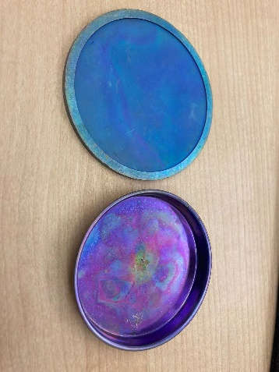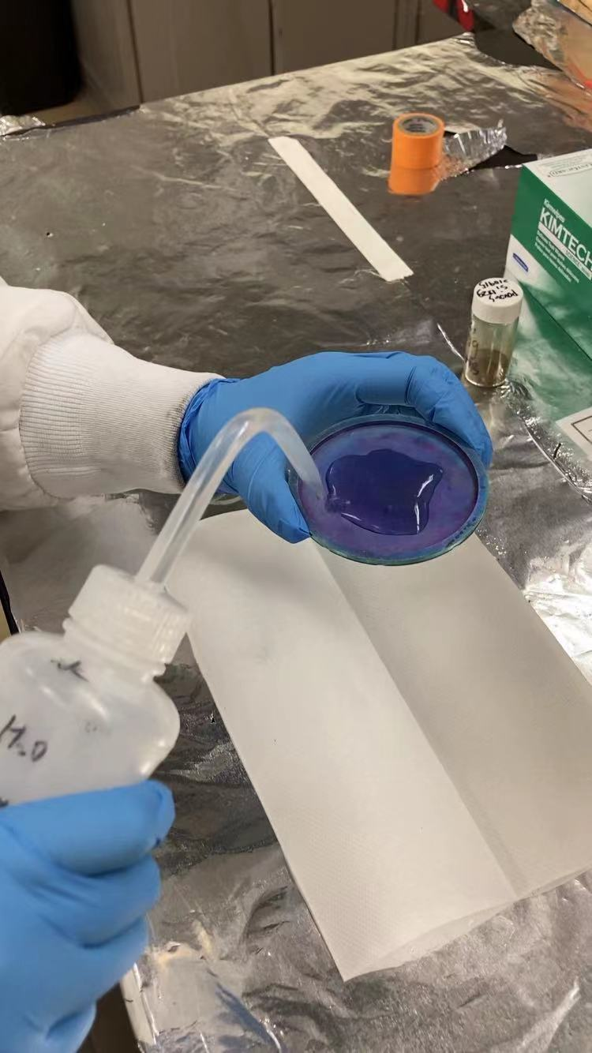
- Amount and form. 1 gram of solid powder sealed in a sample holder.
- Storage: No need to store my samples in the cleanroom.
- Disposal: No need to dispose my samples in the cleanroom

To be completed by the PROM COMMITTEE:
Special handling requirements:

On-going approval or staff interaction requirements:

Approved By/Date:

