Request Title: Use of external power supply for localized heated samples in flipchipbonder
Requestor: Hansen Qiao Date: 01/25/19
Non-SNF staff, please complete the following:
Badger ID: hansenq
Company name/PI: Stanford University (Mechanical Engineering)/Kenneth Goodson
Send completed form to: snf-promcommittee@lists.stanford.edu

- The chemical or material.
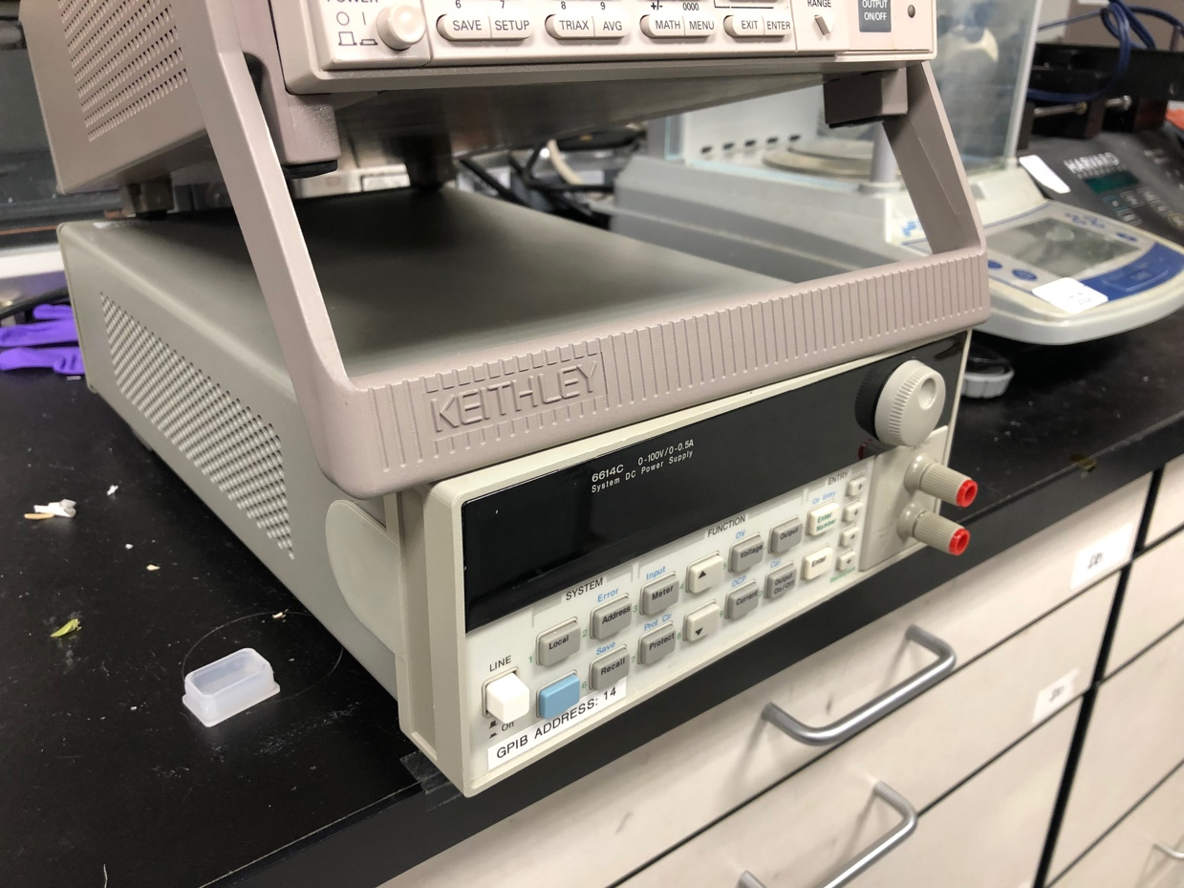
Agilent Model 6614C (0-100V/0-0.5A) System DC Power Supply
(In this picture, the “Agilent” brand is covered by some black sticker in the corner. “Keithley” is for another equipment on the top.)
User guide: http://user.engineering.uiowa.edu/~expeng/equipment/hp_6612c_manual.pdf
- Vendor/manufacturer info:
Agilent https://www.agilent.com Phone: +1 408-345-8886 Fax: +1 408-345-8474
Address: 5301 Stevens Creek Blvd, Santa Clara, CA 95051 United States
- Reason for request:
During the study of eutectic bonding on flip chip bonder, in order to get a better view of the bonding metal between the substrates, we use Pyrex glass as the top substrate. Pyrex is not only transparent, but also has similar coefficient of thermal expansion to that of Si, which makes it a good choice for bonding with Si pieces.
However, one big problem for Pyrex is that it has very low thermal conductivity. In the flip chip bonder, as the heat comes from the chip holders and needs to go through the substrate, the temperature of metal in the middle is limited by the poor heat conduction. This low temperature will affect the choice of metal in the recipe, as well as the quality of bonding. If the sample could be localized heated, which means the heat is generated in between the layers, the metal region would probably reach higher temperature, as shown in the figure below:
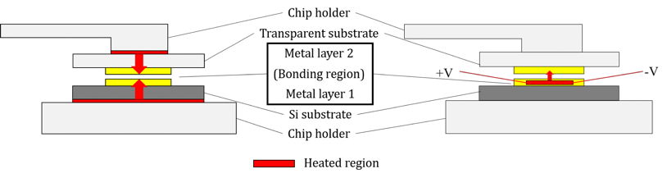
Traditional heating (left) & Localized heating (right)

To achieve localized heating, we re-designed the pattern of the metal layer. The old pattern is a simple square, and it is not sufficient enough for joule heating. In contrast, the new pattern contains serpentine lines of metal, which serve not only as the bonding material, but also the electric heater due to the relatively larger resistance. With the pattern deposited, we need an external power supply to provide the current going through.
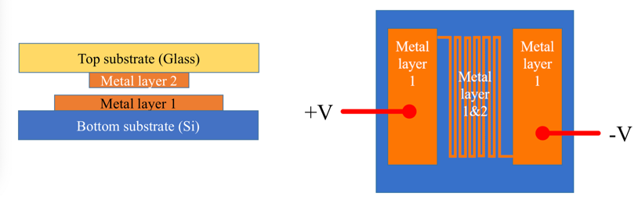
Pattern of metal layer 1&2
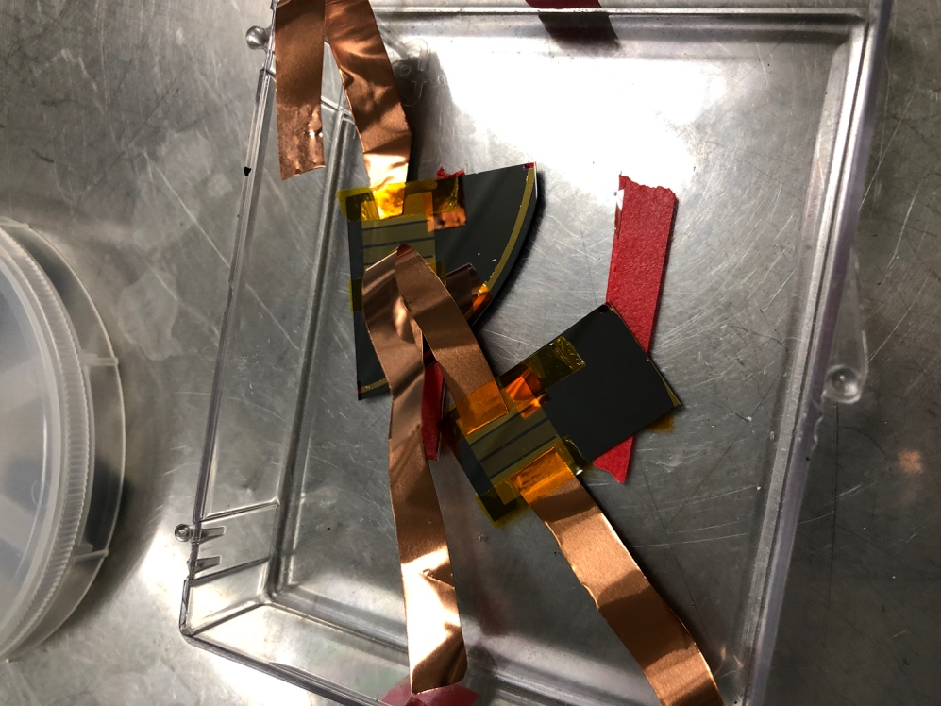
Wire-connected bottom substrate
- Process Flow (and safety concern):
Most of the operating steps are the same as the normal flip chip bonding process. However, no heating program will be installed in the computer: in other words, the flip chip bonder only provides the pressure on the samples.
The temperature of bonding may be controlled by adjusting the current/voltage output of the external power supply. However, there exists some difficulty in calculating the temperature according to the power applied. On one hand, the temperature may be affected by factors including various contact resistance, convective heat transfer coefficient and deviation in physical properties of thin films from bulk materials. It is hard to give good estimate for all the uncertainties according to calculation only. On the other hand, the spatial distribution of temperature is not uniform: the temperature distribution inside the small features (~10 micron) may not be well characterized.
Despite the uncertainty in bonding temperature, the localized bonding process is not likely to heat the substrate holder over 400 °C. (1) According to the Au-Si phase diagram, the minimum of temperature needed is 360°C, while the temperature of the holder in contact with the substrate would be even lower due to the conductive resistance of silicon/pyrex. (2) During ENGR 241 course in the autumn quarter of 2016, a recipe for eutectic bonding of Au-Si was developed for two silicon pieces. The class project proved that the eutectic bonding of Au-Si could be completed at temperature not more than 400°C.
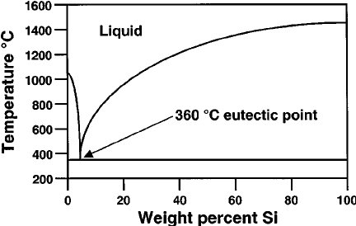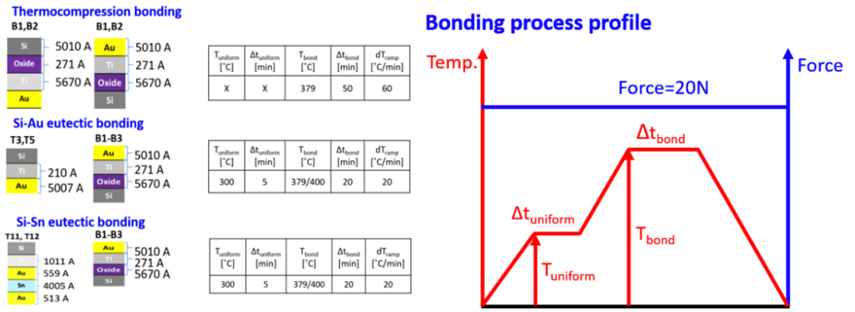
Left: Au-Si phase diagram
Right: Recipe for Au-Si eutectic bonding
(Ki wook & Heungdong, ENGR241 class project, autumn 2016)

- Amount and form
No extra chemical or mixture included.
- Storage:
May store the power supply under the tables near the flipchipbonder in the ExFab. However, if required, the power supply could be brought out of the cleanroom after using each time.
- Disposal:
The usage of the external power supply is not expected to add extra waste to the traditional bonding process. The samples after bonding will be taken out of the cleanroom and not disposed inside SNF.

To be completed by the PROM COMMITTEE:
Special handling requirements:

On-going approval or staff interaction requirements:

Approved By/Date:

