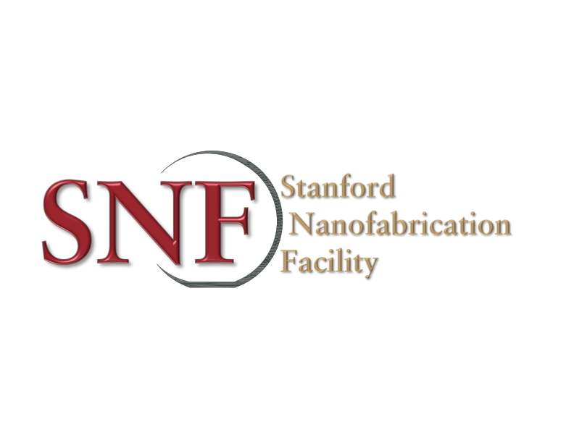
Process or Materials Review Request Form
Request Title: Request to use Aqua Regia to wet etch Pt
Requestor: Archana Kumar Date: 05/08/2019
Non-SNF staff, please complete the following:
Badger ID: archana_kumar@amat.com
Company name/PI: Applied Materials
Send completed form to: snf-promcommittee@lists.stanford.edu
- The chemical or material.
This request is for a non-standard process with standard available chemicals in SNF. Aqua Regia is a mixture of concentrated nitric acid and concentrated hydrochloric acid in a 1:3 molar ratio (1:4 volume ratio for 37% HCl and 69% HNO3). Both Nitric acid and hydrochloric acid are standard available approved chemicals in SNF and will be mixed in a beaker at the time of use. SNF versions of MSDS apply (links on SNF wiki). nitric acid is corrosive and toxic and hydrochloric acid is corrosive and toxic.
https://fscimage.fishersci.com/msds/16550.htm
https://fscimage.fishersci.com/msds/11155.htm
- Vendor/manufacturer info
Standard SNF provided chemicals.
- Reason for request
This mixture will be used to test the selective etch of Pt metal on Pt silicide. Thin <50nm layers of Pt will be etched from 1”x1” Silicon pieces. This specific process is necessary for comparison with a customer flow in a commercial fabrication facility and cannot be substituted with another process due to the nature of customer deliverables for this project.
- Process Flow:
Both nitric acid and hydrochloric acid are standard available approved chemicals in SNF and will be mixed in a beaker at wbflexcorr-1/2 at the time of use.
- Starting substrate: Oxide patterned silicon pieces (1.2”x1.2”)
- 50nm Pt deposited at Lesker sputter at 200W
- Anneal in N2, 550C 5 min AW610_R to form PtSi
- Anneal in O2, 550C, 2 min, AW610_R
- Etch unreacted Pt from coupon using Aqua Regia dip and rinse in DI water

Full PPE will be used. both sides of the bench will be reserved and enabled for other users’ safety. The process will be done during daytime office hours with staff members around if needed.

Web references with the chemical equations etc:
https://en.wikipedia.org/wiki/Aqua_regia
https://www.thoughtco.com/making-aqua-regia-acid-solution-603641
- Amount and form:
No new chemical will be brought in. Both nitric acid and hydrochloric acid are standard available approved chemicals in SNF and will be mixed in a beaker at the time of use. Estimated volume of use - 200ml perhaps once a week for 2 or 3 weeks. Nitric acid will be added to the hydrochloric acid in that order, as per recommended procedure.
- Storage:
No mixture will be stored. The mixture will be made and used within 2 hours at wbflexcorr-1/2 for the etch process.
- Disposal:
The used chemical will have etched metal (Pt), on staff recommendation, the chemical will be disposed in the HF drain immediately with copious amounts of water down the drain to dilute the chemistry.
To be completed by the PROM COMMITTEE:
Special handling requirements:
On-going approval or staff interaction requirements:
Approved By/Date:
V1.0

