# CS 255 System Design Document

## UML Diagrams

Dusty Cook - 04/19/2025 – Professor Madeley - CS255

### UML Use Case Diagram

### UML Activity Diagrams

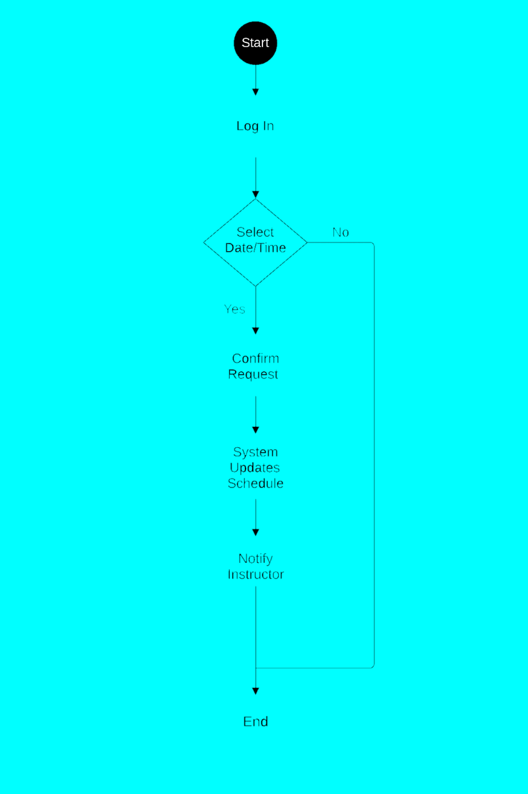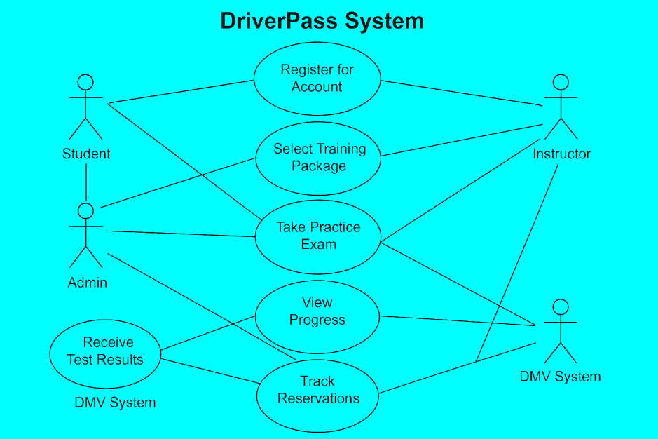

### UML Sequence Diagram

### UML Class Diagram

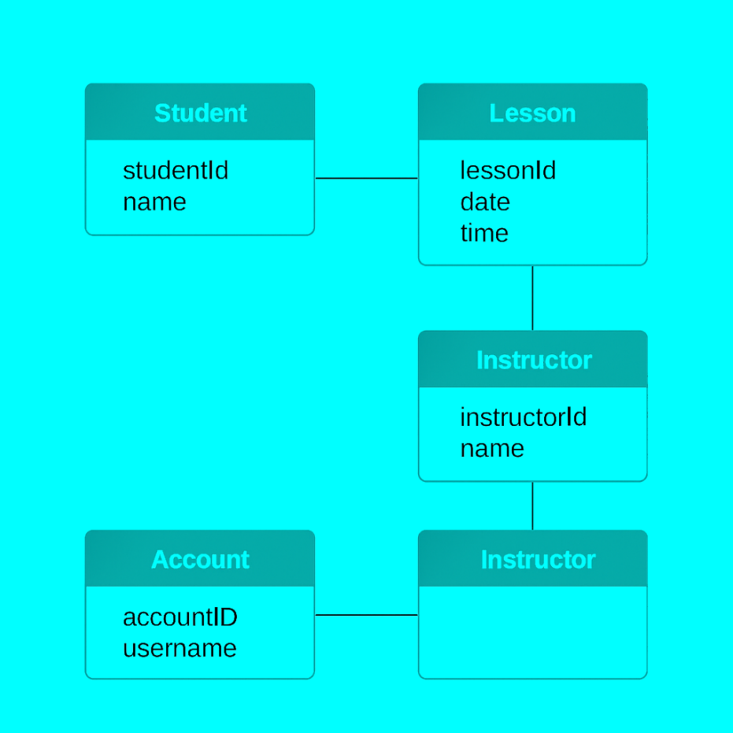

## Technical Requirements

The DriverPass system needs a cloud-based infrastructure for accessibility, scalability, and low maintenance requirements. The backend will utilize a modern framework such as Node.js or Python (Flask or Django), while the frontend will incorporate HTML, CSS, and JavaScript to create a responsive user interface. A relational database such as MySQL or PostgreSQL will handle user accounts, lesson schedules, and tracking progress. To ensure security, the system will implement HTTPS encryption and role-based access control (RBAC), allowing students, instructors, and administrators to access only the features relevant to them. Furthermore, tools like Lucidchart will facilitate system modeling, whereas GitHub and Jira will aid in version control and project management. The system will also feature automated daily backups and email integration for notifications and registration confirmations.