Name: Shah Nawaz Hussain
Roll No: 244CA49

Computer Graphics Lab – 2

Assginment – 1

Q1.

CODE:
#include<GL/glut.h>

int point[3][2] = { {50, 100}, {75, 150}, {100, 200} };

void init() {
glClearColor(0.0,1.0,0.0,0.5);
glMatrixMode(GL_PROJECTION);
gluOrtho2D(0.0,500.0,0.0,500.0);
}

void display() {
glClear(GL_COLOR_BUFFER_BIT);
glColor3f(1.0,0.0,1.0);
glPointSize(10.0);
glBegin(GL_LINE_STRIP);
for(int i=0; i<3; i++) {
glVertex2iv(point[i]);

}
glEnd();
glFlush();
}

int main(int argc, char** argv) {
glutInit(&argc,argv);
glutInitDisplayMode(GLUT_SINGLE | GLUT_RGB);
glutInitWindowSize(500,500);
glutCreateWindow("Point Example");
init();
glutDisplayFunc(display);
glutMainLoop();
return 0;
}

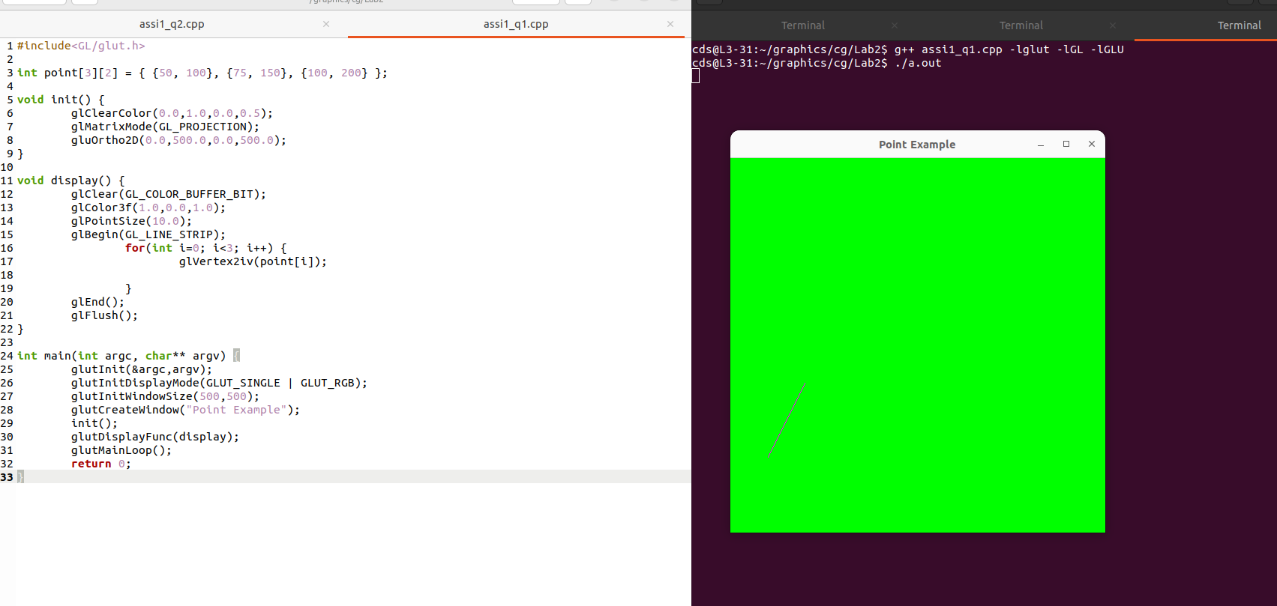

Q2 .
CODE:
#include<GL/glut.h>

int point[3][2] = { {100, 200}, {150, 150}, {100, 100} };

void init() {
glClearColor(0.2,0.7,0.8,0.5);
glMatrixMode(GL_PROJECTION);
gluOrtho2D(0.0,500.0,0.0,500.0);
}

void display() {
glClear(GL_COLOR_BUFFER_BIT);
glColor3f(1.0,0.0,1.0);
glPointSize(10.0);
glBegin(GL_LINES);
for(int i=0; i<3; i++) {
glVertex2iv(point[i]);
glVertex2iv(point[(i+1)%3]);
}
glEnd();
glFlush();
}

int main(int argc, char** argv) {
glutInit(&argc,argv);
glutInitDisplayMode(GLUT_SINGLE | GLUT_RGB);
glutInitWindowSize(800,800);
glutCreateWindow("Trianlge");
init();
glutDisplayFunc(display);
glutMainLoop();
return 0;
}

OUTPUT:

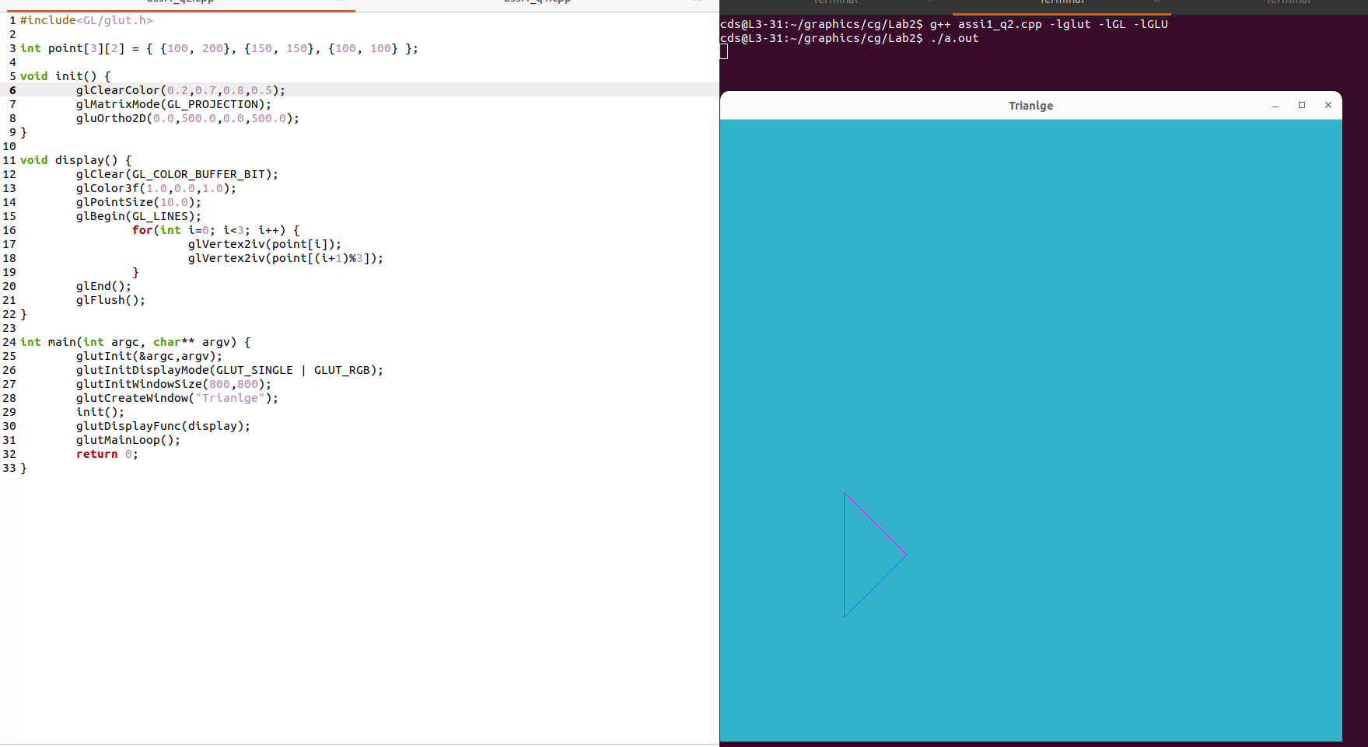

Q3.
CODE:
#include<GL/glut.h>

int x = 0;
int lower_level = 100;
int upper_level = 200;
int gap = 20;

void init() {
glClearColor(0.0,1.0,0.0,0.5);
glMatrixMode(GL_PROJECTION);
gluOrtho2D(0.0,500.0,0.0,500.0);
}

void display() {
glClear(GL_COLOR_BUFFER_BIT);
glColor3f(1.0,0.0,1.0);
glPointSize(10.0);
glBegin(GL_LINES);
for(int i=0; i<25; i++) {
if(i%2 == 0) {
glVertex2i(x, lower_level);
glVertex2i(x+gap, upper_level);
}
else {
glVertex2i(x, upper_level);
glVertex2i(x+gap, lower_level);
}
x += gap;
}
glEnd();
glFlush();
}

int main(int argc, char** argv) {
glutInit(&argc,argv);
glutInitDisplayMode(GLUT_SINGLE | GLUT_RGB);
glutInitWindowSize(800,800);
glutCreateWindow("ZigZag Example");
init();
glutDisplayFunc(display);
glutMainLoop();
return 0;
}

OUTPUT:
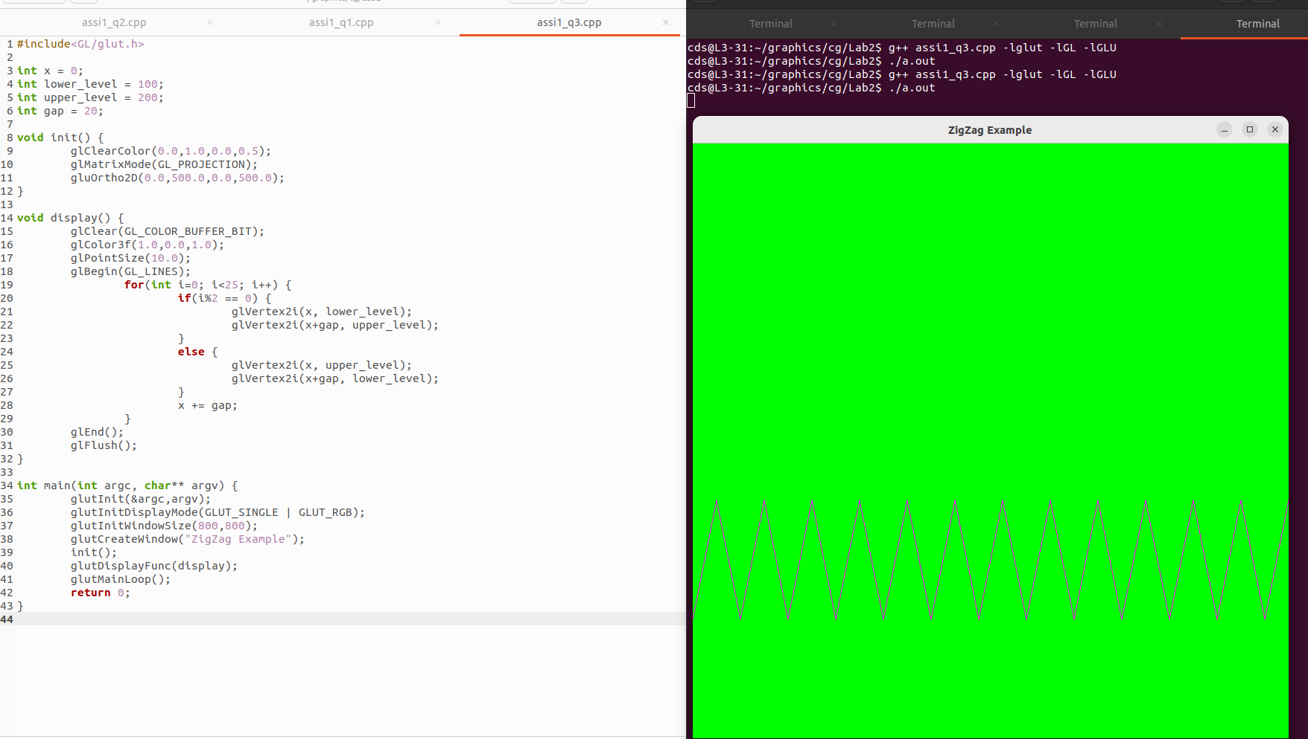

Q4.

CODE:
#include<GL/glut.h>

int points[5][2] = { {100, 100}, {150, 200}, {200, 100}, {100, 175}, {200, 175} };

void init() {
glClearColor(0.0,1.0,0.0,0.5);
glMatrixMode(GL_PROJECTION);
gluOrtho2D(0.0,500.0,0.0,500.0);
}

void display() {
glClear(GL_COLOR_BUFFER_BIT);
glColor3f(1.0,0.0,1.0);
glPointSize(10.0);
glBegin(GL_LINES);
for(int i=0; i<5; i++) {
glVertex2iv(points[i%5]);
glVertex2iv(points[(i+1)%5]);
}
glEnd();
glFlush();
}

int main(int argc, char** argv) {
glutInit(&argc,argv);
glutInitDisplayMode(GLUT_SINGLE | GLUT_RGB);
glutInitWindowSize(800,800);
glutCreateWindow("Star");
init();
glutDisplayFunc(display);
glutMainLoop();
return 0;
}

OUTPUT:

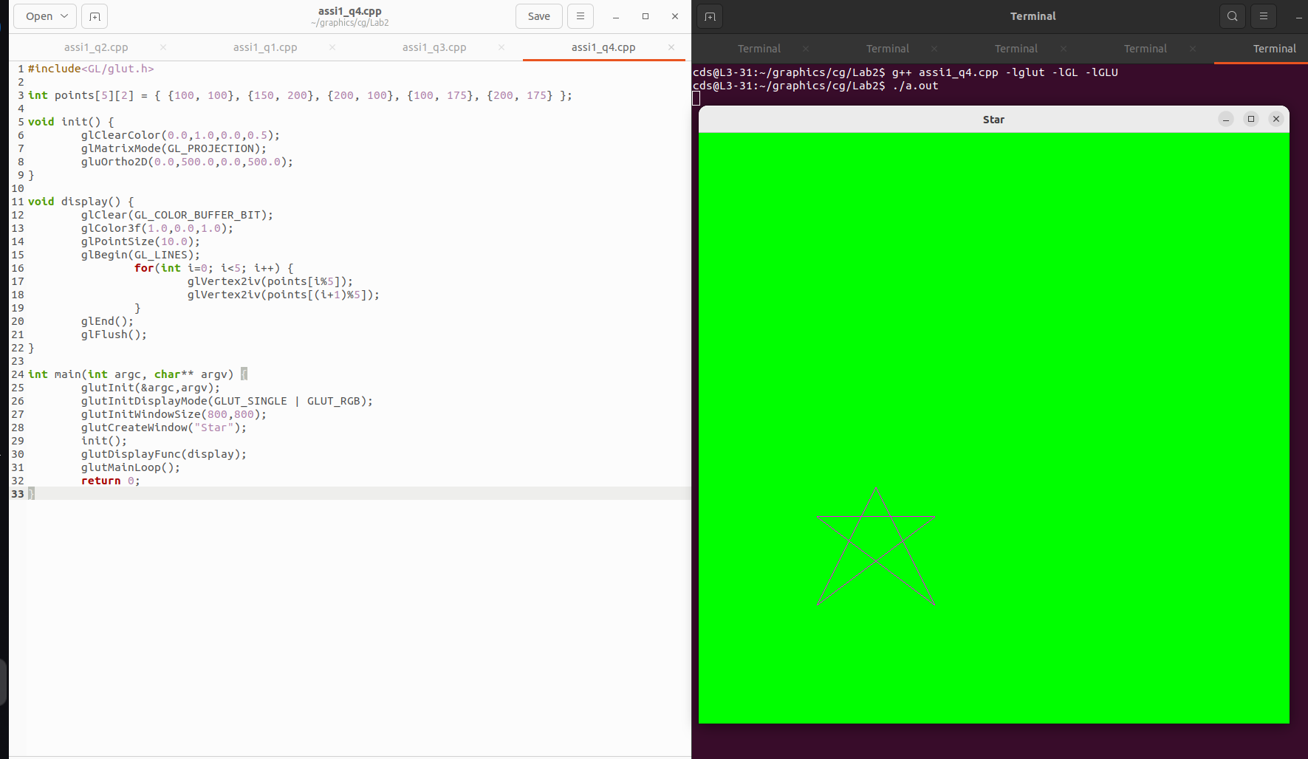

Q5.

CODE:
#include<GL/glut.h>

int point[5][2] = { {50, 100}, {50, 200}, {150, 200}, {300, 200}, {300, 400} };

void init() {
glClearColor(0.0,1.0,0.0,0.5);
glMatrixMode(GL_PROJECTION);
gluOrtho2D(0.0,500.0,0.0,500.0);
}

void display() {
glClear(GL_COLOR_BUFFER_BIT);
glColor3f(1.0,0.0,1.0);
glPointSize(10.0);
glBegin(GL_LINE_STRIP);
for(int i=0; i<5; i++) {
glVertex2iv(point[i]);
}
glEnd();
glFlush();
}

int main(int argc, char** argv) {
glutInit(&argc,argv);
glutInitDisplayMode(GLUT_SINGLE | GLUT_RGB);
glutInitWindowSize(800,800);
glutCreateWindow("Line Strip Example");
init();
glutDisplayFunc(display);
glutMainLoop();
return 0;
}

OUTPUT:

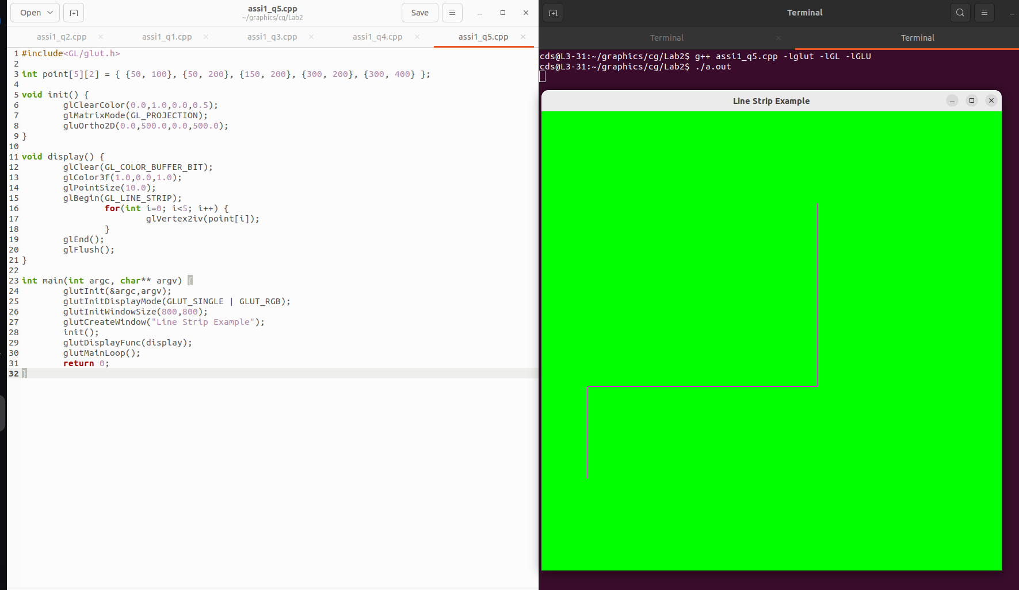

Q6.

CODE:
#include <GL/glut.h>
#define MAX_POINTS 100
int points[MAX_POINTS][2];
int pointCount = 0;
int windowWidth = 800;
int windowHeight = 800;
void init() {
glClearColor(0.0, 1.0, 0.0, 1.0); // Green background
glMatrixMode(GL_PROJECTION);
glLoadIdentity();
gluOrtho2D(0, windowWidth, 0, windowHeight);
}

void myMouseClick(int button, int state, int x, int y) {
if (button == GLUT_LEFT_BUTTON && state == GLUT_DOWN) {
if (pointCount < MAX_POINTS) {
points[pointCount][0] = x;
points[pointCount][1] = windowHeight - y; // flip Y
pointCount++;
}
glutPostRedisplay();
}
}

void display() {
glClear(GL_COLOR_BUFFER_BIT);

glColor3f(1.0, 0.0, 0.0); // Red points
glPointSize(8.0);

glBegin(GL_POINTS);
for (int i = 0; i < pointCount; i++) {
glVertex2i(points[i][0], points[i][1]);
}
glEnd();

glFlush();
}

int main(int argc, char** argv) {
glutInit(&argc, argv);
glutInitDisplayMode(GLUT_SINGLE | GLUT_RGB);
glutInitWindowSize(windowWidth, windowHeight);
glutCreateWindow("Mouse Click Point Plot");

init();
glutDisplayFunc(display);
glutMouseFunc(myMouseClick);

glutMainLoop();
return 0;
}

OUTPUT:
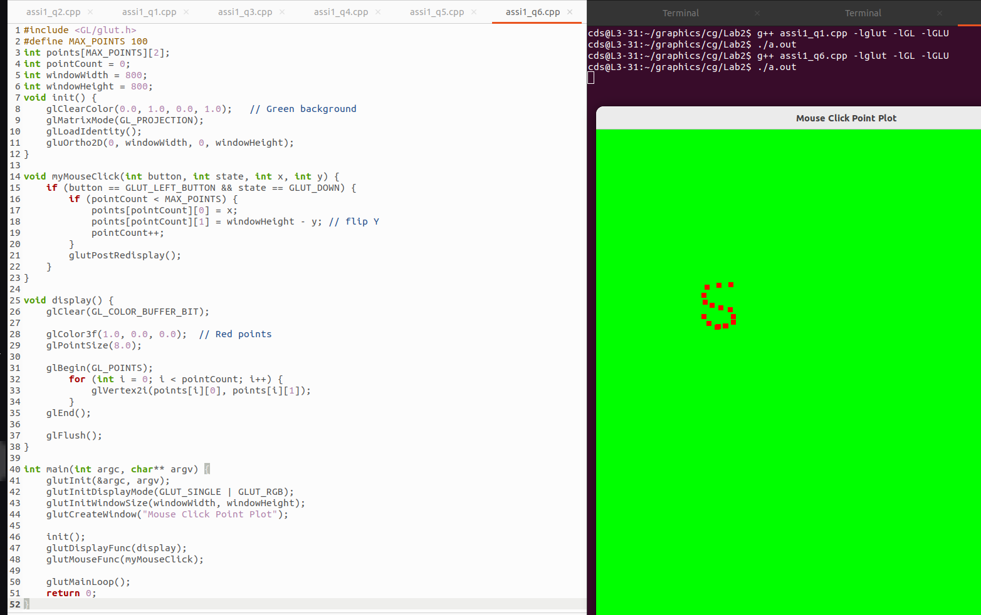

Q7.
CODE:

#include <GL/glut.h>
#include <math.h>
#include <stdio.h>
int n;
float radius = 200;
float cx = 250, cy = 250;

void init() {
glClearColor(1.0, 1.0, 1.0, 1.0);
glMatrixMode(GL_PROJECTION);
glLoadIdentity();
gluOrtho2D(0, 500, 0, 500);
}

void display() {
glClear(GL_COLOR_BUFFER_BIT);
glColor3f(1.0, 0.0, 0.0);

float angle, x, y;

glBegin(GL_LINE_LOOP);
for (int i = 0; i < n; i++) {
angle = 2 * M_PI * i / n;
x = cx + radius * cos(angle);
y = cy + radius * sin(angle);
glVertex2f(x, y);
}
glEnd();

glFlush();
}

int main(int argc, char** argv) {
printf("Enter number of sides: ");
scanf("%d", &n);

if (n < 3) {
printf("Polygon must have at least 3 sides!\n");
return 0;
}

glutInit(&argc, argv);
glutInitDisplayMode(GLUT_SINGLE | GLUT_RGB);
glutInitWindowSize(500, 500);
glutCreateWindow("Regular Polygon");

init();
glutDisplayFunc(display);
glutMainLoop();

return 0;
}

OUTPUT:
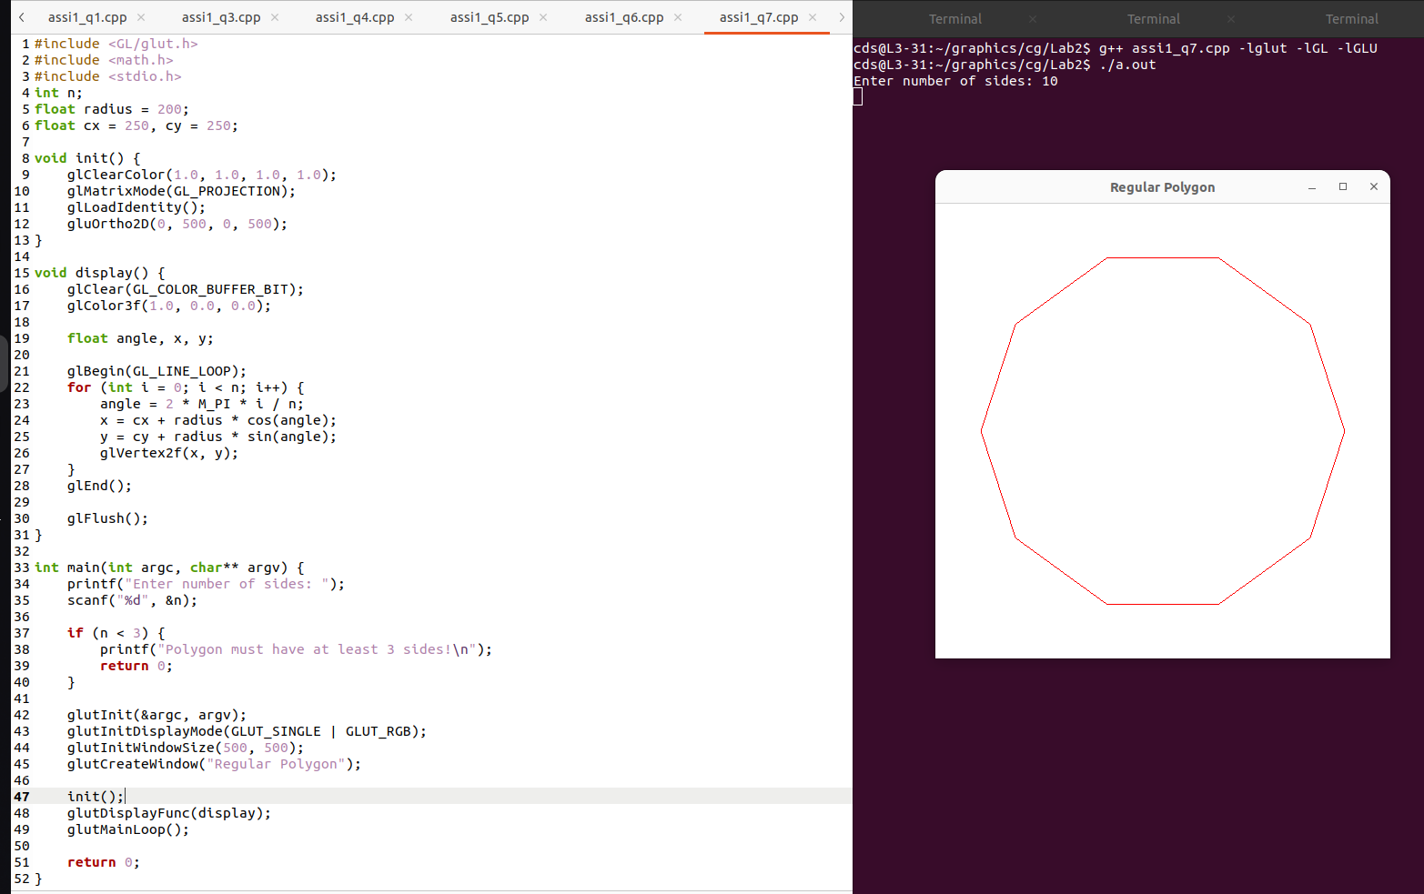

Q8.

CODE:
#include <GL/glut.h>
void init() {
glClearColor(1.0, 1.0, 1.0, 1.0);
glMatrixMode(GL_PROJECTION);
glLoadIdentity();
gluOrtho2D(0, 500, 0, 500);
}
void display() {
glClear(GL_COLOR_BUFFER_BIT);
glColor3f(0.0, 0.0, 0.0);

/* ---- House Body ---- */
glBegin(GL_LINE_LOOP);
glVertex2i(150, 150);
glVertex2i(350, 150);
glVertex2i(350, 300);
glVertex2i(150, 300);
glEnd();

/* ---- Roof ---- */
glBegin(GL_LINES);
glVertex2i(150, 300);
glVertex2i(250, 380);

glVertex2i(250, 380);
glVertex2i(350, 300);
glEnd();

/* ---- Door ---- */
glBegin(GL_LINE_LOOP);
glVertex2i(230, 150);
glVertex2i(270, 150);
glVertex2i(270, 230);
glVertex2i(230, 230);
glEnd();

/* ---- Left Window ---- */
glBegin(GL_LINE_LOOP);
glVertex2i(170, 220);
glVertex2i(210, 220);
glVertex2i(210, 260);
glVertex2i(170, 260);
glEnd();

/* ---- Right Window ---- */
glBegin(GL_LINE_LOOP);
glVertex2i(290, 220);
glVertex2i(330, 220);
glVertex2i(330, 260);
glVertex2i(290, 260);
glEnd();

/* ---- Window Cross Lines ---- */
glBegin(GL_LINES);
// Left window cross
glVertex2i(190, 220);
glVertex2i(190, 260);
glVertex2i(170, 240);
glVertex2i(210, 240);

// Right window cross
glVertex2i(310, 220);
glVertex2i(310, 260);
glVertex2i(290, 240);
glVertex2i(330, 240);
glEnd();

/* ---- Decorative Points ---- */
glPointSize(5.0);
glBegin(GL_POINTS);
glVertex2i(250, 380); // Roof top
glVertex2i(250, 230); // Door top
glEnd();

glFlush();
}

int main(int argc, char** argv) {
glutInit(&argc, argv);
glutInitDisplayMode(GLUT_SINGLE | GLUT_RGB);
glutInitWindowSize(500, 500);
glutCreateWindow("House using Points and Lines");

init();
glutDisplayFunc(display);
glutMainLoop();
return 0;
}

OUTPUT:
