NAME : SHAH NAWAZ HUSSAIN
ROLL NO: 244CA049

CG LAB -3

LAB ASSGINMENT - 3

Q1. Take endpoints as input and draw a line using DDA algorithm for all slope cases.

Q2. Take endpoints as input and draw a line using Bresenham’s algorithm for all slope cases .

Q3. Draw a dotted line using any algorithm.

Q4. Draw an alternate dotted-dashed line using any algorithm.

Q5. Draw HELLO on screen using only lines.

CODE :

#include <GL/glut.h>
#include <cmath>
#include <iostream>

using namespace std;

/* Plot a point */
void plot(int x, int y)
{
glBegin(GL_POINTS);
glVertex2i(x, y);
glEnd();
}

/* ---------------- DDA Line Algorithm ---------------- */
void DDA(int x1, int y1, int x2, int y2)
{
float dx = x2 - x1;
float dy = y2 - y1;

int steps = abs(dx) > abs(dy) ? abs(dx) : abs(dy);

float xInc = dx / steps;
float yInc = dy / steps;

float x = x1;
float y = y1;

for (int i = 0; i <= steps; i++)
{
plot(round(x), round(y));
x += xInc;
y += yInc;
}
}

/* ---------------- Bresenham Line Algorithm ---------------- */
void Bresenham(int x1, int y1, int x2, int y2)
{
int dx = abs(x2 - x1);
int dy = abs(y2 - y1);

int sx = (x1 < x2) ? 1 : -1;
int sy = (y1 < y2) ? 1 : -1;

int err = dx - dy;

while (true)
{
plot(x1, y1);

if (x1 == x2 && y1 == y2)
break;

int e2 = 2 * err;

if (e2 > -dy)
{
err -= dy;
x1 += sx;
}
if (e2 < dx)
{
err += dx;
y1 += sy;
}
}
}

/* ---------------- Dotted Line ---------------- */
void dottedLine(int x1, int y1, int x2, int y2)
{
float dx = x2 - x1;
float dy = y2 - y1;

int steps = abs(dx) > abs(dy) ? abs(dx) : abs(dy);

float xInc = dx / steps;
float yInc = dy / steps;

float x = x1;
float y = y1;

for (int i = 0; i <= steps; i++)
{
if (i % 4 == 0) // dot pattern
plot(round(x), round(y));

x += xInc;
y += yInc;
}
}

/* ---------------- Dotted-Dashed Line ---------------- */
void dottedDashedLine(int x1, int y1, int x2, int y2)
{
float dx = x2 - x1;
float dy = y2 - y1;

int steps = abs(dx) > abs(dy) ? abs(dx) : abs(dy);

float xInc = dx / steps;
float yInc = dy / steps;

float x = x1;
float y = y1;

for (int i = 0; i <= steps; i++)
{
if (i % 10 < 5 || i % 10 == 7) // dash + dot pattern
plot(round(x), round(y));

x += xInc;
y += yInc;
}
}

/* ---------------- Draw HELLO using Lines ---------------- */
void drawHELLO()
{
// H
DDA(50, 200, 50, 300);
DDA(80, 200, 80, 300);
DDA(50, 250, 80, 250);

// E
DDA(100, 200, 100, 300);
DDA(100, 300, 140, 300);
DDA(100, 250, 130, 250);
DDA(100, 200, 140, 200);

// L
DDA(160, 300, 160, 200);
DDA(160, 200, 200, 200);

// L
DDA(220, 300, 220, 200);
DDA(220, 200, 260, 200);

// O
DDA(280, 200, 280, 300);
DDA(280, 300, 320, 300);
DDA(320, 300, 320, 200);
DDA(320, 200, 280, 200);
}

/* ---------------- Display Function ---------------- */
void display()
{
glClear(GL_COLOR_BUFFER_BIT);

// DDA Line
glColor3f(1, 0, 0);
DDA(50, 50, 200, 100);

// Bresenham Line
glColor3f(0, 1, 0);
Bresenham(50, 80, 200, 150);

// Dotted Line
glColor3f(0, 0, 1);
dottedLine(50, 120, 200, 200);

// Dotted-Dashed Line
glColor3f(1, 0, 1);
dottedDashedLine(50, 160, 200, 260);

// HELLO
glColor3f(1, 1, 1);
drawHELLO();

glFlush();
}

/* ---------------- Initialization ---------------- */
void init()
{
glClearColor(0, 0, 0, 1);
glColor3f(1, 1, 1);
glPointSize(2);
gluOrtho2D(0, 500, 0, 500);
}

/* ---------------- Main ---------------- */
int main(int argc, char** argv)
{
glutInit(&argc, argv);
glutInitDisplayMode(GLUT_SINGLE | GLUT_RGB);
glutInitWindowSize(600, 600);
glutInitWindowPosition(100, 100);
glutCreateWindow("Line Drawing Algorithms");

init();
glutDisplayFunc(display);
glutMainLoop();

return 0;
}

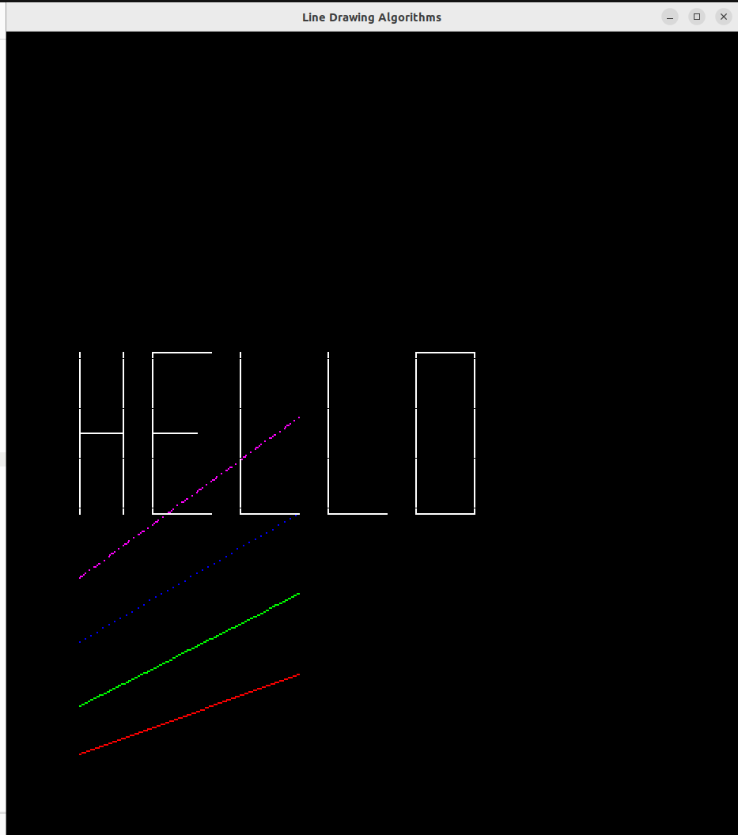
OUTPUT :

