NAME: SHAH NAWAZ HUSSAIN
ROLL NO: 244CA049

LAB – 4

Q1.Implement the midpoint circle draw algo print the pixel coordinates of the circles centre of origin.

CODE:

#include <GL/glut.h>
#include <stdio.h>

int xc = 0, yc = 0, r = 100;

void plotPoints(int x, int y)
{
glBegin(GL_POINTS);
glVertex2i(xc + x, yc + y);
glVertex2i(xc - x, yc + y);
glVertex2i(xc + x, yc - y);
glVertex2i(xc - x, yc - y);
glVertex2i(xc + y, yc + x);
glVertex2i(xc - y, yc + x);
glVertex2i(xc + y, yc - x);
glVertex2i(xc - y, yc - x);

glEnd();
}

void midpointCircle()
{
int x = 0;
int y = r;
int p = 1 - r;

while (x <= y)
{
plotPoints(x, y);
x++;

if (p < 0)
{
p = p + 2 * x + 1;
}
else
{
y--;
p = p + 2 * x - 2 * y + 1;
}
}
}

void display()
{
glClear(GL_COLOR_BUFFER_BIT);
glColor3f(1.0, 1.0, 1.0);
midpointCircle();
glFlush();
}

void init()
{
glClearColor(0.0, 0.0, 0.0, 1.0);
glColor3f(1.0, 1.0, 1.0);
glPointSize(2.0);

glMatrixMode(GL_PROJECTION);
glLoadIdentity();
gluOrtho2D(-300, 300, -300, 300);
}

int main(int argc, char** argv)
{
glutInit(&argc, argv);
glutInitDisplayMode(GLUT_SINGLE | GLUT_RGB);
glutInitWindowSize(600, 600);
glutInitWindowPosition(100, 100);
glutCreateWindow("Midpoint Circle Algorithm - OpenGL");

init();
glutDisplayFunc(display);
glutMainLoop();

return 0;
}

OUTPUT:

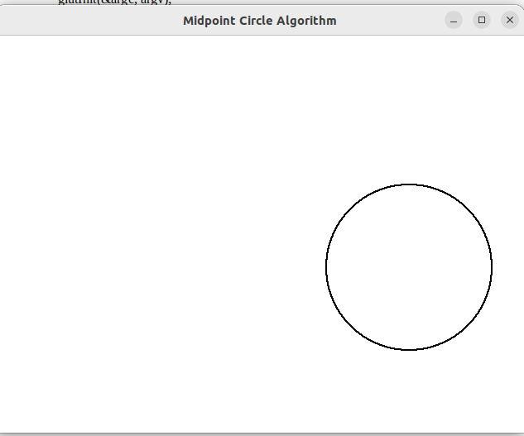

Q2. Draw a circle at any given centre.

CODE:

#include <GL/glut.h>
#include <stdio.h>

int xc, yc, r;

void plotPoints(int x, int y)
{
glBegin(GL_POINTS);

glVertex2i(xc + x, yc + y);
glVertex2i(xc - x, yc + y);
glVertex2i(xc + x, yc - y);
glVertex2i(xc - x, yc - y);
glVertex2i(xc + y, yc + x);
glVertex2i(xc - y, yc + x);
glVertex2i(xc + y, yc - x);
glVertex2i(xc - y, yc - x);

glEnd();
}

void midpointCircle()
{
int x = 0;
int y = r;
int p = 1 - r;

while (x <= y)
{
plotPoints(x, y);
x++;

if (p < 0)
{
p = p + 2 * x + 1;
}
else
{
y--;
p = p + 2 * x - 2 * y + 1;
}
}
}

void display()
{
glClear(GL_COLOR_BUFFER_BIT);
glColor3f(1.0, 1.0, 1.0);
midpointCircle();
glFlush();
}

void init()
{
glClearColor(0.0, 0.0, 0.0, 1.0);
glPointSize(2.0);

glMatrixMode(GL_PROJECTION);
glLoadIdentity();
gluOrtho2D(-500, 500, -500, 500);
}

int main(int argc, char** argv)
{
printf("Enter centre coordinates (xc yc): ");
scanf("%d %d", &xc, &yc);

printf("Enter radius: ");
scanf("%d", &r);

glutInit(&argc, argv);
glutInitDisplayMode(GLUT_SINGLE | GLUT_RGB);
glutInitWindowSize(600, 600);
glutCreateWindow("Midpoint Circle - Any Centre");

init();
glutDisplayFunc(display);
glutMainLoop();

return 0;
}

OUTPUT:
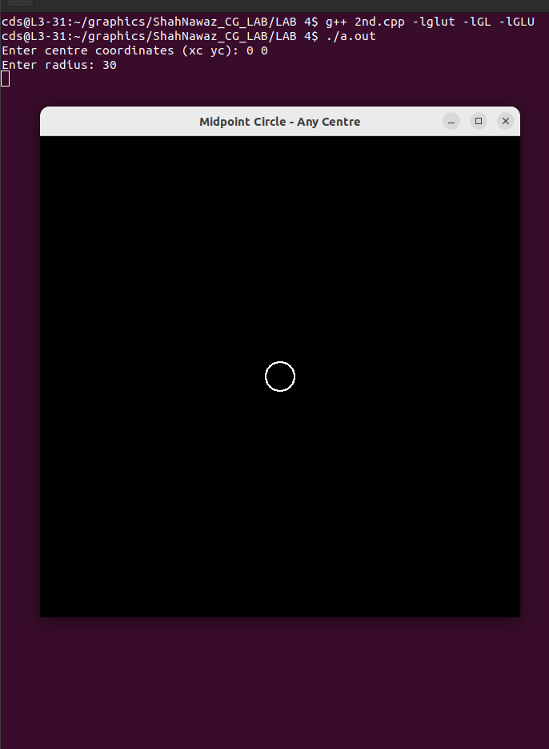

Q3.Draw Concentric circle with centre at origin.

CODE:

#include <GL/glut.h>
#include <stdio.h>

int rMax = 200;
int rStep = 20;

void plotPoints(int x, int y, int xc, int yc)
{
glBegin(GL_POINTS);
glVertex2i(xc + x, yc + y);
glVertex2i(xc - x, yc + y);
glVertex2i(xc + x, yc - y);
glVertex2i(xc - x, yc - y);
glVertex2i(xc + y, yc + x);
glVertex2i(xc - y, yc + x);
glVertex2i(xc + y, yc - x);
glVertex2i(xc - y, yc - x);
glEnd();
}

void drawCircle(int xc, int yc, int r)
{
int x = 0, y = r;
int p = 1 - r;

while (x <= y)
{
plotPoints(x, y, xc, yc);
x++;
if (p < 0)
p = p + 2*x + 1;
else
{
y--;
p = p + 2*x - 2*y + 1;
}
}
}

void display()
{
glClear(GL_COLOR_BUFFER_BIT);
glColor3f(1.0, 1.0, 1.0);

int r;
for(r = rStep; r <= rMax; r += rStep)
drawCircle(0, 0, r);
glFlush();
}

void init()
{
glClearColor(0.0, 0.0, 0.0, 1.0);
glPointSize(2.0);

glMatrixMode(GL_PROJECTION);
glLoadIdentity();
gluOrtho2D(-250, 250, -250, 250);
}

int main(int argc, char** argv)
{
glutInit(&argc, argv);
glutInitDisplayMode(GLUT_SINGLE | GLUT_RGB);
glutInitWindowSize(500, 500);
glutCreateWindow("Concentric Circles - OpenGL");

init();
glutDisplayFunc(display);
glutMainLoop();

return 0;
}

OUTPUT:

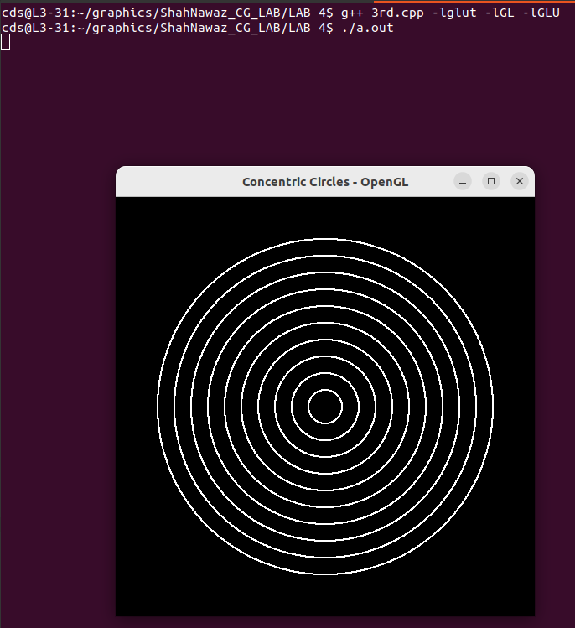

Q4.Draw multiple circles with diff position.

CODE:
#include <GL/glut.h>
#include <stdio.h>

#define NUM_CENTRES 5

int centres[NUM_CENTRES][2] = {
{0, 0},
{100, 100},
{-100, 50},
{-50, -100},
{150, -50}
};

int radius[NUM_CENTRES] = {50, 30, 70, 40, 60};

void plotPoints(int x, int y, int xc, int yc)
{
glBegin(GL_POINTS);
glVertex2i(xc + x, yc + y);
glVertex2i(xc - x, yc + y);
glVertex2i(xc + x, yc - y);
glVertex2i(xc - x, yc - y);
glVertex2i(xc + y, yc + x);
glVertex2i(xc - y, yc + x);
glVertex2i(xc + y, yc - x);
glVertex2i(xc - y, yc - x);
glEnd();
}

void drawCircle(int xc, int yc, int r)
{
int x = 0, y = r;
int p = 1 - r;

while (x <= y)
{
plotPoints(x, y, xc, yc);
x++;
if (p < 0)
p = p + 2*x + 1;
else
{
y--;
p = p + 2*x - 2*y + 1;
}
}
}

void display()
{
glClear(GL_COLOR_BUFFER_BIT);
glColor3f(1.0, 1.0, 1.0);

for (int i = 0; i < NUM_CENTRES; i++)
drawCircle(centres[i][0], centres[i][1], radius[i]);

glFlush();
}

void init()
{
glClearColor(0.0, 0.0, 0.0, 1.0);
glPointSize(2.0);

glMatrixMode(GL_PROJECTION);
glLoadIdentity();
gluOrtho2D(-300, 300, -300, 300);
}

int main(int argc, char** argv)
{
glutInit(&argc, argv);
glutInitDisplayMode(GLUT_SINGLE | GLUT_RGB);
glutInitWindowSize(600, 600);
glutCreateWindow("Multiple Circles - OpenGL");

init();
glutDisplayFunc(display);
glutMainLoop();

return 0;
}

OUTPUT:

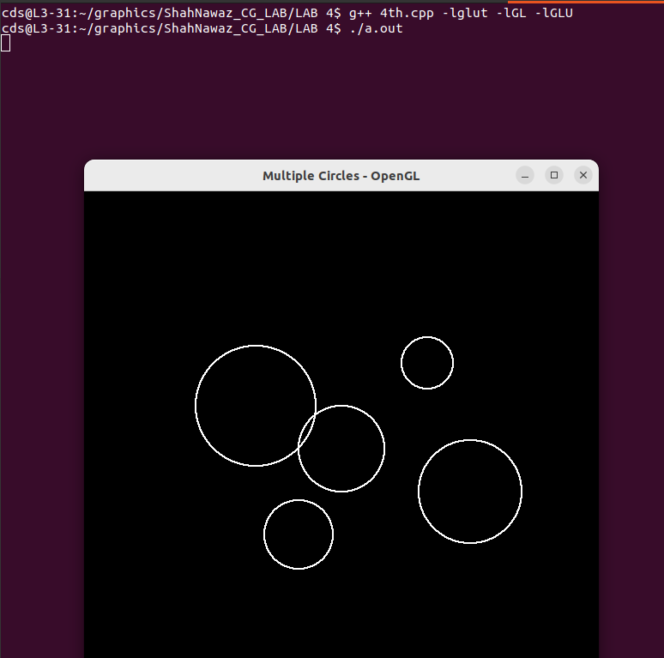

Q5. Draw Olympics Grids.

CODE:

#include <GL/glut.h>

struct Circle {
int xc, yc, r;
float color[3];
};

Circle rings[5] = {
{-120, 50, 50, {0.0, 0.0, 1.0}},
{0, 50, 50, {0.0, 0.0, 0.0}},
{120, 50, 50, {1.0, 0.0, 0.0}},
{-60, 0, 50, {1.0, 1.0, 0.0}},
{60, 0, 50, {0.0, 1.0, 0.0}}
};

void plotPoints(int x, int y, int xc, int yc) {
glBegin(GL_POINTS);
glVertex2i(xc + x, yc + y);
glVertex2i(xc - x, yc + y);
glVertex2i(xc + x, yc - y);
glVertex2i(xc - x, yc - y);
glVertex2i(xc + y, yc + x);
glVertex2i(xc - y, yc + x);
glVertex2i(xc + y, yc - x);
glVertex2i(xc - y, yc - x);
glEnd();
}

void drawCircle(int xc, int yc, int r) {
int x = 0, y = r;
int p = 1 - r;
while (x <= y) {
plotPoints(x, y, xc, yc);
x++;
if (p < 0)
p = p + 2*x + 1;
else {
y--;
p = p + 2*x - 2*y + 1;
}
}
}

void display() {
glClear(GL_COLOR_BUFFER_BIT);

for(int i = 0; i < 5; i++) {
glColor3f(rings[i].color[0], rings[i].color[1], rings[i].color[2]);
drawCircle(rings[i].xc, rings[i].yc, rings[i].r);
}

glFlush();
}

void init() {
glClearColor(1.0, 1.0, 1.0,1.0);
glPointSize(5.0);
glMatrixMode(GL_PROJECTION);
glLoadIdentity();
gluOrtho2D(-300, 300, -100, 150);
}

int main(int argc, char** argv) {
glutInit(&argc, argv);
glutInitDisplayMode(GLUT_SINGLE | GLUT_RGB);
glutInitWindowSize(700, 400);
glutCreateWindow("Olympic Logo - OpenGL");

init();
glutDisplayFunc(display);
glutMainLoop();
return 0;
}

OUTPUT:
