NAME : SHAH NAWAZ HUSSAIN
ROLL NO : 244CA049

LAB – 7

Q1. Write an OpenGL program to perform 3D Translation of a Cube and display both the original and translated cube.

Ans.1
CODE :
#include <GL/glut.h>

float tx = 2.0, ty = 2.0, tz = -2.0;
float v[8][3] = {
{-1,-1,-1}, {1,-1,-1}, {1,1,-1}, {-1,1,-1},
{-1,-1, 1}, {1,-1, 1}, {1,1, 1}, {-1,1, 1}
};

int e[12][2] = {
{0,1},{1,2},{2,3},{3,0},
{4,5},{5,6},{6,7},{7,4},
{0,4},{1,5},{2,6},{3,7}
};

void drawCube(float v[8][3])
{
glBegin(GL_LINES);
for(int i=0;i<12;i++)
{
glVertex3fv(v[e[i][0]]);
glVertex3fv(v[e[i][1]]);
}
glEnd();
}

void display()
{
glClear(GL_COLOR_BUFFER_BIT | GL_DEPTH_BUFFER_BIT);
glLoadIdentity();

gluLookAt(5,5,5, 0,0,0, 0,1,0);
glColor3f(1,1,1);
drawCube(v);

glPushMatrix();
glTranslatef(tx, ty, tz);
glColor3f(1,0,0);
drawCube(v);
glPopMatrix();

glutSwapBuffers();
}

void init()
{
glEnable(GL_DEPTH_TEST);
glClearColor(0,0,0,1);

glMatrixMode(GL_PROJECTION);
gluPerspective(60,1,1,100);

glMatrixMode(GL_MODELVIEW);
}

int main(int argc, char** argv)
{
glutInit(&argc, argv);
glutInitDisplayMode(GLUT_DOUBLE | GLUT_RGB | GLUT_DEPTH);
glutInitWindowSize(600,600);
glutCreateWindow("3D Translation of Cube");

init();
glutDisplayFunc(display);
glutMainLoop();

return 0;
}

OUTPUT :
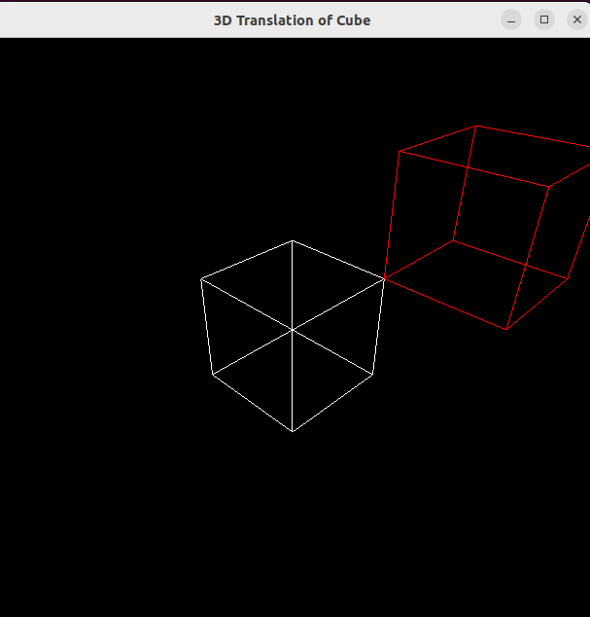

Q2. Program to perform 3D Scaling of a Pyramid and display both the original and scaled object.

Ans.2
CODE :
#include <GL/glut.h>

float sx = 1.5, sy = 2.0, sz = 1.5;
float v[5][3] = {
{0, 1, 0}, {-1,-1, 1}, { 1,-1, 1}, { 1,-1,-1},{-1,-1,-1} };

float sv[5][3];

void drawPyramid(float vert[5][3])
{
glBegin(GL_LINES);

glVertex3fv(vert[1]); glVertex3fv(vert[2]);
glVertex3fv(vert[2]); glVertex3fv(vert[3]);
glVertex3fv(vert[3]); glVertex3fv(vert[4]);
glVertex3fv(vert[4]); glVertex3fv(vert[1]);

glVertex3fv(vert[0]); glVertex3fv(vert[1]);
glVertex3fv(vert[0]); glVertex3fv(vert[2]);
glVertex3fv(vert[0]); glVertex3fv(vert[3]);
glVertex3fv(vert[0]); glVertex3fv(vert[4]);

glEnd();
}

void scalePyramid()
{
for(int i=0;i<5;i++)
{
sv[i][0] = v[i][0] * sx;
sv[i][1] = v[i][1] * sy;
sv[i][2] = v[i][2] * sz;
}
}

void display()
{
glClear(GL_COLOR_BUFFER_BIT | GL_DEPTH_BUFFER_BIT);
glLoadIdentity();

gluLookAt(5,5,5, 0,0,0, 0,1,0);

glColor3f(1,1,1);
drawPyramid(v);

glColor3f(1,0,0);
drawPyramid(sv);

glutSwapBuffers();
}

void init()
{
glEnable(GL_DEPTH_TEST);
glClearColor(0,0,0,1);

glMatrixMode(GL_PROJECTION);
gluPerspective(60,1,1,100);

glMatrixMode(GL_MODELVIEW);

scalePyramid();
}

int main(int argc, char** argv)
{
glutInit(&argc, argv);
glutInitDisplayMode(GLUT_DOUBLE | GLUT_RGB | GLUT_DEPTH);
glutInitWindowSize(600,600);
glutCreateWindow("Manual Scaling of Pyramid");

init();
glutDisplayFunc(display);
glutMainLoop();

return 0;
}

OUTPUT :

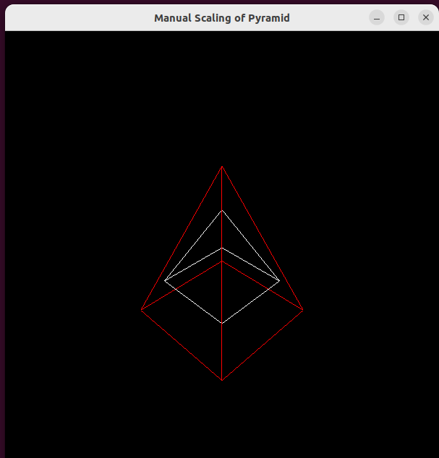

Q3. Program to perform 3D Rotation about the X-axis and display the rotated object along with the original.

Ans.3
CODE :
#include <GL/glut.h>
#include <math.h>

float angle = 45;
float v[8][3] = {
{-1,-1,-1}, {1,-1,-1}, {1,1,-1}, {-1,1,-1},
{-1,-1, 1}, {1,-1, 1}, {1,1, 1}, {-1,1, 1}
};

float rv[8][3];
int e[12][2] = {
{0,1},{1,2},{2,3},{3,0},
{4,5},{5,6},{6,7},{7,4},
{0,4},{1,5},{2,6},{3,7}
};

void rotateX()
{
float rad = angle * 3.14 / 180;

for(int i=0;i<8;i++)
{
rv[i][0] = v[i][0];
rv[i][1] = v[i][1]*cos(rad) - v[i][2]*sin(rad);
rv[i][2] = v[i][1]*sin(rad) + v[i][2]*cos(rad);
}
}

void drawCube(float v[8][3])
{
glBegin(GL_LINES);
for(int i=0;i<12;i++)
{
glVertex3fv(v[e[i][0]]);
glVertex3fv(v[e[i][1]]);
}
glEnd();
}

void display()
{
glClear(GL_COLOR_BUFFER_BIT | GL_DEPTH_BUFFER_BIT);
glLoadIdentity();

gluLookAt(5,5,5, 0,0,0, 0,1,0);
glColor3f(1,1,1);
drawCube(v);

glColor3f(1,0,0);
drawCube(rv);
glutSwapBuffers();
}

void init()
{
glEnable(GL_DEPTH_TEST);
glClearColor(0,0,0,1);

glMatrixMode(GL_PROJECTION);
gluPerspective(60,1,1,100);

glMatrixMode(GL_MODELVIEW);

rotateX();
}

int main(int argc, char** argv)
{
glutInit(&argc, argv);
glutInitDisplayMode(GLUT_DOUBLE | GLUT_RGB | GLUT_DEPTH);
glutInitWindowSize(600,600);
glutCreateWindow("Manual Rotation about X-axis");

init();
glutDisplayFunc(display);
glutMainLoop();

return 0;
}

OUTPUT :

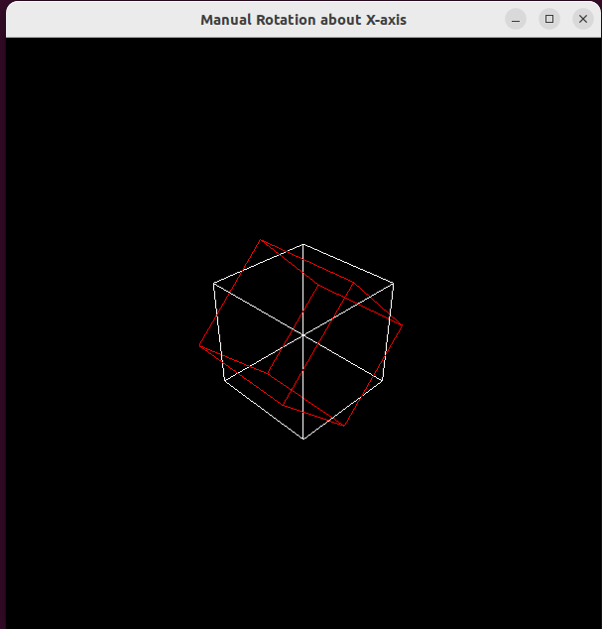

Q4. Program to implement the Cohen–Sutherland Line Clipping Algorithm to clip a line against a rectangular clipping window.

Ans.4
CODE :
#include <GL/glut.h>
#include <iostream>
using namespace std;

float xmin = 100, ymin = 100, xmax = 400, ymax = 400;

const int INSIDE = 0;
const int LEFT = 1;
const int RIGHT = 2;
const int BOTTOM = 4;
const int TOP = 8;

float x0 = 50, y_0 = 50, x1 = 450, y_1 = 450;

int computeCode(float x, float y)
{
int code = INSIDE;

if(x < xmin) code |= LEFT;
else if(x > xmax) code |= RIGHT;
if(y < ymin) code |= BOTTOM;
else if(y > ymax) code |= TOP;

return code;
}

void cohenSutherlandClip(float x0, float y_0, float x1, float y_1)
{
int code0 = computeCode(x0, y_0);
int code1 = computeCode(x1, y_1);
bool accept = false;

while(true)
{
if(code0 == 0 && code1 == 0)
{
accept = true;
break;
}
else if(code0 & code1) break;
else
{
float x, y;
int code_out = code0 ? code0 : code1;

if(code_out & TOP)
{
x = x0 + (x1 - x0) * (ymax - y_0) / (y_1 - y_0);
y = ymax;
}
else if(code_out & BOTTOM)
{
x = x0 + (x1 - x0) * (ymin - y_0) / (y_1 - y_0);
y = ymin;
}
else if(code_out & RIGHT)
{
y = y_0 + (y_1 - y_0) * (xmax - x0) / (x1 - x0);
x = xmax;
}
else if(code_out & LEFT)
{
y = y_0 + (y_1 - y_0) * (xmin - x0) / (x1 - x0);
x = xmin;
}

if(code_out == code0)
{
x0 = x; y_0 = y;
code0 = computeCode(x0, y_0);
}
else
{
x1 = x; y_1 = y;
code1 = computeCode(x1, y_1);
}
}
}

if(accept)
{
glColor3f(1,0,0);
glBegin(GL_LINES);
glVertex2f(x0, y_0);
glVertex2f(x1, y_1);
glEnd();
}
}

void display()
{
glClear(GL_COLOR_BUFFER_BIT);

glColor3f(0,1,0);
glBegin(GL_LINE_LOOP);
glVertex2f(xmin, ymin);
glVertex2f(xmax, ymin);
glVertex2f(xmax, ymax);
glVertex2f(xmin, ymax);
glEnd();

glColor3f(0,0,1);
glBegin(GL_LINES);
glVertex2f(x0, y_0);
glVertex2f(x1, y_1);
glEnd();

cohenSutherlandClip(x0, y_0, x1, y_1);

glFlush();
}

void init()
{
glClearColor(0,0,0,1);
gluOrtho2D(0,500,0,500);
}

int main(int argc, char** argv)
{
glutInit(&argc, argv);
glutInitDisplayMode(GLUT_SINGLE | GLUT_RGB);
glutInitWindowSize(500,500);
glutCreateWindow("Cohen–Sutherland Line Clipping");

init();
glutDisplayFunc(display);
glutMainLoop();

return 0;
}

OUTPUT :

