NAME : SHAH NAWAZ HUSSAIN
ROLL NO: 244CA049

COMPUTER GRAPHICS - LAB ASSGINMENT

PART – 1

Q1. Write about OpenGL, GLU and GLUT. Mention and explain the output primitives and other commonly used builtin functions in these libraries.

Ans.1 1. OpenGL (Open Graphics Library)
OpenGL is a cross-platform API used for rendering 2D and 3D graphics. It provides a set of low-level functions to draw points, lines, polygons, and complex scenes.
🔹 Features
Platform-independent
Works with hardware acceleration (GPU)
Supports 2D & 3D graphics
Uses a state machine model
2. GLU (OpenGL Utility Library)
GLU is a utility library built on top of OpenGL that provides higher-level functions.
🔹 Purpose
Simplifies complex OpenGL tasks
Provides functions for:
Coordinate transformations
Drawing quadrics (spheres, cylinders)
Viewing and projection helpers
🔹 Example Functions
gluOrtho2D() → sets 2D orthographic projection
gluPerspective() → defines perspective projection
gluLookAt() → sets camera/view position
3. GLUT (OpenGL Utility Toolkit)
GLUT is a toolkit for managing windows and user interaction.
🔹 Features
Window creation
Input handling (keyboard, mouse)
Event-driven programming
Menu creation
🔹 Example Functions
glutInit() → initializes GLUT
glutCreateWindow() → creates window
glutDisplayFunc() → registers display callback
glutMainLoop() → starts event loop
Output Primitives in OpenGL
Output primitives are basic shapes used to draw graphics.
🔹 1. Points
glBegin(GL_POINTS);
glVertex2i(100, 100);
glEnd();
Draws a single point
🔹 2. Lines
glBegin(GL_LINES);
glVertex2i(100, 100);
glVertex2i(200, 200);
glEnd();
Draws a straight line between two points
Other line types:
GL_LINE_STRIP → connected lines
GL_LINE_LOOP → closed loop
🔹 3. Polygons
glBegin(GL_POLYGON);
glVertex2i(100, 100);
glVertex2i(200, 100);
glVertex2i(200, 200);
glVertex2i(100, 200);
glEnd();
Draws filled shapes
🔹 4. Triangles & Quads
GL_TRIANGLES
GL_QUADS
Used for building complex shapes.
Commonly Used Built-in Functions
🔹 1. Drawing Functions
glBegin(mode) → starts drawing
glEnd() → ends drawing
glVertex*() → specifies vertex
glColor*() → sets color
🔹 2. Transformation Functions
glTranslatef(x, y, z) → move object
glRotatef(angle, x, y, z) → rotate object
glScalef(x, y, z) → scale object
🔹 3. Viewing Functions
glMatrixMode() → selects matrix type
glLoadIdentity() → resets matrix
gluLookAt() → camera positioning
🔹 4. Projection Functions
gluOrtho2D(left, right, bottom, top) → 2D view
glOrtho() → orthographic projection
gluPerspective() → perspective view
🔹 5. Window & Display Functions (GLUT)
glutInit()
glutInitDisplayMode()
glutInitWindowSize()
glutDisplayFunc()
glutMainLoop()
🔹 6. Input Handling (GLUT)
glutKeyboardFunc() → keyboard input
glutMouseFunc() → mouse input
🔹 7. Utility Functions
glClear() → clears screen
glClearColor() → sets background color
glFlush() → forces execution
glReadPixels() → reads pixel data

PART – 2

LAB – 1

Q1.

CODE:
#include<GL/glut.h>

int point[3][2] = { {50, 100}, {75, 150}, {100, 200} };

void init() {
glClearColor(0.0,1.0,0.0,0.5);
glMatrixMode(GL_PROJECTION);
gluOrtho2D(0.0,500.0,0.0,500.0);
}

void display() {
glClear(GL_COLOR_BUFFER_BIT);
glColor3f(1.0,0.0,1.0);
glPointSize(10.0);
glBegin(GL_LINE_STRIP);
for(int i=0; i<3; i++) {
glVertex2iv(point[i]);

}
glEnd();
glFlush();
}

int main(int argc, char** argv) {
glutInit(&argc,argv);
glutInitDisplayMode(GLUT_SINGLE | GLUT_RGB);
glutInitWindowSize(500,500);
glutCreateWindow("Point Example");
init();
glutDisplayFunc(display);
glutMainLoop();
return 0;
}

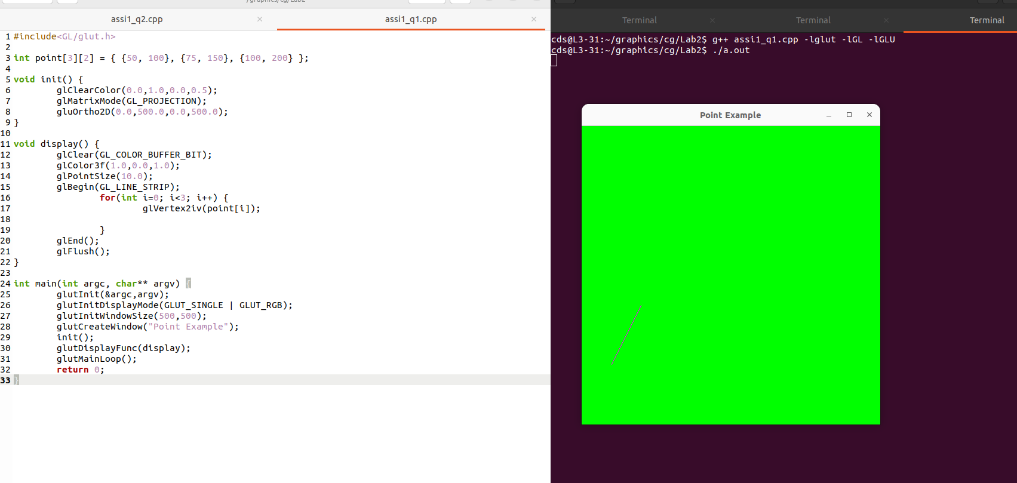

Q2 .
CODE:
#include<GL/glut.h>

int point[3][2] = { {100, 200}, {150, 150}, {100, 100} };

void init() {
glClearColor(0.2,0.7,0.8,0.5);
glMatrixMode(GL_PROJECTION);
gluOrtho2D(0.0,500.0,0.0,500.0);
}

void display() {
glClear(GL_COLOR_BUFFER_BIT);
glColor3f(1.0,0.0,1.0);
glPointSize(10.0);
glBegin(GL_LINES);
for(int i=0; i<3; i++) {
glVertex2iv(point[i]);
glVertex2iv(point[(i+1)%3]);
}
glEnd();
glFlush();
}

int main(int argc, char** argv) {
glutInit(&argc,argv);
glutInitDisplayMode(GLUT_SINGLE | GLUT_RGB);
glutInitWindowSize(800,800);
glutCreateWindow("Trianlge");
init();
glutDisplayFunc(display);
glutMainLoop();
return 0;
}

OUTPUT:

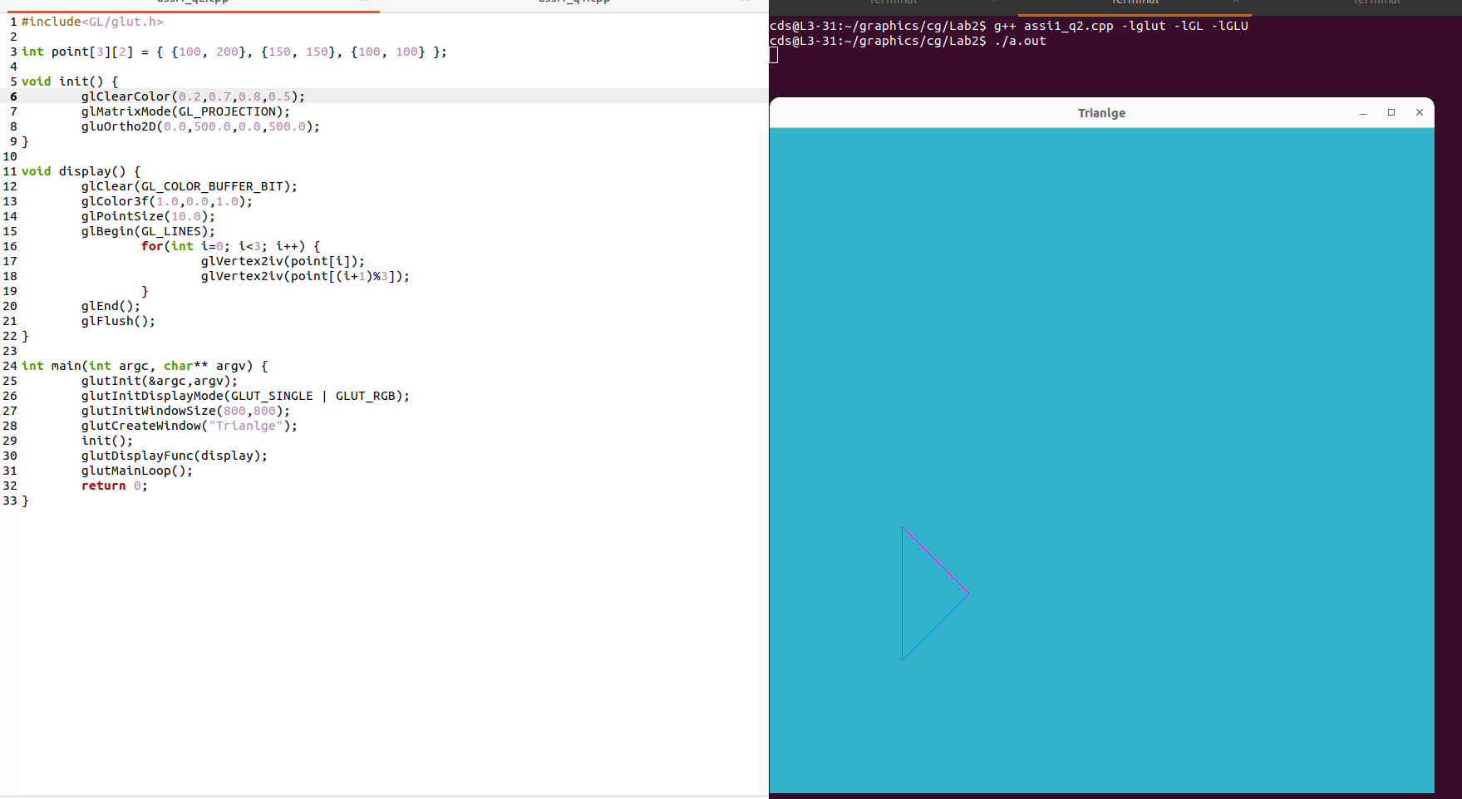

Q3.
CODE:
#include<GL/glut.h>

int x = 0;
int lower_level = 100;
int upper_level = 200;
int gap = 20;

void init() {
glClearColor(0.0,1.0,0.0,0.5);
glMatrixMode(GL_PROJECTION);
gluOrtho2D(0.0,500.0,0.0,500.0);
}

void display() {
glClear(GL_COLOR_BUFFER_BIT);
glColor3f(1.0,0.0,1.0);
glPointSize(10.0);
glBegin(GL_LINES);
for(int i=0; i<25; i++) {
if(i%2 == 0) {
glVertex2i(x, lower_level);
glVertex2i(x+gap, upper_level);
}
else {
glVertex2i(x, upper_level);
glVertex2i(x+gap, lower_level);
}
x += gap;
}
glEnd();
glFlush();
}

int main(int argc, char** argv) {
glutInit(&argc,argv);
glutInitDisplayMode(GLUT_SINGLE | GLUT_RGB);
glutInitWindowSize(800,800);
glutCreateWindow("ZigZag Example");
init();
glutDisplayFunc(display);
glutMainLoop();
return 0;
}

OUTPUT:
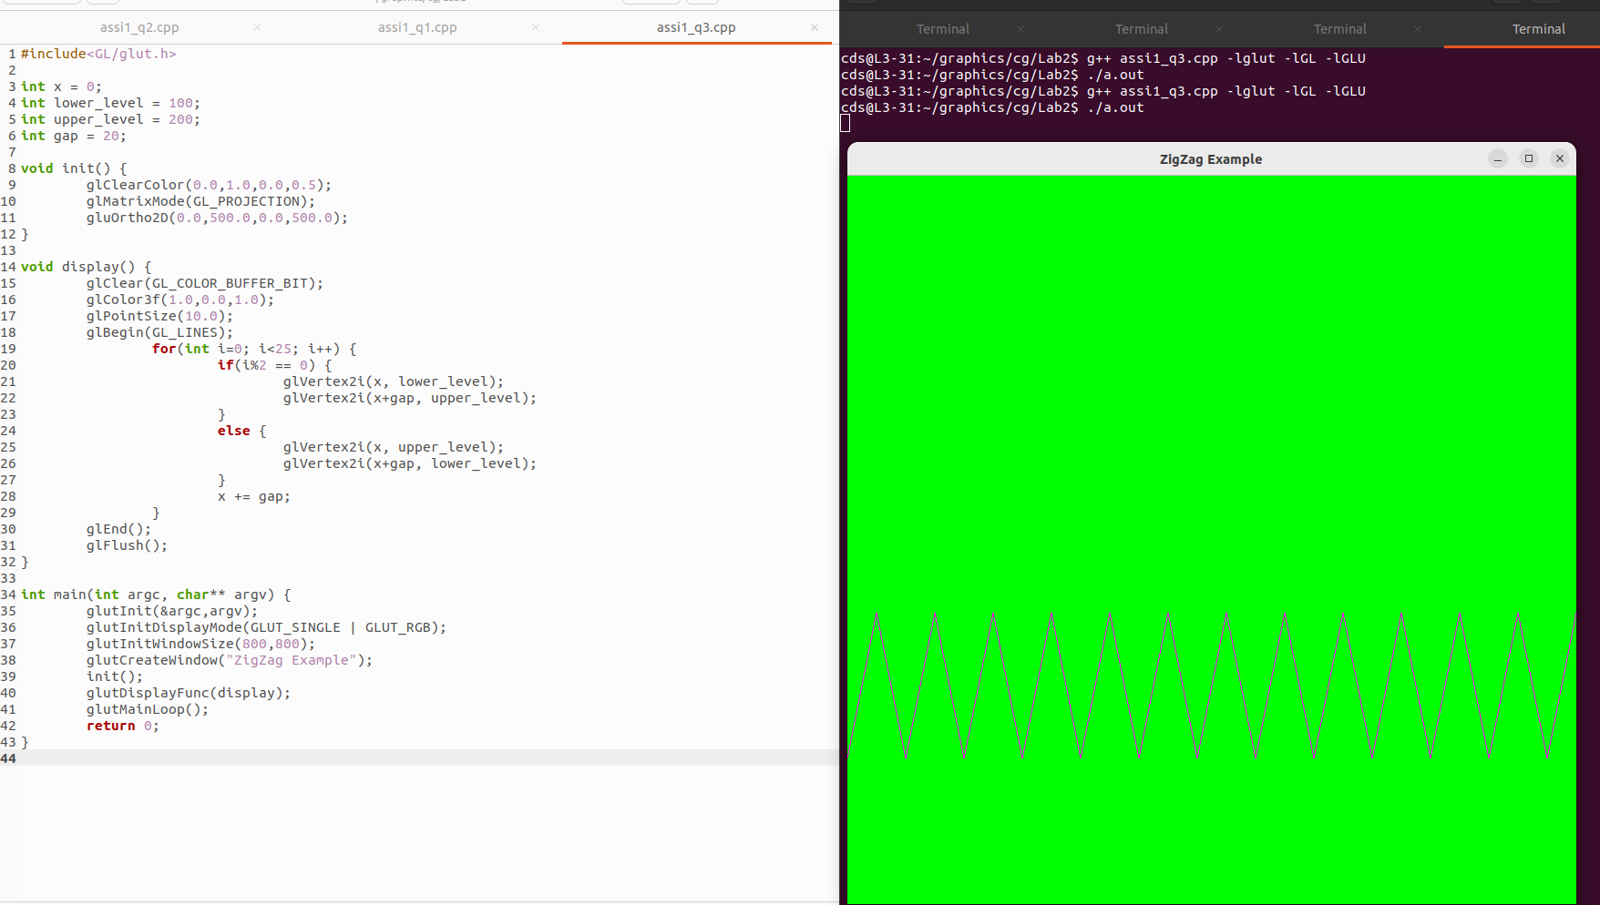

Q4.

CODE:
#include<GL/glut.h>

int points[5][2] = { {100, 100}, {150, 200}, {200, 100}, {100, 175}, {200, 175} };

void init() {
glClearColor(0.0,1.0,0.0,0.5);
glMatrixMode(GL_PROJECTION);
gluOrtho2D(0.0,500.0,0.0,500.0);
}

void display() {
glClear(GL_COLOR_BUFFER_BIT);
glColor3f(1.0,0.0,1.0);
glPointSize(10.0);
glBegin(GL_LINES);
for(int i=0; i<5; i++) {
glVertex2iv(points[i%5]);
glVertex2iv(points[(i+1)%5]);
}
glEnd();
glFlush();
}

int main(int argc, char** argv) {
glutInit(&argc,argv);
glutInitDisplayMode(GLUT_SINGLE | GLUT_RGB);
glutInitWindowSize(800,800);
glutCreateWindow("Star");
init();
glutDisplayFunc(display);
glutMainLoop();
return 0;
}

OUTPUT:

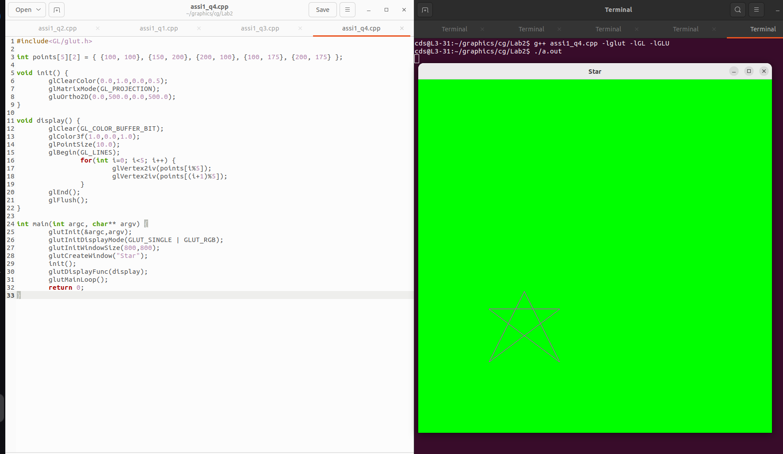

Q5.

CODE:
#include<GL/glut.h>

int point[5][2] = { {50, 100}, {50, 200}, {150, 200}, {300, 200}, {300, 400} };

void init() {
glClearColor(0.0,1.0,0.0,0.5);
glMatrixMode(GL_PROJECTION);
gluOrtho2D(0.0,500.0,0.0,500.0);
}

void display() {
glClear(GL_COLOR_BUFFER_BIT);
glColor3f(1.0,0.0,1.0);
glPointSize(10.0);
glBegin(GL_LINE_STRIP);
for(int i=0; i<5; i++) {
glVertex2iv(point[i]);
}
glEnd();
glFlush();
}

int main(int argc, char** argv) {
glutInit(&argc,argv);
glutInitDisplayMode(GLUT_SINGLE | GLUT_RGB);
glutInitWindowSize(800,800);
glutCreateWindow("Line Strip Example");
init();
glutDisplayFunc(display);
glutMainLoop();
return 0;
}

OUTPUT:

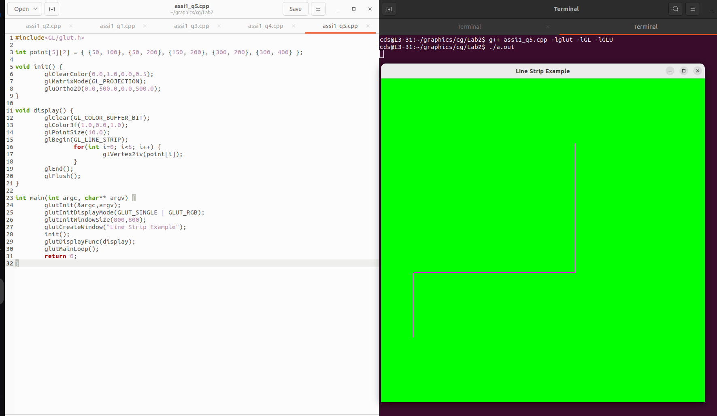

Q6.

CODE:
#include <GL/glut.h>
#define MAX_POINTS 100
int points[MAX_POINTS][2];
int pointCount = 0;
int windowWidth = 800;
int windowHeight = 800;
void init() {
glClearColor(0.0, 1.0, 0.0, 1.0); // Green background
glMatrixMode(GL_PROJECTION);
glLoadIdentity();
gluOrtho2D(0, windowWidth, 0, windowHeight);
}

void myMouseClick(int button, int state, int x, int y) {
if (button == GLUT_LEFT_BUTTON && state == GLUT_DOWN) {
if (pointCount < MAX_POINTS) {
points[pointCount][0] = x;
points[pointCount][1] = windowHeight - y; // flip Y
pointCount++;
}
glutPostRedisplay();
}
}

void display() {
glClear(GL_COLOR_BUFFER_BIT);

glColor3f(1.0, 0.0, 0.0); // Red points
glPointSize(8.0);

glBegin(GL_POINTS);
for (int i = 0; i < pointCount; i++) {
glVertex2i(points[i][0], points[i][1]);
}
glEnd();

glFlush();
}

int main(int argc, char** argv) {
glutInit(&argc, argv);
glutInitDisplayMode(GLUT_SINGLE | GLUT_RGB);
glutInitWindowSize(windowWidth, windowHeight);
glutCreateWindow("Mouse Click Point Plot");

init();
glutDisplayFunc(display);
glutMouseFunc(myMouseClick);

glutMainLoop();
return 0;
}

OUTPUT:
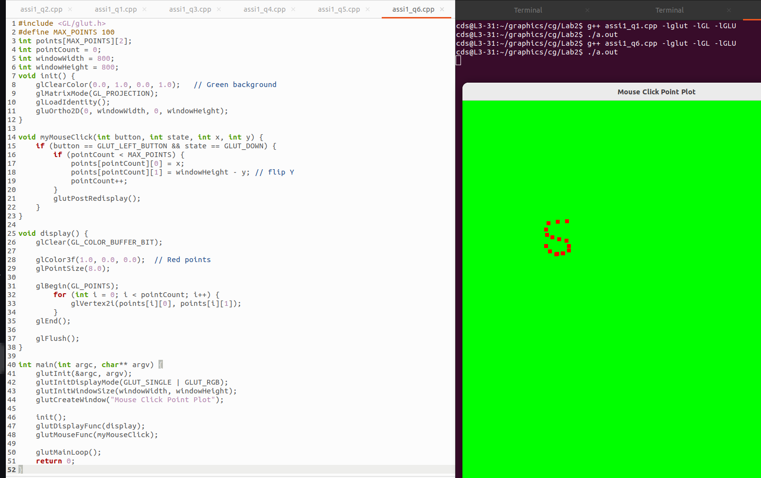

Q7.
CODE:

#include <GL/glut.h>
#include <math.h>
#include <stdio.h>
int n;
float radius = 200;
float cx = 250, cy = 250;

void init() {
glClearColor(1.0, 1.0, 1.0, 1.0);
glMatrixMode(GL_PROJECTION);
glLoadIdentity();
gluOrtho2D(0, 500, 0, 500);
}

void display() {
glClear(GL_COLOR_BUFFER_BIT);
glColor3f(1.0, 0.0, 0.0);

float angle, x, y;

glBegin(GL_LINE_LOOP);
for (int i = 0; i < n; i++) {
angle = 2 * M_PI * i / n;
x = cx + radius * cos(angle);
y = cy + radius * sin(angle);
glVertex2f(x, y);
}
glEnd();

glFlush();
}

int main(int argc, char** argv) {
printf("Enter number of sides: ");
scanf("%d", &n);

if (n < 3) {
printf("Polygon must have at least 3 sides!\n");
return 0;
}

glutInit(&argc, argv);
glutInitDisplayMode(GLUT_SINGLE | GLUT_RGB);
glutInitWindowSize(500, 500);
glutCreateWindow("Regular Polygon");

init();
glutDisplayFunc(display);
glutMainLoop();

return 0;
}

OUTPUT:
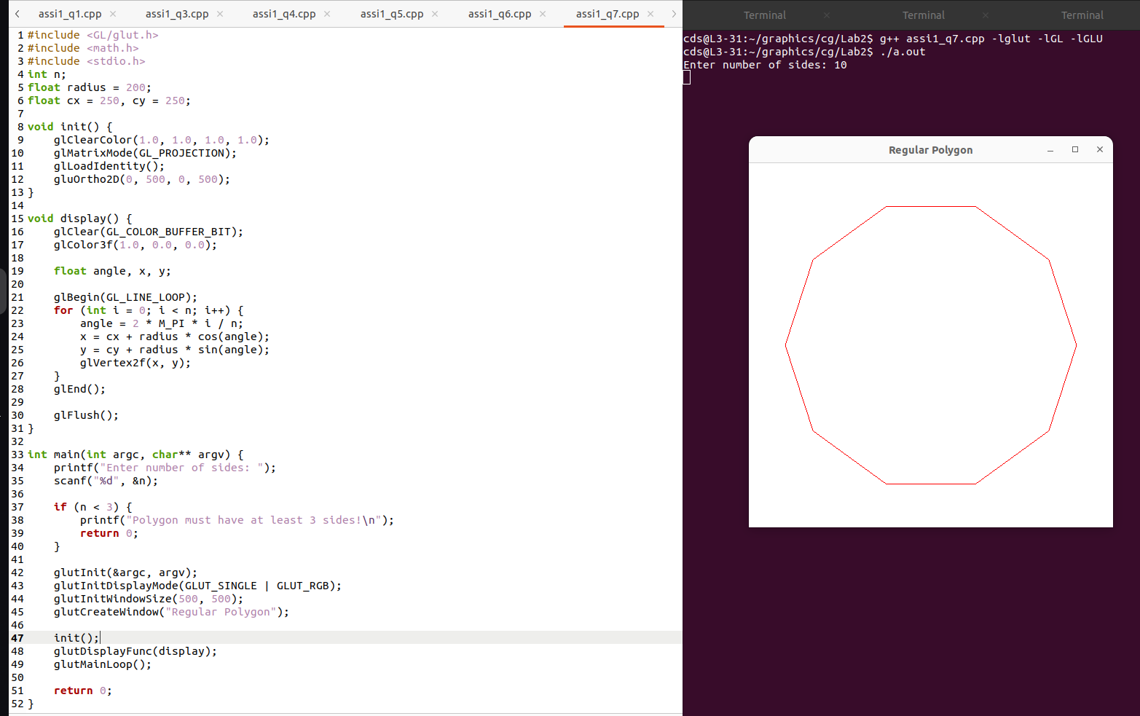

Q8.

CODE:
#include <GL/glut.h>
void init() {
glClearColor(1.0, 1.0, 1.0, 1.0);
glMatrixMode(GL_PROJECTION);
glLoadIdentity();
gluOrtho2D(0, 500, 0, 500);
}
void display() {
glClear(GL_COLOR_BUFFER_BIT);
glColor3f(0.0, 0.0, 0.0);

/* ---- House Body ---- */
glBegin(GL_LINE_LOOP);
glVertex2i(150, 150);
glVertex2i(350, 150);
glVertex2i(350, 300);
glVertex2i(150, 300);
glEnd();

/* ---- Roof ---- */
glBegin(GL_LINES);
glVertex2i(150, 300);
glVertex2i(250, 380);

glVertex2i(250, 380);
glVertex2i(350, 300);
glEnd();

/* ---- Door ---- */
glBegin(GL_LINE_LOOP);
glVertex2i(230, 150);
glVertex2i(270, 150);
glVertex2i(270, 230);
glVertex2i(230, 230);
glEnd();

/* ---- Left Window ---- */
glBegin(GL_LINE_LOOP);
glVertex2i(170, 220);
glVertex2i(210, 220);
glVertex2i(210, 260);
glVertex2i(170, 260);
glEnd();

/* ---- Right Window ---- */
glBegin(GL_LINE_LOOP);
glVertex2i(290, 220);
glVertex2i(330, 220);
glVertex2i(330, 260);
glVertex2i(290, 260);
glEnd();

/* ---- Window Cross Lines ---- */
glBegin(GL_LINES);
// Left window cross
glVertex2i(190, 220);
glVertex2i(190, 260);
glVertex2i(170, 240);
glVertex2i(210, 240);

// Right window cross
glVertex2i(310, 220);
glVertex2i(310, 260);
glVertex2i(290, 240);
glVertex2i(330, 240);
glEnd();

/* ---- Decorative Points ---- */
glPointSize(5.0);
glBegin(GL_POINTS);
glVertex2i(250, 380); // Roof top
glVertex2i(250, 230); // Door top
glEnd();

glFlush();
}

int main(int argc, char** argv) {
glutInit(&argc, argv);
glutInitDisplayMode(GLUT_SINGLE | GLUT_RGB);
glutInitWindowSize(500, 500);
glutCreateWindow("House using Points and Lines");

init();
glutDisplayFunc(display);
glutMainLoop();
return 0;
}

OUTPUT:

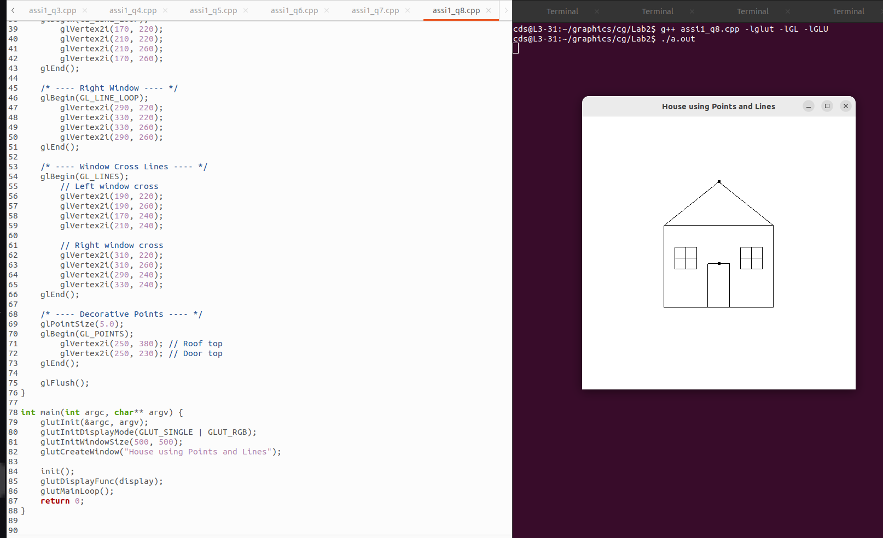

LAB – 2

Q1. Take endpoints as input and draw a line using DDA algorithm for all slope cases.

Q2. Take endpoints as input and draw a line using Bresenham’s algorithm for all slope cases .

Q3. Draw a dotted line using any algorithm.

Q4. Draw an alternate dotted-dashed line using any algorithm.

Q5. Draw HELLO on screen using only lines.

CODE :

#include <GL/glut.h>
#include <cmath>
#include <iostream>

using namespace std;

/* Plot a point */
void plot(int x, int y)
{
glBegin(GL_POINTS);
glVertex2i(x, y);
glEnd();
}

/* ---------------- DDA Line Algorithm ---------------- */
void DDA(int x1, int y1, int x2, int y2)
{
float dx = x2 - x1;
float dy = y2 - y1;

int steps = abs(dx) > abs(dy) ? abs(dx) : abs(dy);

float xInc = dx / steps;
float yInc = dy / steps;

float x = x1;
float y = y1;

for (int i = 0; i <= steps; i++)
{
plot(round(x), round(y));
x += xInc;
y += yInc;
}
}

/* ---------------- Bresenham Line Algorithm ---------------- */
void Bresenham(int x1, int y1, int x2, int y2)
{
int dx = abs(x2 - x1);
int dy = abs(y2 - y1);

int sx = (x1 < x2) ? 1 : -1;
int sy = (y1 < y2) ? 1 : -1;

int err = dx - dy;

while (true)
{
plot(x1, y1);

if (x1 == x2 && y1 == y2)
break;

int e2 = 2 * err;

if (e2 > -dy)
{
err -= dy;
x1 += sx;
}
if (e2 < dx)
{
err += dx;
y1 += sy;
}
}
}

/* ---------------- Dotted Line ---------------- */
void dottedLine(int x1, int y1, int x2, int y2)
{
float dx = x2 - x1;
float dy = y2 - y1;

int steps = abs(dx) > abs(dy) ? abs(dx) : abs(dy);

float xInc = dx / steps;
float yInc = dy / steps;

float x = x1;
float y = y1;

for (int i = 0; i <= steps; i++)
{
if (i % 4 == 0) // dot pattern
plot(round(x), round(y));

x += xInc;
y += yInc;
}
}

/* ---------------- Dotted-Dashed Line ---------------- */
void dottedDashedLine(int x1, int y1, int x2, int y2)
{
float dx = x2 - x1;
float dy = y2 - y1;

int steps = abs(dx) > abs(dy) ? abs(dx) : abs(dy);

float xInc = dx / steps;
float yInc = dy / steps;

float x = x1;
float y = y1;

for (int i = 0; i <= steps; i++)
{
if (i % 10 < 5 || i % 10 == 7) // dash + dot pattern
plot(round(x), round(y));

x += xInc;
y += yInc;
}
}

/* ---------------- Draw HELLO using Lines ---------------- */
void drawHELLO()
{
// H
DDA(50, 200, 50, 300);
DDA(80, 200, 80, 300);
DDA(50, 250, 80, 250);

// E
DDA(100, 200, 100, 300);
DDA(100, 300, 140, 300);
DDA(100, 250, 130, 250);
DDA(100, 200, 140, 200);

// L
DDA(160, 300, 160, 200);
DDA(160, 200, 200, 200);

// L
DDA(220, 300, 220, 200);
DDA(220, 200, 260, 200);

// O
DDA(280, 200, 280, 300);
DDA(280, 300, 320, 300);
DDA(320, 300, 320, 200);
DDA(320, 200, 280, 200);
}

/* ---------------- Display Function ---------------- */
void display()
{
glClear(GL_COLOR_BUFFER_BIT);

// DDA Line
glColor3f(1, 0, 0);
DDA(50, 50, 200, 100);

// Bresenham Line
glColor3f(0, 1, 0);
Bresenham(50, 80, 200, 150);

// Dotted Line
glColor3f(0, 0, 1);
dottedLine(50, 120, 200, 200);

// Dotted-Dashed Line
glColor3f(1, 0, 1);
dottedDashedLine(50, 160, 200, 260);

// HELLO
glColor3f(1, 1, 1);
drawHELLO();

glFlush();
}

/* ---------------- Initialization ---------------- */
void init()
{
glClearColor(0, 0, 0, 1);
glColor3f(1, 1, 1);
glPointSize(2);
gluOrtho2D(0, 500, 0, 500);
}

/* ---------------- Main ---------------- */
int main(int argc, char** argv)
{
glutInit(&argc, argv);
glutInitDisplayMode(GLUT_SINGLE | GLUT_RGB);
glutInitWindowSize(600, 600);
glutInitWindowPosition(100, 100);
glutCreateWindow("Line Drawing Algorithms");

init();
glutDisplayFunc(display);
glutMainLoop();

return 0;
}

OUTPUT :

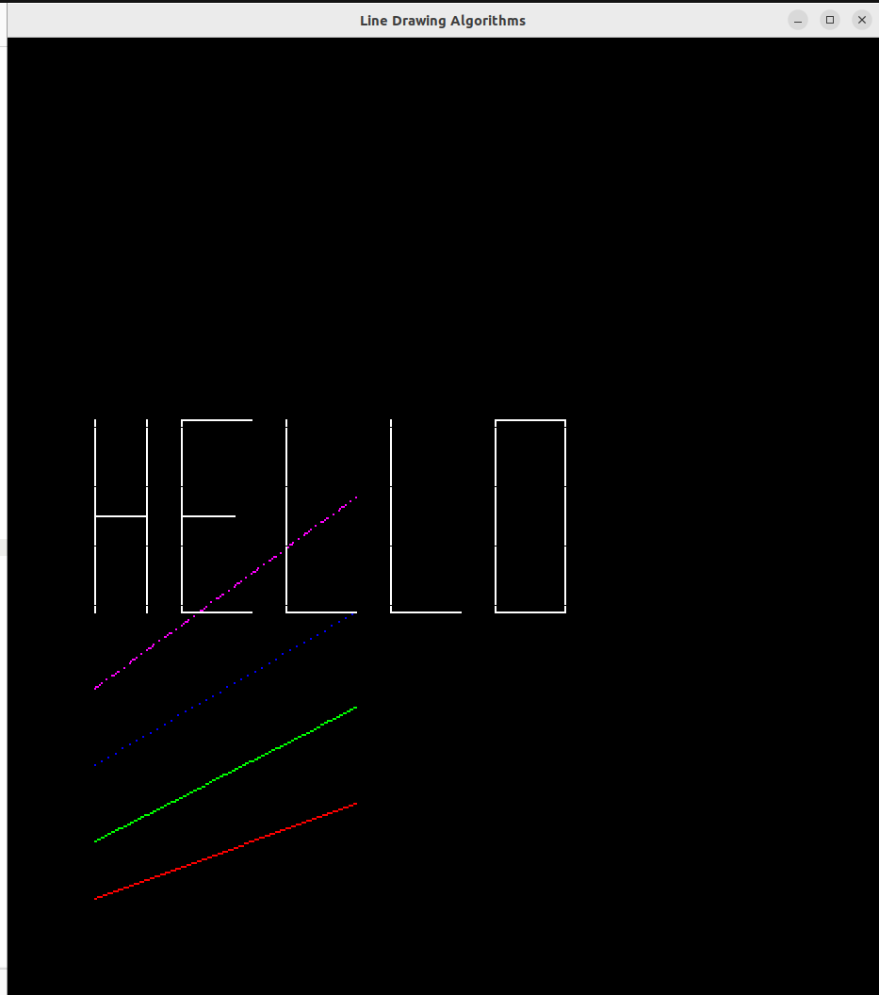

LAB – 3

Q1.Implement the midpoint circle draw algo print the pixel coordinates of the circles centre of origin.

CODE:

#include <GL/glut.h>
#include <stdio.h>

int xc = 0, yc = 0, r = 100;

void plotPoints(int x, int y)
{
glBegin(GL_POINTS);
glVertex2i(xc + x, yc + y);
glVertex2i(xc - x, yc + y);
glVertex2i(xc + x, yc - y);
glVertex2i(xc - x, yc - y);
glVertex2i(xc + y, yc + x);
glVertex2i(xc - y, yc + x);
glVertex2i(xc + y, yc - x);
glVertex2i(xc - y, yc - x);

glEnd();
}

void midpointCircle()
{
int x = 0;
int y = r;
int p = 1 - r;

while (x <= y)
{
plotPoints(x, y);
x++;

if (p < 0)
{
p = p + 2 * x + 1;
}
else
{
y--;
p = p + 2 * x - 2 * y + 1;
}
}
}

void display()
{
glClear(GL_COLOR_BUFFER_BIT);
glColor3f(1.0, 1.0, 1.0);
midpointCircle();
glFlush();
}

void init()
{
glClearColor(0.0, 0.0, 0.0, 1.0);
glColor3f(1.0, 1.0, 1.0);
glPointSize(2.0);

glMatrixMode(GL_PROJECTION);
glLoadIdentity();
gluOrtho2D(-300, 300, -300, 300);
}

int main(int argc, char** argv)
{
glutInit(&argc, argv);
glutInitDisplayMode(GLUT_SINGLE | GLUT_RGB);
glutInitWindowSize(600, 600);
glutInitWindowPosition(100, 100);
glutCreateWindow("Midpoint Circle Algorithm - OpenGL");

init();
glutDisplayFunc(display);
glutMainLoop();

return 0;
}

OUTPUT:

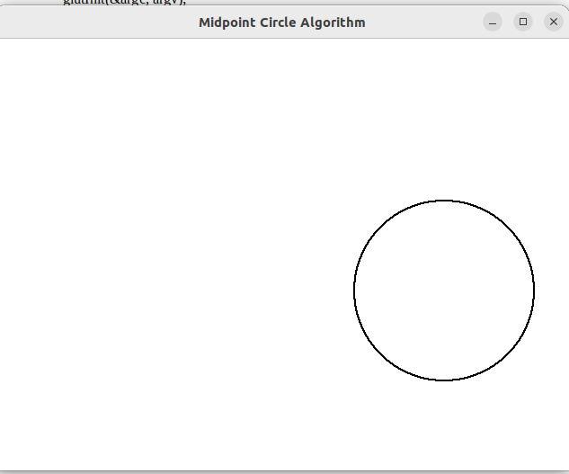

Q2. Draw a circle at any given centre.

CODE:

#include <GL/glut.h>
#include <stdio.h>

int xc, yc, r;

void plotPoints(int x, int y)
{
glBegin(GL_POINTS);

glVertex2i(xc + x, yc + y);
glVertex2i(xc - x, yc + y);
glVertex2i(xc + x, yc - y);
glVertex2i(xc - x, yc - y);
glVertex2i(xc + y, yc + x);
glVertex2i(xc - y, yc + x);
glVertex2i(xc + y, yc - x);
glVertex2i(xc - y, yc - x);

glEnd();
}

void midpointCircle()
{
int x = 0;
int y = r;
int p = 1 - r;

while (x <= y)
{
plotPoints(x, y);
x++;

if (p < 0)
{
p = p + 2 * x + 1;
}
else
{
y--;
p = p + 2 * x - 2 * y + 1;
}
}
}

void display()
{
glClear(GL_COLOR_BUFFER_BIT);
glColor3f(1.0, 1.0, 1.0);
midpointCircle();
glFlush();
}

void init()
{
glClearColor(0.0, 0.0, 0.0, 1.0);
glPointSize(2.0);

glMatrixMode(GL_PROJECTION);
glLoadIdentity();
gluOrtho2D(-500, 500, -500, 500);
}

int main(int argc, char** argv)
{
printf("Enter centre coordinates (xc yc): ");
scanf("%d %d", &xc, &yc);

printf("Enter radius: ");
scanf("%d", &r);

glutInit(&argc, argv);
glutInitDisplayMode(GLUT_SINGLE | GLUT_RGB);
glutInitWindowSize(600, 600);
glutCreateWindow("Midpoint Circle - Any Centre");

init();
glutDisplayFunc(display);
glutMainLoop();

return 0;
}

OUTPUT:
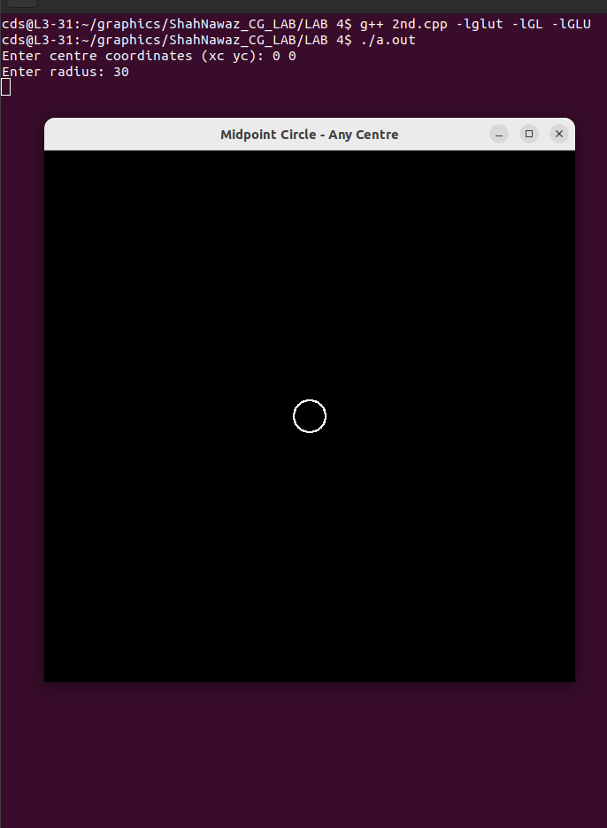

Q3.Draw Concentric circle with centre at origin.

CODE:

#include <GL/glut.h>
#include <stdio.h>

int rMax = 200;
int rStep = 20;

void plotPoints(int x, int y, int xc, int yc)
{
glBegin(GL_POINTS);
glVertex2i(xc + x, yc + y);
glVertex2i(xc - x, yc + y);
glVertex2i(xc + x, yc - y);
glVertex2i(xc - x, yc - y);
glVertex2i(xc + y, yc + x);
glVertex2i(xc - y, yc + x);
glVertex2i(xc + y, yc - x);
glVertex2i(xc - y, yc - x);
glEnd();
}

void drawCircle(int xc, int yc, int r)
{
int x = 0, y = r;
int p = 1 - r;

while (x <= y)
{
plotPoints(x, y, xc, yc);
x++;
if (p < 0)
p = p + 2*x + 1;
else
{
y--;
p = p + 2*x - 2*y + 1;
}
}
}

void display()
{
glClear(GL_COLOR_BUFFER_BIT);
glColor3f(1.0, 1.0, 1.0);

int r;
for(r = rStep; r <= rMax; r += rStep)
drawCircle(0, 0, r);
glFlush();
}

void init()
{
glClearColor(0.0, 0.0, 0.0, 1.0);
glPointSize(2.0);

glMatrixMode(GL_PROJECTION);
glLoadIdentity();
gluOrtho2D(-250, 250, -250, 250);
}

int main(int argc, char** argv)
{
glutInit(&argc, argv);
glutInitDisplayMode(GLUT_SINGLE | GLUT_RGB);
glutInitWindowSize(500, 500);
glutCreateWindow("Concentric Circles - OpenGL");

init();
glutDisplayFunc(display);
glutMainLoop();

return 0;
}

OUTPUT:

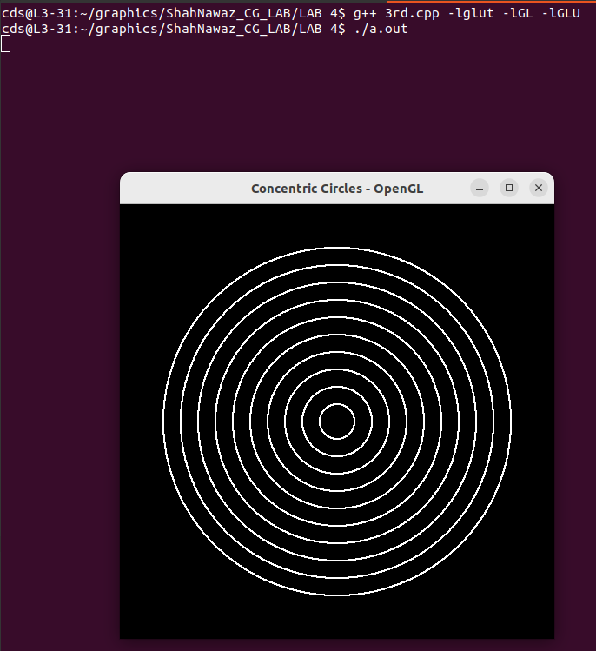

Q4.Draw multiple circles with diff position.

CODE:
#include <GL/glut.h>
#include <stdio.h>

#define NUM_CENTRES 5

int centres[NUM_CENTRES][2] = {
{0, 0},
{100, 100},
{-100, 50},
{-50, -100},
{150, -50}
};

int radius[NUM_CENTRES] = {50, 30, 70, 40, 60};

void plotPoints(int x, int y, int xc, int yc)
{
glBegin(GL_POINTS);
glVertex2i(xc + x, yc + y);
glVertex2i(xc - x, yc + y);
glVertex2i(xc + x, yc - y);
glVertex2i(xc - x, yc - y);
glVertex2i(xc + y, yc + x);
glVertex2i(xc - y, yc + x);
glVertex2i(xc + y, yc - x);
glVertex2i(xc - y, yc - x);
glEnd();
}

void drawCircle(int xc, int yc, int r)
{
int x = 0, y = r;
int p = 1 - r;

while (x <= y)
{
plotPoints(x, y, xc, yc);
x++;
if (p < 0)
p = p + 2*x + 1;
else
{
y--;
p = p + 2*x - 2*y + 1;
}
}
}

void display()
{
glClear(GL_COLOR_BUFFER_BIT);
glColor3f(1.0, 1.0, 1.0);

for (int i = 0; i < NUM_CENTRES; i++)
drawCircle(centres[i][0], centres[i][1], radius[i]);

glFlush();
}

void init()
{
glClearColor(0.0, 0.0, 0.0, 1.0);
glPointSize(2.0);

glMatrixMode(GL_PROJECTION);
glLoadIdentity();
gluOrtho2D(-300, 300, -300, 300);
}

int main(int argc, char** argv)
{
glutInit(&argc, argv);
glutInitDisplayMode(GLUT_SINGLE | GLUT_RGB);
glutInitWindowSize(600, 600);
glutCreateWindow("Multiple Circles - OpenGL");

init();
glutDisplayFunc(display);
glutMainLoop();

return 0;
}

OUTPUT:

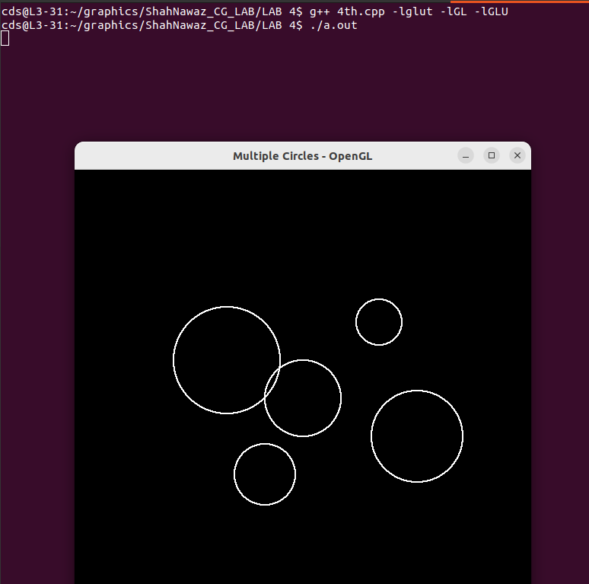

Q5. Draw Olympics Grids.

CODE:

#include <GL/glut.h>

struct Circle {
int xc, yc, r;
float color[3];
};

Circle rings[5] = {
{-120, 50, 50, {0.0, 0.0, 1.0}},
{0, 50, 50, {0.0, 0.0, 0.0}},
{120, 50, 50, {1.0, 0.0, 0.0}},
{-60, 0, 50, {1.0, 1.0, 0.0}},
{60, 0, 50, {0.0, 1.0, 0.0}}
};

void plotPoints(int x, int y, int xc, int yc) {
glBegin(GL_POINTS);
glVertex2i(xc + x, yc + y);
glVertex2i(xc - x, yc + y);
glVertex2i(xc + x, yc - y);
glVertex2i(xc - x, yc - y);
glVertex2i(xc + y, yc + x);
glVertex2i(xc - y, yc + x);
glVertex2i(xc + y, yc - x);
glVertex2i(xc - y, yc - x);
glEnd();
}

void drawCircle(int xc, int yc, int r) {
int x = 0, y = r;
int p = 1 - r;
while (x <= y) {
plotPoints(x, y, xc, yc);
x++;
if (p < 0)
p = p + 2*x + 1;
else {
y--;
p = p + 2*x - 2*y + 1;
}
}
}

void display() {
glClear(GL_COLOR_BUFFER_BIT);

for(int i = 0; i < 5; i++) {
glColor3f(rings[i].color[0], rings[i].color[1], rings[i].color[2]);
drawCircle(rings[i].xc, rings[i].yc, rings[i].r);
}

glFlush();
}

void init() {
glClearColor(1.0, 1.0, 1.0,1.0);
glPointSize(5.0);
glMatrixMode(GL_PROJECTION);
glLoadIdentity();
gluOrtho2D(-300, 300, -100, 150);
}

int main(int argc, char** argv) {
glutInit(&argc, argv);
glutInitDisplayMode(GLUT_SINGLE | GLUT_RGB);
glutInitWindowSize(700, 400);
glutCreateWindow("Olympic Logo - OpenGL");

init();
glutDisplayFunc(display);
glutMainLoop();
return 0;
}

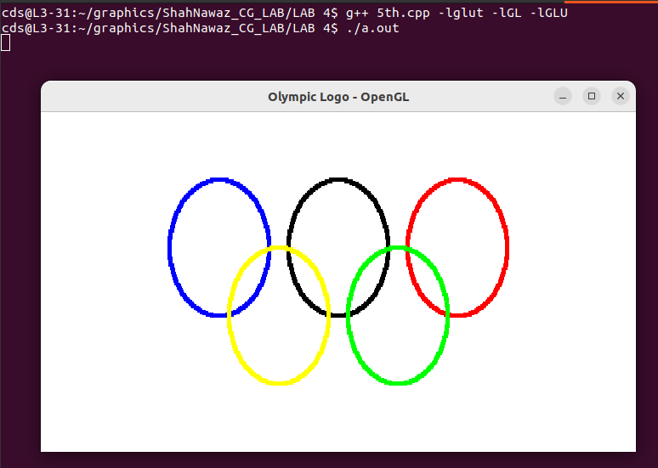
OUTPUT:

LAB – 4

Q1. Ellipse drawing algorithm.

Ans.1

CODE:

#include <GL/glut.h>
#include <cmath>

int xc = 0, yc = 0;
int a = 200;
int b = 200;

void plotPoint(int x, int y) {
glBegin(GL_POINTS);
glVertex2i(xc + x, yc + y);
glVertex2i(xc - x, yc + y);
glVertex2i(xc + x, yc - y);
glVertex2i(xc - x, yc - y);
glEnd();
}

void midpointEllipse() {

float dx, dy, d1, d2, x, y;
x = 0;
y = b;

d1 = (b*b) - (a*a*b) + (0.25*a*a);
dx = 2 * b * b * x;
dy = 2 * a * a * y;

while (dx < dy) {
plotPoint(x, y);

if (d1 < 0) {
x++;
dx = dx + (2 * b * b);
d1 = d1 + dx + (b * b);
}
else {
x++;
y--;
dx = dx + (2 * b * b);
dy = dy - (2 * a * a);
d1 = d1 + dx - dy + (b * b);
}
}

d2 = ((b*b) * ((x + 0.5)*(x + 0.5))) +((a*a) * ((y - 1)*(y - 1))) - (a*a*b*b);

while (y >= 0) {
plotPoint(x, y);

if (d2 > 0) {
y--;
dy = dy - (2 * a * a);
d2 = d2 + (a * a) - dy;
}
else {
y--;
x++;
dx = dx + (2 * b * b);
dy = dy - (2 * a * a);
d2 = d2 + dx - dy + (a * a);
}
}
}

void display() {
glClear(GL_COLOR_BUFFER_BIT);
glColor3f(1.0, 1.0, 1.0);
midpointEllipse();
glFlush();
}

void init() {
glClearColor(0.0, 0.0, 0.0, 1.0);
glMatrixMode(GL_PROJECTION);
gluOrtho2D(-400, 400, -300, 300);
}

int main(int argc, char** argv) {
glutInit(&argc, argv);
glutInitWindowSize(800, 600);
glutCreateWindow("Midpoint Ellipse Algorithm - OpenGL");
init();
glutDisplayFunc(display);
glutMainLoop();
return 0;
}

OUTPUT:

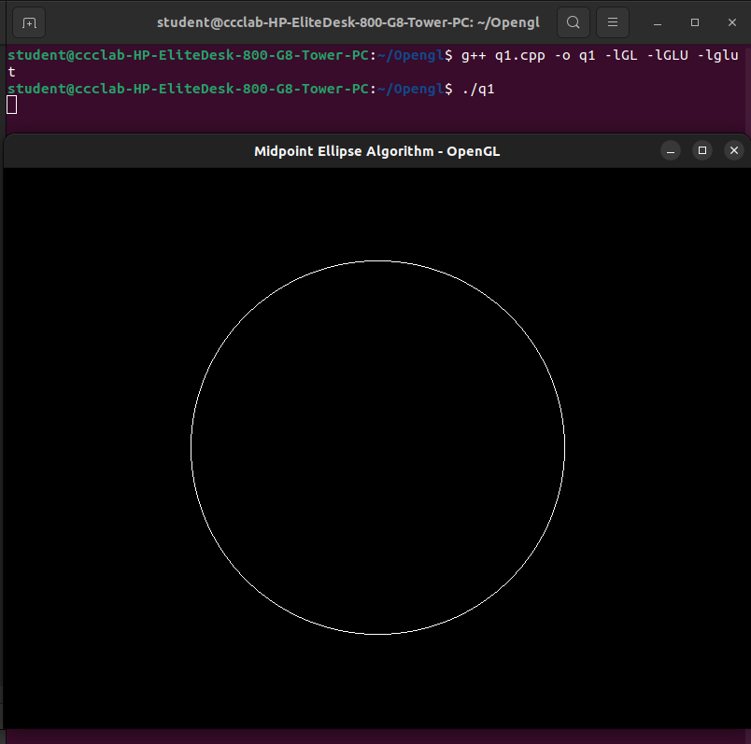

Q2. Create 3 houses, a sun and a fence.

Ans.2

CODE:

#include <GL/glut.h>
#include <cmath>

const int WIDTH = 800;
const int HEIGHT = 600;
void drawSun() {
float cx = 600, cy = 500, r = 50;
glBegin(GL_LINE_LOOP);
for(int i = 0; i < 100; i++) {
float angle = 2 * 3.1416 * i / 100;
float x = r * cos(angle);
float y = r * sin(angle);
glVertex2f(cx + x, cy + y);
}
glEnd();
}

void drawFence() {
for(int i = 0; i < 800; i += 20){
glBegin(GL_LINES);
glVertex2f(i, 50);
glVertex2f(i, 90);
glEnd();
}
glBegin(GL_LINES);
glVertex2f(0, 70);
glVertex2f(800, 70);
glEnd();
}

void drawSimpleHouse(float x, float y) {

glBegin(GL_LINE_LOOP);
glVertex2f(x, y);
glVertex2f(x + 100, y);
glVertex2f(x + 100, y + 80);
glVertex2f(x, y + 80);
glEnd();

glBegin(GL_LINE_LOOP);
glVertex2f(x - 10, y + 80);
glVertex2f(x + 110, y + 80);
glVertex2f(x + 50, y + 120);
glEnd();

glBegin(GL_LINE_LOOP);
glVertex2f(x + 40, y);
glVertex2f(x + 60, y);
glVertex2f(x + 60, y + 40);
glVertex2f(x + 40, y + 40);
glEnd();

glBegin(GL_LINE_LOOP);
glVertex2f(x + 10, y + 45);
glVertex2f(x + 30, y + 45);
glVertex2f(x + 30, y + 65);
glVertex2f(x + 10, y + 65);
glEnd();
}

void display() {
glClear(GL_COLOR_BUFFER_BIT);

drawSun();

drawSimpleHouse(100, 150);
drawSimpleHouse(300, 150);
drawSimpleHouse(500, 150);

drawFence();

glFlush();
}

void init() {
glClearColor(0, 0, 0, 1);
glMatrixMode(GL_PROJECTION);
gluOrtho2D(0, WIDTH, 0, HEIGHT);
}

int main(int argc, char** argv) {
glutInit(&argc, argv);
glutInitWindowSize(WIDTH, HEIGHT);
glutCreateWindow("Final Wireframe Scene");
init();
glutDisplayFunc(display);
glutMainLoop();
return 0;
}

OUTPUT:

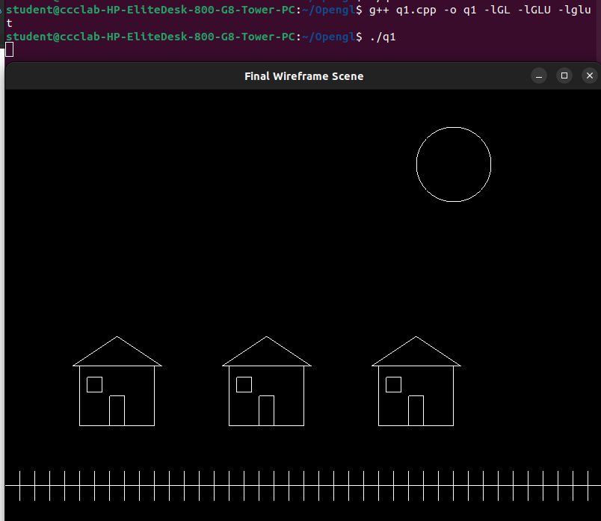

LAB – 5

OUTPUT:
