PROJECT ASSIGNMENT #2:   
COMBUSTION THERMODYNAMICS



Shiyao Ni

260886495

Submitted to:

Professor. Jeffrey Bergthorson

Part II – Explosion theory 3

1. Calculate the volume and surface of this reactor 3

2. Execute the simulation and calculate the heat release per time step 3

3. Does the mixture ignite? 3

4. Plot the heat release of the reactor versus its temperature 3

5. Using a lighter gas methane 4

6. Compute the heat loss function 5

7. Plot 5

8. Determine if the mixture will ignite. 5

9. Confirm your theory by computing a reactor with the same heat loss functions than for Q6. 5

a. T_env = 700K 6

b. T_env = 1200K 6

c. T_env = 1500K 7

10. Ignition time calculation and comment 7

Part III – Perfectly stirred reactor 8

1. Mass flow rate and equivalence ratio of iso-Octane 8

2. Equilibrium flame temperature, mole fractions of CO and NO 8

3. The concentration of PSR 8

4. The residence time of PSR 8

5. How does the PSR concentration values for CO and NO compare with the equilibrium values 8

6. Temperature difference 8

Bonus- 9

7. Looping through different power output, from 100MW to 350MW, in steps of 50MW 10

Part VI: Relate this assignment to your design project 10

# Part II – Explosion theory

Note that all the figures regarding heat release, the unit should be in Watt instead of J, as displayed on the axis.

## Calculate the volume and surface of this reactor

$$A=4πr^{2}=4π*{0.037}^{2}=0.017203 m^{2}$$

$$V=\frac{4}{3} πr^{3}=\frac{4}{3} π*{\left(0.037\right)}^{3}=2.12175*{10}^{-4} m^{3}$$

## Execute the simulation and calculate the heat release per time step

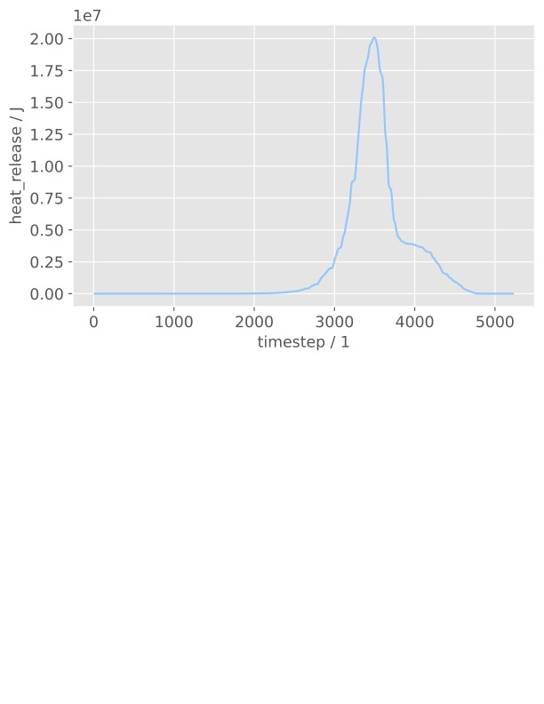

## Does the mixture ignite?

Yes, it auto ignites at t = 2.844500375606927s

## Plot the heat release of the reactor versus its temperature

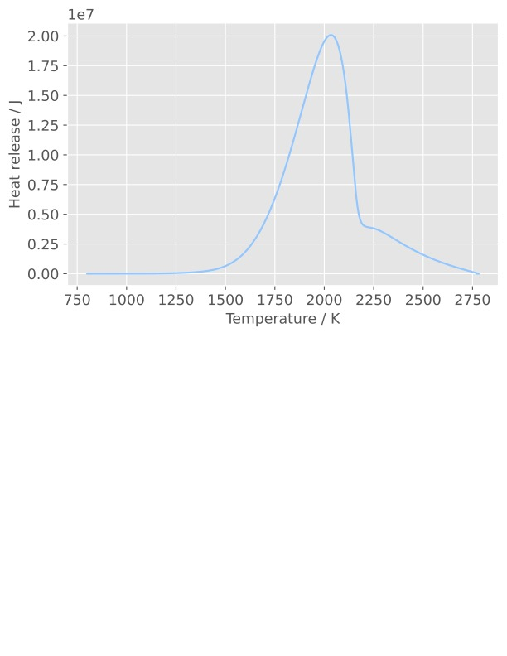

## Using a lighter gas methane

While a lighter gas methane is used, after researching about its ignition temperature at 1 atm, which is higher than that of the iso-octane, the estimated ignition delay time was pushed back to 200s to successfully auto-ignite the species.

The computed ignition delay is 143.24537259330438 s

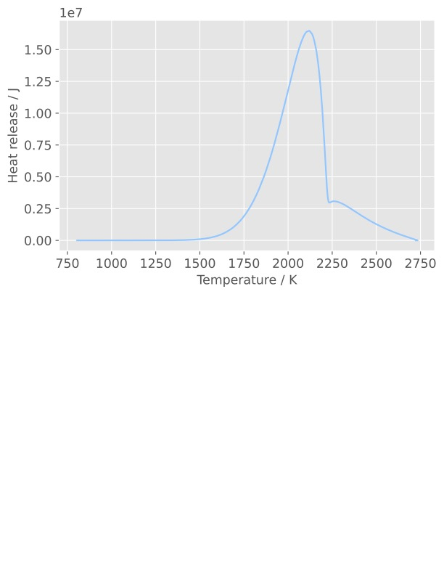

The maximum heat release of methane is lower than that of the iso-octane, since methane is a more stable specie compared to isooctane hence a longer reaction time. IDT of such reaction should be longer compared to IDT of isooctane.

## Compute the heat loss function

## Plot

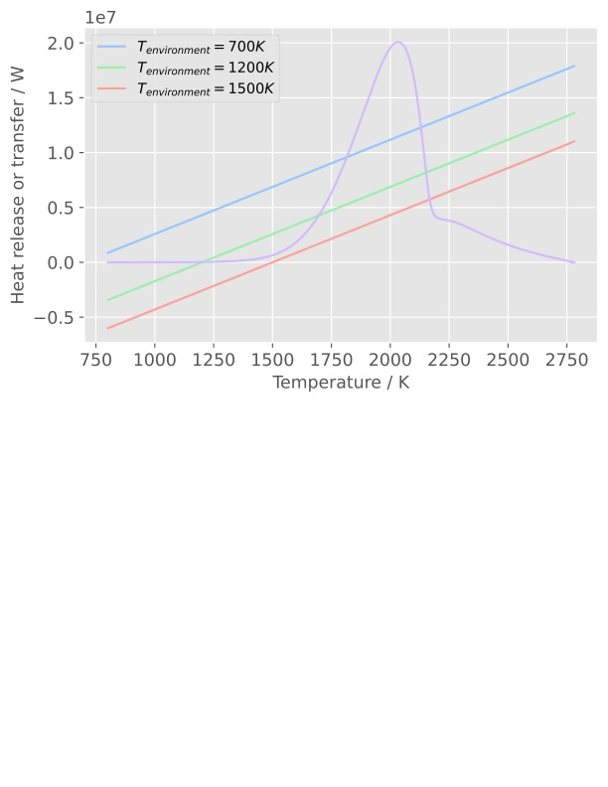

## Determine if the mixture will ignite.

From the above plot, the mixture will only ignite when the environmental temperature is 1500K. Two other environmental temperature will not lead to auto-ignition for the following reason:

* The slope is higher than the critical condition, hence the heat loss will be more than the heat generation in the combustor, causing the ignition to fail.
* For the case T_env = 1500K, the slope is lower than the point of criticality, and that means the heat generation in the combustor is higher than the heat loss to the surroundings, therefore the ignition could still be successful.

## Confirm your theory by computing a reactor with the same heat loss functions than for Q6.

### T_env = 700K

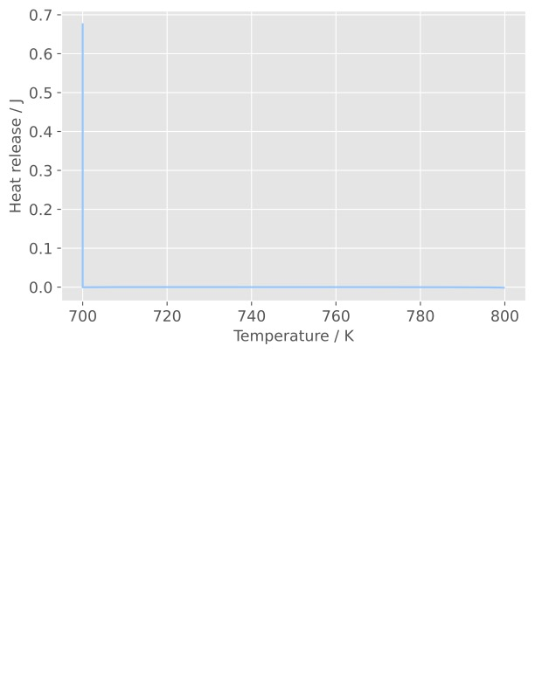

Heat release = 0, no auto ignition until t = 500s.

### T_env = 1200K

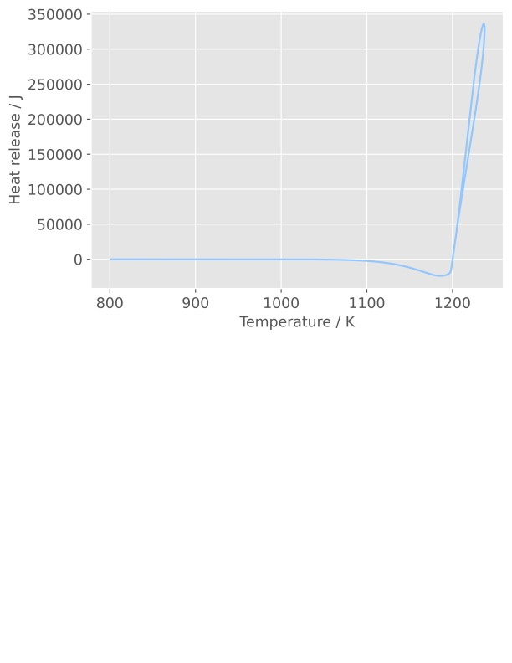

There exists heat release due to heat transfer to the surrounding, but it is still not high enough to conclude that there have been an auto ignition.

### T_env = 1500K

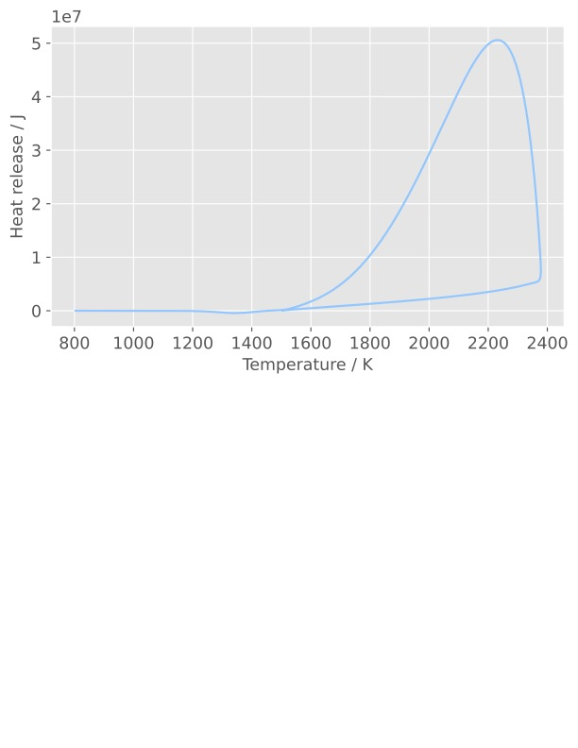

There exists enough heat release (around 50MW) to conclude that there have been an auto-ignition in the combustor, the temperature inside the combustor have also raised far above the environment due to the release of chemical potential energy inside the fuel.

## Ignition time calculation and comment

As stated above, auto-ignition will only take place for T_env = 1500 K, and the calculated ignition delay for such case is 1.569007381918055e-05 s. Compared to the delay in the adiabatic case, t = 2.844500375606927s, the ignition delay for the non-adiabatic case was much shorter. The reason behind that is probably:

* The ignition delay was computed when the mixture reached a temperature of 1300K (800K initial combustor temp + 500K), hence at T_env = 1500K, the have been heat transfer into the combustor, causing the ignition delay to decrease

# Part III – Perfectly stirred reactor

## Mass flow rate and equivalence ratio of iso-Octane

$$η=\frac{P_{out}}{\dot{Q_{in}}} = 42\% \\ \dot{Q_{in}}=P_{out}/0.42=120/0.42=285.714 MJ/s$$

$$\dot{m_{in}}=\frac{\dot{Q_{in}}}{Heating Value}=285.714/45=6.3492 kg/s$$

$$ϕ=\frac{6.3429/240}{144/1716}=\frac{0.03536173768}{0.04}=0.3982$$

## Equilibrium flame temperature, mole fractions of CO and NO

$$T_{equilibrium}=1720K$$

$$X_{CO}=0.0000023209=2.3209PPM$$

e $X_{NO}=0.0023688935$

## The concentration of PSR

$$X_{CO} = 0.0002324804=232.4804PPM$$

$$X_{CO} = 0.0000051471=5.1471PPM$$

## The residence time of PSR

$$T_{res} = 9.9ms$$

## How does the PSR concentration values for CO and NO compare with the equilibrium values

|  |  |  |
| --- | --- | --- |
|  | Equilibrium | PSR |
| X_CO / PPM | 2.32 | 232.48 |
| X_NO / PPM | 2368.89 | 5.1471 |

* The concentration of CO is higher in PSR due to the limited T_res, not enough CO is having time to be oxidized to CO2 before exiting the reactor, also since in the equilibrium condition is assuming complete combustion, less CO concentration is formed.
* The concentration of NO is much lower than the equilibrium condition, also due to the short T_res. The formation of NO is highly dependent on reaction time. The reaction is not complete in the PSR reactor, and in the equilibrium case, more time could be taken to form the NO. As the formation of NO requires long time and high heat release.

## Temperature difference

|  |  |  |
| --- | --- | --- |
|  | Equilibrium | PSR |
| Flame Temperature / K | 1720 | 1723 |

* The temperature in the PSR is only slightly higher than that of the equilibrium case since the reaction time is long enough to consume all the chemical potential of the reactant. However, due to less NO is formed in the reactor, although more CO is formed in the PSR compared to equilibrium case, in total, more energy is used to form product, hence lower the temperature.

## Bonus -

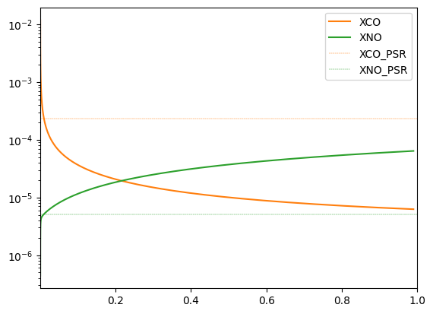

The x axis label will be T_res / s and y axis label is concentration, in log scale.

From the figure above, we could conclude that as the T_res increases, the concentration of CO decreases and that of the NO increases. The interception points between the dotted and solid line for both orange and green colour stands for the T_res = 9.9 ms. Although both concentrations are not converging to the values in the equilibrium conditions, the trend could explain the drill here – more complete combustion, more NO formed and less CO formed at the given equivalence ratio, pressure. Since the formation of NO is endothermic and that of CO is exothermic, the temperature of the PSR is slightly higher than that of the equilibrium condition.

## Looping through different power output, from 100MW to 350MW, in steps of 50MW

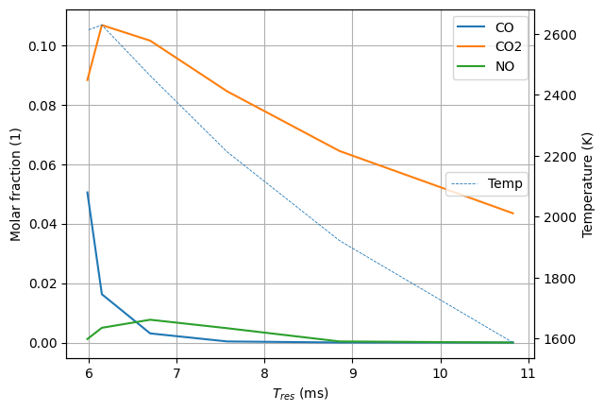

|  |  |  |  |
| --- | --- | --- | --- |
| Power (MW) | M dot (kg/s) | phi | T_res(ms) |
| 100 | 5.291 | 0.33146 | 10.84062 |
| 150 | 7.937 | 0.49719 | 8.82521 |
| 200 | 10.582 | 0.66291 | 7.54112 |
| 250 | 13.228 | 0.82864 | 6.68887 |
| 300 | 15.873 | 0.99437 | 6.14994 |
| 350 | 18.519 | 1.16010 | 5.98743 |

* The optimal residence time is around 6.15ms, since the temperature is at its peak at such time.
* When the residence time is decreased from 6.15s, there is too much fuel going into the combustor, resulting in a incomplete combustion.
* When the residence temperature increases from 6.15s, the is too much air going in, resulting in a incomplete combustion, however the CO concentration decreases.
* At 6.15ms, the concentration of NO pollutant is high. The optimal selection for industrial setting is probably 8ms or 9ms depending on if a cleaner solution is desired or a higher output is desired. At such values, less pollutant is formed than the 6.15ms case.

# Part VI: Relate this assignment to your design project

A good ignition delay time tracer for NH3 + H2 combustion is the maximum gradient of the OH* species (OH in an excited state). The OH* formation sub-mechanism is included in the mechanism file.

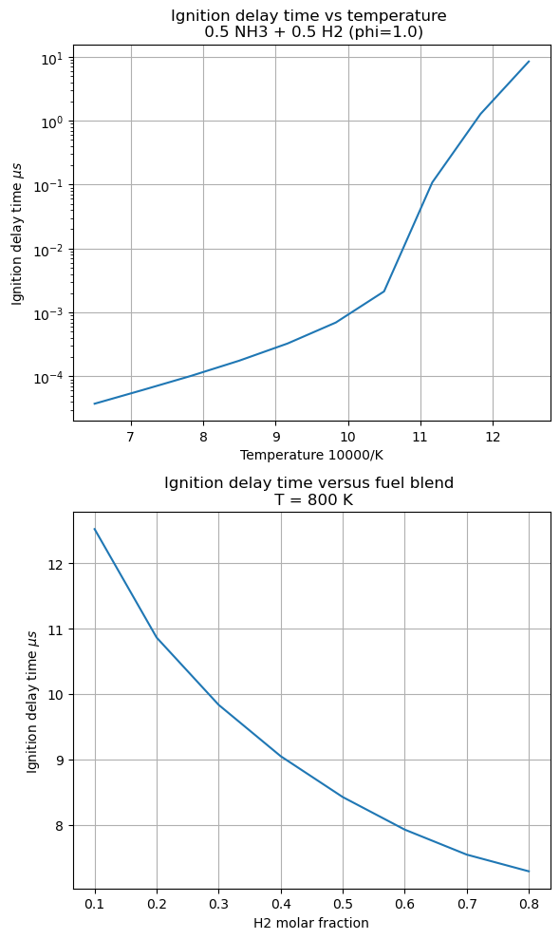

* Reaction is faster when the initial state is hotter
* IDT is slower compared to C8H18 (around 8.5 s versus 2.85 s) for the X(H2) = 0.5 blend
* When there is more hydrogen, the mixture ignites faster
* The range if IDT when modifying the hydrogen molar fraction suggests that a blend can be made to obtain specific combustion properties

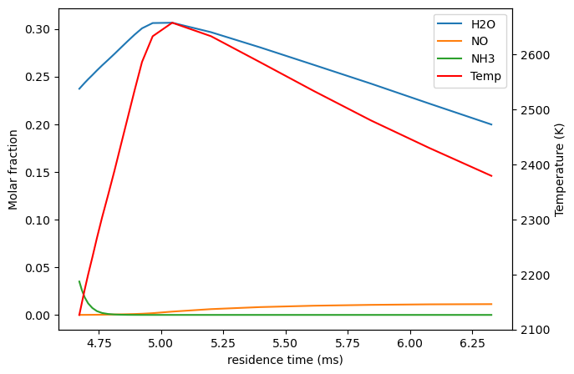

* Lean combustion reduces the amount of NO produced but NH3, another harmful pollutant remains in important quantities
* At the stochiometric residence time an important amount of NO is present in the exhaust
* For similar equivalence ratio, and the same air mass flow the temperature is much higher than for C8H18

Some improvements:

* Two points exists where X(NO) = X(NH3) which could be used to react them together in an exhaust post treatment process
* Lean combustion cannot be used to reduce the pollution, thus inventive techniques should be used, such as a two-stage combustor
* Adding ammonia to hydrogen reduces the IDT and makes it safer.