PROJECT ASSIGNMENT #2:   
COMBUSTION THERMODYNAMICS



Shiyao Ni

260886495

Submitted to:

Professor. Jeffrey Bergthorson

Table of Contents

Part II – Explosion theory 3

1. Calculate the volume and surface of this reactor 3

2. Execute the simulation and calculate the heat release per time step 3

3. Does the mixture ignite? 3

4. Plot the heat release of the reactor versus its temperature 3

5. Using a lighter gas methane 4

6. Compute the heat loss function 5

7. Plot 5

8. Determine if the mixture will ignite. 5

9. Confirm your theory by computing a reactor with the same heat loss functions than for Q6. 5

a. T_env = 700K 5

# Part II – Explosion theory

Note that all the figures regarding heat release, the unit should be in Watt instead of J, as displayed on the axis.

## Calculate the volume and surface of this reactor

## Execute the simulation and calculate the heat release per time step

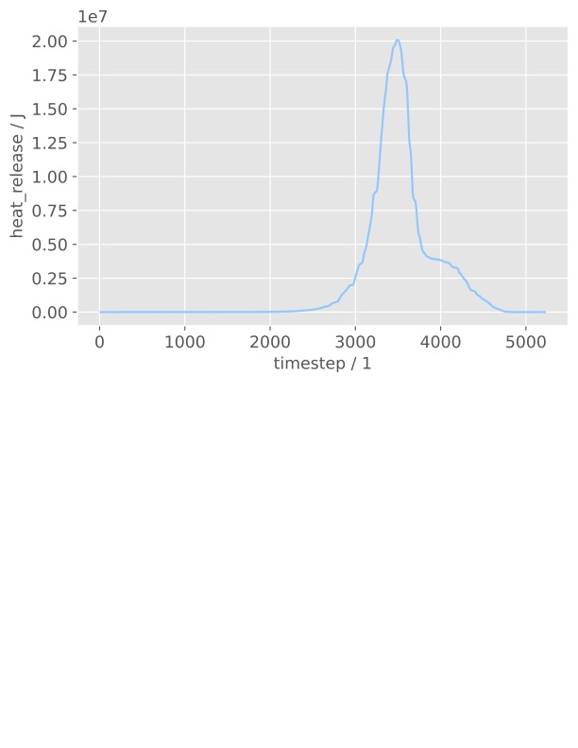

## Does the mixture ignite?

Yes, it auto ignites at t = 2.844500375606927s

## Plot the heat release of the reactor versus its temperature

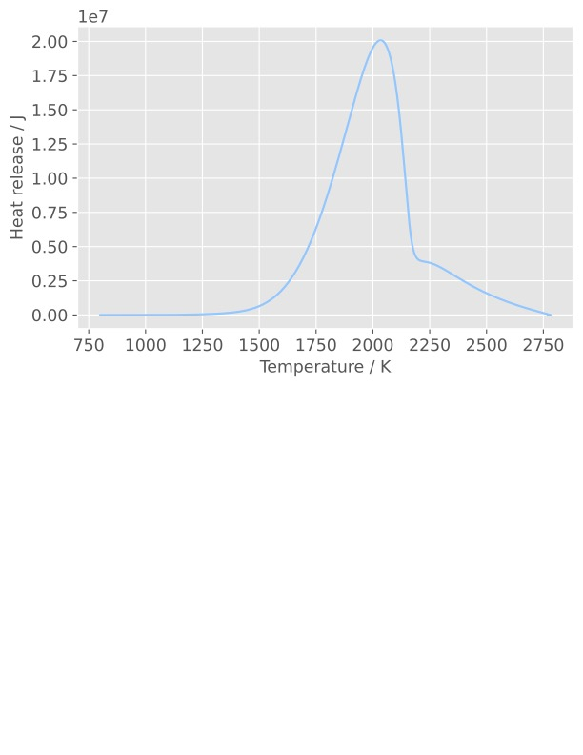

## Using a lighter gas methane

While a lighter gas methane is used, after researching about its ignition temperature at 1 atm, which is higher than that of the iso-octane, the estimated ignition delay time was pushed back to 200s to successfully auto-ignite the species.

The computed ignition delay is 143.24537259330438 s

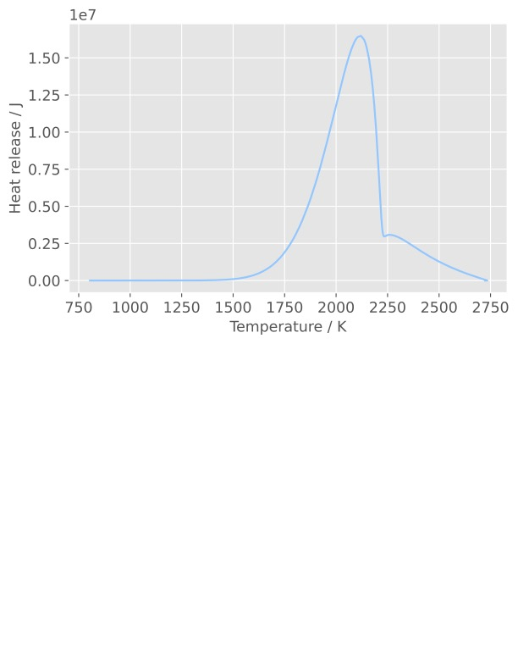

The heat release of methane is lower than that of the iso-octane. Why

## Compute the heat loss function

## Plot

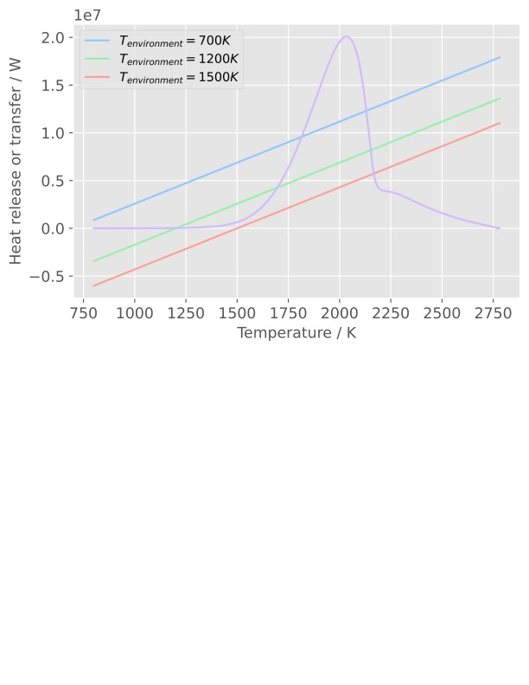

## Determine if the mixture will ignite.

From the above plot, the mixture will only ignite when the environmental temperature is 1500K. Two other environmental temperature will not lead to auto-ignition for the following reason:

* The slope is higher than the critical condition, hence the heat loss will be more than the heat generation in the combustor, causing the ignition to fail.
* For the case T_env = 1500K, the slope is lower than the point of criticality, and that means the heat generation in the combustor is higher than the heat loss to the surroundings, therefore the ignition could still be successful.

## Confirm your theory by computing a reactor with the same heat loss functions than for Q6.

### T_env = 700K

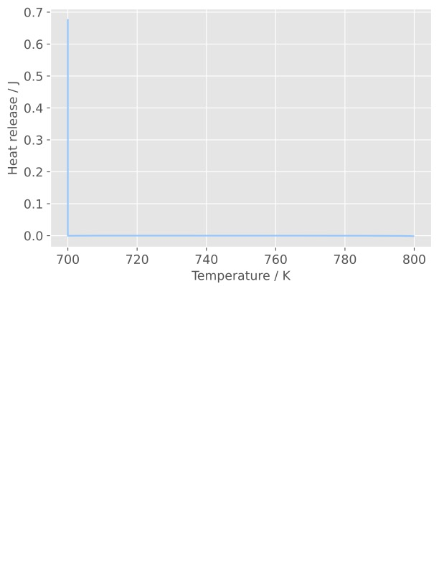

Heat release = 0, no auto ignition until t=500s.

### T_env = 1200K

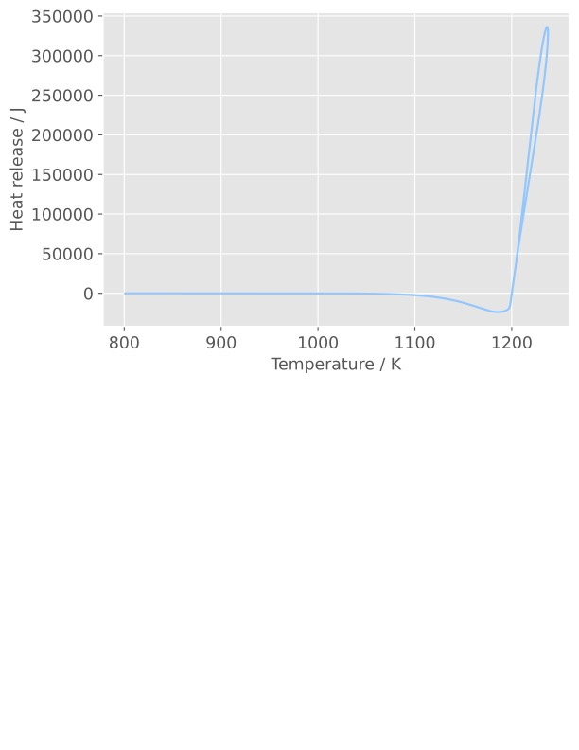

There exists heat release due to heat transfer to the surrounding, but it is still not high enough to conclude that there have been an auto ignition.

### T_env = 1500K

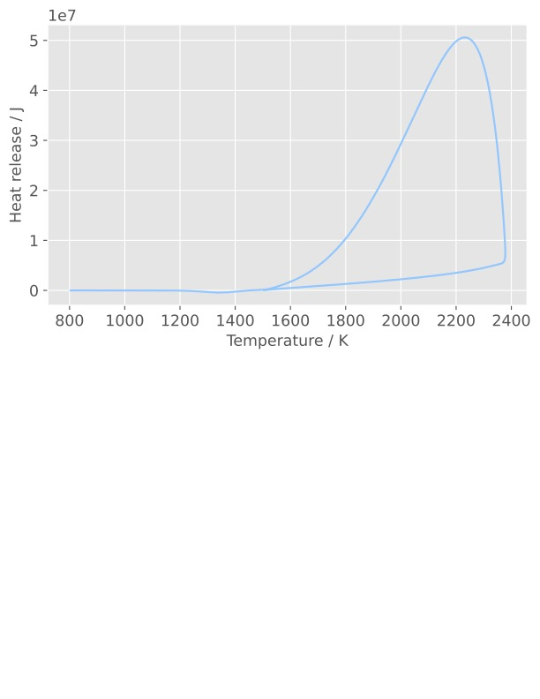

There exists enough heat release (around 50MW) to conclude that there have been an auto-ignition in the combustor, the temperature inside the combustor have also raised far above the environment due to the release of chemical potential energy inside the fuel.

## Ignition time calculation and comment

As stated above, auto-ignition will only take place for T_env = 1500 K, and the calculated ignition delay for such case is 1.569007381918055e-05 s. Compared to the delay in the adiabatic case, t = 2.844500375606927s, the ignition delay for the non-adiabatic case was much shorter. The reason behind that is probably:

* The ignition delay was computed when the mixture reached a temperature of 1300K (800K initial combustor temp + 500K), hence at T_env = 1500K, the have been heat transfer into the combustor, causing the ignition delay to decrease

# Part III – Perfectly stirred reactor

## Mass flow rate and equivalence ratio of iso-Octane

## Equilibrium flame temperature, mole fractions of CO and NO