**Autogen Tool**: For resource implementation of all RF/SF resources

* Library requirement:
* xmltodict
* psutil
* urllib
* requests
* To generate *_api.py file for all the resources, run the below command:

python script_api.py [schema_path]

[schema_path] should be the path of the XML schema directory

* To generate a *.py template file for all the resources, run the following command:

python script_template.py [xml_schema_path] [json_schema_path]

[xml_schema_path] should be the path of the XML schema directory.

[json_schema_path] should be the path of the JSON schema directory.

* To generate resource implementation for a specific resource, use the following programs:
* generate_api.py
  + This program will create API implementation code for the resource in the 'APIs' folder.
  + Input to this program would be the XML schema URL for the resource.
* generate_service_api.py
  + This program will create API implementation code for the service and/or subservice in the 'Service APIs' folder.
  + Input to this program would be XML schema URL for the service and/or subservice.
* To generate a template file for each individual resource, run the following program:
* generate_template.py
  + This program will generate template code for the resource in the 'Templates' folder.
  + Input to this program would be JSON and XML schema URLs for the resource.
* This tool also generates add_resource/add_service_resource and add_import files.
* add_resource/add_service_resource contains "g.api.add_resource" statements for all implemented resource.
* add_import contains import statements for generated classes

You can copy the contents from these files to the emulator's resource_manager.py program.

* Notes:
* Autogen would do resource implementation of all the resources for those having "*Redfish.Uris*", with <resource*>_api.py file for each of the URI paths.
* For implementation for resource instance path will get added in the ‘Service APIs’ folder.
* Every *_api.py file contains “Program name” and “Resource implementation for” which is a URI of the resource.

**Emulator changes:**

* Library requirements:
* flask
* flask_restful
* pyjwt – to encode/decode web token used for authentication
* emulator-config.json file new parameters:
* "AUTHENTICATION"
  + Used for authentication service
  + It should be either “Enable” or “Disable”.
  + If enabled, the user must provide either basic authentication or session authentication. Also, the user should run HTTPS requests while querying any resource.
  + If disabled, then run the emulator without any authentication.
* "CERTIFICATE"
  + To run HTTPS service, the emulator requires an HTTPS certificate file and private key file.
  + Follow the steps to create the certificate file and private key file given in “Self signed certificate and key generation guide.docx”
  + Give both file names as array values for the “CERTIFICATE” parameter, first the certificate file name and then the private key file name.
* Authentication implementation:
* Basic Authentication
  + Provide username and password as login credentials.
  + Username value should be “Administrator” or “User”
  + Password value should be “Password” for both usernames.
* Session Authentication
  + Create a session instance with POST to /SessionService/Session/
  + Provide username and password in the post body. Both would have values similar to Basic Authentication
  + After a successful post to the session, note the “X-Auth-Token” and “Location” header values from the response header.
  + Add “X-Auth-Token” to subsequent request headers.
  + To delete the session run, DELETE on the “Location” header value.
* g.py file changes: To encode/decode the authentication token, a secret key is required which is initialized in g.py. Hence to run the emulator with a session, make sure to have an updated g.py file.
* Serviceroot index.json updated with AccountService path details.
* How to run the emulator with authentication?
  + First, start the emulator by running emulator.py program
  + For basic authentication:
    - provide authorization details with the type “Basic Auth” and give Username and Password as “Administrator” and “Password” respectively. Below screenshot is from postman tool.

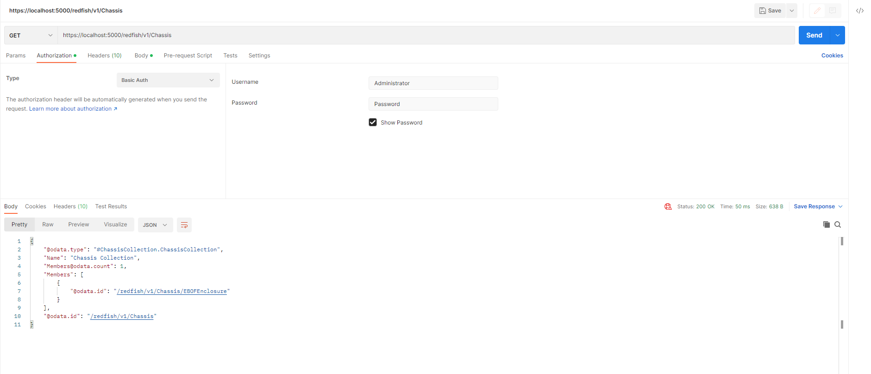

* + For session authentication:
    - To start a session, first create a session instance by POST request to SessionService/Sessions and in request body provide UserName and Password.

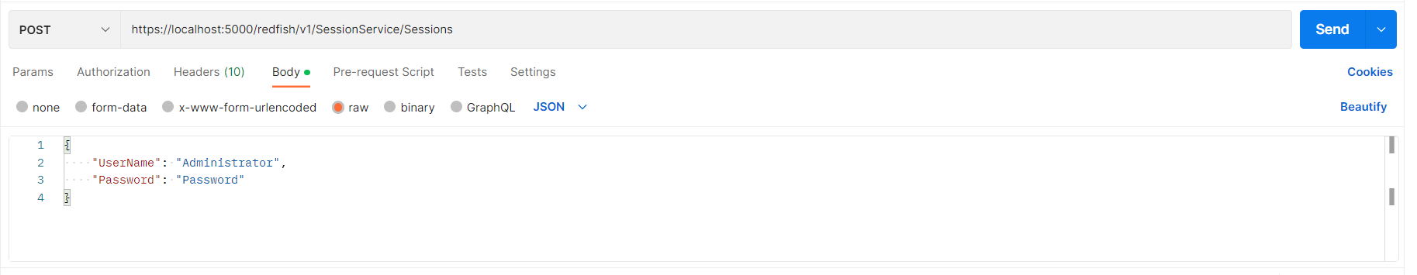

* + - After successfully starting a session instance, find X-Auth-Token and Location headers in response to the POST request. Note down the values of both headers. X-Auth-Token value is required to be added in subsequent request headers.

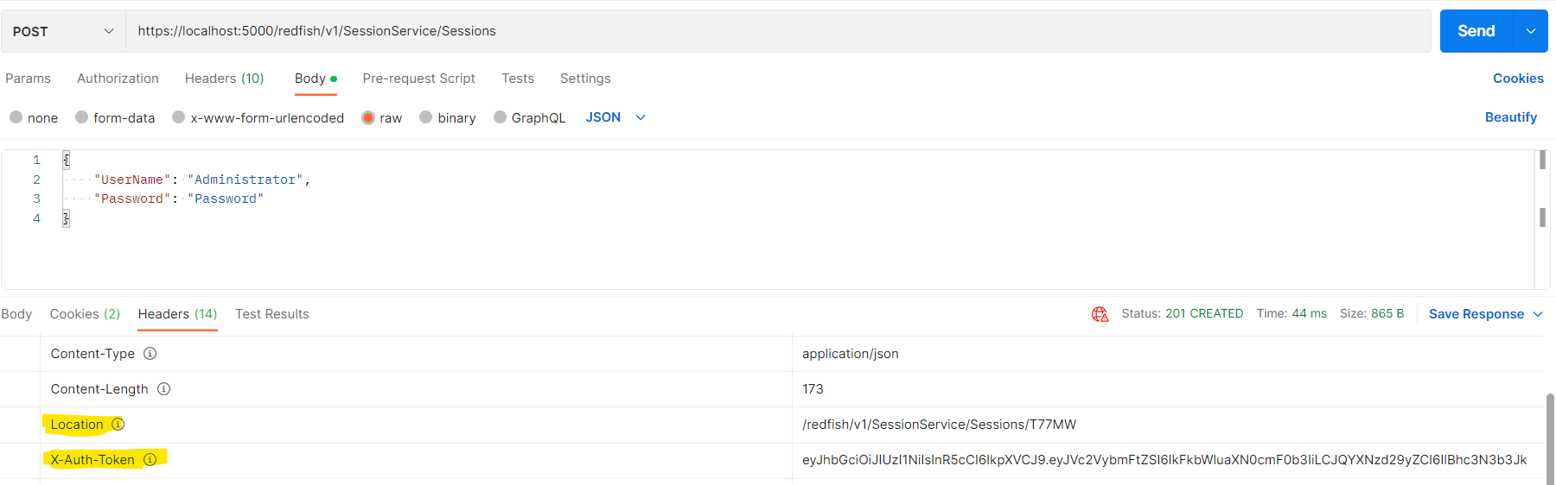

* + - Now use add the “X-Auth-Token” header in the subsequent request header. Below example shows the GET request for Chassis resource collection with token header.

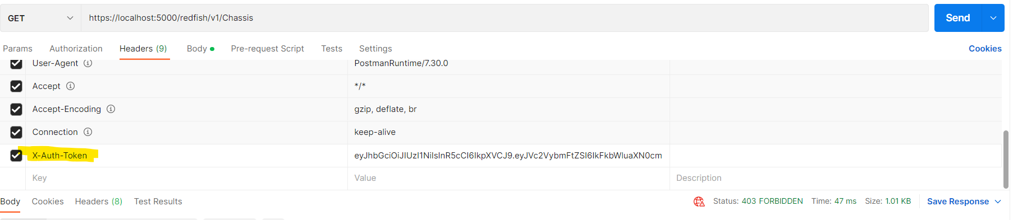

* + - Value of a “Location” header is required for deleting a session. Request a DELETE method on the “Location” value. While requesting DELETE as well, provide X-Auth-Token in the header.

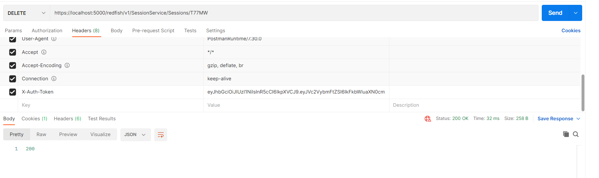

* + - After posting a session instance, the session will get started for some specific time period according to the value given for "SessionTimeout" in SessionService. If the session is inactive for that period, then the session will get logged out automatically.
  + For any authentication, make sure to send a HTTPS request and not HTTP request.