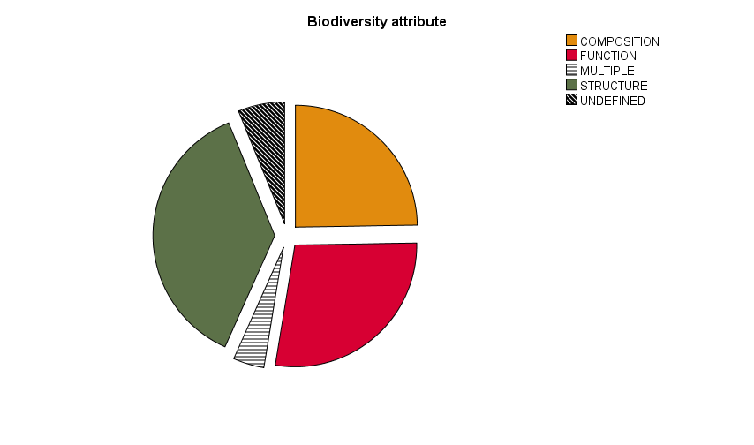
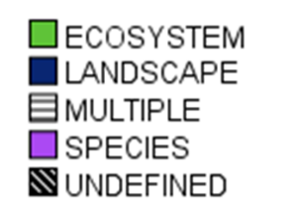
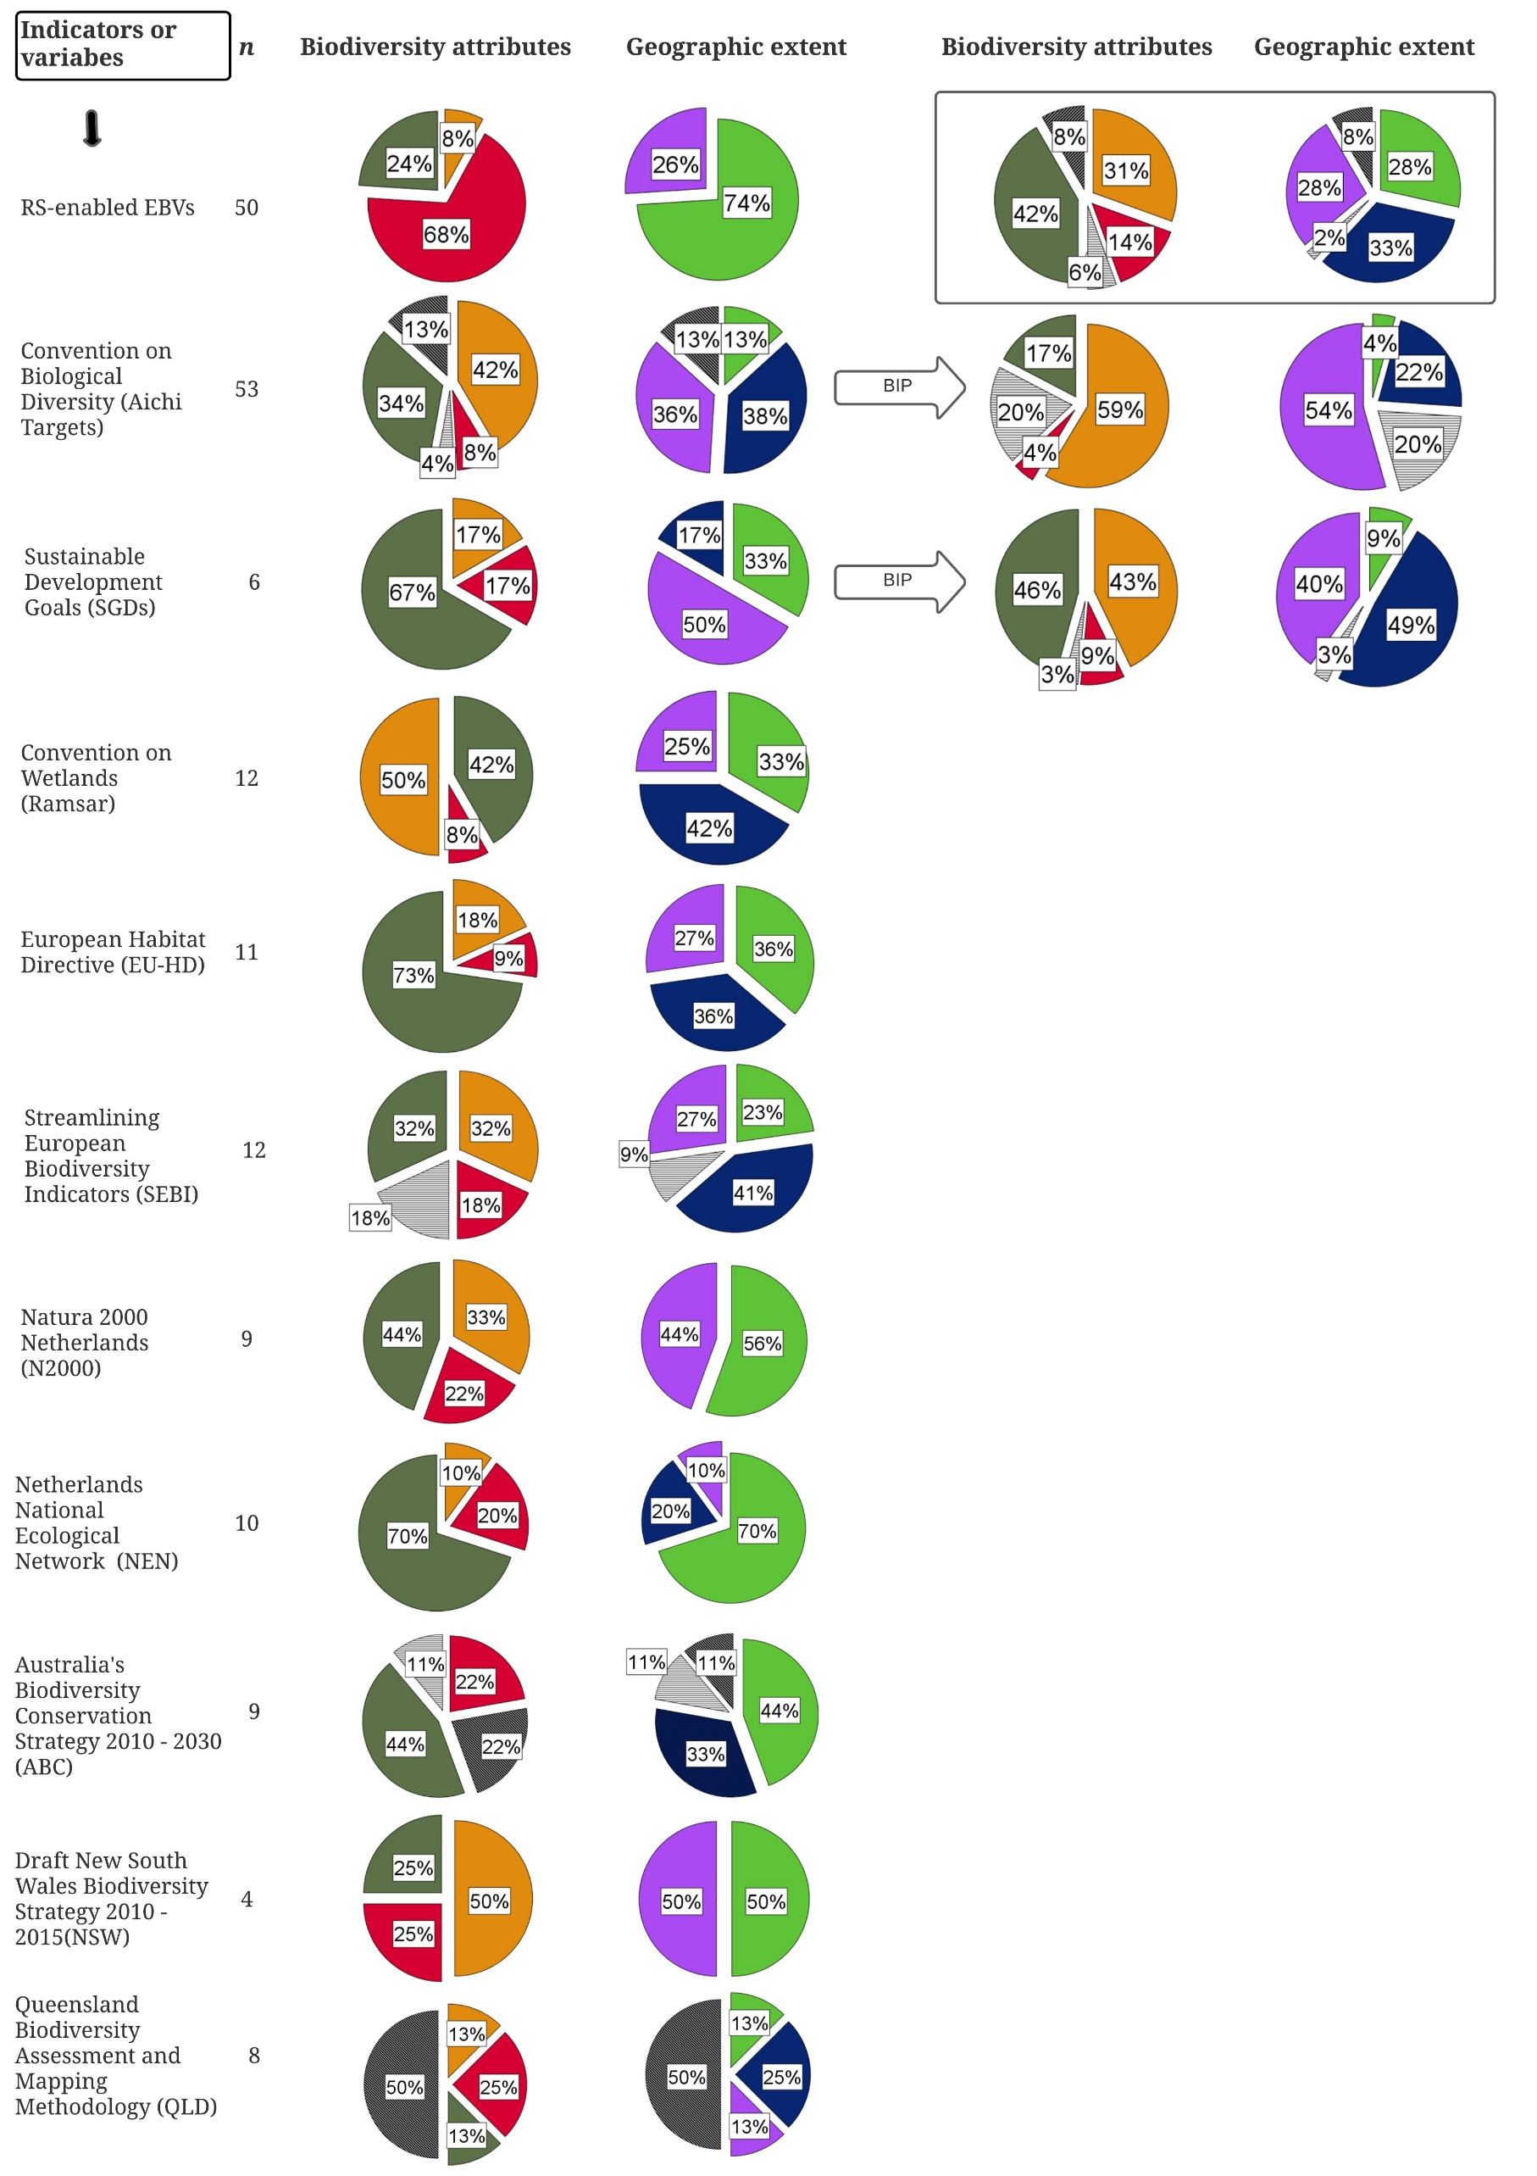
All policies
Legend

Figure 2. For each examined policy and RS-enabled EBVs, the pie charts show the percentage of indicators labeled on species, ecosystem or landscape level for geographic extent and composition, structure or function for biodiversity attributes, or labeled undefined/multiple.

