EXP 7 Monitoring HTTP and HTTPS packets using Wireshark
NAVIN 192512111
OBJECTIVE 1 HTTP
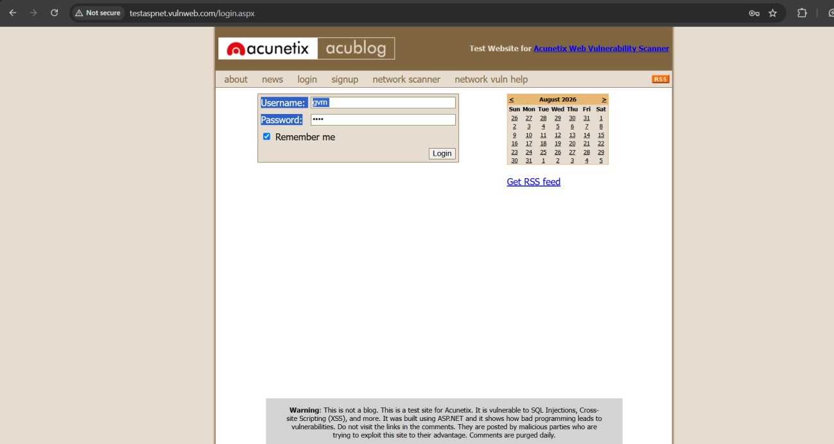

OUTPUT :
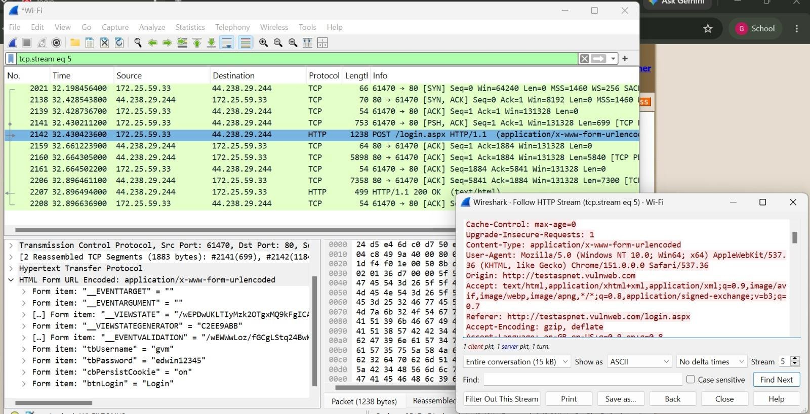

OBJECTIVE 2 : HTTPS


OUTPUT:
