陕西师范大学 可视化程序设计 实验报告
姓名： 赵旗 学号： 41612164 班级： 计创1601
指导教师： 卢俊岭
实验日期：2018.4.16
实验名称：C#.NET控件与界面设计

实验三 C#.NET控件与界面设计
一、实验目的
1．掌握利用VB/C#.NET基本控件构建界面。
2．掌握利用VB/C#.NET常用控件构建界面。
3．掌握利用VB/C#.NET特殊控件构建界面。
二、实验器材
1、微机（安装VB.NET开发环境）
2、开发程序：visual Studio 2015；开发语言：C#
三、实验内容
- 制作跑马灯实现动画设计。
  - 源代码:
public partial class Form1 : Form
{
Boolean flag=true ;//跑马灯方向朝左
public Form1()
{
InitializeComponent();
lblMsg.BackColor = Color.Aqua;
lblMsg.Text = "41612164_赵旗";
timer1.Enabled = true;
timer1.Interval = 10;
}

private void timer1_Tick(object sender, EventArgs e)
{
lblLocation.Text = "跑马灯位置:" + lblMsg.Left;
if(flag==true )//左移
{
lblMsg.Left -= 1;
lblDirection.Text = "目前方向:往左移";
if (lblMsg.Left <= 0)
flag = false;
}
else//右移
{
lblMsg.Left += 1;
lblDirection.Text = "目前方向: 往右移";
if (lblMsg.Width+lblMsg.Left >= this.Width)
flag = true;
}
}
}
  - 设计界面:
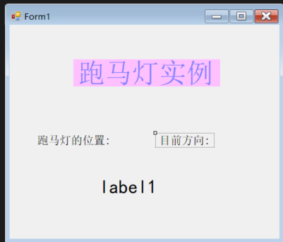
  - 实验结果:
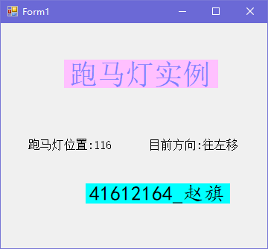
- 标签控件动态生成和三个窗体切换实例。
  - 源代码:
public partial class Form1 : Form
{
public Form1()
{
InitializeComponent();
}

private void button1_Click(object sender, EventArgs e)
{
Label mylabel = new Label();
this.Controls.Add(mylabel);
mylabel.Width = 200;
mylabel.Height = 20;
mylabel.Top = 10;
mylabel.BackColor = Color.Red;
mylabel.AutoSize = true;
mylabel.Text = "欢迎光临.....大家好!";
mylabel.Font = new Font("宋体", 17);
}

private void button2_Click(object sender, EventArgs e)
{
this.Hide();
Form2 yourform = new Form2();
yourform.Show();
}

private void button3_Click(object sender, EventArgs e)
{
this.Close();
Application.Exit();
}
}
public partial class Form2 : Form
{
public Form2()
{
InitializeComponent();
label1.Font = new Font("宋体", 36);
label1.Text = "这是窗体2!";
label1.AutoSize = true;
}

private void button1_Click(object sender, EventArgs e)
{
this.Hide();
Form1 myform = new Form1();
myform.Show();
}
}
  - 设计界面:
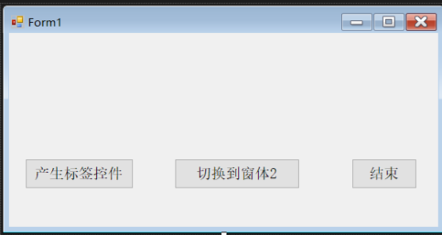
窗体一的设计界面
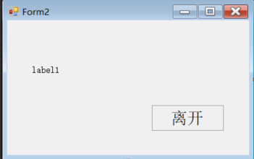
窗体二的设计界面
  - 实验结果:
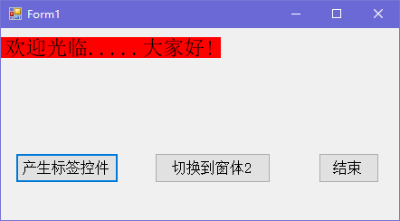
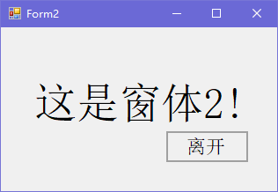
- 益智游戏。
  - 源代码:
public partial class Form1 : Form
{
double time;//时间
int count;//次数
int[,] a;
Random rand;

public Form1()
{
InitializeComponent();
btnStart.Enabled = true;
btnEnd.Enabled = false;
timer1.Interval = 100;
button1.Enabled = false;
button2.Enabled = false;
button3.Enabled = false;
button4.Enabled = false;
button5.Enabled = false;
button6.Enabled = false;
button7.Enabled = false;
button8.Enabled = false;
button9.Enabled = false;
}

private void btnEnd_Click(object sender, EventArgs e)
{
Close();
}

private void btnStart_Click(object sender, EventArgs e)
{
button1.Enabled = true;
button2.Enabled = true;
button3.Enabled = true;
button4.Enabled = true;
button5.Enabled = true;
button6.Enabled = true;
button7.Enabled = true;
button8.Enabled = true;
button9.Enabled = true;
count = 0;
time = 0.0;
timer1.Enabled = true;
btnStart.Enabled = false;
btnEnd.Enabled = true;
a = new int[4, 4];
rand = new Random((int)DateTime.Now.Ticks);
for (int i = 1; i <= 3; i++)
for (int j = 1; j <= 3; j++)
{
if (rand.NextDouble() > 0.5)
a[i, j] = 1;
else
a[i, j] = -1;
}
Display();
}
private void Display()
{
if (a[1, 1] == 1)
button1.BackColor = Color.Coral;
else
button1.BackColor = Color.Yellow;
if ((a[1, 2] == 1))
button2.BackColor = Color.Coral;
else
button2.BackColor = Color.Yellow;
if (a[1, 3] == 1)
button3.BackColor = Color.Coral;
else
button3.BackColor = Color.Yellow;
if (a[2, 1] == 1)
button4.BackColor = Color.Coral;
else
button4.BackColor = Color.Yellow;
if (a[2, 2] == 1)
button5.BackColor = Color.Coral;
else
button5.BackColor = Color.Yellow;
if (a[2, 3] == 1)
button6.BackColor = Color.Coral;
else
button6.BackColor = Color.Yellow;
if (a[3, 1] == 1)
button7.BackColor = Color.Coral;
else
button7.BackColor = Color.Yellow;
if (a[3, 2] == 1)
button8.BackColor = Color.Coral;
else
button8.BackColor = Color.Yellow;
if (a[3, 3] == 1)
button9.BackColor = Color.Coral;
else
button9.BackColor = Color.Yellow;
lblCount.Text = "次数: " + count + "次";
}
private void Check()
{
int sum = 0;
for (int i = 1; i <= 3; i++)
for (int j = 1; j <= 3; j++)
{
sum += a[i, j];
}
if (sum == 7)
{
btnStart.Enabled = true;
time = 0;
timer1.Enabled = false;
MessageBox.Show("恭喜!过关......");
}
}

private void timer1_Tick(object sender, EventArgs e)
{
time += 0.1;
lblTime.Text = "秒数： " + time.ToString("0.0") + "秒";
}

private void button1_Click(object sender, EventArgs e)
{
count++;
string temp = ((Button)sender).Text;
switch (temp)
{
case "1":
a[1, 1] = -a[1, 1];
a[1, 2] = -a[1, 2];
a[2, 1] = -a[2, 1];
a[2, 2] = -a[2, 2];
break;
case "2":
a[1, 1] = -a[1, 1];
a[1, 2] = -a[1, 2];
a[1, 3] = -a[1, 3];
break;
case "3":
a[1, 2] = -a[1, 2];
a[1, 3] = -a[1, 3];
a[2, 2] = -a[2, 2];
a[2, 3] = -a[2, 3];
break;
case "4":
a[1, 1] = -a[1, 1];
a[2, 1] = -a[2, 1];
a[3, 1] = -a[3, 1];
break;
case "5":
a[1, 2] = -a[1, 2];
a[2, 1] = -a[2, 1];
a[2, 2] = -a[2, 2];
a[2, 3] = -a[2, 3];
a[3, 2] = -a[3, 2];
break;
case "6":
a[1, 3] = -a[1, 3];
a[2, 3] = -a[2, 3];
a[3, 3] = -a[3, 3];
break;
case "7":
a[2, 1] = -a[2, 1];
a[2, 2] = -a[2, 2];
a[3, 1] = -a[3, 1];
a[3, 2] = -a[3, 2];
break;
case "8":
a[3, 1] = -a[3, 1];
a[3, 2] = -a[3, 2];
a[3, 3] = -a[3, 3];
break;
case "9":
a[2, 2] = -a[2, 2];
a[2, 3] = -a[2, 3];
a[3, 2] = -a[3, 2];
a[3, 3] = -a[3, 3];
break;
}
Display();
Check();
}
}
  - 设计界面:
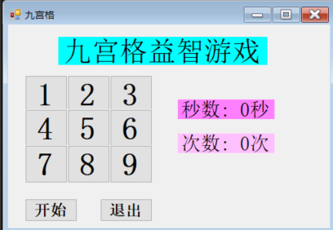
  - 实验结果:
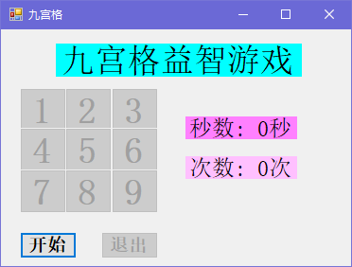
游戏开始前
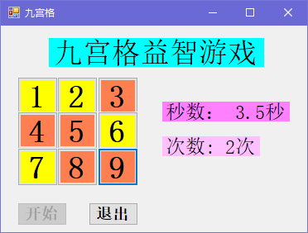
游戏中
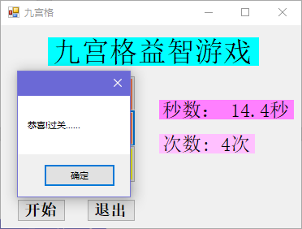
游戏获胜
- 制作调色板。
  - 源代码:
public partial class Form1 : Form
{
public Form1()
{
InitializeComponent();
}

private void tkbRed_Scroll(object sender, EventArgs e)
{
pictureshow.BackColor = Color.FromArgb(tkbRed.Value, tkbGreen.Value, tkbBlue.Value);
lblshow.Text = "当前设置:RGB(" + tkbRed.Value.ToString() + "," +
tkbGreen.Value.ToString() + "," + tkbBlue.Value.ToString() + ")";
lblRed.Text = tkbRed.Value.ToString();
lblGreen.Text = tkbGreen.Value.ToString();
lblBlue.Text = tkbBlue.Value.ToString();
}
private void Form1_Load(object sender, EventArgs e)
{
pictureshow.BackColor = Color.FromArgb(tkbRed.Value, tkbGreen.Value, tkbBlue.Value);
lblshow.Text = "当前设置:RGB(" + tkbRed.Value.ToString() + "," +
tkbGreen.Value.ToString() + "," + tkbBlue.Value.ToString() + ")";
}
}
  - 设计界面:
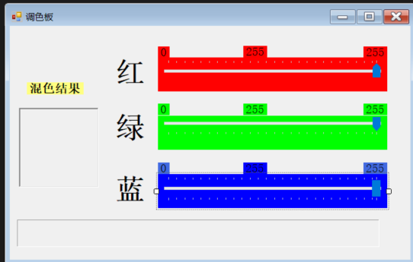
  - 实验结果:
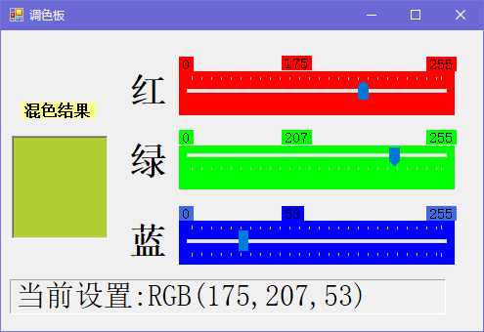

- 不破坏背景的慢跑动画。
  - 源代码:
public partial class Form1 : Form
{
int n=0;

public Form1()
{
InitializeComponent();
pic1.Visible = false;
pic2.Visible = false;
pic3.Visible = false;
pic4.Visible = false;
timer1.Interval = 100;
timer1.Enabled = true;
picRunner.Location = new Point(this.Width, 130);
}

private void timer1_Tick(object sender, EventArgs e)
{
switch(n%4)
{
case 0:
picRunner.Image = pic1.Image;
n++;
break;
case 1:
picRunner.Image = pic2.Image;
n++;
break;
case 2:
picRunner.Image = pic3.Image;
n++;
break;
case 3:
picRunner.Image = pic4.Image;
n = 0;
break;
}
if (picRunner.Location.X + picRunner.Width > 0)
picRunner.Location = new Point(picRunner.Location.X - 10, 130);
else
picRunner.Location = new Point(this.Width, 130);
}
private void Form1_Resize(object sender, EventArgs e)
{
this.Size = new Size(493, 289);
}
}
  - 设计界面:
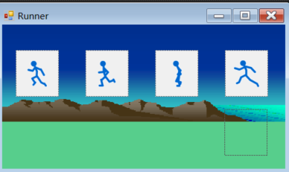
  - 实验结果:
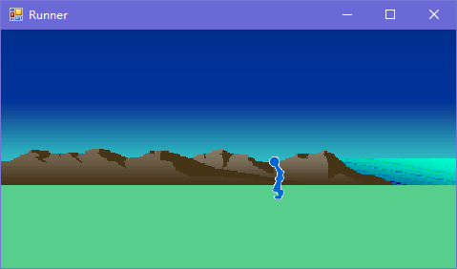
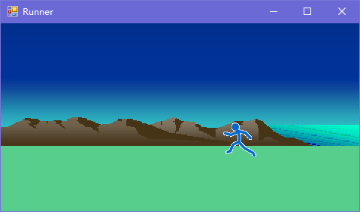
- 制作常见菜单。
  - 源代码:
public partial class Form1 : Form
{
string fontstyle = "宋体";
int fontsize = 48;
public Form1()
{
InitializeComponent();
label1.AutoSize = true;
}

private void 宋体ToolStripMenuItem_Click(object sender, EventArgs e)
{
fontstyle = "宋体";
label1.Font = new Font(fontstyle, fontsize);
}

private void 楷体ToolStripMenuItem_Click(object sender, EventArgs e)
{
fontstyle = "楷体";
label1.Font = new Font(fontstyle, fontsize);
}

private void 白色ToolStripMenuItem_Click(object sender, EventArgs e)
{
label1.ForeColor = Color.White;
}

private void 浅蓝ToolStripMenuItem_Click(object sender, EventArgs e)
{
label1.ForeColor = Color.LightBlue;
}

private void 黄色ToolStripMenuItem_Click(object sender, EventArgs e)
{
label1.ForeColor = Color.Yellow;
}

private void 红色ToolStripMenuItem_Click(object sender, EventArgs e)
{
label1.BackColor = Color.Red;
}

private void 深蓝色ToolStripMenuItem_Click(object sender, EventArgs e)
{
label1.BackColor = Color.Blue;
}

private void 深绿色ToolStripMenuItem_Click(object sender, EventArgs e)
{
label1.BackColor = Color.Green;
}

private void toolStripMenuItem5_Click(object sender, EventArgs e)
{
fontsize = 10;
label1.Font = new Font(fontstyle, fontsize);
}

private void toolStripMenuItem6_Click(object sender, EventArgs e)
{
fontsize = 24;
label1.Font = new Font(fontstyle, fontsize);
}

private void toolStripMenuItem7_Click(object sender, EventArgs e)
{
fontsize = 36;
label1.Font = new Font(fontstyle, fontsize);
}
}
  - 设计界面:
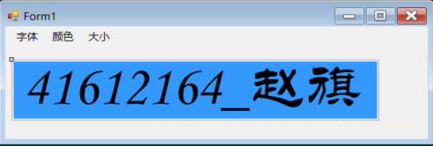
  - 实验结果:
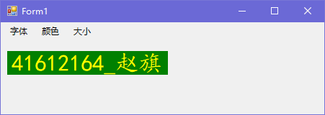
四、实验总结
1、VB.NET中用Me表示当前窗体,C#.NET中可用this来表示当前窗体.可以通过Me.Width或者this.Width来设置当前窗体的宽度等。
2、VB.NET中可通过Private Sub Button1_Click(ByVal sender As System.Object, ByVal e As System.EventArgs) Handles Button1.Click，Button2.Click，Button3.Click，Button4.Click
的方式或AddHandler Button1.Click, AddressOf MixedControls_Clcik的方式来实现多个按钮共享事件。而在C#中，可先编写一个按钮的Click事件的函数，然后选中所有需要共享事件的按钮，点击“闪电”按钮，找到Click事件，然后选择刚才编写的Click事件的函数，Visual Studio会自动在设计器代码和中生成相应的代码。或者通过在Form_load()中添加一行代码，如: this.button5.Click += new System.EventHandler(this.button1_Click);。
3、在九宫格益智游戏实验中，解决了老师上课演示中出现的没有点击“开始”按钮就能开始游戏的问题，以及使用一个timer控件实现了游戏时间的动态改变。
4、在多窗体切换的实验中可在“离开”按钮的Click事件中加一行Application.Exit()来彻底结束程序，防止出现程序运行过程中新建的窗体关闭，但进程仍驻留在内存中的情况，造成资源浪费。
5、在多窗体切换的实验中，在form1的一个Button控件的Click事件中new了一个form2窗体，当尝试去调用form2中的一个label控件时，IDE提示不能调用。解决方法:将form2设计器代码中对该控件的访问权限由private改为public。

