陕西师范大学 可视化程序设计 实验报告
姓名： 赵旗 学号： 41612164 班级： 计创1601
指导教师： 卢俊岭
实验日期：2018.5.20
实验名称：ADO.NET数据库应用

实验五 ADO.NET数据库应用
一、实验目的
1．掌握ADO.NET数据库连接与访问。
2. 掌握ADO.NET数据库浏览与绑定。
二、实验器材
1、微机（安装VB.NET开发环境）
2、开发程序：visual Studio 2015；开发语言：C#
三、实验内容
1．制作一个可插入、删除、修改PERSON数据表的员工工资系统。
1.1 源代码:
public Form1()
{
InitializeComponent();
ShowPerson();
}
private void ShowPerson()
{
string connStr, selectCmd;
connStr = "Provider=Microsoft.Jet.OLEDB.4.0;Data Source=PERSONDB.mdb";
selectCmd = "Select id_no AS 序号,name AS 姓名,id_position AS 职位,tel AS 电话,salary AS 工资 From PERSON Order By id_no DESC";
OleDbConnection conn;
OleDbDataAdapter myAdapter;
DataSet myDataSet = new DataSet();
conn = new OleDbConnection(connStr);
conn.Open();
myAdapter = new OleDbDataAdapter(selectCmd, conn);
myAdapter.Fill(myDataSet, "PERSON");
DataGrid1.DataSource = myDataSet.Tables["PERSON"];
}
string GetSqlStr(string str)
{
return str.Replace("'", "''");
}
private void btnAdd_Click(object sender, EventArgs e)
{
string connStr, insertCmd;
connStr = "Provider=Microsoft.Jet.OLEDB.4.0;Data Source=PERSONDB.mdb";
//insertCmd = "Insert Into PERSON(name, id_position, tel, salary) Values('" + GetSqlStr(txtName.Text) + "','" + GetSqlStr(txtPosition.Text) + "','" + GetSqlStr(txtTel.Text) + "'," + txtSalary.Text + ")";
insertCmd = "Insert Into PERSON(name, id_position, tel, salary) Values(@姓名, @职称, @电话, @工资)";
OleDbConnection conn = new OleDbConnection(connStr);
conn.Open();
OleDbCommand cmd = new OleDbCommand(insertCmd, conn);
cmd.Parameters.Add(new OleDbParameter("@姓名", OleDbType.Char));
cmd.Parameters.Add(new OleDbParameter("@职称", OleDbType.Char));
cmd.Parameters.Add(new OleDbParameter("@电话", OleDbType.Char));
cmd.Parameters.Add(new OleDbParameter("@工资", OleDbType.Integer));
cmd.Parameters["@姓名"].Value = txtName.Text;
cmd.Parameters["@职称"].Value = txtPosition.Text;
cmd.Parameters["@电话"].Value = txtTel.Text;
cmd.Parameters["@工资"].Value = Convert.ToInt32( txtSalary.Text);
cmd.ExecuteNonQuery();
conn.Close();
ShowPerson();
}

private void btnUpdate_Click(object sender, EventArgs e)
{
string connStr, updateCmd;
connStr = "Provider=Microsoft.Jet.OLEDB.4.0;Data Source=PERSONDB.mdb";
updateCmd = "UPDATE PERSON Set id_position=@职称, tel=@电话, salary=@工资 Where name=@姓名"
OleDbConnection conn = new OleDbConnection(connStr);
conn.Open();
OleDbCommand cmd = new OleDbCommand(updateCmd, conn);
cmd = new OleDbCommand(updateCmd, conn);
cmd.Parameters.Add(new OleDbParameter("@职称", OleDbType.Char));
cmd.Parameters.Add(new OleDbParameter("@电话", OleDbType.Char));
cmd.Parameters.Add(new OleDbParameter("@工资", OleDbType.Integer));
cmd.Parameters.Add(new OleDbParameter("@姓名", OleDbType.Char));
cmd.Parameters["@职称"].Value = txtPosition.Text;
cmd.Parameters["@电话"].Value = txtTel.Text;
cmd.Parameters["@工资"].Value = Convert.ToInt32( txtSalary.Text);
cmd.Parameters["@姓名"].Value = txtName.Text;
cmd.ExecuteNonQuery();
conn.Close();
ShowPerson();
}

private void btnDel_Click(object sender, EventArgs e)
{
string connStr, delCmd;
connStr = "Provider=Microsoft.Jet.OLEDB.4.0;Data Source=PERSONDB.mdb";
delCmd = "Delete From PERSON Where name = '" + GetSqlStr(txtName.Text) + "'";
OleDbConnection conn = new OleDbConnection(connStr);
conn.Open();
OleDbCommand cmd = new OleDbCommand(delCmd, conn);
cmd.ExecuteNonQuery();
conn.Close();
ShowPerson();
}
}
1.2 设计界面
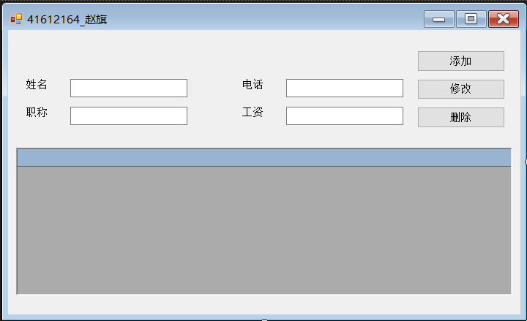
1.3 实验结果
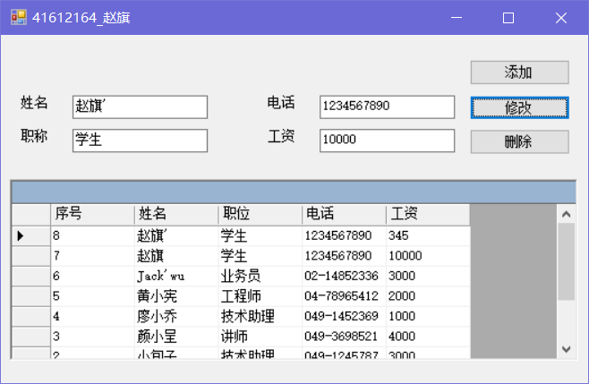
2. 使用DataView对象对SCOREDB.mdb数据库的SCORE数据表作排序，过滤学生的成绩。
2.1 源代码
public partial class Form1 : Form
{
string selectCmd = "Select id_no as 学号, name as 姓名, chi as 语文, eng as 英语, math as 数学 From SCORE";

public Form1()
{
InitializeComponent();
DataGrid1.DataSource = CreateView("SCOREDB.mdb", selectCmd, "SCORE");
}
private DataView CreateView(string DBName, string SQLcmd, string TabName)
{
string connstr = "Provider=Microsoft.Jet.OLEDB.4.0;Data Source=" + DBName;
OleDbConnection conn;
OleDbDataAdapter myAdapter;
DataSet myDataSet = new DataSet();
conn = new OleDbConnection(connstr);
conn.Open();
myAdapter = new OleDbDataAdapter(SQLcmd, conn);
myAdapter.Fill(myDataSet, TabName);
return myDataSet.Tables[TabName].DefaultView;
}
private void btnOk_Click(object sender, EventArgs e)
{
string sortStr = string.Empty;
if (rdbChi.Checked)
sortStr += rdbChi.Text;
if (rdbEng.Checked)
sortStr += rdbEng.Text;
if (rdbMath.Checked)
sortStr += rdbMath.Text;
if (rdbDesc.Checked)
sortStr += " DESC";
if (rdbAsc.Checked)
sortStr += " ASC";
DataView myDataView = new DataView();
myDataView = CreateView("SCOREDB.mdb", selectCmd, "SCORE");
myDataView.RowFilter = txtFilter.Text;
myDataView.Sort = sortStr;
DataGrid1.DataSource = myDataView;
}
}
2.2设计界面
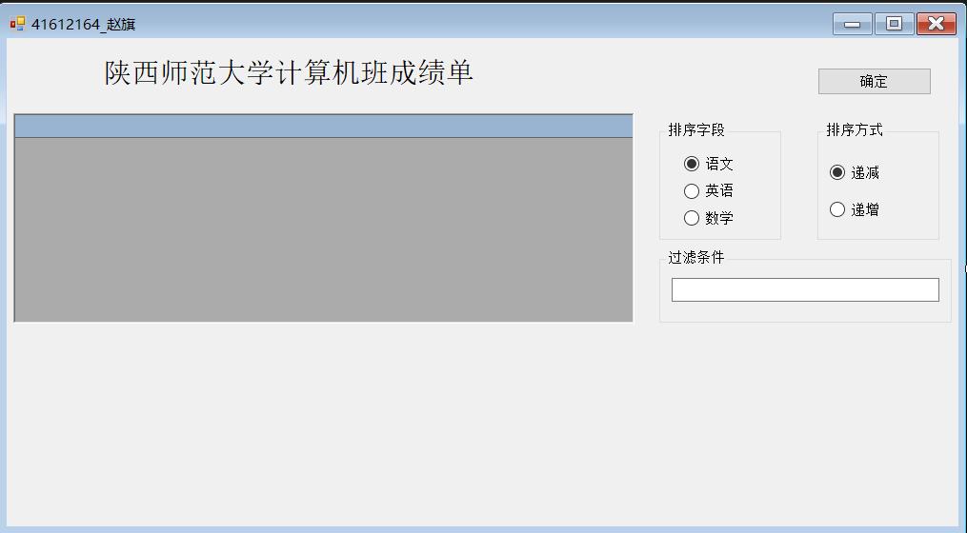
2.3 实验界面
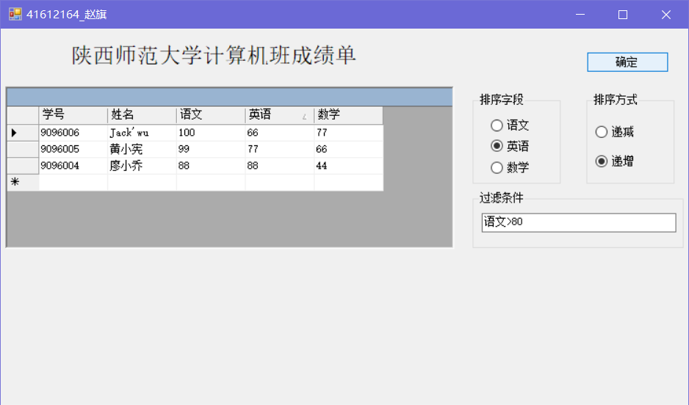
如上图，筛选语文大于80的同学，并以英语为字段降序排列。
3. 将MEMBER数据表的数据记录与TextBox、ComboBox、DataGrid控件做数据绑定。
3.1 源代码
public partial class Form1 : Form
{
public Form1()
{
InitializeComponent();
}

private void Form1_Load(object sender, EventArgs e)
{
string selectCmd = "Select * from MEMBER";
string connStr = "Provider=Microsoft.Jet.OLEDB.4.0;Data Source=MEMBERDB.mdb";
OleDbConnection conn;
OleDbDataAdapter myAdapter;
DataSet myDataSet = new DataSet();
conn = new OleDbConnection(connStr);
conn.Open();
myAdapter = new OleDbDataAdapter(selectCmd, conn);
myAdapter.Fill(myDataSet, "MEMBER");
cboId.DataSource = myDataSet;
cboId.DisplayMember = "MEMBER.id_no";

txtName.DataBindings.Add("Text", myDataSet, "MEMBER.name");
txtTel.DataBindings.Add("Text", myDataSet, "MEMBER.tel");
txtSex.DataBindings.Add("Text", myDataSet, "MEMBER.sex");
txtAdd.DataBindings.Add("Text", myDataSet, "MEMBER.address");

DataGrid1.DataSource = myDataSet;
DataGrid1.DataMember = "MEMBER";

//DataGrid1.DataSource = myDataSet.Tables["MEMBER"];
//DataGrid1.DataSource = myDataSet.Tables["MEMBER"].DefaultView;
}
}
3.2设计界面
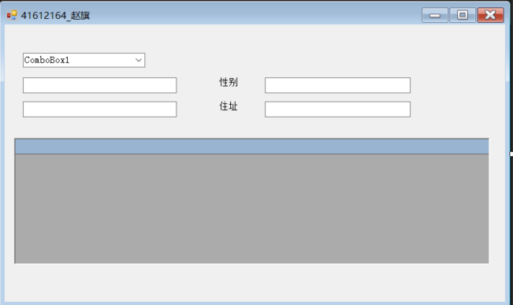
3.3 实验界面
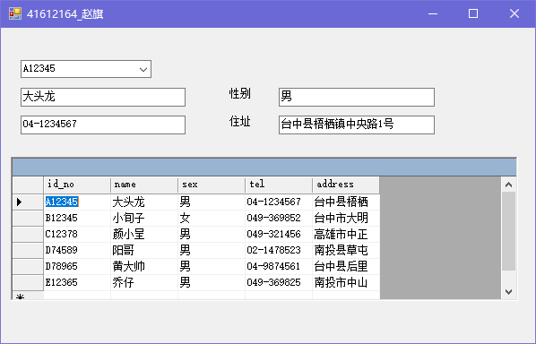
4. 制作两个关系数据表的数据库应用程序。
4.1源代码
public partial class Form1 : Form
{
public Form1()
{
InitializeComponent();
}

private void Form1_Load(object sender, EventArgs e)
{
string selectCmd1, selectCmd2, connstr;
selectCmd1 = "Select order_id as 订单编号, customers as 客户名称, order_date as 订购日期 From ORDERTITLE";
selectCmd2 = "Select order_id as 订单编号, PRODUCT as 订购产品, price as 产品单价, qty as 订购数量 From ORDERDETAIL";
connstr = "Provider=Microsoft.Jet.OLEDB.4.0;Data Source=ORDERSDB.mdb";
OleDbConnection conn;
OleDbDataAdapter myAdapter;
DataSet myDataSet = new DataSet();
conn = new OleDbConnection(connstr);
conn.Open();
myAdapter = new OleDbDataAdapter(selectCmd1, conn);
myAdapter.Fill(myDataSet, "ORDERTITLE");
myAdapter = new OleDbDataAdapter(selectCmd2, conn);
myAdapter.Fill(myDataSet, "ORDERDETAIL");
myDataSet.Relations.Add("relations_order_id", myDataSet.Tables["ORDERTITLE"].Columns["订单编号"],
myDataSet.Tables["ORDERDETAIL"].Columns["订单编号"]);
dgTitle.DataSource = myDataSet;
dgTitle.DataMember = "ORDERTITLE";
dgDetail.DataSource = myDataSet;
dgDetail.DataMember = "ORDERTITLE.relations_order_id";
cboOrderId.DataSource = myDataSet;
cboOrderId.DisplayMember = "ORDERTITLE.订单编号";
txtCustomers.DataBindings.Add("Text", myDataSet, "ORDERTITLE.客户名称");
txtDate.DataBindings.Add("Text", myDataSet, "ORDERTITLE.订购日期");
}

private void btnEnd_Click(object sender, EventArgs e)
{
Application.Exit();
}
}
4.2 设计界面
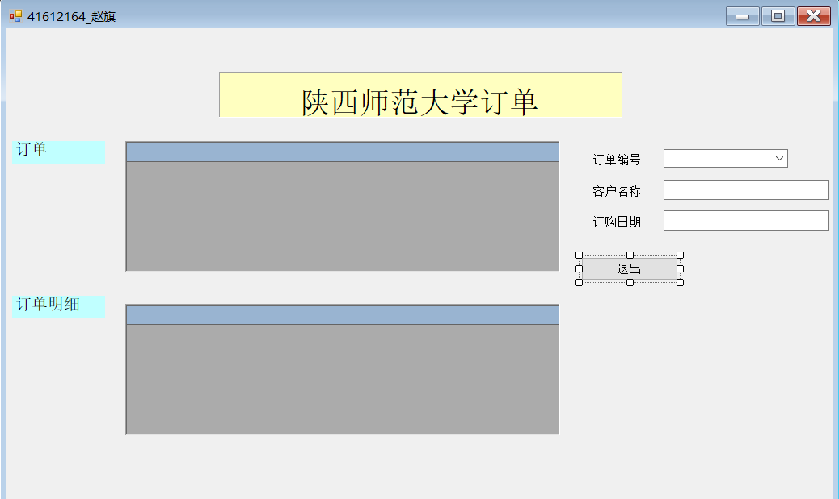
4.3 实验结果
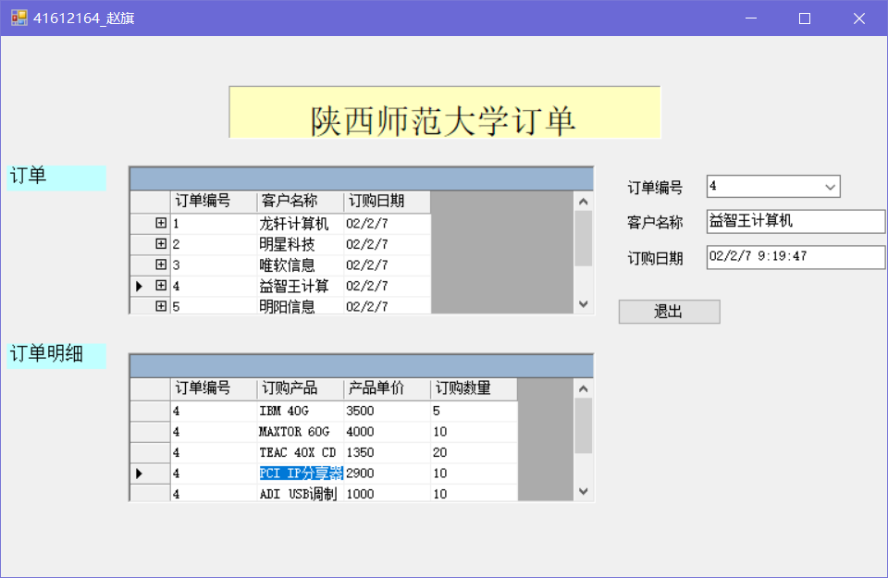
5. 使用BindingManagerBase对象与TextBox控件做数据绑定的操作，且可动态浏览BOOK数据表的上一条、下一条记录。
5.1 源代码
public partial class Form1 : Form
{
BindingManagerBase Bm;
public Form1()
{
InitializeComponent();
}

private void CheckBm()
{
if (Bm.Position == 0)
{
btnFirst.Enabled = false;
btnPrev.Enabled = false;
btnNext.Enabled = true;
btnLast.Enabled = true;
}
else if (Bm.Position == Bm.Count - 1)
{

btnFirst.Enabled = true;
btnPrev.Enabled = true;
btnNext.Enabled = false;
btnLast.Enabled = false;
}
else
{
btnFirst.Enabled = true;
btnPrev.Enabled = true;
btnNext.Enabled = true;
btnLast.Enabled = true;
}
lblShow.Text = (Bm.Position + 1) + "/" + Bm.Count;
}
private void btnFirst_Click(object sender, EventArgs e)
{
Bm.Position = 0;
CheckBm();
}

private void btnPrev_Click(object sender, EventArgs e)
{
Bm.Position -= 1;
CheckBm();
}

private void btnNext_Click(object sender, EventArgs e)
{
Bm.Position += 1;
CheckBm();
}

private void btnLast_Click(object sender, EventArgs e)
{
Bm.Position = Bm.Count - 1;
CheckBm();
}

private void Form1_Load(object sender, EventArgs e)
{
string selectCmd = "select id_no as 书号, name as 书名, price as 单价, qty as 数量 From BOOK";
string connStr = "Provider=Microsoft.Jet.OLEDB.4.0;Data Source=BOOKDB.mdb";
OleDbConnection conn;
OleDbDataAdapter myAdapter;
DataSet myDataSet = new DataSet();
conn = new OleDbConnection(connStr);
conn.Open();
myAdapter = new OleDbDataAdapter(selectCmd, conn);
myAdapter.Fill(myDataSet, "BOOK");
Binding bindId = new Binding("Text", myDataSet, "BOOK.书号");
Binding bindName = new Binding("Text", myDataSet, "BOOK.书名");
Binding bindPrice = new Binding("Text", myDataSet, "BOOK.单价");
Binding bindQty = new Binding("Text", myDataSet, "BOOK.数量");
txtId.DataBindings.Add(bindId);
txtName.DataBindings.Add(bindName);
txtPrice.DataBindings.Add(bindPrice);
txtQty.DataBindings.Add(bindQty);
Bm = this.BindingContext[myDataSet, "BOOK"];
CheckBm();
}
}
5.2 设计界面
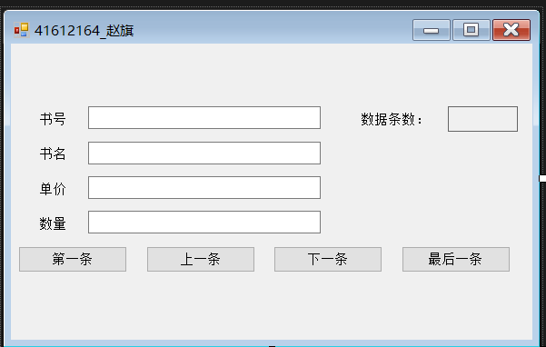
5.3 实验结果
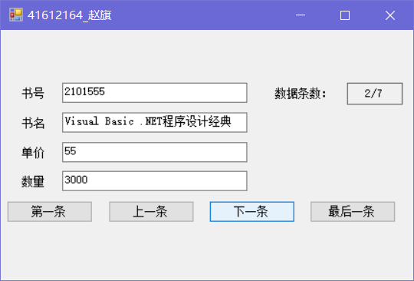
四、实验总结
1、调试过程中出现异常，异常信息为“未在本地计算机上注册“Microsoft.Jet.OLEDB.4.0”提供程序”，在配置管理器中新建一个平台为“X86”并选择即可。
2、向数据库中插入一条记录可以有两种方法：①将完整的SQL语句保存到字符串中②SQL语句里面加入参数，然后指定参数类型并给参数赋对应数据的值如:cmd.Parameters.Add
(new OleDbParameter("@姓名", OleDbType.Char))；最后调用cmd.ExecuteNonQuery();
3、为了使在DataGridView中显示的列名为中文，可在SQL查询语句中为每一个字段指定别名，或者使用一条语句为英文列明指定别名，如:datagridview1.Columns["NAME"].He
aderText = "姓名"。
4、在C#中引用Dataset的Table或者Colum时，应使用中括号，而在VB中则可使用小括号。
5、若使用最新版Acces中扩展名为accdb的文件在存储表，则数据库连接串应写为” ""Provider=Microsoft.ACE.OLEDB.12.0;Data Source="ORDERSDB.accdb";”

