陕西师范大学 可视化程序设计 实验报告
姓名： 赵旗 学号： 41612164 班级： 计创1601
指导教师： 卢俊岭
实验日期：2018.5.10
实验名称：窗口事件应用技巧

实验四 窗口事件应用技巧
一、实验目的
1．熟悉掌握VS.NET集成开发环境。
2．掌握一个VB/C#.NET程序的完整上机过程（编辑、保存、运行、编译）。
二、实验器材
1、微机（安装VB.NET开发环境）
2、开发程序：visual Studio 2015；开发语言：C#
三、实验内容
1．创建过滤字符的TextBox控件。
  - 源代码:
public partial class Form1 : Form
{
public Form1()
{
InitializeComponent();
}
private void txtId_KeyPress(object sender, KeyPressEventArgs e)
{
if (txtId.Text.Length < 6)
{
if (txtId.SelectionStart == 0)
{
string s = e.KeyChar.ToString().ToUpper();
if (string.Compare(s, "A") < 0 || string.Compare(s, "Z") > 0)
e.Handled = true;
}
else
{
if ((e.KeyChar < '0' || e.KeyChar > '9') && e.KeyChar != '\b')
e.Handled = true;
}
}
else
{
if (e.KeyChar != '\b')
e.Handled = true;
}
}
private void txtId_TextChanged(object sender, EventArgs e)
{
//Textbox中的文本改变后,SelectionStart会置为0
int loc = txtId.SelectionStart;
txtId.Text = txtId.Text.ToUpper();//转换为大写
txtId.SelectionStart = loc;
}
  - 设计界面；
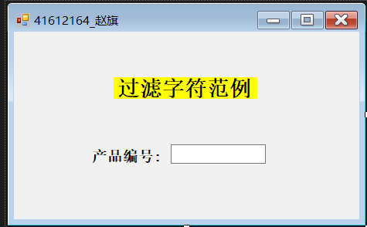
  - 实验结果:
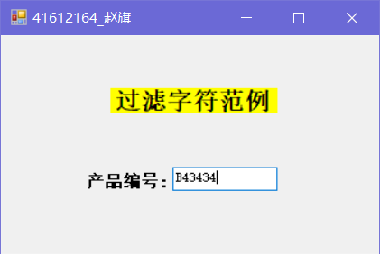
2. 利用上下左右键控制坦克图移动。
  - 源代码:
public partial class Form1 : Form
{
public Form1()
{
InitializeComponent();
}

private void Form1_Load(object sender, EventArgs e)
{
lblX.Text = "X坐标:" + picTank.Left ;
lblY.Text = "Y坐标:" + picTank.Top ;
picTank.Image = picTankU.Image;
picTankU.Visible = false;
picTankD.Visible = false;
picTankL.Visible = false;
picTankR.Visible = false;
}

private void Form1_KeyDown(object sender, KeyEventArgs e)
{
switch (e.KeyCode)
{
case Keys.Up:
picTank.Image = picTankU.Image;
if ((picTank.Top + picTank.Height) <= 0)
picTank.Top = this.Height;
else
picTank.Top -= 10;
break;
case Keys.Down:
picTank.Image = picTank.Image;
if (picTankD.Top > this.Height)
picTank.Top = 0 - picTank.Height;
else
picTank.Top += 10;
break;
case Keys.Left:
picTank.Image = picTankL.Image;
if (picTank.Width + picTank.Left <= 0)
picTank.Left = this.Width;
else
picTank.Left -= 10;
break;
case Keys.Right:
picTank.Image = picTankR.Image;
if (picTank.Left >= this.Width)
picTank.Left = 0 - picTank.Width;
else
picTank.Left += 10;
break;
}
lblX.Text = "X坐标:" + picTank.Left ;
lblY.Text = "Y坐标:" + picTank.Top ;
lblMsg.Text = "现在按下" + e.KeyCode.ToString() + "键，键值为" + Convert.ToInt32(e.KeyCode) + "!!";
}

private void Form1_KeyUp(object sender, KeyEventArgs e)
{
lblMsg.Text = "请按上下左右键控制坦克！";
}
}
  - 设计界面:
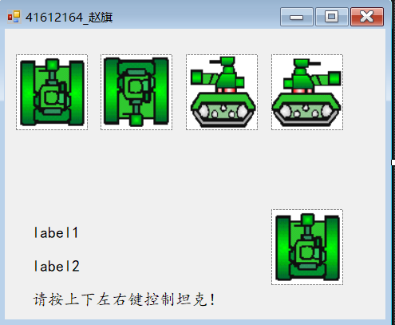
  - 实验结果:
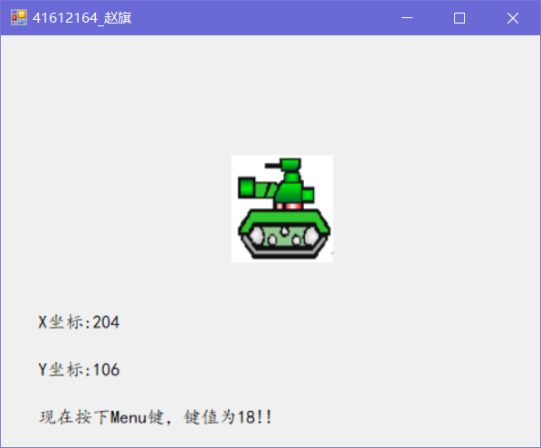
3. 使用鼠标事件来创建画图。
  - 源代码:
public partial class Form1 : Form
{
private int oldX,oldY;
Color pen_color;
Bitmap bmp;
public Form1()
{
InitializeComponent();
}

private void Form1_Load(object sender, EventArgs e)
{
piccolor.BackColor = Color.FromArgb(0, 0, 0);
pen_color = new Color();
pen_color = Color.Black;
bmp = new Bitmap(picShow.Width,picShow.Height);
picShow.Image = bmp;
}

private void tkbRed_Scroll(object sender, EventArgs e)
{
piccolor.BackColor = Color.FromArgb(tkbRed.Value, tkbGreen.Value, tkbBlue.Value);
pen_color = piccolor.BackColor;
}

private void picShow_MouseDown(object sender, MouseEventArgs e)
{
oldX = e.X;
oldY = e.Y;
}

private void picShow_MouseMove(object sender, MouseEventArgs e)
{
if (e.Button == MouseButtons.Left)
{
Graphics g = Graphics.FromImage(bmp);
Pen pen = new Pen(pen_color,3);
g.DrawLine(pen, oldX, oldY, e.X, e.Y);
picShow.Image = bmp;
oldX = e.X;
oldY = e.Y;
picShow.Refresh();
}
}
}
  - 设计界面:
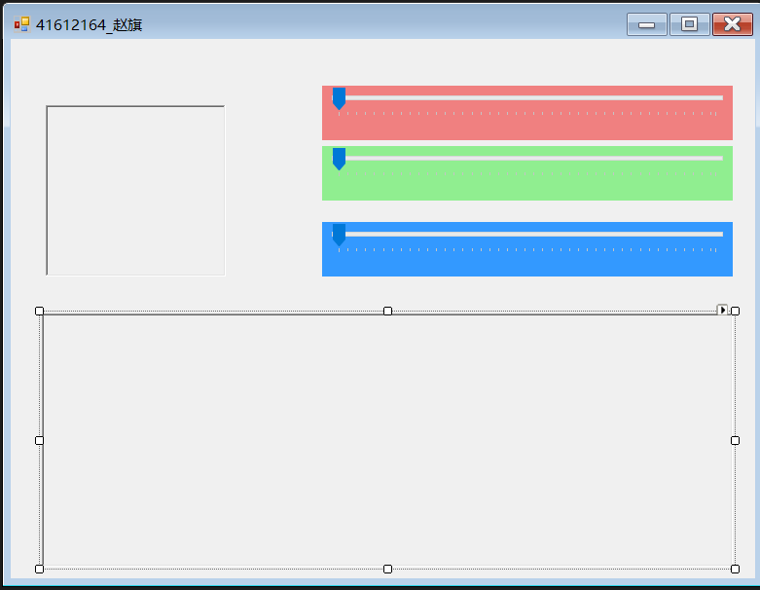
  - 实验结果:
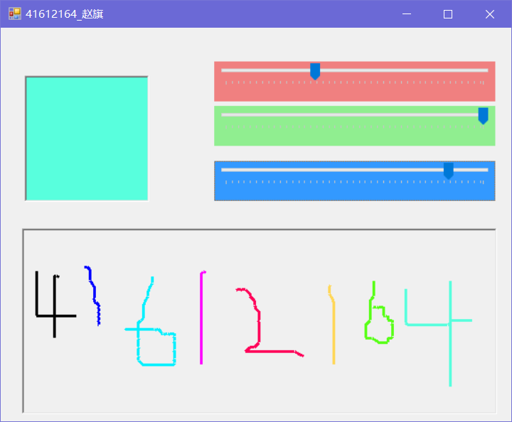
4. 添加和删除控件共享事件过程实例。
  - 源代码:
public partial class Form1 : Form
{
public Form1()
{
InitializeComponent();
}

private void Form1_Load(object sender, EventArgs e)
{
this.textBox1.TextChanged += new System.EventHandler(Mybutton_Click);
this.textBox2.TextChanged += new System.EventHandler(Mybutton_Click);
textBox1.Text = "";
textBox2.Text = "";
}

private void btnAdd_Click(object sender, EventArgs e)
{
this.textBox1.TextChanged += new System.EventHandler(Mybutton_Click);
this.textBox2.TextChanged += new System.EventHandler(Mybutton_Click);
}

private void btnDel_Click(object sender, EventArgs e)
{
this.textBox1.TextChanged -= new System.EventHandler(Mybutton_Click);
this.textBox2.TextChanged -= new System.EventHandler(Mybutton_Click);
}
private void Mybutton_Click(object sender, EventArgs e)
{
//string x=Convert.ToString(Convert.ToInt32(textBox1.Text)+ Convert.ToInt32(textBox2.Text));
long a = string.IsNullOrEmpty(textBox1.Text) ? 0 : Convert.ToInt64(textBox1.Text);
long b = string.IsNullOrEmpty(textBox2.Text) ? 0 : Convert.ToInt64(textBox2.Text);
label3.Text = (a + b).ToString();
}
}
  - 设计界面:
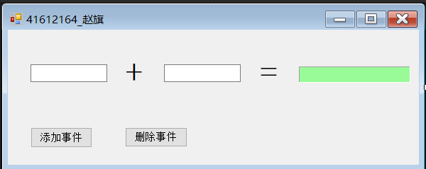
  - 实验结果:
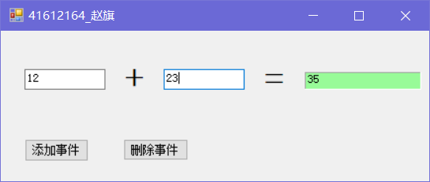
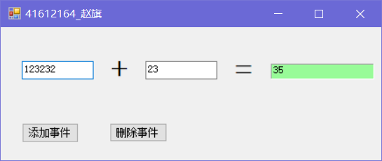
四、实验总结
1、在控制坦克图移动的实验中，按下键盘上的任意键，窗体中均会显示当前所按键的ASCII值。为了解决该问题，可以用一个if条件判断所按下的键是否为四个方向键。
2、在添加和删除事件的实验中，用Convert.ToInt32(textBox1.Text)将输入文本框的内容转换为int类型，出现System.FormatException错误（字符串格式不正确）。原因是:开始在一个文本框中输入的时候，另一个文本框中的内容为空，此时若用上述方法进行转换则会出现错误。解决方法是：先判断文本框是否为空，然后再决定是否要进行转换。如: string.IsNullOrEmpty(textBox2.Text) ? 0 : Convert.ToInt64(textBox2.Text)。

