|  |  |
| --- | --- |
| A picture of a winding road and trees  Pandas Challenge | Abstract  To analyse and aggregate the district-wide standardized school data to showcase the obvious trends in school performance.  Nandhini N  Data Analytics Boot Camp |

Student ID Number: 2545553

Data Submitted: 26th September 2022

Table of Contents

1. Conclusions on School and Standardized Test Data 1

1.1. Conclusion 1 based on School Type 1

1.2. Conclusion 2 based on School Size 2

2. Limitations 3

3. References 3

# Conclusions on School and Standardized Test Data

From the data provided, it can be seen that there is not much of a difference in the average Math and Reading scores of the students across the 15 schools. However, considering the %Pass in Math and Reading, students have fared well in Reading compared to Math. There is a big difference of about 10-15% between the Math and Reading % Pass in bigger schools and 0.5 - 4% in small and medium sized schools.

Coincidentally all the bigger schools are District Schools, while the medium and small sized ones are Charter Schools.

The large schools have a higher Per Student Budget compared to that of the small and medium schools.

Analysing the data further, the following conclusions can be made:

## Conclusion 1 based on School Type

The schools from the given data can be categorised into two types: District and Charter.

Out of the 15 schools, 7 are District and 8 are Charter schools.

The following table created using Pandas, gives the overall picture of the state of the Charter and District schools:

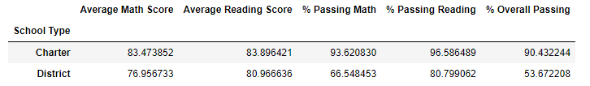

While there is not much of a difference in the Average Math and Reading scores, there is a huge difference in the pass percentages.

The Charter schools have out-performed the District schools in both Math and Reading as well as the Overall % Passing.

The % Passing in Math and Reading at the district-level are 74.98% and 85.80% respectively and the Overall % Passing is 65.17%. 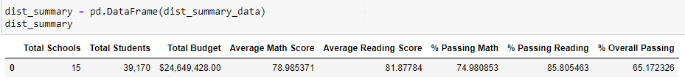

The Charter School percentages are way higher than the district-level at 93.62, 96.58 and 90.43 respectively, while the District School results are way below that of the District scores.

This coincides with the Top and Bottom 5 Performing Schools (By % Overall Passing). All the Top 5 schools are of the Charter type and all the Bottom 5 schools are District schools.

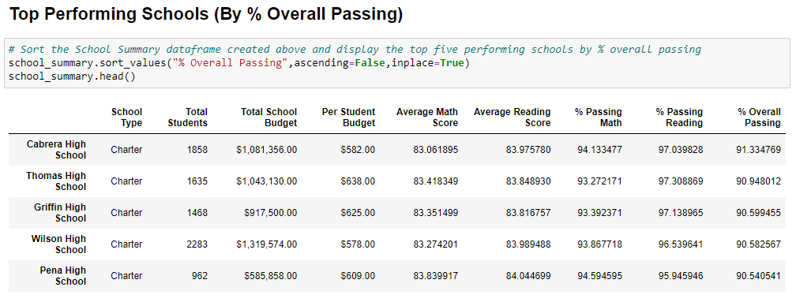

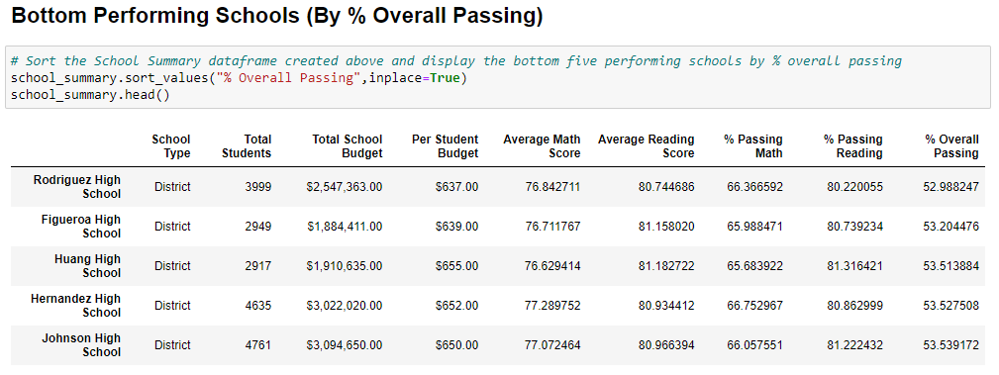

## Conclusion 2 based on School Size

The School Size is determined by the number of students studying in the schools. The following are the three broad categories based on number of students:

1. Small – less than 1000 students
2. Medium – 1000 to 2000 students
3. Large – 2000 to 5000 students

The following table created using Pandas gives an idea about the performance of schools based on size:

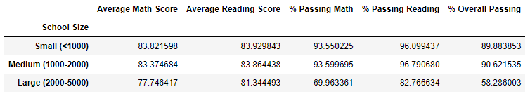

Here again, there is not much of a difference in terms of the average Math and Reading scores.

However, Math, Reading and Overall % Passing of Large schools are way lower than that of the Small and Medium sized schools.

The Small and Medium schools have done well than the Large schools.

# Limitations

The following data if collected and analysed, would help make informed decisions:

(Chen, 2022) (Shakeel & Peterson, 2021) (Anon., 2022)

1. Are the Math and Reading scores alone enough to measure the performance of schools?
2. Are the socioeconomic and demographic status of the Charter school children different from that of the District school children. Do these really impact the performance?
3. Though the Per Student Budget for the District schools are higher than that of the Charter schools, how is it being used? Will an increase in budget help spending more on tuitions?
4. Do the Charter schools have different syllabus and teaching methods compared to that of the District schools?
5. With the large number of students, do the District schools have enough staff?

# References

1. Anon., 2022. *ncsl.* [Online]   
   Available at: https://www.ncsl.org/research/education/charter-schools-research-and-report.aspx#:~:text=A%20well%2Dpublicized%20study%20of,significantly%20better%20than%20traditional%20public  
   [Accessed 2022 September 2022].
2. Chen, G., 2022. *publicschoolreview.* [Online]   
   Available at: https://www.publicschoolreview.com/blog/charter-schools-vs-traditional-public-schools-which-one-is-under-performing  
   [Accessed 20 September 2022].
3. Shakeel, M. D. & Peterson, P. E., 2021. *educationnext.* [Online]   
   Available at: https://www.educationnext.org/charter-schools-show-steeper-upward-trend-student-achievement-first-nationwide-study/  
   [Accessed 20 September 2022].