# Python Challenge – PyBank Results

Output printed on the Console

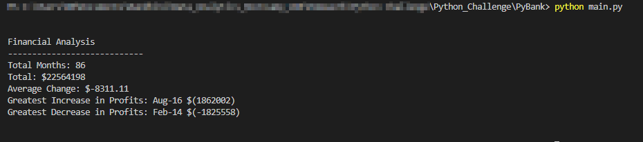

Output printed in the Text file

