# Python Challenge – PyPoll Results

Output printed on the Console

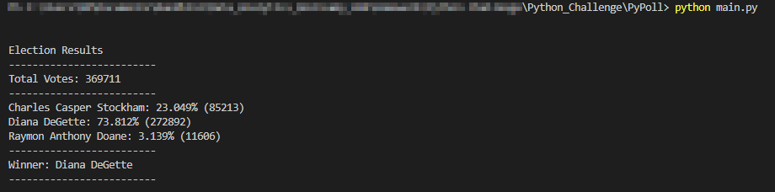

Output printed in the Text file

