Stock Data Analysis & Bonus for the year 2018

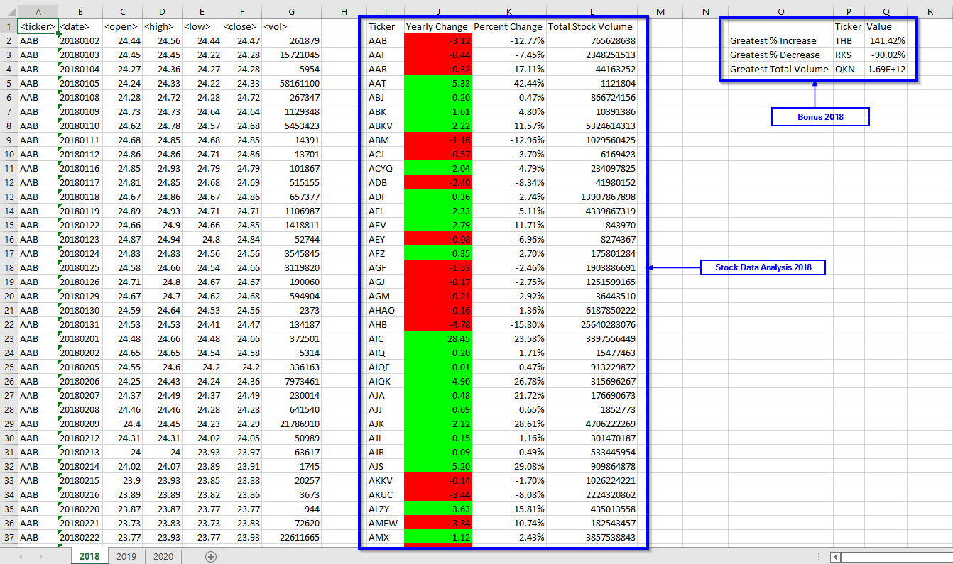

Stock Data Analysis & Bonus for the year 2019

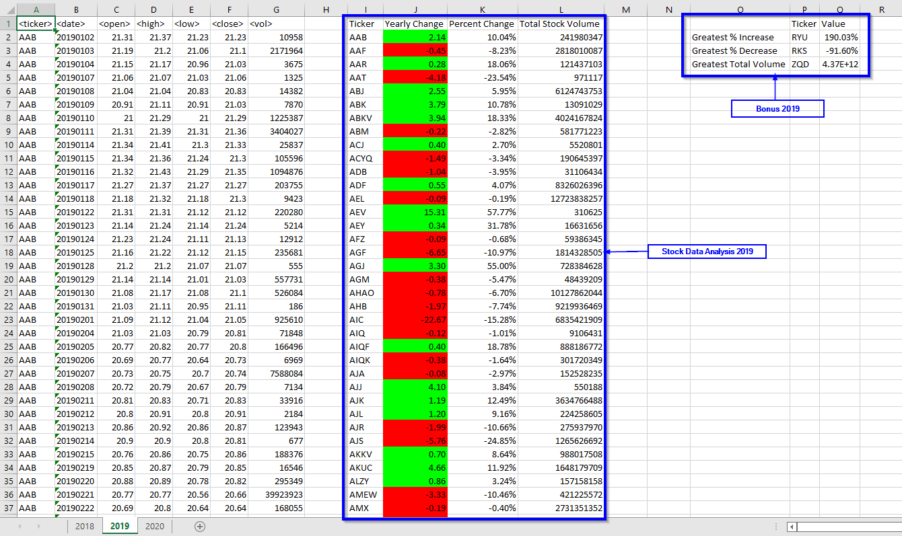

Stock Data Analysis & Bonus for the year 2020

